INDOOR AIR QUALITY ASSESSMENT

Massachusetts Department of Transportation
10 Park Plaza, 6th Floor
Boston, Massachusetts

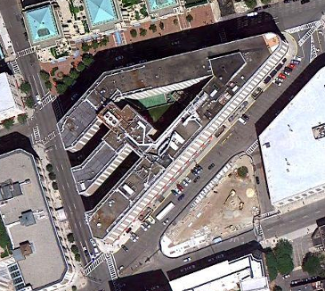

Prepared by:
Massachusetts Department of Public Health
Bureau of Environmental Health
Indoor Air Quality Program
February 2011

Background/Introduction
In response to a request from Mr. Aric Warren, Director of Administrative Services, Massachusetts’ Registry of Motor Vehicles (RMV), the Massachusetts Department of Public Health (MDPH), Bureau of Environmental Health (BEH) provided assistance and consultation regarding indoor air quality concerns at the Bridges & Structures Section (BSS) of the Massachusetts Department of Transportation, Highway Division (HD) located at 10 Park Plaza, Boston, Massachusetts. The request was prompted by occupant concerns related to musty odors and possible mold growth reported in the building.
On July 21, 2010, a visit to conduct an indoor air quality assessment was made by Michael Feeney, Director, of BEH’s Indoor Air Quality (IAQ) Program. Mr. Feeney was accompanied by Cory Holmes, Environmental Analyst/Regional Inspector within BEH’s IAQ Program and Mr. Robert Rafail, Manager of Real Property Management, Department of Transportation.
The Bridges & Structures Section of the Department of Transportation’s HD occupies office space on the 6th floor of 10 Park Plaza. The area is made up of large open work spaces/cubicles, service area/waiting room, conference rooms, offices and storage space/file rooms. Perimeter work areas have openable windows.

Methods
Air tests for carbon dioxide, carbon monoxide, temperature and relative humidity were taken with the TSI, Q-Trak, IAQ Monitor 7565. Air tests for airborne particle matter with a diameter less than 2.5 micrometers were taken with the TSI, DUSTTRAK™ Aerosol Monitor Model 8520. BEH staff also performed visual inspection of building materials for water damage and/or microbial growth.

Results
The HD has an employee population of approximately 75. The tests were taken during normal operations. Test results appear in Table 1. Test locations correspond with locations in Map 1.

Discussion

Ventilation
It can be seen from Table 1 that carbon dioxide levels were below 800 parts per million (ppm) in all areas surveyed, indicating optimal air exchange at the time of the assessment. Mechanical ventilation is provided by air-handling units (AHUs) located in mechanical rooms. Fresh air is drawn into the AHUs, filtered and heated/cooled before it is distributed by variable air volume (VAV) boxes to occupied areas via ducted vents around light fixtures (Pictures 1 and 2). Return air is drawn back into ducted vents around light fixtures, which is returned to the AHUs.
To maximize air exchange, the MDPH recommends that both supply and exhaust ventilation operate continuously during periods of occupancy. In order to have proper ventilation with a mechanical supply and exhaust system, the systems must be balanced to provide an adequate amount of fresh air to the interior of a room while removing stale air from the room. It is recommended that HVAC systems be re-balanced every five years to ensure adequate air systems function (SMACNA, 1994). The date of the last balancing of these systems was not available at the time of the assessment.
The Massachusetts Building Code requires a minimum ventilation rate of 20 cubic feet per minute (cfm) per occupant of fresh outside air or have openable windows in each room (SBBRS, 1997; BOCA, 1993). The ventilation must be on at all times that the room is occupied. Providing adequate fresh air ventilation with open windows and maintaining the temperature in the comfort range during the cold weather season is impractical. Mechanical ventilation is usually required to provide adequate fresh air ventilation.
Carbon dioxide is not a problem in and of itself. It is used as an indicator of the adequacy of the fresh air ventilation. As carbon dioxide levels rise, it indicates that the ventilating system is malfunctioning or the design occupancy of the room is being exceeded. When this happens, a buildup of common indoor air pollutants can occur, leading to discomfort or health complaints. The Occupational Safety and Health Administration (OSHA) standard for carbon dioxide is 5,000 parts per million parts of air (ppm). Workers may be exposed to this level for 40 hours/week, based on a time-weighted average (OSHA, 1997).
The MDPH uses a guideline of 800 ppm for publicly occupied buildings. A guideline of 600 ppm or less is preferred in schools due to the fact that the majority of occupants are young and considered to be a more sensitive population in the evaluation of environmental health status. Inadequate ventilation and/or elevated temperatures are major causes of complaints such as respiratory, eye, nose and throat irritation, lethargy and headaches. For more information concerning carbon dioxide, please see Appendix A.
Temperature readings ranged from 73º F to 75 º F during the assessment, which were within the MDPH recommended comfort guidelines. The MDPH recommends that indoor air temperatures be maintained in a range of 70 º F to 78 º F in order to provide for the comfort of building occupants. In many cases concerning indoor air quality, fluctuations of temperature in occupied spaces are typically experienced, even in a building with an adequate fresh air supply.
Due to temperature control complaints and HVAC issues, training room 6424 was retro-fitted with a portable floor model air conditioning unit (Picture 3). This air conditioner is designed for use in a building that has a ceiling plenum return air system. Based on the unit design, waste heat generated by the portable air conditioner would be drawn into the ventilation system. However, the HVAC system at the DOT is ducted for both supply and return. The DOT does not use the ceiling plenum for return ventilation. In its current configuration, waste heat is vented into the ceiling plenum, which becomes pressurized and forces heated air back into the room. In addition, pressurization of the ceiling plenum can force any dirt, dust and loose debris that accumulates above the ceiling tiles into occupied areas, providing sources of eye and respiratory irritation. This system should be ducted directly to the outdoors through an exterior wall or window.
The relative humidity measured during the assessment ranged from 50 to 58 percent, which was within the MDPH recommended comfort range in all areas surveyed the day of the assessment. The MDPH recommends a comfort range of 40 to 60 percent for indoor air relative humidity. Relative humidity levels in the building would be expected to drop during the winter months due to heating. Relative humidity levels in the building would be expected to drop during the heating season.

Microbial/Moisture Concerns
In order to address concerns regarding mold in the BSS, BEH staff examined the office for water-damaged materials and moisture sources. In order to support mold growth, a material susceptible to fungal colonization must be exposed to moisture. As noted previously, the installation of the portable air conditioner would pressurize the ceiling plenum as well as vent direct heated and moisture into this space ceiling plenum. The portable air conditioner would be the most likely source of musty odors previously reported in the BSS.
A few areas had water-damaged ceiling tiles. Water-damaged ceiling tiles can provide a source of mold and should be replaced after a water leak is discovered and repaired. Many areas had water-damaged, soiled or worn carpeting (Pictures 4 and 5). It was not clear whether the DOT had a carpet cleaning program in place. The Institute of Inspection, Cleaning and Restoration Certification (IICRC), recommends that carpeting be cleaned annually (or semi-annually in soiled high traffic areas) (IICRC, 2005). Since the average lifespan of a carpet is approximately eleven years, consideration should be given to replace flooring (Bishop, 2002).
The US Environmental Protection Agency (US EPA) and the American Conference of Governmental Industrial Hygienists (ACGIH) recommend that porous materials be dried with fans and heating within 24 to 48 hours of becoming wet (US EPA, 2001; ACGIH, 1989). If not dried within this time frame, mold growth may occur. Once mold has colonized porous materials, they are difficult to clean and should be removed.

Other IAQ Evaluations
Indoor air quality can be negatively influenced by the presence of respiratory irritants, such as products of combustion. The process of combustion produces a number of pollutants. Common combustion emissions include carbon monoxide, carbon dioxide, water vapor and smoke (fine airborne particle material). Of these materials, exposure to carbon monoxide and particulate matter with a diameter of 2.5 micrometers (μm) or less (PM2.5) can produce immediate, acute health effects upon exposure. To determine whether combustion products were present in the indoor environment, BEH staff obtained measurements for carbon monoxide and PM2.5.

Carbon Monoxide
Carbon monoxide is a by-product of incomplete combustion of organic matter (e.g., gasoline, wood and tobacco). Exposure to carbon monoxide can produce immediate and acute health affects. Several air quality standards have been established to address carbon monoxide and prevent symptoms from exposure to these substances. The MDPH established a corrective action level concerning carbon monoxide in ice skating rinks that use fossil-fueled ice resurfacing equipment. If an operator of an indoor ice rink measures a carbon monoxide level over 30 ppm, taken 20 minutes after resurfacing within a rink, that operator must take actions to reduce carbon monoxide levels (MDPH, 1997).
The American Society of Heating Refrigeration and Air-Conditioning Engineers (ASHRAE) has adopted the National Ambient Air Quality Standards (NAAQS) as one set of criteria for assessing indoor air quality and monitoring of fresh air introduced by HVAC systems (ASHRAE, 1989). The NAAQS are standards established by the US EPA to protect the public health from six criteria pollutants, including carbon monoxide and particulate matter (US EPA, 2006). As recommended by ASHRAE, pollutant levels of fresh air introduced to a building should not exceed the NAAQS levels (ASHRAE, 1989). The NAAQS were adopted by reference in the Building Officials & Code Administrators (BOCA) National Mechanical Code of 1993 (BOCA, 1993), which is now an HVAC standard included in the Massachusetts State Building Code (SBBRS, 1997). According to the NAAQS, carbon monoxide levels in outdoor air should not exceed 9 ppm in an eight-hour average (US EPA, 2006).
Carbon monoxide should not be present in a typical, indoor environment. If it is present, indoor carbon monoxide levels should be less than or equal to outdoor levels. On the day of the assessment, outdoor carbon monoxide concentrations were non-detect (ND) (Table 1). No measurable levels of carbon monoxide were detected inside the building during the assessment (Table 1).

Particulate Matter
The US EPA has established NAAQS limits for exposure to particulate matter. Particulate matter is airborne solids that can be irritating to the eyes, nose and throat. The NAAQS originally established exposure limits to particulate matter with a diameter of 10 μm or less (PM10). According to the NAAQS, PM10 levels should not exceed 150 micrograms per cubic meter (μg/m³) in a 24-hour average (US EPA, 2006). These standards were adopted by both ASHRAE and BOCA. Since the issuance of the ASHRAE standard and BOCA Code, US EPA established a more protective standard for fine airborne particles. This more stringent PM2.5 standard requires outdoor air particle levels be maintained below 35 μg/m³ over a 24-hour average (US EPA, 2006). Although both the ASHRAE standard and BOCA Code adopted the PM10 standard for evaluating air quality, MDPH uses the more protective PM2.5 standard for evaluating airborne particulate matter concentrations in the indoor environment.
Outdoor PM2.5 concentrations were measured at 20 μg/m³ (Table 1). PM2.5 levels measured indoors ranged from 7 to 17 μg/m³ (Table 1), which were below the NAAQS PM2.5 level of 35 μg/m³. Frequently, indoor air levels of particulates (including PM2.5) can be at higher levels than those measured outdoors. A number of mechanical devices and/or activities that occur indoors can generate particulate during normal operations. Sources of indoor airborne particulates may include but are not limited to particles generated during the operation of fan belts in the HVAC system, use of stoves and/or microwave ovens in kitchen areas; use of photocopiers, fax machines and computer printing devices; operation of an ordinary vacuum cleaner and heavy foot traffic indoors.

Other Conditions
Other conditions that can affect indoor air quality were observed during the assessment. In several areas, items were observed on windowsills, tabletops, counters, bookcases and desks. The large number of items stored provides a source for dusts to accumulate. These items (e.g., papers, folders, boxes) make it difficult for maintenance staff to clean. Items should be relocated and/or be cleaned periodically to avoid excessive dust build up. Particular attention should be made to the file storage rooms.
A number of air diffusers, exhaust/return vents and personal fans were observed to have accumulated dust. If exhaust vents are not functioning, backdrafting can occur, which can re-aerosolize accumulated dust particles. Re-activated vents and fans can also reareosolized dust accumulated on vents/fan blades.
Of note is the pressure differential between the hallway and the BSS/HD offices. A strong current was noted blowing into the offices when the hallway door was opened. This is likely due to the fact that the hallway is open near the upper portion of the atrium (Picture 6). Air rises from the floor of the atrium and pressurizes the upper area of it, which then causes air to be forced into hallways that lead off from atrium balconies. In this configuration, odors, heated air and other airborne materials can be forced into office space. Customarily, office space is pressurized in relation to hallways to prevent the migration of odors from adjoining spaces. The top of the atrium appears to have a number of smoke ejector fans in the case of fire (Picture 7). If one of these fans can be adapted to operate continuously, the hallway pressurization in the upper areas of the atrium would likely be alleviated.

Conclusions/Recommendations
In view of the findings at the time of the visit, the following recommendations are made:
- Continue to operate all ventilation systems (e.g., AHUs) throughout the building continuously during occupied periods.
- Vent the portable air conditioner in training room 6424 to the outdoors.
- Consider adopting a balancing schedule of every 5 years for all mechanical ventilation systems, as recommended by ventilation industrial standards (SMACNA, 1994).
- For buildings in New England, periods of low relative humidity during the winter are often unavoidable. Therefore, scrupulous cleaning practices should be adopted to minimize common indoor air contaminants whose irritant effects can be enhanced when the relative humidity is low. To control for dusts, a high efficiency particulate arrestance (HEPA) filter equipped vacuum cleaner in conjunction with wet wiping of all surfaces is recommended. Drinking water during the day can help ease some symptoms associated with a dry environment (throat and sinus irritations).
- Ensure leaks are repaired and replace water-damaged ceiling tiles. Examine the area above and around these areas for mold growth. Disinfect areas of water leaks with an appropriate antimicrobial as needed.
- Clean carpeting annually or semi-annually in soiled high traffic areas as per the recommendations of the Institute of Inspection, Cleaning and Restoration Certification (IICRC). Copies of the IICRC fact sheet can be downloaded at: http://www.cleancareseminars.com/carpet_cleaning_faq4.htm (IICRC, 2005)
- Consider a long-term plan to replace carpeting as funds become available. Consider replacing carpeting with carpet squares or a non-porous surface such as vinyl tile.
- Relocate or consider reducing the amount of materials stored in offices, work stations and common areas to allow for more thorough cleaning. Clean items regularly with a wet cloth or sponge to prevent excessive dust build-up. Particular attention should be made to the file storage rooms.
- Clean personal fans, air diffusers, and return/exhaust vents periodically of accumulated dust/debris.
- Examine the feasibility of adapting/operating one of the fans in Picture 7 in a manner to help relieve hallway pressurization.
- Refer to resource manuals and other related indoor air quality documents for further building-wide evaluations and advice on maintaining public buildings. Copies of these materials are located on the MDPH’s website: http://mass.gov/dph/iaq.

References
ACGIH. 1989. Guidelines for the Assessment of Bioaerosols in the Indoor Environment. American Conference of Governmental Industrial Hygienists, Cincinnati, OH.
Bishop, J. & Institute of Inspection, Cleaning and Restoration Certification. 2002. A Life Cycle Cost Analysis for Floor Coverings in School Facilities.
BOCA. 1993. The BOCA National Mechanical Code/1993. 8th ed. Building Officials and Code Administrators International, Inc., Country Club Hill, IL. Section M-308.1.1.
IICRC. 2005. Carpet Cleaning FAQ 4 Institute of Inspection, Cleaning and Restoration Certification. Institute of Inspection Cleaning and Restoration, Vancouver, WA.
MDPH. 1997. Requirements to Maintain Air Quality in Indoor Skating Rinks (State Sanitary Code, Chapter XI). 105 CMR 675.000. Massachusetts Department of Public Health, Boston, MA.
OSHA. 1997. Limits for Air Contaminants. Occupational Safety and Health Administration. Code of Federal Regulations. 29 C.F.R 1910.1000 Table Z-1-A.
SBBRS. 1997. Mechanical Ventilation. State Board of Building Regulations and Standards. Code of Massachusetts Regulations. 780 CMR 1209.0.
SMACNA. 1994. HVAC Systems Commissioning Manual. 1st ed. Sheet Metal and Air Conditioning Contractors’ National Association, Inc., Chantilly, VA.
US EPA. 2001. Mold Remediation in Schools and Commercial Buildings. US Environmental Protection Agency, Office of Air and Radiation, Indoor Environments Division, Washington, DC. EPA 402-K-01-001. March 2001.
US EPA. 2006. National Ambient Air Quality Standards (NAAQS). US Environmental Protection Agency, Office of Air Quality Planning and Standards, Washington, DC. http://www.epa.gov/air/criteria.html.
Map 1
Configuration of 6th Floor DOT Bridges & Structures Section

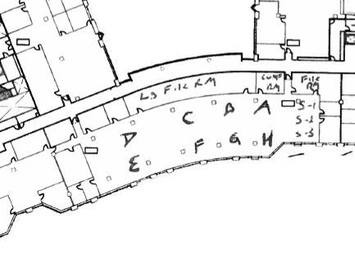
Picture 1

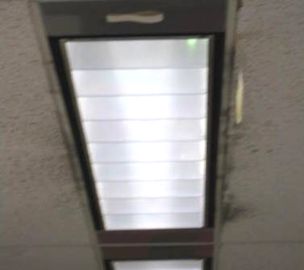

Vents around Light Fixtures, Note Dust/Debris Accumulation Adjacent to Vents

Picture 2

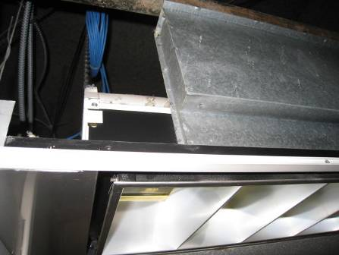

Ducted Supply Vent above Light Fixture

Picture 3

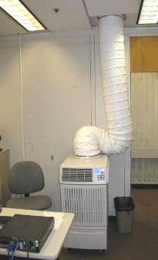

Floor Model Air Conditioning Unit in Training Room 6424,
Note Unit is Ducted into Ceiling Plenum

Picture 4

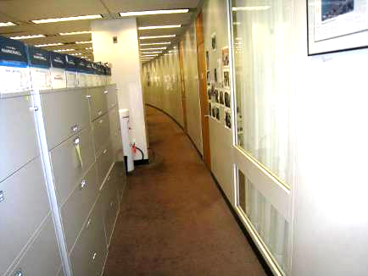

Water-Damaged Carpet (Note Discoloration)
Picture 5

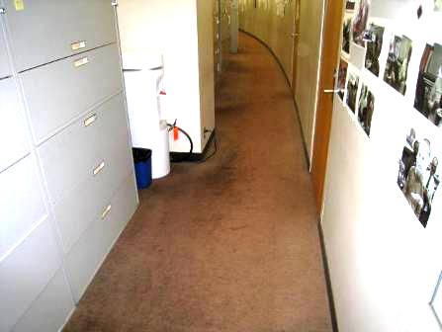

Water-Damaged, Soiled, Worn Carpeting

Picture 6

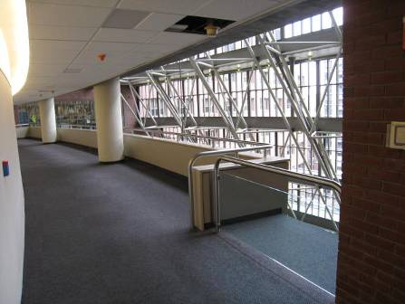

Hallway Leading to Open Balcony

Picture 7

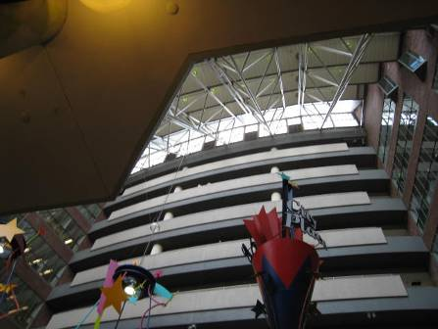

Fans near Apex of Atrium
Location | Occupants  in Room | Temp  (°F) | Relative  Humidity  (%) | Carbon  Dioxide  (ppm) | Carbon  Monoxide  (ppm) | PM2.5 (ug/m3) | Windows  Openable | Ventilation |  | Remarks
Outside  (Background) |  | 88 | 90 | 362 | ND | 20 |  |  |  | Hazy, hot and humid
Small File Room | 0 | 75 | 53 | 740 | ND | 9 | N | Y | Y | Ripped, damaged/stained carpeting
A | 7 | 74 | 55 | 723 | ND | 7 | N | Y | Y
B | 4 | 75 | 56 | 776 | ND | 13 | Y | Y | Y
C | 5 | 74 | 58 | 710 | ND | 13 | N | Y | Y
D | 4 | 75 | 57 | 730 | ND | 14 | N | Y | Y
E | 0 | 75 | 55 | 679 | ND | 14 | Y | Y | Y
F | 4 | 75 | 55 | 680 | ND | 14 | Y | Y | Y
G | 4 | 75 | 55 | 717 | ND | 10 | Y | Y | Y
H | 4 | 75 | 55 | 728 | ND | 8 | Y | Y | Y | 2 WD CT, items on window vents (boxes, papers, etc)
6412 | 0 | 74 | 53 | 750 | ND | 17 | N
6424 | 1 | 74 | 50 | 668 | ND | 14 | N | Y | Y | Spot cooling floor AC ducted into ceiling plenum, Laser temp of CT around exhaust duct 80/exhaust duct temp 93°F, CTs opposite end of room 70°F
6431 Lg File Room/Storage | 0 | 73 | 56 | 693 | ND | 12 | N | Y | Y | Misc storage, MTs, dust/debris on carpet/flat surfaces, old files, plans, paper
6462 Conf Room | 0 | 74 | 56 | 668 | ND | 15 | N | Y | Y | MT

The space above a suspended ceiling is called a plenum

