INDOOR AIR QUALITY ASSESSMENT

Massachusetts Department of Transportation
District 2 Office-new wing
811 North King Street
Northampton, Massachusetts

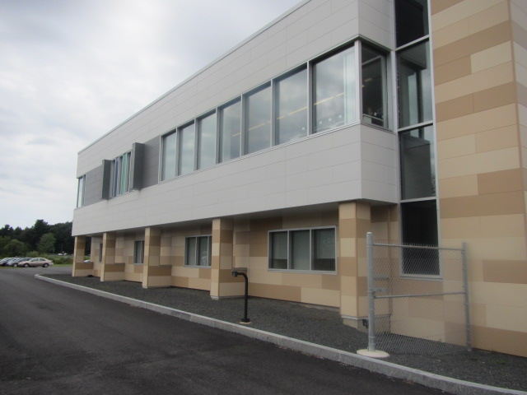

Prepared by:
Massachusetts Department of Public Health
Bureau of Environmental Health
Indoor Air Quality Program
October 2015

Background
Building: | Massachusetts Department of Transportation  District 2 Office (new wing)
Address: | 811 North King Street, Northampton, MA
Assessment Requested by: | Lori J. Camposeo, District Administrator  Mass DOT
Date of Assessment: | August 14, 2015
BEH/IAQ Staff Conducting Assessment: | Michael Feeney, Director  Lisa Hebert, Chief
Date of Building Construction: | 2015
Reason for Request: | Allergy issues

Building Description
The District 2 office is a three building complex, consisting of the original building; new wing containing office space and testing labs; and garage. The subject of this report is the new wing that was opened in 2015 that is connected to the original building by a lobby.

Methods/Results
Results appear in Table 1. Methods and indoor air related air sampling can be found in the IAQ Manual and Appendices for IAQ Reports that can be found at:
http://www.mass.gov/eohhs/gov/departments/dph/programs/environmental-health/exposure-topics/iaq/iaq-rpts/general-appendices-for-iaq-reports.html

Discussion

Ventilation
It can be seen from Table 1 that carbon dioxide levels were below 800 parts per million (ppm) in all areas surveyed during the assessment. Note that many areas were empty or sparsely populated and one window was open on the second floor. Higher occupancy would be expected to result in higher carbon dioxide levels.
Ventilation air in the new wing is provided by fresh air diffusers and exhaust vents connected to a rooftop air handling unit (AHU) via ductwork. Exhaust vents are present in the restrooms.
To maximize air exchange, the MDPH recommends that both supply and exhaust ventilation operate continuously during periods of occupancy. In order to have proper ventilation with a mechanical supply and exhaust system, the systems must be balanced to provide an adequate amount of fresh air to the interior of a room while removing stale air from the room. It is recommended that HVAC systems be re-balanced every five years to ensure adequate air systems function (SMACNA, 1994). The new wing was balanced prior to its occupancy.

Temperature
Indoor temperature measurements at the time of the assessment ranged from 70°F to 75°F (Table 1), which were within the MDPH recommended comfort range. The MDPH recommends that indoor air temperatures be maintained in a range of 70°F to 78°F in order to provide for the comfort of building occupants. In many cases concerning indoor air quality, fluctuations of temperature in occupied spaces are typically experienced, even in a building with an adequate fresh air supply.
Relative Humidity
Indoor relative humidity at the time of the assessment ranged from 41 to 54 percent (Table 1). The MDPH recommends a comfort range of 40 to 60 percent for indoor air relative humidity. Relative humidity levels in the building would be expected to drop during winter months due to heating. The sensation of dryness and irritation is common in a low relative humidity environment. Low relative humidity is a very common problem during the heating season in the northeast part of the United States.

Microbial/Moisture Concerns
The concerns initiating the request for assessment were regarding mold and odors.
Plants were observed in some offices and open areas (Table 1). Plants can be a source of pollen and mold, which can be respiratory irritants to some individuals. Plants should be properly maintained, over-watering of plants should be avoided and drip pans should be inspected periodically for mold growth and cleaned or replaced as necessary. An aquarium was observed in one office, which can be a source of odors if not properly maintained.
Water dispensers were observed on carpeted areas. Spills or leaks from these appliances can moisten carpeting and lead to mold growth. They should be located in a non-carpeted area or on waterproof mats.

Other IAQ Evaluations
Indoor air quality can be negatively influenced by the presence of respiratory irritants, such as products of combustion. The process of combustion produces a number of pollutants. Common combustion emissions include carbon monoxide, carbon dioxide, water vapor, and smoke (fine airborne particle material). Of these materials, exposure to carbon monoxide and particulate matter with a diameter of 2.5 micrometers (μm) or less (PM2.5) can produce immediate, acute health effects upon exposure. To determine whether combustion products were present in the indoor environment, BEH/IAQ staff obtained measurements for carbon monoxide and PM2.5

Carbon Monoxide
Carbon monoxide should not be present in a typical, indoor environment. If it is present, indoor carbon monoxide levels should be less than or equal to outdoor levels. No carbon monoxide was detected (ND) in any indoor or outdoor measurements (Table 1).

Particulate Matter
Outdoor PM2.5 concentrations were 15 μg/m³ (Table 1. Indoor PM2.5 levels ranged from 5 to 12 μg/m³ (Table 1), which were below the NAAQS PM2.5 level of 35 μg/m³ in most samples. Of note was that in a number of areas, PM2.5 levels rose after the carpet was trod upon in a number of areas (Example: Room 202 had a measurement of 6 to 46 μg/m³). A likely source of airborne particulate is use of the building areas by DOT staff and contractors that work in the field at construction projects that come directly into the building for meeting, conference and education activities.
BEH staff examined the second floor and noted the presence of plastic chair mats installed in cubicles having hard laminate floors. Of note was the accumulation of debris beneath the chair mat edges (Picture 1), which likely indicates the floor as swept instead of vacuumed. A used, stand-up dust pan found in a restroom also indicates floors are swept (Picture 2). Floor sweeping can readily aerosolize and suspend in the air respirable dust, which can lead to allergic symptoms in hypersensitive individuals. DOT staff also identified the vacuum cleaners used in the building. None of the vacuum cleaners identified as used in the building are equipped with a high efficiency particle arrestance (HEPA) filter. Non-HEPA filter vacuum cleaners can also readily aerosolize and suspend respirable dust. The Institute of Inspection, Cleaning and Restoration Certification (IICRC) outlines floor covering in its guideline, Standard for Professional Cleaning of Textile Floor Coverings (IICRC, 2015). Based on this standard, the IICRC recommends twice daily vacuuming and/or pile-lifting cleaning for commercial carpeting in heavy traffic areas. This frequency of cleaning of the building as well as the use and upgrade of vacuum cleaners equipped with HEPA filter would remove respirable dust from the indoor air.
The ground level of the building contains a materials testing lab where concrete cylinders are broken to test compression strength. This process generates a considerable amount of concrete dust. Many flat surfaces in the lab have a thick coating of concrete dust (Picture 3). The lab is equipped with a fume hood to vent waste heat and concrete dust from the lab. The fan for this hood was deactivated. This lab also contains a concrete curing room in which concrete cylinders are continuously misted with water vapor. Of note is the condition of the grilles over the ceiling-mounted return vents for the building’s HVAC system which have a circle of discoloration on their surfaces (Picture 4). This corrosion likely indicates that water vapor and dust from the materials testing lab is entrained into the general ventilation system and may be distributed into other areas of the building.

Volatile Organic Compounds (VOCs)
VOCs are carbon-containing substances that have the ability to evaporate at room temperature. Frequently, exposure to low levels of total VOCs (TVOCs) may produce eye, nose, throat and/or respiratory irritation in some sensitive individuals.
Hand sanitizer was observed in office areas (Table 1). These products may contain ethyl alcohol and/or isopropyl alcohol, which are highly volatile and may be irritating to the eyes and nose. Sanitizing products may also contain fragrances to which some people may be sensitive.
Cleaning products were also observed. Cleaning products, air fresheners and other air deodorizers contain chemicals that can be irritating to the eyes, nose and throat of sensitive individuals. Many air fresheners contain 1,4-dichlorobenzene, a VOC which can reduce lung function (NIH, 2006). Furthermore, deodorizing agents do not remove materials causing odors, but rather mask odors that may be present in the area. Cleaning products should be properly labeled and stored in an appropriate area. In addition, a Material Safety Data Sheet (MSDS) should be available at a central location for each product in the event of an emergency.
Several areas had dry erase boards and related materials (Table 1). Materials such as dry erase markers and dry erase board cleaners may contain VOCs, such as methyl isobutyl ketone, n-butyl acetate and butyl-cellusolve (Sanford, 1999), which can be irritating to the eyes, nose and throat.
Other conditions that can affect IAQ were observed during the assessment. Personal fans, air purifiers and heaters were observed in some offices. Some of these appliances were dusty. Dust on these items can be aerosolized and cause irritation or odors. In addition, air purifiers may have filters or other components that need to be cleaned and maintained so that they do not become a source of air pollution.
In some areas, accumulation of items, including papers, boxes and personal items were stored on floors desks, tables and counters. Large numbers of items provide a source for dusts to accumulate. These items make it difficult for custodial staff to clean. Items should be relocated and/or cleaned periodically to avoid excessive dust build up.

Conclusions/Recommendations
In view of the findings at the time of the visit, the following recommendations are made:
- Discontinue the use of brooms and dust pans.
- Discontinue the use of wet mops on laminate floors.
- Acquire and utilize a high efficiency particulate arrestance (HEPA) filter equipped vacuum cleaner in conjunction with wet wiping of all surfaces. Have the high traffic area vacuumed twice daily.
- Operate the fume hood in the materials testing lab during normal hours continuously. Have a timer installed to activate and deactivate this system.
- Seal the general HVAC system return vents in the Materials Testing Lab.
- Have all flat surfaces wet wiped once a week in the Materials Testing Lab.
- Discontinue the use of plastic chair mats in cubicles with hard wood floors.
- Maintain indoor plants, use non-porous drips pans and prevent overwatering.
- Reduce the use of dry erase materials, hand sanitizer and cleaning/scented products to avoid exposure to TVOCs.
- Store items in an organized manner and move them to clean periodically to prevent a buildup of dust.
- Refer to resource manuals and other related indoor air quality documents for further building-wide evaluations and advice on maintaining public buildings. These materials are located on the MDPH’s website: http://mass.gov/dph/iaq.

References

IICRC 2015, Institute of Inspection, Cleaning and Restoration Certification, S100 Standard and IICRC R100 Reference Guide for Professional Inspection of Textile Floorcoverings (6st edition, 2015).
Sanford. 1999. Material Safety Data Sheet (MSDS No: 198-17). Expo Dry Erase Markers Bullet, Chisel, and Ultra Fine Tip. Sanford Corporation. Bellwood, IL.
SMACNA. 1994. HVAC Systems Commissioning Manual. 1st ed. Sheet Metal and Air Conditioning Contractors’ National Association, Inc., Chantilly, VA.
Picture 1
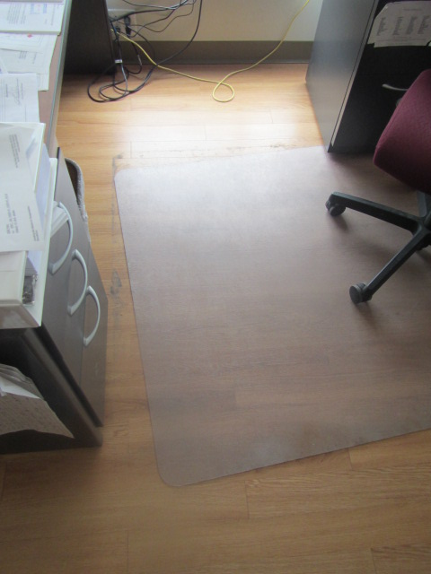
Accumulation of debris beneath the chair mat edges

Picture 2
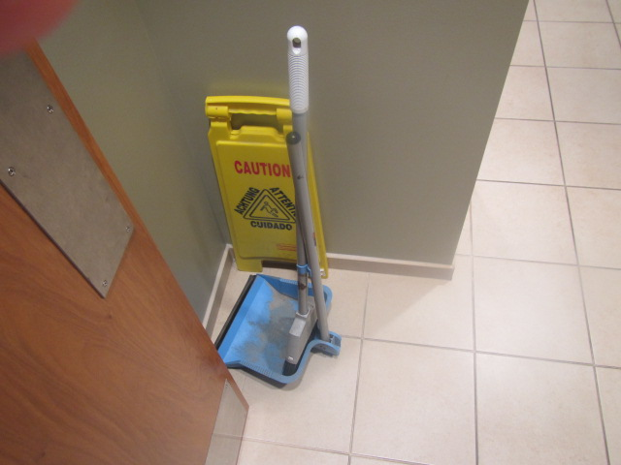
Broom and dust pan

Picture 3
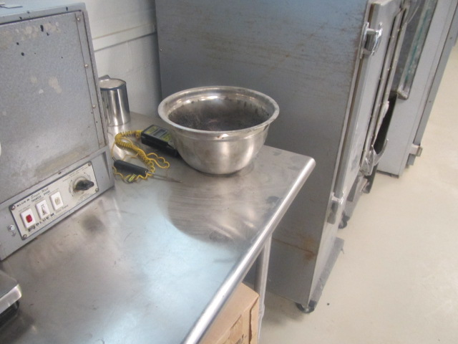
Surfaces in the lab have a thick coating of concrete dust

Picture 4
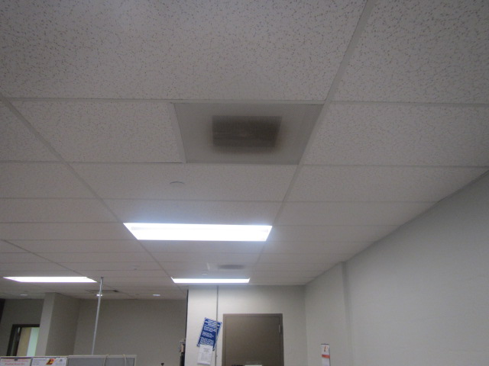
Discoloration on the surface of return vent grills
Location | Carbon  Dioxide  (ppm) | Carbon Monoxide  (ppm) | Temp  (°F) | Relative  Humidity  (%) | PM2.5  (µg/m³) | Occupants  in Room | Windows  Openable | Ventilation |  | Remarks
 |  |  |  |  |  |  |  | Supply | Exhaust
Background (outside) | 383 | ND | 75 | 63 | 15 |  |  |  |  | Asphalt sloped toward bldg
225 | 460 | ND | 72 | 42 | 5 | 0 | N | Y | Y | Clutter
226 | 462 | ND | 72 | 45 | 5 | 1 | N | Y | Y | Plants
227 | 468 | ND | 71 | 44 | 5 | 1 | N | Y | Y | Door open
222 | 418 | ND | 70 | 44 | 5 | 0 | N | Y | Y
B21 | 465 | ND | 73 | 44 | 5-12 | 0 | N | Y | Y
B33 | 496 | ND | 72 | 46 | 5 | 0 | N | Y | Y | Floor fan, plants
B27 | 449 | ND | 72 | 46 | 1 | 1 | N | Y | Y
B26 | 435 | ND | 72 | 46 | 5 | 0 | N | Y | Y | Plants, clutter, door open
B31 | 430 | ND | 72 | 46 | 5 | 0 | N | Y | Y | Boxes, door open
B30 | 440 | ND | 71 | 45 | 5 | 0 | N | Y | Y
B29 | 456 | ND | 72 | 49 | 5 | 0 | N | Y | Y | Floor fan
Rm 223 outside Rm 224 | 470 | ND | 73 | 44 | 11 | 2 | N | Y | Y in plenum
Rm 223 near exterior exit stairs | 420 | ND | 72 | 44 | 11 | 2 | N | Y | Y in plenum
Room 223 near training rm door | 439 | ND | 73 | 44 | 11 | 2 | N | Y | Y in plenum
Rm 228 | 461 | ND | 71 | 44 | 11 | 0 | N | Y | Y in plenum | Carpet
B-23 | 660 | ND | 75 | 41 | 8 | 0 | N | Y | Y in plenum | Carpet
B-36 front | 483 | ND | 73 | 51 | 5 | 2 | N | Y | Y in plenum | Carpet
B-25 | 533 | ND | 73 | 45 | 5 | 2 | N | Y | Y in plenum | Carpet, plants
B-36 rear | 455 | ND | 72 | 47 | 5 | 0 | N | Y | Y in plenum | Carpet
B-31 | 432 | ND | 72 | 47 | 5 | 0 | N | Y | Y in plenum | Carpet, plants
B-26 | 505 | ND | 72 | 50 | 5 | 0 | N | Y | Y | Carpet, plants
B-27 | 421 | ND | 72 | 54 | 6 | 1 | N | Y | Y | Carpet
B-13 | 445 | ND | 73 | 49 | 6 | 0 | N | N | N
B-13 (inner rm) | 458 | ND | 74 | 50 | 7 | 0 | Y | N | N

