INDOOR AIR QUALITY ASSESSMENT

Massachusetts Department of Transportation
District 2 Office-old wing
811 North King Street
Northampton, Massachusetts

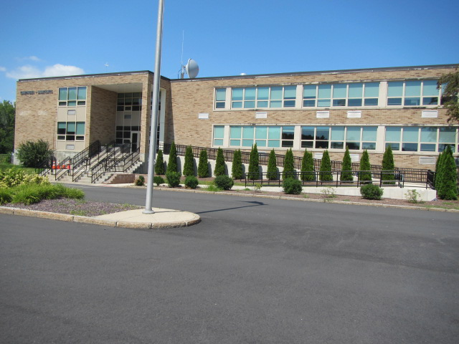

Prepared by:
Massachusetts Department of Public Health
Bureau of Environmental Health
Indoor Air Quality Program
November 2015

Background
Building: | Massachusetts Department of Transportation  District 2 Office (old wing)
Address: | 811 North King Street, Northampton, MA
Assessment Requested by: | Lori J. Camposeo, District Administrator  Mass DOT
Date of Assessment: | August 14, 2015
BEH/IAQ Staff Conducting Assessment: | Michael Feeney, Director  Lisa Hebert, Chief
Date of Building Construction: | 1963
Reason for Request: | Allergy issues

Building Description
The District 2 office is a three building complex, consisting of the old building; new wing containing office space and testing labs; and garage. The subject of this report is the old wing that was opened in 1963 that is connected to the new building by a lobby. The old building was renovated subsequent to its opening at an undetermined date.

Methods/Results
Results appear in Table 1. Methods and indoor air related air sampling can be found in the IAQ Manual and Appendices for IAQ Reports that can be found at:
http://www.mass.gov/eohhs/gov/departments/dph/programs/environmental-health/exposure-topics/iaq/iaq-rpts/general-appendices-for-iaq-reports.html

Discussion

Ventilation
It can be seen from Table 1 that carbon dioxide levels were below 800 parts per million (ppm) in all areas surveyed during the assessment. Note that many areas were empty or sparsely populated and one window was open on the second floor. Higher occupancy would be expected to result in higher carbon dioxide levels.
Ventilation air in the old wing is provided by univents located in each office. Offices do not have exhaust vent. It is believed that office hallway doors were originally equipped with a transfer air vent, which would allow for air from offices to be vented into the hallways. Exhaust ventilation was provided by ceiling- mounted vents as well as draw of air through transfer air vents (Picture 1) in restroom doors. Exhaust vents are present in the restrooms. At some point of time prior to this assessment, a number of original restroom and hallway doors with transfer air vents were replaced with solid doors. Without the transfer air vent, the original design of the airflow provided by the ventilation system was disrupted. Exhaust ventilation is necessary to remove environmental pollutants from the occupied space.
In addition, although some motors appear to have been replaced, univents are original to the building’s construction, which makes them close to 50 years old. Efficient function of such aged equipment is difficult, since compatible replacement parts are often unavailable. According to the American Society of Heating, Refrigeration and Air-Conditioning Engineering (ASHRAE), the service life for a unit heater, hot water or steam is 20 years, assuming routine maintenance of the equipment (ASHRAE, 1991). Despite attempts to maintain the equipment, the operational lifespan of this equipment has been exceeded.
To maximize air exchange, the MDPH recommends that both supply and exhaust ventilation operate continuously during periods of occupancy. In order to have proper ventilation with a mechanical supply and exhaust system, the systems must be balanced to provide an adequate amount of fresh air to the interior of a room while removing stale air from the room. It is recommended that HVAC systems be re-balanced every five years to ensure adequate air systems function (SMACNA, 1994). In its current configuration, the old wing HVAC system cannot be balanced.

Temperature
Indoor temperature measurements at the time of the assessment ranged from 72°F to 75°F (Table 1), which were within the MDPH recommended comfort range. The MDPH recommends that indoor air temperatures be maintained in a range of 70°F to 78°F in order to provide for the comfort of building occupants. In many cases concerning indoor air quality, fluctuations of temperature in occupied spaces are typically experienced, even in a building with an adequate fresh air supply.

Relative Humidity
Indoor relative humidity at the time of the assessment ranged from 38 to 59 percent (Table 1). The MDPH recommends a comfort range of 40 to 60 percent for indoor air relative humidity. Relative humidity levels in the building would be expected to drop during winter months due to heating. The sensation of dryness and irritation is common in a low relative humidity environment. Low relative humidity is a very common problem during the heating season in the northeast part of the United States.

Microbial/MoistureConcerns
The concerns initiating the request for assessment were regarding mold and odors.
Plants were observed in some offices and open areas (Table 1). Plants can be a source of pollen and mold, which can be respiratory irritants to some individuals. Plants should be properly maintained, over-watering of plants should be avoided and drip pans should be inspected periodically for mold growth and cleaned or replaced as necessary.

Other IAQ Evaluations
Indoor air quality can be negatively influenced by the presence of respiratory irritants, such as products of combustion. The process of combustion produces a number of pollutants. Common combustion emissions include carbon monoxide, carbon dioxide, water vapor, and smoke (fine airborne particle material). Of these materials, exposure to carbon monoxide and particulate matter with a diameter of 2.5 micrometers (μm) or less (PM2.5) can produce immediate, acute health effects upon exposure. To determine whether combustion products were present in the indoor environment, BEH/IAQ staff obtained measurements for carbon monoxide and PM2.5

Carbon Monoxide
Carbon monoxide should not be present in a typical, indoor environment. If it is present, indoor carbon monoxide levels should be less than or equal to outdoor levels. No carbon monoxide was detected (ND) in any indoor or outdoor measurements (Table 1).

Particulate Matter
Outdoor PM2.5 concentrations were 15 μg/m³ (Table 1. Indoor PM2.5 levels ranged from 4 to 13 μg/m³ (Table 1), which were below the NAAQS PM2.5 level of 35 μg/m³ in most samples.
DOT staff identified the vacuum cleaners used in the building. None of the vacuum cleaners identified as used in the building are equipped with a high efficiency particle arrestance (HEPA) filter. Non-HEPA filter vacuum cleaners can also readily aerosolize and suspend respirable dust. The Institute of Inspection, Cleaning and Restoration Certification (IICRC) outlines floor covering in its guideline, Standard for Professional Cleaning of Textile Floor Coverings (IICRC, 2015). Based on this standard, the IICRC recommends twice daily vacuuming and/or pile-lifting cleaning for commercial carpeting in heavy traffic areas. This frequency of cleaning of the building as well as the use and upgrade of vacuum cleaners equipped with HEPA filters would remove respirable dust from the indoor air.

Volatile Organic Compounds (VOCs)
VOCs are carbon-containing substances that have the ability to evaporate at room temperature. Frequently, exposure to low levels of total VOCs (TVOCs) may produce eye, nose, throat and/or respiratory irritation in some sensitive individuals.
Cleaning products and oil difusser sticks were observed. Cleaning products, air fresheners, diffuser sticks and other air deodorizers contain chemicals that can be irritating to the eyes, nose and throat of sensitive individuals. Many air fresheners contain 1,4-dichlorobenzene, a VOC which can reduce lung function (NIH, 2006). Furthermore, deodorizing agents do not remove materials causing odors, but rather mask odors that may be present in the area. Cleaning products should be properly labeled and stored in an appropriate area. In addition, a Material Safety Data Sheet (MSDS) should be available at a central location for each product in the event of an emergency.
In some areas, accumulation of items, including papers, boxes and personal items were stored on floors desks, tables and counters. Large numbers of items provide a source for dusts to accumulate. These items make it difficult for custodial staff to clean. Items should be relocated and/or cleaned periodically to avoid excessive dust build up.
DOT staff report a long-standing rodent infestation associated with the building’s basement. The basement is used for records storage (Picture 2) and contain large numbers of cardboard boxes. Rodent will use cardboard boxes and other hidden locations to hide, take up shelter and reproduce. The front stairs to the building contain multiple breaches that allow for rodents to enter the building’s basement.
Under Massachusetts law, the principles of integrated pest management (IPM) must be used to remove pests in state buildings (Mass Act, 2000). Pesticide use indoors can introduce chemicals into the indoor environment that can be sources of eye, nose and throat irritation. The reduction/elimination of pathways/food sources that are attracting these insects should be the first step taken to prevent or eliminate infestation.
Rodent infestation can result in indoor air quality related symptoms due to materials in their wastes. Mouse urine contains a protein that is a known sensitizer (US EPA, 1992). A sensitizer is a material that can produce symptoms including running nose or skin rashes in sensitive individuals. A three-step approach is necessary to eliminate rodent infestation:
1. Removal of the rodents;
2. Cleaning of waste products from the interior of the building; and
3. Reduction/elimination of pathways/food sources that are attracting rodents.
To eliminate exposure to allergens, rodents must be removed from the building. Please note that removal, even after cleaning, may not provide immediate relief since allergens can exist in the interior for several months after rodents are eliminated (Burge, 1995). A combination of cleaning, along with an increase in ventilation and filtration should serve to reduce rodent associated allergens once the infestation is eliminated.

Conclusions/Recommendations
In view of the findings at the time of the visit, the following recommendations are made:
- Seal the holes in the front staircase to prevent rodent ingress. Use plywood to seal these openings temporarily until repairs to this staircase can be completed.
- Acquire and utilize a high efficiency particulate arrestance (HEPA) filter equipped vacuum cleaner in conjunction with wet wiping of all surfaces. Have the high traffic area vacuumed twice daily.
- Maintain indoor plants, use non-porous drip pans and prevent overwatering.
- Store items in an organized manner and move them to clean periodically to prevent a buildup of dust.
- Discontinue the use of diffuser sticks.
- It is highly recommended that the principles of integrated pest management (IPM) be used to rid the building of pests. A copy of the IPM recommendations can be obtained from the Massachusetts Department of Food and Agriculture (MDFA) website at the following website: http://www.state.ma.us/dfa/pesticides/publications/IPM_kit_for_bldg_mgrs.pdf. Activities that can be used to eliminate pest infestation may include the following activities:
  - Rinse out recycled food containers. Seal recycled containers in a tight fitting lid to prevent rodent access.
  - Remove non-food items that rodents are consuming.
  - Store food in tight fitting containers.
  - Avoid eating at workstations. In areas were food is consumed, periodic vacuuming to remove crumbs is recommended.
  - Regularly clean crumbs and other food residues from ovens, toasters, toaster ovens, microwave ovens, coffee pots and other food preparation equipment.
  - Holes as small as ¼” are enough space for rodents to enter an area. Examine each room and the exterior walls of the building for means of rodent egress and seal. If doors do not seal at the bottom, install a weather strip as a barrier to rodents. Reduce harborages (cardboard boxes) where rodents may reside (MDFA, 1996).
- Consider consulting a ventilation engineer concerning the current configuration of the HVAC system.
- Refer to resource manuals and other related indoor air quality documents for further building-wide evaluations and advice on maintaining public buildings. These materials are located on the MDPH’s website: http://mass.gov/dph/iaq.

References

ASHRAE. 1991. ASHRAE Applications Handbook, Chapter 33 “Owning and Operating Costs”. American Society of Heating, Refrigeration and Air Conditioning Engineers, Atlanta, GA.
Burge, H.A. 1995. Bioaerosols. Lewis Publishing Company, Boca Raton, FL.
IICRC. 2015. Carpet Cleaning FAQ 4 Institute of Inspection, Cleaning and Restoration Certification. Institute of Inspection Cleaning and Restoration, Vancouver, WA.
NIH. 2006. Chemical in Many Air Fresheners May Reduce Lung Function. NIH News. National Institute of Health. July 27, 2006. http://www.nih.gov/news/pr/jul2006/niehs-27.htm.
SMACNA. 1994. HVAC Systems Commissioning Manual. 1st ed. Sheet Metal and Air Conditioning Contractors’ National Association, Inc., Chantilly, VA.
US EPA. 1992. Indoor Biological Pollutants. US Environmental Protection Agency, Environmental Criteria and Assessment Office, Office of Health and Environmental Assessment, research Triangle Park, NC. EPA 600/8-91/202. January 1992.
Picture 1
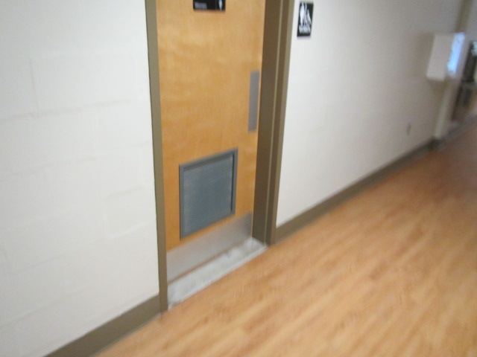
Passive vent in rest room door

Picture 2
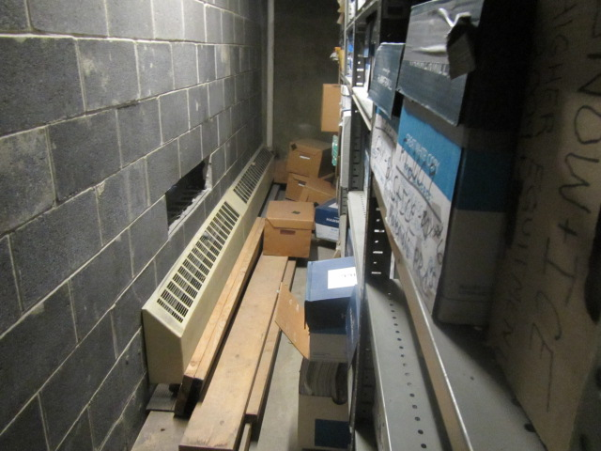
Storage in basement

Location | Carbon  Dioxide  (ppm) | Carbon Monoxide  (ppm) | Temp  (°F) | Relative  Humidity  (%) | PM2.5  (µg/m³) | Occupants  in Room | Windows  Openable | Ventilation |  | Remarks
 |  |  |  |  |  |  |  | Supply | Exhaust
Background (outside) | 383 | ND | 75 | 63 | 15 |  |  |  |  | Asphalt sloped toward bldg
225 | 460 | ND | 72 | 42 | 5 | 0 | N | Y | Y | Clutter
226 | 462 | ND | 72 | 45 | 5 | 1 | N | Y | Y | Plants
227 | 468 | ND | 71 | 44 | 5 | 1 | N | Y | Y | Door open
222 | 418 | ND | 70 | 44 | 5 | 0 | N | Y | Y
B21 | 465 | ND | 73 | 44 | 5-12 | 0 | N | Y | Y
B33 | 496 | ND | 72 | 46 | 5 | 0 | N | Y | Y | Floor fan, plants
B27 | 449 | ND | 72 | 46 | 1 | 1 | N | Y | Y
B26 | 435 | ND | 72 | 46 | 5 | 0 | N | Y | Y | Plants, clutter, door open
B31 | 430 | ND | 72 | 46 | 5 | 0 | N | Y | Y | Boxes, door open
B30 | 440 | ND | 71 | 45 | 5 | 0 | N | Y | Y
B29 | 456 | ND | 72 | 49 | 5 | 0 | N | Y | Y | Floor fan
Rm 223 outside Rm 224 | 470 | ND | 73 | 44 | 11 | 2 | N | Y | Y in plenum
Rm 223 near exterior exit stairs | 420 | ND | 72 | 44 | 11 | 2 | N | Y | Y in plenum
Room 223 near training rm door | 439 | ND | 73 | 44 | 11 | 2 | N | Y | Y in plenum
Rm 228 | 461 | ND | 71 | 44 | 11 | 0 | N | Y | Y in plenum | Carpet
B-23 | 660 | ND | 75 | 41 | 8 | 0 | N | Y | Y in plenum | Carpet
B-36 front | 483 | ND | 73 | 51 | 5 | 2 | N | Y | Y in plenum | Carpet
B-25 | 533 | ND | 73 | 45 | 5 | 2 | N | Y | Y in plenum | Carpet, plants
B-36 rear | 455 | ND | 72 | 47 | 5 | 0 | N | Y | Y in plenum | Carpet
B-31 | 432 | ND | 72 | 47 | 5 | 0 | N | Y | Y in plenum | Carpet, plants
B-26 | 505 | ND | 72 | 50 | 5 | 0 | N | Y | Y | Carpet, plants
B-27 | 421 | ND | 72 | 54 | 6 | 1 | N | Y | Y | Carpet
B-13 | 445 | ND | 73 | 49 | 6 | 0 | N | N | N
B-13 (inner rm) | 458 | ND | 74 | 50 | 7 | 0 | Y | N | N

The service life is the median time during which a particular system or component of …[an HVAC]… system remains in its original service application and then is replaced. Replacement may occur for any reason, including, but not limited to, failure, general obsolescence, reduced reliability, excessive maintenance cost, and changed system requirements due to such influences as building characteristics or energy prices (ASHRAE, 1991).

