INDOOR AIR QUALITY ASSESSMENT

Department of Transportation Temporary Office
694 Main Street
Holden, MA



Prepared by:
Massachusetts Department of Public Health
Bureau of Climate and Environmental Health
Division of Environmental Health Regulations and Standards
January 2026

BACKGROUND
Building: | Department of Transportation (DOT) Temporary Office
Address: | 694 Main Street, Holden, MA
Assessment Coordinated Through: | DOT
Reason for Request: | Mold concerns
Date of Assessment: | January 21, 2026
Massachusetts Department of Public Health, Bureau of Climate and Environmental Health, Division of Environmental Health Regulations and Standards (MDPH/BCEH/EHRS) Staff Conducting Assessment: | Cory Holmes, Senior Advisor for Indoor Air Quality Inspections, Audits, Outreach, and Trainings, and Patrick Wallace, Environmental Analyst
Building Description: | This one-story building with occupied basement was constructed in 1975 and serves as office space for multiple tenants including private businesses and medical offices. The DOT office is located in the basement and contains gypsum wallboard walls, wall-to-wall carpeting, and suspended ceiling tiles. Windows are openable in the area assessed.

METHODS
EHRS/IAQ Unit staff conducted visual observation of building materials for water damage and mold growth. Moisture meter measurements were also taken of porous building materials. Several other indoor air quality (IAQ) parameters were also taken including carbon monoxide, carbon dioxide, temperature, relative humidity, and particulate matter (PM2.5). Please refer to the IAQ Manual for methods, sampling procedures, and interpretation of results (MDPH, 2015).

Background
On March 22, 2025, the building manager hired a private consultant A1 Spectrum Services to conduct airborne mold testing. The report indicated that mold levels indoors were lower than outdoors, in addition the species found indoors were similar to those found outdoors. A1 Spectrum Services concluded that based on these findings, there did not indicate an abnormal mold growth situation (A1 Spectrum Services, 2025).
A second round of mold testing was done on December 17, 2025, by LeBlanc’s Environmental Services. These tests indicated that indoor levels were above outdoors and that several species were found indoors that were not found outdoors, indicating moisture issues and chronic condensation. The report also did not find any visual mold or mildew stains on walls or ceilings in any areas examined. As a result of these findings LeBlanc’s Environmental Services made a number of recommendations:
- A portable High Efficiency Particulate Air (HEPA) cleaner machine and dehumidifier should be placed inside the basement main offices area to filter fungal spores and particulates, and circulate the air in the basement main offices area.
- The old fabric couch inside Roger's basement office and the old fabric chair in the adjacent office should be removed from the basement.
- If possible, the basement main offices carpet, or at least the entrance vestibule, should be removed and replaced with waterproof flooring.
- The basement main offices area HEPA cleaning air machine and dehumidifier in the basement will improve indoor air quality and help resist mildew and mold growth on building materials in the basement main offices area.
- The rodent traps and any rodent feces above the basement drop ceilings should be checked and cleaned periodically according to a maintenance schedule (LeBlanc’s Environmental Services, 2025).

RESULTS AND DISCUSSION
Measurements for IAQ parameters are summarized below:
- Carbon dioxide measurements were below the MDPH guideline of 800 parts per million (ppm) indicating adequate air exchange in the space.
- Temperature was slightly below the recommended range of 70°F to 78°F in some areas tested. However the space was unoccupied at the time of assessment.
- Relative humidity was below the recommended range of 40% to 60% in all areas tested, which is common during the heating season.
- Carbon monoxide levels were non-detectable (ND) in all areas tested.
- Fine particulate matter (PM2.5) concentrations were below the National Ambient Air Quality Standard (NAAQS) level of 35 μg/m³ in all areas tested and most were ND.

Ventilation
A heating, ventilating, and air conditioning (HVAC) system has several functions. First, it provides heating and, if equipped, cooling. Second, it is a source of fresh air. Finally, an HVAC system will dilute and remove normally occurring indoor environmental pollutants by not only introducing fresh air but also filtering the airstream and ejecting stale air to the outdoors via exhaust ventilation. Even if an HVAC system is operating as designed, point sources of respiratory irritation may exist and lead to symptoms in sensitive individuals.
Mechanical ventilation is provided by a heat pump/air handling unit (AHU) located in a mechanical closet in the breakroom; it appeared that the unit was outfitted with both supply and exhaust (Pictures 1 and 2). The HVAC system is controlled by a wall-mounted thermostat (Picture 3). Thermostats are typically set to the fan auto position for comfort and energy savings. However, when the fan is set to on, the system provides a continuous source of air circulation and filtration. The automatic setting on the thermostat activates the HVAC system at a preset temperature. Once the preset temperature is reached, the HVAC system is deactivated. Therefore, no mechanical ventilation is provided until the thermostat re-activates the system. The MDPH typically recommends that thermostats be set to the fan on setting during occupied hours to provide continuous air circulation. Without a continuous source of fresh outside air and removal of stale air via the exhaust/return system, indoor environmental pollutants can build up and lead to indoor air quality/comfort complaints.
The MDPH IAQ Unit recommends that filters be changed 2-4 times a year (or in accordance with the manufacturer’s recommendations) and be at least minimum efficiency reporting value (MERV) of 8, or higher if the equipment can handle them without a degradation in airflow, as these are adequate to filter out pollen, mold, and similar particulates (ASHRAE, 2012). The AHU filters for the DOT space appeared to be MERV 8 (Picture 4); it was not known how often filters are changed.

Microbial/Moisture Concerns
The U.S. Environmental Protection Agency (EPA) does not recommend mold testing. DPH follows the guidelines contained in the US EPA Mold Remediation in Schools and Commercial Buildings report for cleaning and removing water-damaged materials. US EPA’s guidelines recommend, in most cases, that if visible mold growth is present, mold sampling is not necessary.
For building materials to support mold growth, a source of moisture is necessary. Identification and elimination of the water moistening building materials is necessary to control mold growth. There were reports of previous water damage from a leaking pipe in the mechanical room. It is recommended that porous material be dried with fans and heating within 24 to 48 hours of becoming wet (US EPA, 2008). If porous materials are not dried within this time frame, mold growth may occur. Water-damaged porous materials cannot be adequately cleaned to remove mold growth.
At the time of assessment, gypsum wallboard (GW) had been replaced (Picture 5) and no current evidence of water damage/visible mold growth was observed on GW or beneath carpeting (Pictures 6 and 7). In addition, moisture measurements were taken in each room on all four walls and carpeting, with all readings normal, indicating porous building materials were dry at the time of assessment (Table 1).
A few water-damaged ceiling tiles were observed in the office (Pictures 8 and 9), which can be from current or historic building envelope or plumbing leaks. Water-damaged ceiling tiles should be removed and replaced once the source of water has been identified and remediated. Evidence of water penetration/leaks were also observed in the form of staining on wooden beams above the ceiling and water-damaged insulation (Pictures 10 and 11).
An exterior evaluation was conducted to identify potential pathways for water penetration. The following issues were noted.
- The downspout at the rear of the building directly outside the DOT office was damaged/pinched (Picture 12), which could limit flow into the underground drainage system and allow pooling water against the building that could lead to water infiltration and/or foundation damage.
- Another potential source of water infiltration was an open seam between the tarmac and building (Pictures 13 and 14), which could allow water to flow down the foundation and find its way in or cause damage due to freezing and thawing during winter months.

Other IAQ Concerns
An air purifier was noted in the main office area, which needed its filter cleaned/changed (Pictures 15 and 16). This appeared to be a unit which uses high efficiency particulate arrestance (HEPA) filters which is a good choice for use in occupied areas. Air purifiers that may produce ozone should not be used (US EPA, 2003) All air purifiers should be cleaned and maintained in accordance with manufacturer’s instructions including filter changes.
Some areas are covered with wall-to-wall carpet that is worn, soiled, and appeared to be past its service life (Picture 17). Carpeting has a service life of approximately 10-11 years (IICRC, 2002). Carpeting that is beyond its service life becomes increasingly difficult to clean and may release fibers which can be irritating if airborne. Carpets should be vacuumed regularly with a HEPA-equipped vacuum cleaner and cleaned annually (or semi-annually in soiled/high traffic areas) in accordance with Institute of Inspection, Cleaning and Restoration Certification (IICRC) recommendations (IICRC, 2012).
Dust/debris buildup was noted on supply vents (Picture 18). This dust can be aerosolized under certain conditions and can also be a medium for mold growth if moistened (e.g., during humid conditions and or condensation).
IAQ staff examined the restroom exhaust vent above the ceiling tile system and noted a hole in the flex duct (Pictures 19 and 20), which can release moisture and odors into the ceiling plenum. In addition, the flex duct was twisted into a 180⁰ hairpin turn, that can decrease its efficiency (Picture 19).
Finally, issues with rodents in the building, in particular, above the ceiling tile system were reported. Pungent odors of decay were noted above the ceiling during the assessment indicating rodent die off.

CONCLUSIONS/RECOMMENDATIONS

Ventilation recommendations
- Consider programing thermostats to operate in fan on mode during periods of occupancy to provide continuous air circulation and filtration.
- Change HVAC filters 2-4 times a year using MERV 8 filters or the best MERV-rating that can work with current equipment.
- During filter changes, clean dust and debris from the inside of HVAC cabinets.
- Use openable windows for additional fresh air during temperate weather when outdoor air quality is good. Tightly close windows at the end of the day and avoid opening windows when air conditioning is in use to prevent condensation and mold growth and during extreme cold to prevent freezing of pipes.

Water damage/mold recommendations
- Ensure leaks are repaired and replace water-damaged suspended ceiling tiles and insulation. Repeated water damage indicates leaks from the roof or plumbing/HVAC system which should be repaired.
- Replace water-damaged insulation.
- Conduct a thorough building envelope evaluation to make repairs/resealing efforts around the building to eliminate any active leaks. Building occupants should ensure they report active leaks to building management for investigation and repairs.
- Make repairs to gutter and downspout system and ensure proper drainage.
- Porous stored items that have become water-damaged should be discarded unless they are valuable enough to require special cleaning.
- For more information on mold remediation, refer to the US EPA’s “Mold Remediation in Schools and Commercial Buildings,” available at: http://www.epa.gov/mold/mold-remediation-schools-and-commercial-buildings-guide.

Other recommendations
- Reduce clutter. Periodically remove unwanted items. Store remaining items neatly and off the floor. Where rooms have a history of moisture issues, consider storing items in waterproof totes.
- Replace worn, soiled, and damaged carpeting beyond its useful life (i.e., >11 years). Carpeting is not recommended in below grade areas, consider replacing with a non-porous flooring material.
- Until carpet can be replaced, clean in accordance with IICRC recommendations (IICRC, 2012); annually (or semi-annually in soiled/high traffic areas).
- For buildings in New England, periods of low relative humidity during the winter are often unavoidable. Therefore, scrupulous cleaning practices should be adopted to minimize common indoor air contaminants whose irritant effects can be enhanced when the relative humidity is low. To control dust, a high efficiency particulate arrestance (HEPA) filter equipped vacuum cleaner in conjunction with wet wiping of all surfaces is recommended. Avoid the use of feather dusters. Drinking water during the day can help ease some symptoms associated with a dry environment (throat and sinus irritations).
- Air purifiers that use HEPA filters, with or without carbon filters, are good choices for occupied areas. Units that may produce ozone should not be used. Maintain all in accordance with manufacturers’ instructions.
- Clean supply, return/exhaust vents and personal fans to regularly to remove accumulated dust/debris.
- Follow the principles of integrated pest management (IPM). Continue working with a professional pest contractor to address rodent infestation issues, including:
  - reducing harborages inside and outside the building,
  - sealing breaches and pathways of entry,
  - centralizing food prep appliances to a central location,
  - inspect and remove any deceased rodents from above ceiling tile system,
  - reducing/eliminating eating in offices and improving cleaning protocols.
  - Once rodent entry has been reduced or eliminated, conduct thorough cleaning to remove rodent wastes and related odors.
- Replace or make repairs to bathroom flex duct.
- Refer to resource manual and other related IAQ documents located on the MDPH’s website for further building-wide evaluations and advice on maintaining public buildings. These documents are available at: http://mass.gov/dph/iaq.

REFERENCES
A1 Spectrum Services. 2025. Report for Mold Testing at DOT/Perkins Unit #3, 694 Main Street, Holden, MA. Project Date: March 22, 2025.
ASHRAE. 2012. American Society of Heating, Refrigeration and Air Conditioning Engineers (ASHRAE) Standard 52.2-2012 -- Method of Testing General Ventilation Air-Cleaning Devices for Removal Efficiency by Particle Size (ANSI Approved).
IICRC. 2002. Institute of Inspection, Cleaning and Restoration Certification. A Life-Cycle Cost Analysis for Floor Coverings in School Facilities.
IICRC. 2012. Institute of Inspection, Cleaning and Restoration Certification. Carpet Cleaning: FAQ.
LeBlanc’s Environmental Services. 2025. Mold Air Quality Testing; 694 Main Street, Holden, MA. "Air Quality Testing/ Mold Visual Inspection/ Basement Offices". Dated: December 17, 2025.
MDPH. 2015. Massachusetts Department of Public Health. Indoor Air Quality Manual: Chapters I-III. Available at: https://www.mass.gov/lists/indoor-air-quality-manual-and-appendices.
US EPA. 2003. “Ozone Generators that are Sold as Air Cleaners: An Assessment of Effectiveness and Health Consequences”. United States Environmental Protection Agency, Office of Air and Radiation, Indoor Environments Division, Washington, DC. Last updated September, 2018. https://www.epa.gov/indoor-air-quality-iaq/ozone-generators-are-sold-air-cleaners.
US EPA. 2008. “Mold Remediation in Schools and Commercial Buildings”. Office of Air and Radiation, Indoor Environments Division, Washington, DC. EPA 402-K-01-001. September 2008. Available at: http://www.epa.gov/mold/mold-remediation-schools-and-commercial-buildings-guide.

Picture 1
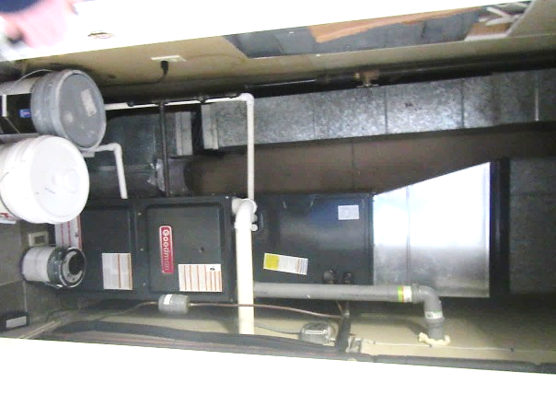
Heat pump/air handling unit (AHU) in mechanical room off breakroom, arrows indicate supply and exhaust
Picture 2
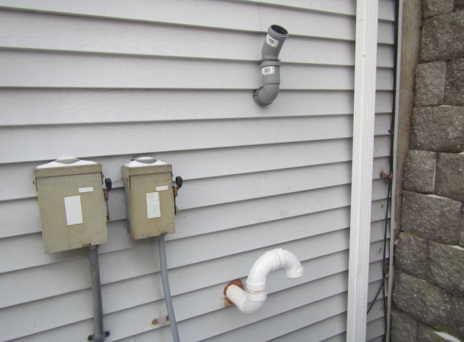
Termini of supply and exhaust vents for heat pump/AHU
Picture 3
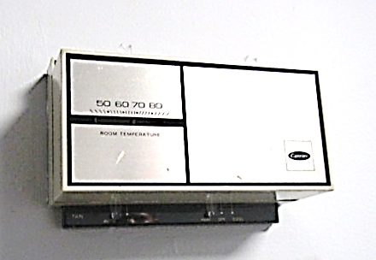
Thermostat, arrow indicates fan set to “auto” position
Picture 4
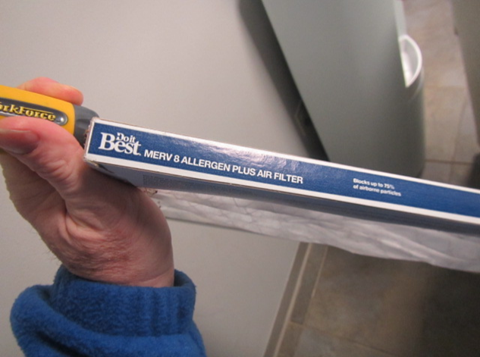
MERV 8 pleated filter
Picture 5
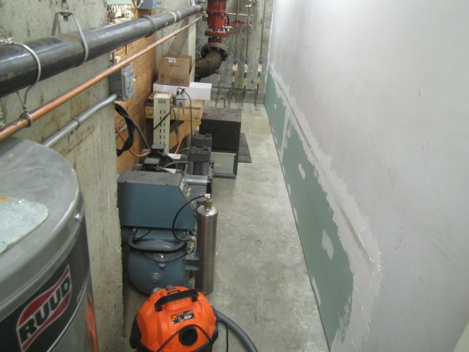
Mechanical room, note replaced portion of wall
Picture 6
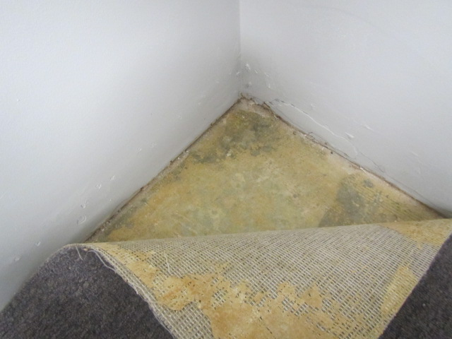
No evidence of mold or associated odors beneath carpet in Chris’s office directly adjacent to mechanical room
Picture 7
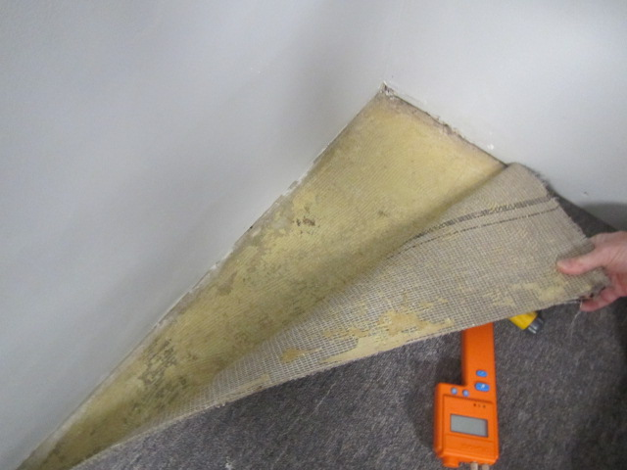
No evidence of mold or associated odors beneath carpet in Roger’s office
Picture 8
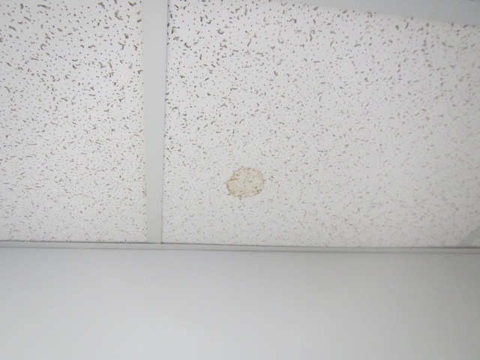
Water-damaged ceiling tile
Picture 9
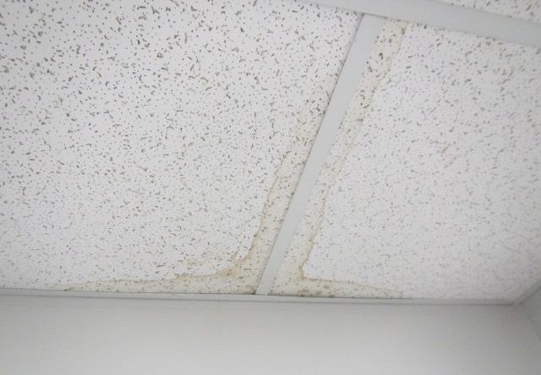
Water-damaged ceiling tile
Picture 10
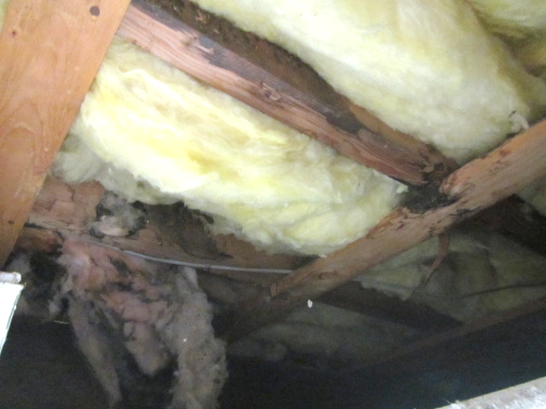
Water-stained wooden beams and insulation above ceiling tiles
Picture 11
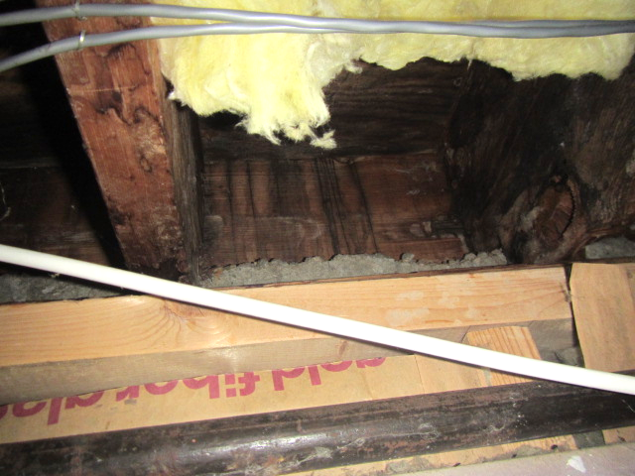
Water-stained wood above ceiling tiles
Picture 12
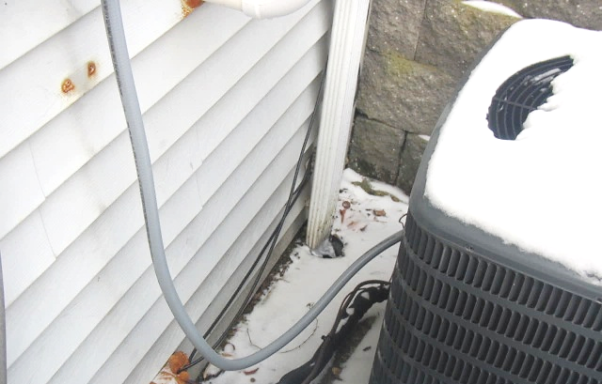
Pinched downspout at rear of building outside DOT office
Picture 13
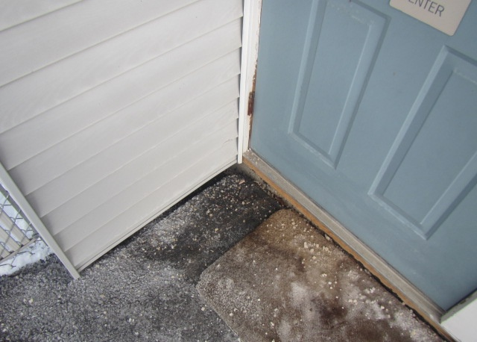
Open seam between tarmac and building
Picture 14
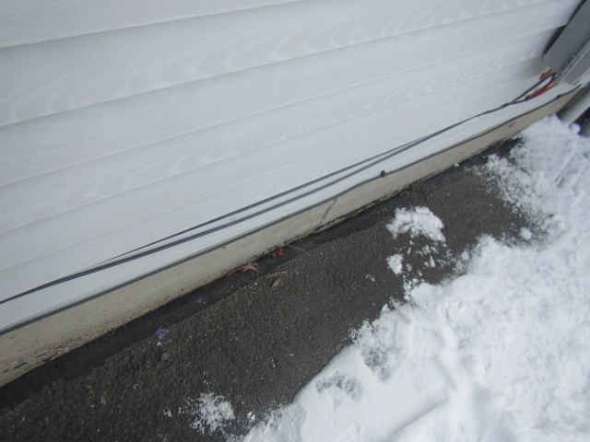
Open seam between tarmac and building
Picture 15
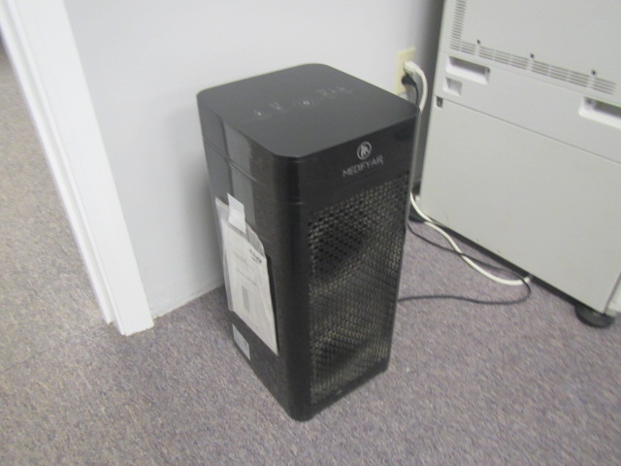
Portable air purifier, note dust/debris buildup on front grill
Picture 16
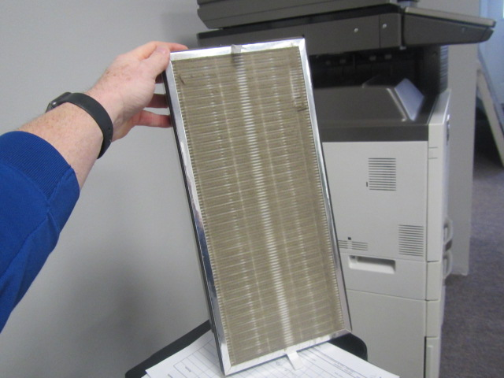
Dust/debris buildup on portable air purifier filter
Picture 17
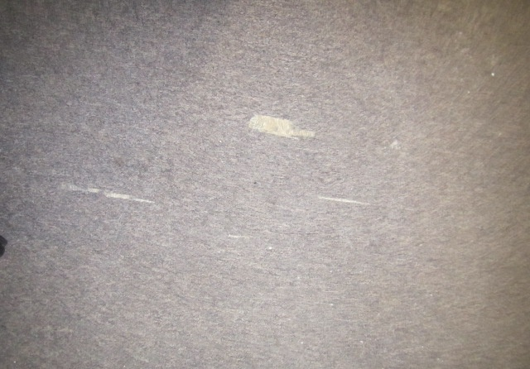
Worn/damaged wall-to-wall carpeting
Picture 18
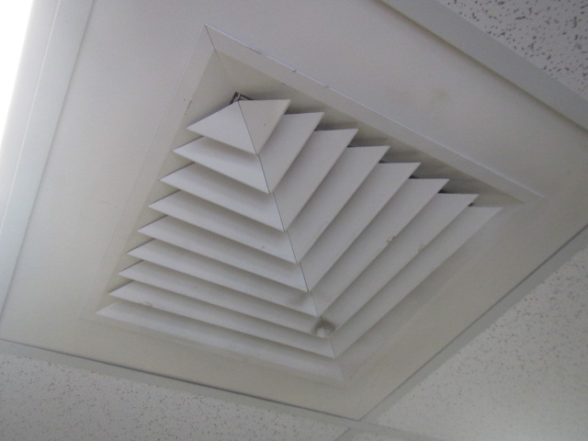
Dust/debris buildup on supply vent
Picture 19
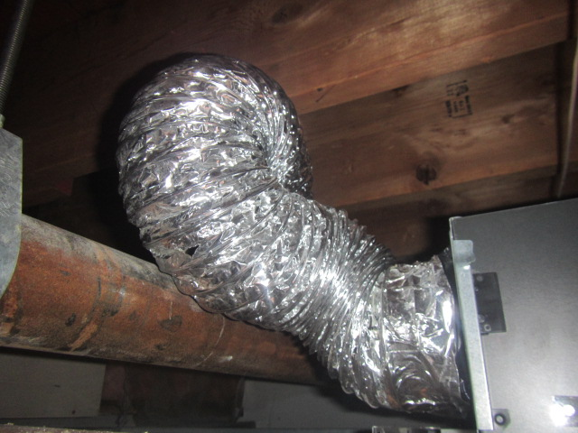
Restroom flex-duct, note duct takes a 180⁰ hairpin turn, arrow indicates hole
Picture 20
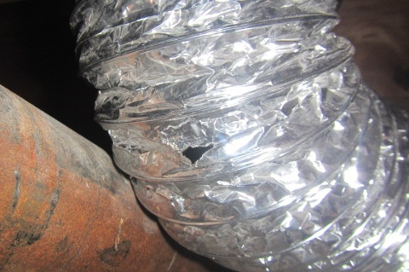
Close up of hole in restroom flex-duct

Location | Carbon  Dioxide  (ppm) | Carbon Monoxide  (ppm) | Temp  (°F) | Relative  Humidity  (%) | PM2.5  (µg/m³) | Occupants  in Room | Windows  Openable | Ventilation |  | Remarks
 |  |  |  |  |  |  |  | Supply | Exhaust | Remarks
Background | 401 | ND | 35 | 30 | 10 |  |  |  |  | Cold, clear and dry, moderate to heavy traffic
Chris’s Office | 748 | ND | 70 | 17 | 4 | 0 | N | Y | N | North wall - dry  South wall - dry  East wall - dry  West wall - dry  Carpet - dry
Roger’s Office | 783 | ND | 70 | 18 | ND | 0 | N | Y | N | North wall - dry  South wall - dry  East wall - dry  West wall - dry  Carpet – dry  2 WD CTs – dry, decaying odors above ceiling tiles, WD/staining on wood above ceiling tiles
Ryan’s Office | 648 | ND | 66 | 14 | 2 | 0 | N | Y | N | North wall - dry  South wall - dry  East wall - dry  West wall - dry  Carpet - dry
Breakroom | 634 | ND | 66 | 18 | 1 | 0 | Y | Y | Y | North wall - dry  South wall - dry  East wall - dry  West wall - dry
Main Office Area | 677 | ND | 67 | 16 | ND | 0 | Y | Y | N | North wall - dry  South wall - dry  East wall - dry  West wall - dry  Carpet – dry, air purifier – filter
Bathroom |  |  |  |  |  |  | N | N | Y | Restroom flex duct - hole
Mechanical Room |  |  |  |  |  |  |  |  |  | Gypsum wallboard replaced from previous water leak, rodent droppings

