INDOOR AIR QUALITY ASSESSMENT

City of Brockton
Department of Weights and Measures
53 Meadowbrook Road
Brockton, MA

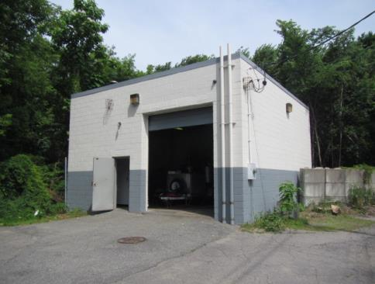

Prepared by:
Massachusetts Department of Public Health
Bureau of Environmental Health
Indoor Air Quality Program
June 2018
BACKGROUND
Building: | City of Brockton, Department of Weights and Measures (DMW)
Address: | 53 Meadowbrook Road, Brockton, MA
Assessment Coordinated via: | City of Brockton Health Department and DMW
Reason for Request: | General indoor air quality (IAQ) assessment
Date of Assessment: | June 18, 2018
Massachusetts Department of Public Health/Bureau of Environmental Health (MDPH/BEH) Staff Conducting Assessment: | Cory Holmes, Environmental Analyst/Inspector, IAQ Program
Date Building Constructed: | 1965, originally built as an auto service garage
Building Description: | Flat-roofed, concrete block building. The building mainly consists of a large vehicle/maintenance bay, with a bathroom built out.
Windows: | None

Methods
Please refer to the IAQ Manual for methods, sampling procedures, and interpretation of results (MDPH, 2015).

IAQ Testing Results
The following is a summary of indoor air testing results (Table 1):
- Carbon dioxide: levels were below the MDPH recommended level of 800 parts per million (ppm).
- Temperature: was above the MDPH recommended range of 70°F to 78°F and reflective of outdoor conditions the day of the assessment.
- Relative humidity: was above the MDPH recommended range of 40 to 60% and reflective of outdoor conditions the day of assessment.
- Carbon monoxide: were non-detectable at the time of assessment.
- Particulate matter (PM2.5): concentrations measured were below the National Ambient Air Quality Standard (NAAQS) level of 35 micrograms per cubic meter (μg/m³).
- Total Volatile Organic Compounds (TVOCs): levels indoors ranged from ND to 3.2 ppm. Exposure to low levels of TVOCs may produce eye, nose, throat, and/or respiratory irritation in some sensitive individuals. It is important to note that measureable levels of TVOCs would be expected in an industrial work setting, however, good depressurization/ventilation techniques should be employed to minimize/reduce exposure.

Ventilation
There was no means of general mechanical ventilation nor were there any windows present. The only source of introducing fresh air into the space is via the exterior doors.
The large bay/garage had a wall-mounted exhaust fan installed in the west wall of the building that was deactivated and sealed at the time of the visit (Pictures 1 and 2). In order for an exhaust fan to properly function, a source of air is needed (makeup air). No make-up air vent for the exhaust fan could be identified, except for opening the garage/exterior doors, which would be inconvenient during freezing winter months.

Microbial/Moisture Concerns
BEH/IAQ staff was asked to examine the building for water damage and mold. It is important to note that the building is primary constructed of materials such as concrete and metal which are unlikely to support mold growth, even when exposed to periodic water leaks.
Chronic water damage and visible mold growth was observed on gypsum wallboard (GW) (Picture 3) and on interior concrete walls (Pictures 4 through 9). Although the concrete itself is not a mold growth medium, the accumulated dirt/dust and debris on the surface of walls can be. The interior walls also showed severe signs of water penetration in the form of peeling paint and efflorescence. Efflorescence is a characteristic sign of water damage to building materials such as brick, mortar, or plaster. As moisture penetrates and works its way through mortar around brick, water-soluble compounds dissolve, creating a solution. As the solution moves to the surface of the brick or mortar, water evaporates, leaving behind white, powdery mineral deposits. This condition indicates that water from the exterior has penetrated into the building. When present, efflorescence can be readily cleaned. At the time of the assessment it was reported that the roof/flashing was slated for repairs within the next several weeks, which should reduce water penetration issues. In addition, the exterior of the building was recently painted (Picture 10).
The US Environmental Protection Agency (US EPA) and the American Conference of Governmental Industrial Hygienists (ACGIH) recommends that porous materials (e.g., wallboard, carpeting) be dried with fans and heating within 24 to 48 hours of becoming wet (US EPA, 2008; ACGIH, 1989). If porous materials are not dried within this time frame, mold growth may occur.
The bathroom also had water-damaged ceiling tiles (Picture 11). Stained or damaged ceiling tiles indicate roof or plumbing leaks. Tiles should be replaced once leaks are found and repaired.
Open spaces were seen around utilities/pipes penetrating exterior walls and underneath the exterior door (Pictures 12 and 13). These breaches can provide pathways for drafts, moisture and/or pests into the building. It is also important to note that the space does not have any means to reduce/remove moisture (e.g., air conditioning, dehumidification); therefore any paper, cardboard or other porous materials would be subject to mold growth from elevated humidity conditions.

Other Conditions
It is important to note that in this building, employees must work with various products that likely contain potentially hazardous materials e.g., (gasoline/oil and other unknown chemicals, Pictures 14 and 15) that are related to job function. For this reason, control of chemicals, proper protective equipment and proper ventilation, as well as emergency response information/procedures should be available. Staff should be trained in the safe handling of materials. As noted previously, the IAQ staff conducted air sampling for TVOCs using a photo ionization detector (PID), which identified measurable levels of TVOCs that were attributed to materials used in the DMW. The PID will identify the presence of detectable volatile organic compounds (VOCs), but does not differentiate between specific VOCs that may be present. Therefore the air sampling for TVOCs only indicate that there may be a source of exposure in the workplace and should not be used to determine compliance of US Occupational Safety and Health Administration (OSHA) regulations regarding hazardous materials Permissible Exposure Limits (PELs).
Other conditions that can affect IAQ were observed during the assessment. The staff restroom has an exhaust fan that vents inside the building (Pictures 11 and 16). Restrooms should be properly vented to the outside to remove excess moisture and odors.

CONCLUSIONS/RECOMMENDATIONS
In view of the findings at the time of the visit, the following recommendations are made:
- Unseal and activate the local exhaust fan to help remove odors and fumes as needed.
- Install make-up air vent for local exhaust system, preferably in opposite wall.
- Continue with plans to make roof/flashing repairs.
- Once repairs are made, remove all items from building in order to properly clean/scrape/pressure wash peeling paint/damaged walls and building interior. Ensure space is properly dried prior to reoccupancy.
- Remove/replace water-damaged/mold contaminated gypsum wallboard and ceiling tiles.
- Remove and discard all water-damaged stored materials (e.g., paper/cardboard).
- Seal any holes/breaches/pathways (e.g., spaces under doors/exterior walls) to prevent drafts, moisture and pests from entering. Install weather-stripping on exterior and garage doors, if doors cannot be made tight to prevent drafts/moisture/pests, repair or consider replacing. Ensure tightness of doors by monitoring for light penetration and drafts around doorframes.
- Consider providing dehumidifiers that self-drain to maintain humidity levels.
- Ensure restroom exhaust is vented properly outside the building.
- For buildings in New England, periods of low relative humidity during the winter are often unavoidable. Therefore, scrupulous cleaning practices should be adopted to minimize common indoor air contaminants whose irritant effects can be enhanced when the relative humidity is low. Use a vacuum cleaner equipped with a high efficiency particulate arrestance (HEPA) filter in conjunction with wet wiping to remove dust from all surfaces. Avoid the use of feather dusters. Drinking water during the day can help ease some symptoms associated with a dry environment (throat and sinus irritations).
- Conduct a thorough chemical inventory of the space and discard any outdated/unwanted materials in accordance with local/state hazardous waste laws and regulations. Ensure remaining chemicals are stored in appropriate, intact, tightly-sealed, and properly-labeled containers.
- Refer to resource manual and other related indoor air quality documents located on the MDPH’s website for further building-wide evaluations and advice on maintaining public buildings. These documents are available at http://mass.gov/dph/iaq.

REFERENCES
ACGIH. 1989. Guidelines for the Assessment of Bioaerosols in the Indoor Environment. American Conference of Governmental Industrial Hygienists, Cincinnati, OH.
MDPH. 2015. Massachusetts Department of Public Health. Indoor Air Quality Manual: Chapters I-III. Available at: http://www.mass.gov/eohhs/gov/departments/dph/programs/environmental-health/exposure-topics/iaq/iaq-manual/.
US EPA. 2008. Mold Remediation in Schools and Commercial Buildings. US Environmental Protection Agency, Office of Air and Radiation, Indoor Environments Division, Washington, D.C. EPA 402-K-01-001. http://www.epa.gov/mold/mold-remediation-schools-and-commercial-buildings-guide.
Picture 1
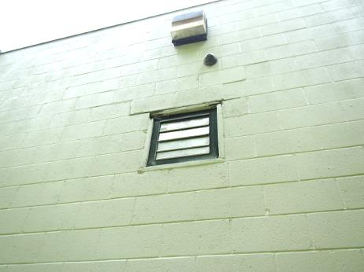
Local exhaust fan in west wall
Picture 2
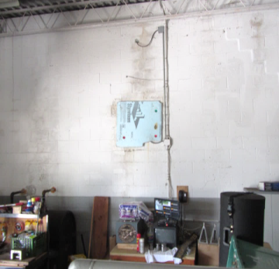
Sealed local exhaust fan in west wall
Picture 3
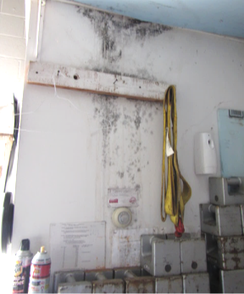
Mold growth (dark staining) on gypsum wallboard
Picture 4
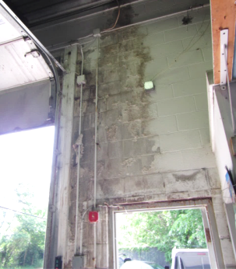
Water-damaged walls
Picture 5
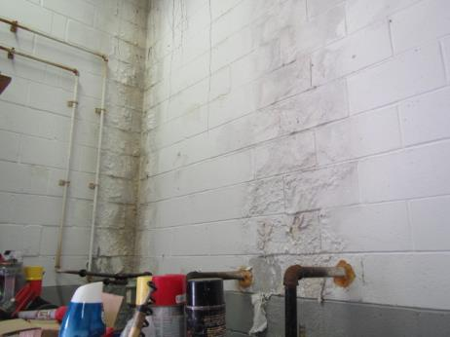
Water-damaged walls
Picture 6
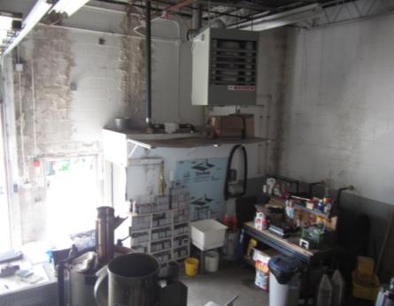
Water-damaged walls
Picture 7
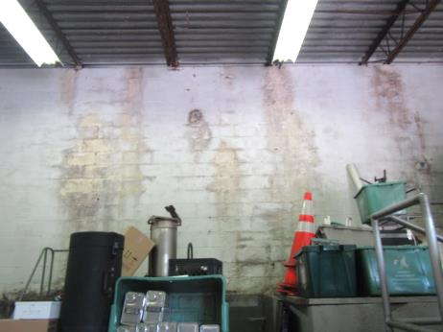
Water-damaged walls
Picture 8
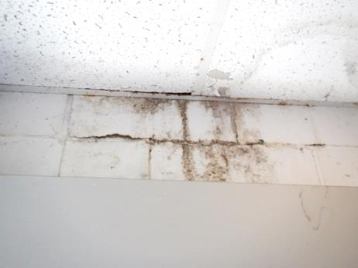
Water-damaged walls
Picture 9
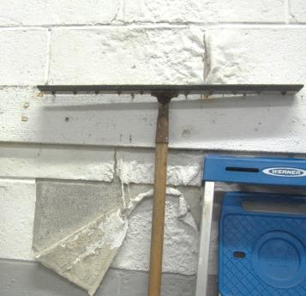
Water-damaged walls
Picture 10
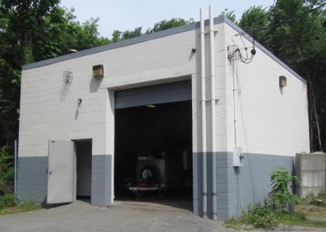
Exterior of building recently painted
Picture 11
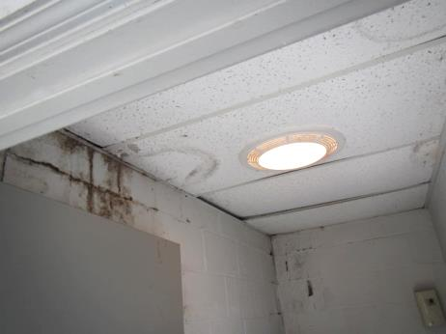
Water-damaged ceiling tiles and walls in bathroom, note exhaust vent/light
Picture 12
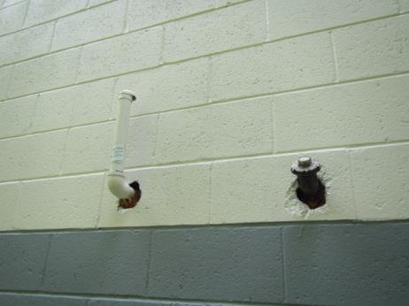
Spaces around utility pipes
Picture 13
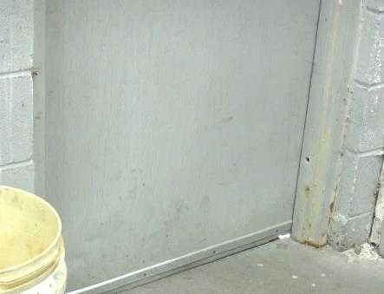
Light penetrating under exterior door
Picture 14
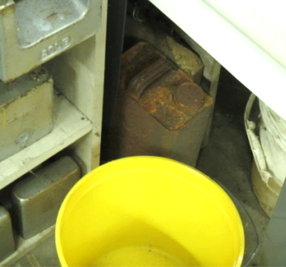
Unknown chemical in corroded container under sink
Picture 15
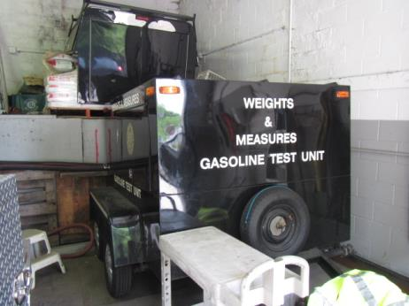
Gasoline test unit
Picture 16
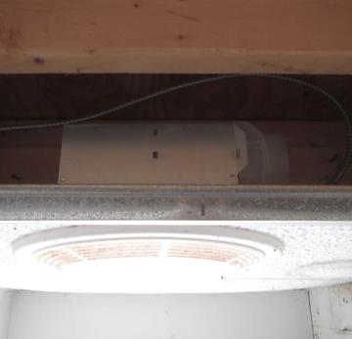
Terminus of restroom exhaust vent (arrow) emptying above ceiling
Location | Carbon  Dioxide  (ppm) | Carbon Monoxide  (ppm) | Temp  (°F) | Relative  Humidity  (%) | PM2.5  (µg/m³) | TVOCs  (ppm) | Occupants  in Room | Windows  Openable | Ventilation |  | Remarks
 |  |  |  |  |  |  |  |  | Supply | Exhaust
Background | 374 | ND | 91 | 52 | 23 | ND |  |  |  |  | Hot & humid
Bay | 623 | ND | 81 | 67 | 29 | ND-3.2 | 2 | N | N | Y | Local exhaust vent in west wall - temporarily sealed, severely water-damaged walls/peeling paint/efflorescence, likely mold growth on gypsum wallboard (bathroom), restroom exhaust not vented outside, utility holes, unknown chemicals in corroded containers

