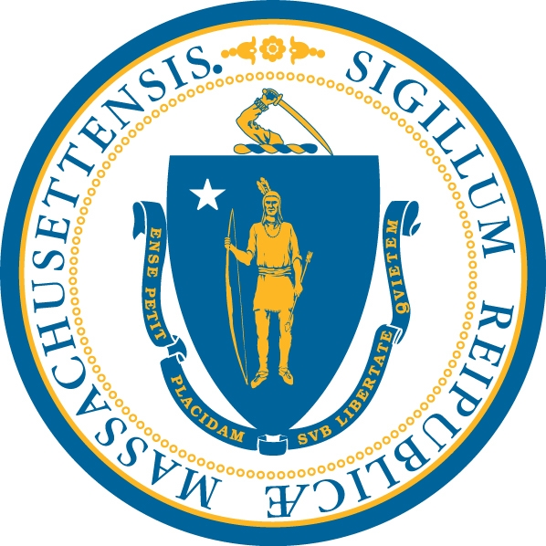
The Department of Developmental Services

The DESE/DDS Residential Prevention Program Interest Form 2019

The Department of Elementary and Secondary Education/The Department of Developmental Services

PLEASE COMPLETE IF YOUR STUDENT IS:
- Currently eligible as a Child for the Department of Developmental Services (DDS)
- Currently enrolled in an approved school program through the local school district
- Is between the ages of 6 and 17
- Is currently living in the family home

Please type responses or print clearly:
Name of Student
Name of Parent/Guardian
Student’s Date of Birth & SSN
Mailing Address: Street, City, State, ZIP
Phone (List Main # and Alternate)
Student’s Insurance Primary & Secondary (if applicable)
In What Language Would You Prefer to Speak About Your Child?*
In What Language Would You Prefer to Receive Written Materials About Your Child’s Care?*
Student’s Primary Diagnosis
Student’s other Diagnostic Information (if applicable)
Does your Student have an IEP (Yes or No)
Does your Student have a year round Program (Yes or No)
Is your Student in an after-school program (Y/N)
If yes, how many hours a week
Does your Student have in-home services from the school (Y/N)
If yes, how many hours a week
Does your Student receive services through ARICA (Y/N)
If yes, how many hours a week?
Does your Student receive CBHI services? (Y/N)
If yes, how many hours a week?
Does your Student receive Personal Care Attendant (PCA)? (Y/N)
If yes, how many hours a week?
Does your Student receive Coordinated Case Management? (Y/N)
If yes, how many hours a week?
Does your Student get Adult Foster Care Services (AFC)? (Y/N)
If yes, Level I or Level II
All Interest Forms must be postmarked between November 4, 2019 and December 31, 2019 Questions? 617-624-7518
- Form must be typed or printed clearly. If dropping off form put it in a sealed envelope marked Interest Form.
- You may drop off forms at local DDS Area Offices, Autism/Family Support Centers-not at the DDS Central Office.
- Mail forms to: DDS-Central Office, Att. DESE/DDS Program, 500 Harrison Ave, Boston, MA 02118
- Forms may also be emailed to DESEDDSPROGRAM@MassMail.State.MA.US.
- DO NOT ATTACH IEP/MEDICAL RECORDS/ ANY OTHER DOCUMENTS AT THIS TIME. SEND ONLY THIS FORM.
I have completed this form accurately and truthfully to the best of my knowledge.
The services and support listed above for my Student are current as of the date signed.
Signature of Parent/Guardian: Date:
*Translation and Interpretation are provided free of charge to participants.

