Department of Elementary and
Secondary Education

Overview of our activities re: students
with autism

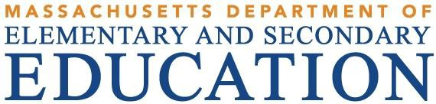

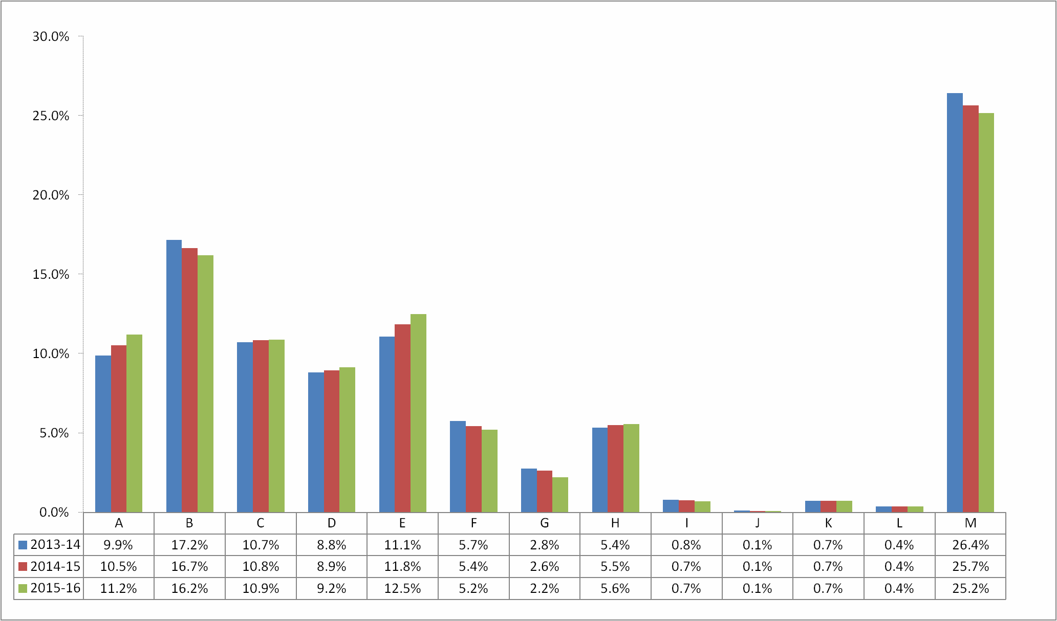
Incidence Info

- Autism
- Communication
- Development Delay D- Emotional
E- Health
F-Intellectual
G- Multiple Disabilities H- Neurological
- Physical
- Sensory/DeafBlind
- Sensory/Hard of Hearing
- Sensory/Vision Impairment M- Specific Learning Disability

2

Number and Percentage of Disability Categories
Ages 3-21 (SY12 and SY16)

3
Primary Disability | SY12 |  | SY16
 | # | % | # | %
Autism | 13,228 | 8.1% | 18,572 | 11.2%
Communication | 29,444 | 18.0% | 26,822 | 16.2%
Development Delay | 17,552 | 10.7% | 18,011 | 10.9%
Emotional | 13,932 | 8.5% | 15,152 | 9.2%
Health | 15,304 | 9.4% | 20,692 | 12.5%
Intellectual | 10,155 | 6.2% | 8,600 | 5.2%
Multiple Disabilities | 4,694 | 2.9% | 3,685 | 2.2%
Neurological | 7,947 | 4.9% | 9,239 | 5.6%
Physical | 1,390 | 0.8% | 1,150 | 0.7%
Sensory/DeafBlind | 164 | 0.1% | 161 | 0.1%
Sensory/Hard of Hearing | 1,221 | 0.7% | 1,201 | 0.7%
Sensory/Vision Impairment | 591 | 0.4% | 606 | 0.4%
Specific Learning Disability | 48,057 | 29.4% | 41,669 | 25.2%
SPED Total | 163,679 | 100% | 165,560 | 100.0%

Source: Massachusetts Student Information Management System

Change Differences of SWD Enrollment Percentages, Ages 3-21,
by Disability Category (SY12-16)

4%

3.1%
3%

2%

1%

0%

0.2%

0.7%

3.1%

0.7%

0.0% 0.0% 0.0%
- Autism
- Communication
- Development Delay D- Emotional
E- Health
F-Intellectual
G- Multiple Disabilities H- Neurological
- Physical
- Sensory/DeafBlind
- Sensory/Hard of Hearing
- Sensory/Vision Impairment M- Specific Learning Disability

A B C D E F G H I J K L M
-0.1%

-1%

-1.0%
-0.7%

-2%

-1.8%

-3%

-4%

4

-4.2%

-5%

Grade | # Autism per Oct 2015 Enrollment | Autism Enroll %
PK | 2,140 | 11.5%
K | 1,270 | 6.8%
1 | 1,198 | 6.5%
2 | 1,233 | 6.6%
3 | 1,276 | 6.9%
4 | 1,270 | 6.8%
5 | 1,279 | 6.9%
6 | 1,336 | 7.2%
7 | 1,323 | 7.1%
8 | 1,251 | 6.7%
9 | 1,196 | 6.4%
10 | 1,093 | 5.9%
11 | 894 | 4.8%
12 | 1,098 | 5.9%
+ | 715 | 3.8%
Total | 18,572 | 100%

5

Performance of students with autism as compared to other students with disabilities in the 10TH grade 2015 tests for MATH and ENGLISH LANGUAGE ARTS
DISABILITY | Gr. | Subject | Total | CPI

Autism | 10 | MTH | 849 | 79.0
Autism | 10 | ELA | 834 | 87.3
Other Disabilities | 10 | MTH | 10893 | 68.9
Other Disabilities | 10 | ELA | 10854 | 88.1

6

45.0%

2015-16 Educational Environment Placement for Students with Autism- Ages 3 to 5

41.1%

40.0%

37.5%

35.0%

30.0%

25.0%

20.0%

15.0%
13.9%

10.0%

5.0%

0.0%

2.6%
3.8%

0.5% 0.4% 0.0% 0.0% 0.3%

>= 10 hrs in
>= 10 hrs in
< 10 hrs in EC < 10 hrs in EC
Substantially
Public Day Private Day Private
Home Service

EC program NOT receiving
> 50%
services in inclusive setting
EC program receiving >
50% services
in inclusive setting
program NOT receiving >
50% services
in inclusive setting
program receiving >
50% services
in inclusive setting
Separate Classroom
Residential
Provider

7

45.0%
2015-16 Educational Environment Placement for Students with Autism- Ages 6 to 21

40.0%
40.4%

35.0%

30.0%
30.0%

25.0%

20.0%

15.0%
14.4%

10.0%

5.0%

0.0%

4.5%

7.7%

2.6%

0.0% 0.0%
8

Full Inclusion Partial Inclusion
Substantially Separate
Public Day Private Day Private
Residential total
Homebound or Hospital
Correctional Facilities

- Autism – A developmental disability significantly affecting verbal and nonverbal communication and social interaction. The term shall have the meaning given it in federal law at 34 CFR 300.7.

Key words from the federal definition: A developmental disability significantly affecting verbal and nonverbal communication and social interaction, generally evident before age 3…adversely affects
…educational performance… engagement in repetitive activities and stereotyped movements, resistance to environmental change or change in daily routines, and unusual responses to sensory experiences.

9

- POSSIBLE ASSESSMENTS & ASSESSMENT FACTORS
- Autism-specific rating scales
- Assessment of social maturity and skills
- Communication Sample and assessment of student’s language skills including pragmatic language skills
- Observations – note if student engages in repetitive or stereotyped movements and the student’s response to change in daily routines or environment
- Assessment of student response to sensory experiences
- Assessment of student’s emotional status (see also emotional
impairment)
- Assessment in multiple environments with a variety of tasks
- Note: Assessors should have experience and knowledge related to appropriate assessment tools
10

- A disabling condition is characterized by significant delays, impairments, or limitations in the student’s capacity(ies). To make this determination, the Team should consider all of the following as indices of limited, impaired, or delayed capacity:
- a pattern of difficulty that persists beyond age
expectations;
- a pattern of difficulty across settings;
- a pattern of difficulty that is not solely the result of cultural, linguistic, or socioeconomic differences; and

- a pattern of difficulty that persists despite instructional support activities.
- The regulatory definitions of disability include impact 11
on learning.

- Performance may be inconsistent and may not be consistent with developmental norms.

- Environmental structure and presentation of materials may significantly affect performance.
- High anxiety is frequently a major component and
may affect performance measures.
- Students may manifest difficulty with incidental
learning.
- The impact of this disability is pervasive.
- Students may manifest attentional issues and issues
with organizing information and understanding 12
abstract concepts.

- In July 2006, Chapter 57 of the Acts of 2006, entitled An Act To Address The Special Education Needs Of Children With Autism Spectrum Disorders, took effect.
- Whenever an evaluation indicates that a child has a disability on the autism spectrum, which includes autistic disorder [autism], Asperger's disorder, pervasive developmental disorder not otherwise specified, childhood disintegrative disorder, and Rhett's Syndrome as defined in the Diagnostic and Statistical Manual of Mental Disorders, fourth edition (DSM-IV, 2000), the IEP Team shall consider and shall specifically address the following: the verbal and nonverbal communication needs of the child; the need to develop social interaction skills and proficiencies; the needs resulting from the child's unusual responses to sensory experiences; the needs resulting from resistance to environmental change or change in daily routines; the needs resulting from engagement in repetitive activities and stereotyped movements; the need for any positive behavioral interventions, strategies, and supports to address any behavioral difficulties resulting from autism spectrum
disorder; and other needs resulting from the child's disability that impact 13 progress in the general curriculum, including social and emotional development.

Technical Assistance Advisory SPED 2007-1:
Autism Spectrum Disorder

⬇Date: August 25, 2006

⬇This advisory represents "best practice" guidance … to address a change to the special education law … The purpose of this advisory is to assist school districts and other interested parties in understanding these new requirements and in implementing best practices for meeting the needs of these students as schools resume instruction for the 2006-2007 school year.
⬇http://www.doe.mass.edu/sped/advisories/07_1t
a.html 14

⬇The bullying prevention and intervention law, section 8 states: For students identified with a disability on the autism spectrum, the IEP Team must consider and specifically address the skills and proficiencies needed to avoid and respond to bullying, harassment, or teasing. (G.L. c. 71B, §3, as amended by Chapter 92 of the Acts of 2010.)
15

The Autism Omnibus Law: Section 24 of Chapter 236 of the Acts of 2014 provides for a teacher endorsement in autism.
- Status:
  - The Board of Elementary and Secondary Education has promulgated licensing regulations to that effect on June 23, 2015 in 603 CMR 7.14(5).
  - The endorsement will be available to special education
teachers and is valid for five years (similar to a license).
  - The Board asked the Department to come back with more comment and thinking regarding making the endorsement available to all teachers. We have been
working with an interest group and hope to have a 16
follow-up recommendation for the Board by next Fall on
this topic.

  - (Status continued) We have a draft of the Guidelines for the Autism Endorsement (the required subject matter knowledge), and are currently receiving and considering public input on these guidelines. Once they are final (anticipated by summer), the Department will accept Higher Education proposals to approve their course of study for the endorsement and we will begin awarding the endorsement.

  - Individuals with at least 3 years experience working with students with autism; can demonstrate subject matter knowledge; and have a special education teacher license can go directly to receiving the endorsement if they
apply prior to 12/31/16. We currently have 46 17
applicants for this.

Advisories

- The Autism Insurance Law: Administrative Advisory
SPED 2012-1:
http://www.doe.mass.edu/sped/advisories/12_1.html
- Autism Spectrum Disorder: Technical Assistance Advisory SPED 2007-1: http://www.doe.mass.edu/sped/advisories/07_1ta.html

- Bullying Prevention and Intervention: Technical Assistance Advisory SPED 2011-2: http://www.doe.mass.edu/sped/advisories/11_2ta.html

- DSM-5 Changes and the Impact on Students with Autism Spectrum Disorders (ASD): Technical Assistance Advisory SPED 2014-1: http://www.doe.mass.edu/sped/advisories/2014- 1ta.html
18

