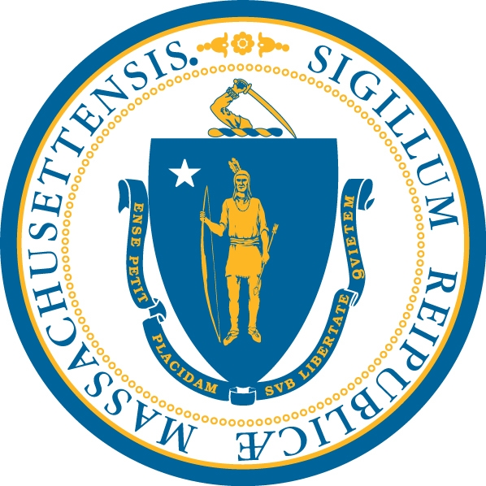
The Department of Developmental Services

THE DESE/DDS PROGRAM

The Department of Elementary and Secondary Education/The Department of Developmental Services

Program Overview and Open Interest Period Instructions 2017

DESE/DDS Program Overview:
The DESE/DDS Program is designed to provide in-home and community based therapeutic supports to students ages 6 to 22, who demonstrate a need for services to prevent a more restrictive out of home residential placement. This Program also offers an increased level of support services to families whose student returns from a residential school placement and requires assistance to remain at home. The DESE/DDS Program is administered by the Department of Developmental Services (DDS) with funding from the Department of Elementary and Secondary Education (DESE). Funding for this Program is subject to an annual legislative appropriation from the state budget.

The DESE/DDS Program requires the following to determine a student’s eligibility:
- The student must be eligible for DDS Children’s Services.
- The parent/guardian must agree to participate in an individualized assessment related to the student.
- The parent/guardian must provide copies of all relevant evaluations/diagnostic information from medical/school professionals.
- The parent/guardian must provide a copy of the most recent Individual Education Plan (IEP).
- The parent/guardian must share information about all other services provided to the student through school, insurance and other state funded programs.

The intent of the program is to increase family capacity to support his/her student in the home and community, as well as to provide an individualized plan of supports that promotes skill building, independence, and social integration. Families must play an active role in the program. All students are required to receive between three to six hours a week of behavioral/skills based training. This may include working on increasing the student’s ability to carry out activities of daily living (ADL), enhancing the student’s ability to communicate, and/or increasing positive behaviors through skills development.

Open Interest Period for the DESE/DDS Program:

DDS will accept Interest Forms for the DESE/DDS Program between January 9, 2017 and January 31, 2017. Completion of the DESE/DDS Interest Form only serves to indicate a family’s interest in the Program. The submission of the Interest Form does not guarantee participation in the DESE/DDS Program which will be determined through an Assessment and Prioritization Process.

Once the period for receiving Interest Forms for the DESE/DDS Program is over, the Department will determine eligibility for the DESE/DDS Program via the process outlined below:
- DDS will sort the Interest Forms geographically based on the DDS regions.
- DDS will determine the number of available slots based on the current distribution of students per region, trying to ensure that each DDS region is adequately represented.
- Area/Regional DDS staff will work with families to complete the individualized assessment process.
- Eligible students will be prioritized based on their level of assessed need, which includes consideration of the other services the student is receiving in their school, home and community.
- Enrollment will continue throughout the year until all available slots are filled.

Please complete this Interest Form if your student is:
- Currently eligible as a child for the Department of Developmental Services (DDS)
- Currently enrolled in an approved school program through the local school district and has an IEP
- Is between the ages of 6 and 17
- Is currently living at home

It is a priority of DDS to ensure that the process for requesting eligibility for the DESE/DDS Program is fully accessible to families and children who are from linguistically and culturally diverse backgrounds. Translation and interpretation is available free of charge to all participants.

This overview and the interest form are available on the DDS web-site at www.mass.gov/DDS. Materials are also available in Spanish.

Questions? Email DESEDDSPROGRAM@MassMail.State.MA.US or call 617-624-7518.

