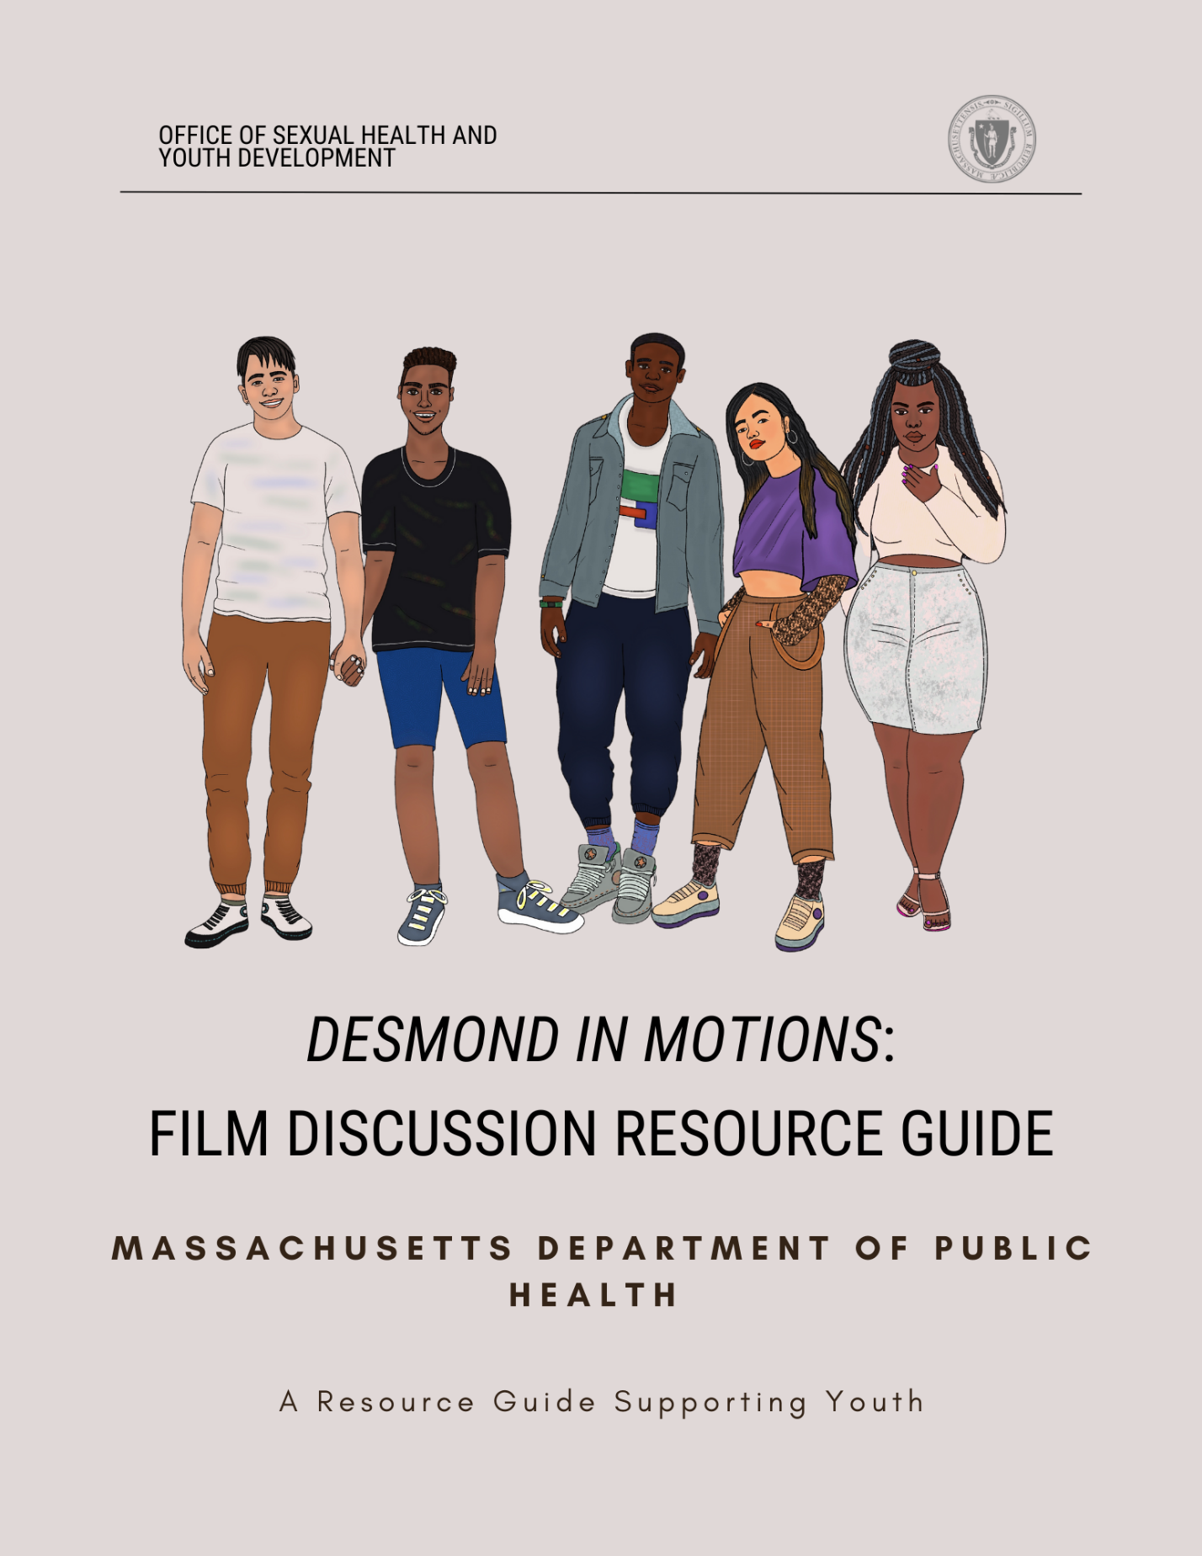

# Table of Contents

This Resource Guide 3

Thank You 4

Definitions 5

Mental Health Resources for Youth 7

988 Suicide and Crisis Lifeline 7

Health Steps 7

MCSP: Greater Boston Regional Suicide 7

Mass Suicide Prevention Program 7

Parent/Professional Advocacy League (PPAL) 7

GLASS 8

Speaking of Hope 8

Young Adult Access Centers 8

Video Summary 9

Guiding Discussion Questions 9

Facilitator Tips 11

Mandated Reporting & Managing Disclosure 11

Talking About How to Manage Disappointment 11

References 13

# This Resource Guide

As a branch of the Massachusetts Department of Public Health, the Office of Sexual Health and Youth Development (OSHYD) is proud to offer this Mental Health Film Discussion Resource Guide to trusted caretakers and educators.

OSHYD is comprised of several programs that work synergistically to increase access to comprehensive sexuality education, decrease teen and unintended pregnancy, decrease the incidence of sexually transmitted infections (STIs), increase the sustainability of delivery networks serving youth and other vulnerable populations, and increase protective factors for young people using a positive youth development lens1.

Youth experience barriers that influence health and wellness. Some youth experience stressors like feeling unsafe, housing instability, or social isolation, and trustworthy adults play a crucial role as lifelines and safeguards for adolescents. Youth mental health outcomes can be improved by having an accepting community, adult, or caregiver; for instance, a dependable adult or caregiver can direct a young person to resources or services that might be useful. Trusted adults in young people’s communities play a significant and important role2. A trusted adult is responsible for creating and maintaining a safe and brave space for youth to explore why talking about mental health and well-being is important.

This document provides a discussion guide that can be used in conjunction with the film, *Desmond in Motion*, on how to ask questions and have potentially challenging conversations with youth. This discussion guide is meant to be a starter kit for facilitators, schools, community organizations, parents, and trustworthy adults on what support systems are available and how to navigate what may feel like uncharted territory.

This guide also includes resources that provide accurate and trauma-informed information that addresses social determinants of health for youth’s mental well-being. Organizations that directly and indirectly focus on mental health needs of youth in Massachusetts are highlighted. As a result, the organizations in this resource guide are committed to providing inclusive care and to respecting and acknowledging the mental health gap that youth experience.

# Thank You

The Massachusetts Department of Public Health and Office of Sexual Health and Youth Development (OSHYD) would like to thank the following organizations and individuals for their input and contribution to this resource guide:

Cecelia Werner, 2023 Fellow at the Boston University Maternal and Child Health Center for Excellence, Master of Public Health candidate

A special thanks to the cast and crew of *Desmond in Motions*

[Making Opportunity Count3](https://www.mocinc.org/)

Shana Fitz, Director of Youth Services, Making Opportunity Count

[Thato Mwosa4](https://thatomwosa.com/), Film Producer, Writer, and Director for Tuli Media

Dara Oloyede (DPH), Adolescent Health Coordinator at the Office of Sexual Health and Youth Development

Lissette Gil-Sanchez (DPH), Director of the Office of Sexual Health and Youth Development

# Definitions

These definitions are based on what is currently appropriate as of November 2023. These definitions are not exhaustive.

|  |  |
| --- | --- |
| Brave Space5 | An environment that acknowledges the challenges that both participants and staff/facilitators have when discussing difficult and/or sensitive topics such as race, power, privilege, and the various forms of oppression for the purpose of learning. |
| Cultural Expectations/  Norms6 | Social and cultural norms are rules or expectations of behavior and thoughts based on shared beliefs within a specific cultural or social group. |
| Disappointment7 | The unhappiness or discouragement that results when your hopes or expectations have not been satisfied, or someone or something that is not as good as you had hoped or expected. |
| Healthy Coping Skills8 | Coping refers to the conscious and voluntary thoughts and behaviors employed to navigate both internal and external stressors. These skills are behaviors that we develop to make sense of negative experiences in a productive way. They help us manage our emotions related to difficult times to improve our emotional health. It is distinct from 'defense mechanisms,' which are subconscious or unconscious adaptive responses.  Examples include but are not limited to movement or physical activity, meditation, creative outlets, journaling, etc. |
|  |  |
| Respect9 | Admiration shown or felt for someone or something that you believe has good ideas or qualities. |
| Trusted Adult10 | A trusted adult is chosen by the young person as a safe figure who listens without judgment, agenda or expectation but with the sole purpose of supporting and encouraging positivity within a young person’s life. |
| Values11 | The beliefs people have, especially about what is right and wrong and what is most important in life, that control their behavior. |

# Mental Health Resources for Youth

## [988 Suicide and Crisis Lifeline](https://www.mass.gov/info-details/about-the-988-suicide-and-crisis-lifeline)

988 is a direct three-digit number to trained Suicide and Crisis Lifeline specialists. 988 is free and available 24/7, 365 days a year via phone call, text or chat12.

## [Health Steps](https://www.211.org/about-us/your-local-211)

211HELPSteps is the online platform of Mass211. From any desktop or mobile device, individuals can search and then connect to local health and human service resources across the Commonwealth. Programs that are included support basic needs such as food security, housing, childcare, transportation, and mental and emotional health resources13.

## [MCSP: Greater Boston Regional Suicide](https://www.greaterbostonpreventssuicide.org/)

The Greater Boston Regional Suicide Prevention Coalition (GBRSPC) is one of ten regional coalitions that operate under the umbrella of the Massachusetts Coalition for Suicide Prevention (MCSP). Massachusetts Coalition for Suicide Prevention (MCSP) is an inclusive alliance of suicide prevention advocates, including public and private agency representatives, policymakers, suicide loss, and attempt survivors, impacted family and friends, mental health and public health consumers and providers, and concerned citizens who are dedicated to working together to reduce the incidence of suicide and self-harm across the Commonwealth. Services include [mental health crisis hotlines](https://www.greaterbostonpreventssuicide.org/mh-crisis-hotlines), [emergency mental health services](https://www.greaterbostonpreventssuicide.org/mh-crisis-support), [statewide resources](https://www.greaterbostonpreventssuicide.org/ma-statewide-resources), [RIAC community services](https://www.greaterbostonpreventssuicide.org/communities-of-color), and [youth mental health resources](https://www.greaterbostonpreventssuicide.org/youth-mental-health)14*.*

## [Mass Suicide Prevention Program](https://www.mass.gov/suicide-prevention-program)

This program aims to reduce the number of suicides and suicide attempts and promote mental health and well-being among Massachusetts residents. We seek to raise awareness of suicide as a public health problem. The Program provides support to community agencies, education and training for professionals and caregivers, and funds programs working with youth, veterans, and older adults. We use data to identify populations and geographic areas of the state that need assistance. We also support and encourage communities to collaborate across disciplines to prevent suicide and suicide attempts across the lifespan. Services include crisis hotlines and [MassMen: Life tools for men](https://www.mass.gov/massmen)15.

## [Parent/Professional Advocacy League (PPAL)](https://ppal.net/)

Parent/Professional Advocacy League is a statewide, grassroots family organization that advocates for improved access to mental health services for children, youth, and their families. PPAL’s goals are to support families, nurture parent leaders, and work for systems change. PPAL is the only Massachusetts organization whose work focuses solely on the interests of families whose children have mental health needs. Founded in 1991, PPAL continues to work on behalf of children, youth, and families as a critical voice shaping policy and practice. Services include [family support services](https://ppal.net/family-support-services/) and [juvenile justice help](https://ppal.net/juvenile-justice/)16.

## [GLASS](https://jri.org/services/health-and-housing/health/boston-glass)

GLASS provides [behavioral health services](https://jri.org/services/behavioral-health-and-trauma), [educational services](https://jri.org/services/educational-and-residential), and other [youth opportunities](https://jri.org/services) to LGBTQ+ youth of color and their allies in the Greater Boston and Greater Framingham areas17.

## [Speaking of Hope](https://www.speakingofhope.org/)

Speaking of Hope is a web and social media platform that supports mental wellness for young adults in Massachusetts and offers key resources such as employment and training services, mental health support, and substance use recovery support for young adults18.

## [Young Adult Access Centers](https://www.speakingofhope.org/access-centers/)

Young Adult Access Centers provide timely and effective services for young adults facing mental health concerns. These centers focus on outreach to those dealing with challenges such as mental illness, substance misuse, economic insecurity, and homelessness. Services are free and available in Massachusetts. Find a center at <https://www.speakingofhope.org/access-centers/> or contact Heidi Holland, Director of Young Adult Transitional Services, at [Heidi.holland@mass.gov](mailto:Heidi.holland@mass.gov). Centers are affirming and inclusive spaces that promote an environment that specifically and effectively engages Black, Indigenous, People of Color (BIPOC) and Lesbian, Gay, Bisexual Queer/Questioning (LGBTQIA+) young people19.

# Video Summary: Desmond in Motions

This short film follows Desmond, a high school senior who awaits news from his first-choice university. Struggling to understand and accept an unexpected turn, Desmond navigates feelings of self-doubt, comparison, and uncertainty.

# Guiding Discussion Questions

Below are a series of questions that can be used after watching the film, *Desmond in Motions*, to guide a discussion on key themes in the film.

* **Key Themes**
* Experiencing disappointment
* Healthy coping skills
* Mental health
* Trusted adults
* **Reflection Questions for Facilitators**

1. How do you distinguish between healthy and unhealthy coping mechanisms?
   1. Can healthy coping mechanisms become unhealthy?
   2. Can you share any personal experiences?
2. How, as a facilitator, will you model brave space, respect towards others, and call in any harm that has been done?
3. How can cultural expectations or norms be a protective factor for youth?
4. How would you approach a youth whom you notice has been more withdrawn from programming?
5. What is your agency’s policy around disclosure and mandatory reporting? See considerations.
6. What mental health resources or referral partners can your program provide for youth? Is there any protocol for follow-up?
7. Has this conversation challenged your values in any way?
   1. If not, how does it align with your values?

* **Discussion Questions for Youth**

1. How do you think Desmond felt when all his friends were accepted into their top choice schools, and he was not?
2. How did the adults in Desmond’s life try to support him?
   1. How did his friend try to support him?
3. Imagine Desmond after the film ended. What are healthy and positive next steps for him?
4. How does your culture view mental health?
   1. What are examples of cultural practices, e.g., family gatherings and ceremonies, or religious and spiritual practices that contribute to mental well-being?
   2. Are there any that could potentially be challenging?
5. What are examples of healthy coping skills that you find effective in managing stress or difficult emotions?
   1. What can make a coping skill unhealthy?
6. Do you feel like you have at least one trusted adult you can go to if you are struggling? What makes them a supportive adult?
7. Can you list student support resources at your school? In your community?

# Facilitator Tips

Below are recommendations and factors to consider while leading a conversation about mental health in a youth group or one-on-one setting.

## Mandated Reporting & Managing Disclosure

Under Massachusetts law, the Department of Children and Families (DCF) is the state agency that receives all reports of suspected abuse and/or neglect of children under the age of 18. Professionals who have regular contact with children are mandated by state law to inform the DCF if they have suspicions of child abuse or neglect20. If you work in childcare, you may find it necessary to submit a report to DCF regarding suspected child abuse or neglect21. To learn more about the process of reporting alleged child abuse or neglect under section 51A, please click [here](https://www.mass.gov/how-to/report-child-abuse-or-neglect) for additional information.

Below is a list of positions that are mandated reporters20:

1. Physicians, dentists, nurses, medical interns, hospital personnel, and all medical staff.
2. Public or private school teachers, educational administrators, guidance, or family counselors.
3. Early education, preschool, childcare, or after-school program staff, including any person paid to care for or work with a child in any public or private facility funded or licensed by the Commonwealth.
4. Voucher management agencies, family childcare, and childcare food programs.
5. Childcare licensors, such as staff from the Department of Early Education and Care.

Being well-informed about your organization’s policies regarding mandated reporting and managing disclosures is crucial. Setting up a pre-planned strategy with your team for managing disclosures and locating post-disclosure support are essential for effectively managing such challenging situations. It is vital to maintain transparency and honesty when interacting with children or students under the age of 18 and disclose that you are a mandated reporter. This disclosure is essential, as it can provide children or students with support or guide them to other resources to feel comfortable and safe.

## Talking About How to Manage Disappointment

Disappointment can be a very difficult emotion to deal with for both youth and adults. It is important to emphasize that there are healthy and unhealthy ways to work through disappointments or setbacks. Below is a list of strategies you can use to help youth deal with disappointment and uncertainty:

1. Validate and acknowledge the disappointment.
2. Emphasize that it may take time to get to acceptance.
3. Ask if they are ready to brainstorm possible solutions and/or alternatives.
   1. Differentiate between situations that are controllable and uncontrollable.
   2. Reflect and learn from both.
4. Discuss referrals and resources.
5. Follow up with the young person after the conversation.

It is important to understand that some of these suggestions and conversations can be challenging and uncomfortable. Many young individuals in this context may be actively seeking and in need of resources. Using motivational interviewing strategies will help facilitate open-ended discussions and provide answers to their questions. These techniques will assist you as a facilitator in understanding their perspective and exploring their values and goals22. It is important to remember that your role as a facilitator is not to offer counseling (unless you are a licensed behavioral health clinician or similar and it fits within your responsibilities at the organization), but to serve as a trustworthy adult and direct the young person to the appropriate resources. Always seek permission before sharing resources, such as connecting them with a therapist or school staff member. Follow up with the students to see how they are doing and ensure they are mentally and physically safe.

Additionally, safeguarding your own mental health is critical. Engaging empathetically with youth who have experienced trauma can lead to vicarious trauma. Be watchful for signs of emotional exhaustion, reduced personal accomplishment, and dissociation. Establish a plan with your leadership team and seek mental health support for yourself 23.

# References

1. Office of Sexual Health and Youth Development. Mass.gov. Accessed February 10,

2023. <https://www.mass.gov/orgs/office-of-sexual-health-and-youth-development>.

1. Youth Online: High school YRBS - Massachusetts 2021 results | DASH | CDC. Accessed

May 10, 2023. <https://nccd.cdc.gov/youthonline/App/Results.aspx?LID=MA>.

1. Making Opportunity Count, May 22, 2023. <https://www.mocinc.org/>.
2. Thato R. Mwosa, October 6, 2023. <https://thatomwosa.com/>.
3. The 6 Pillars of a Brave Space. University of Maryland. Accessed November 10, 2023.

<https://www.ssw.umaryland.edu/media/ssw/field-education/2---The-6-Pillars-of-Brave-Space.pdf>.

1. National Academies. Addressing the Social and Cultural Norms that Underlie the

Acceptance of Violence: A Workshop. (2015) Accessed November 10, 2023. <https://www.nationalacademies.org/our-work/addressing-the-social-and-cultural-norms-that-underlie-the-acceptance-of-violence-a-workshop#:~:text=Social%20and%20cultural%20norms%20are,acceptable%20in%20interactions%20among%20people>.

1. Cambridge Dictionary. Definition of “Disappointment.” Accessed November 10, 2023.

<https://dictionary.cambridge.org/us/dictionary/english/disappointment>.

1. Folkman, S., & Moskowitz, J. T. (2004). Coping: Pitfalls and Promise. *Annual Review of*

*Psychology*, *55*(1), 745–774. <https://doi.org/10.1146/annurev.psych.55.090902.141456>.

1. Cambridge Dictionary. Definition of “Respect.” Accessed November 10, 2023.

<https://dictionary.cambridge.org/us/dictionary/english/respect>.

1. YoungMinds. Definitions. Accessed. November 15, 2023.

<https://www.youngminds.org.uk/professional/community-support/someone-to-turn-to/defining-a-trusted-adult/#:~:text=What%20is%20a%20trusted%20adult,within%20a%20young%20person's%20life>.

1. Cambridge Dictionary. Definition of “Values.” Accessed November 10, 2023.

<https://dictionary.cambridge.org/us/dictionary/english/values>.

1. 988 Suicide and Crisis Lifeline. Mass.gov. Accessed October 6, 2023.

<https://www.mass.gov/info-details/about-the-988-suicide-and-crisis-lifeline>

1. 211HELPSteps. Accessed May 10, 2023. <https://www.helpsteps.com/#/>.
2. “Home: Greater Boston Regional Suicide Prevention.” Mysite. Accessed June 14, 2023.

<https://www.greaterbostonpreventssuicide.org/>.

1. Suicide prevention program. Mass.gov. Accessed May 10, 2023.

<https://www.mass.gov/suicide-prevention-program>.

1. “PPAL: Children’s Mental Health.” Parent Professional Advocacy League |

Massachusetts Family Voice for Children’s Mental Health. Accessed June 12, 2023. <https://ppal.net/>.

1. “GLASS (GLBTQ+ Adolescent Social Services).” Leader in Social Justice (LRI).

Accessed August 7, 2023. <https://jri.org/services/health-and-housing/health/boston-glass>.

1. Speaking of Hope. Accessed October 6, 2023. <https://www.speakingofhope.org/>
2. Access Centers. Speaking of Hope. Accessed October 6, 2023.

<https://www.speakingofhope.org/access-centers/>

1. Massachusetts Department of Children & Families. Mass.gov. Accessed May 10, 2023.

<https://www.mass.gov/orgs/massachusetts-department-of-children-families>.

1. Reporting alleged child abuse or neglect (filing a 51A report). Mass.gov. Accessed

October 6, 2023. <https://www.mass.gov/info-details/reporting-alleged-child-abuse-or-neglect-filing-a-51a-report>.

1. Rubak, S., Sandbaek, A., Lauritzen, T., Christensen, B. Motivational interviewing: a

systematic review and meta-analysis. April, 2005. Accessed October 6, 2023. <https://bjgp.org/content/55/513/305.short>.

1. Bell, H., Kulkarni, S., Dalton, L. Organizational Prevention of Vicarious Trauma.

*Families in Society*, *84*(4), 463-470. 2003. <https://doi.org/10.1606/1044-3894.131>