Payments by Category

Important symbols used for running and viewing your report:

When viewing a report, this icon will allow you to return to the search selection screen and add to your search results
- Globe icon (HTML format) allows you to change the view format to see your report as a .pdf or .csv (spreadsheet) file
.pdf format icon
.csv (spreadsheet) format icon
Will take you completely out of the report (not back one page or to the previous screen view)

When creating a report, do not use the Back button on your browser; it will take you completely out of the report.

When you click on the link: Run Payments by Category Report on the Custom Reports page, you will see this screen containing two large boxes:

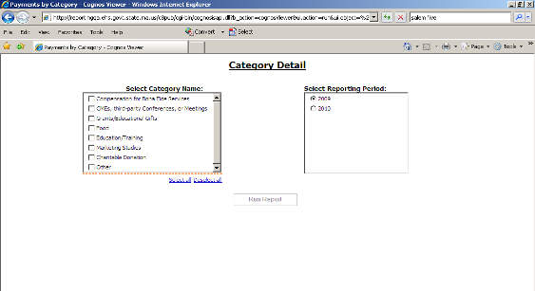

In the “Select Category Name” box, click on the boxes next to the categories of payments about which you would like to see information. For example, if you wanted to see the payments made for Food and for Charitable Donations, you would click those boxes. You can select one or more categories.

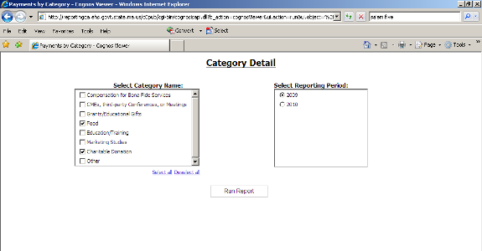

If you would like to see all categories, you can click on the Select All link below the box and checkmarks will appear next to all of the boxes. If you click the “Deselect All” link, all checkmarks will be removed.

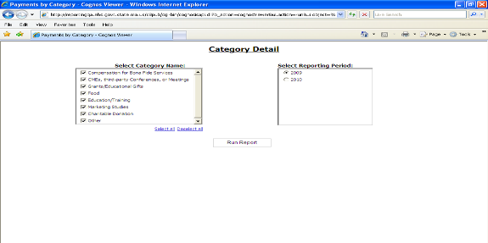

Select a reporting period in the “Select Reporting Period” box on the right. 2009 is the default selection.

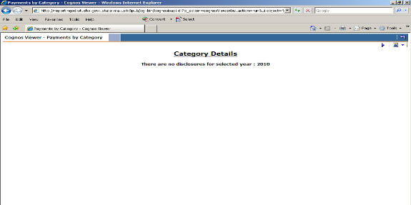

To return to the selection screen, click the purple arrow next to the Globe in the upper right of the white section of the screen.

After you have selected the categories you want to see, click on the “Run Report” box in the lower middle of the screen. You may see an hourglass appear. Do not click on it. Wait a few seconds and it will disappear.

When the report appears, it will look like this. You will see all of the companies that reported payments in the selected categories. The category name appears at the top of each report section. The company name and total amount reported in that category will be displayed. In this example, all of the companies that provided Charitable Donations will be shown alphabetically. After all of the Charitable Donations are shown, then the Food category will be shown.
If you want to go back to the category selection page, click the purple arrow next to the Globe in the upper right of the white section of the screen. You will see your original search selections and can make changes and rerun the report.

Do not use the Back button on your browser; it will take you out of the report.
Do not click on the “left turn arrow” in the upper right corner of the page. It will take you completely out of your report and it will not take you back one page or to the previous screen view.

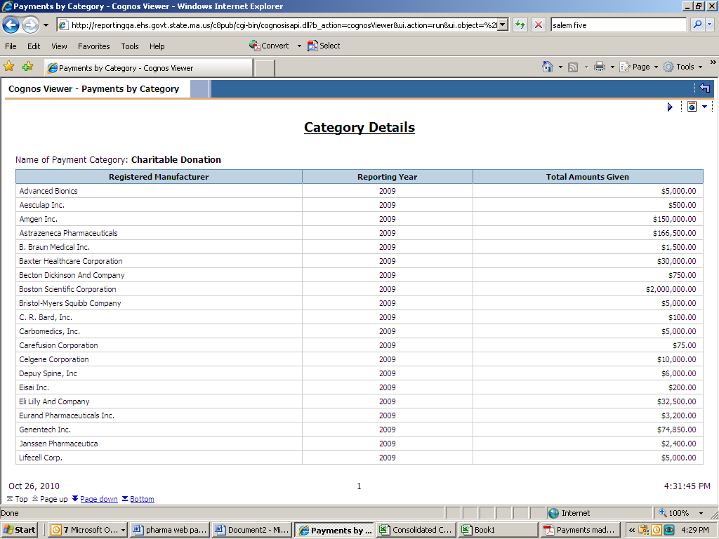

You will have to scroll through the report to see all of the pages, using the “Page up” and “Page down” buttons in the lower left. However, rather than having to click on “page up” or “page down” to view each page, we highly recommend viewing the reports in either a .pdf file or a .csv file (spreadsheet) format, as it will be easier to scroll through the pages. If you are not planning to do any further analysis of the results, the .pdf format will be the easiest to use.

To view the report as a .pdf document:
- Click on the small box with a globe in it on the upper right of the white section of the screen. A new box will appear under the globe.
- Click on second line “View in pdf format”. A new window will launch that will display your report. If an hourglass appears, wait a few seconds and it will disappear.

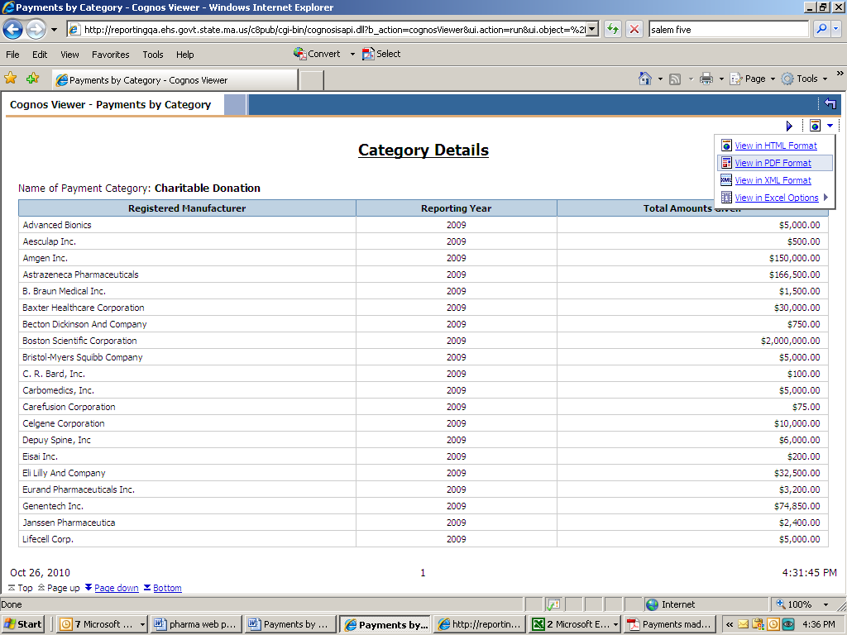
Your report will look like this:

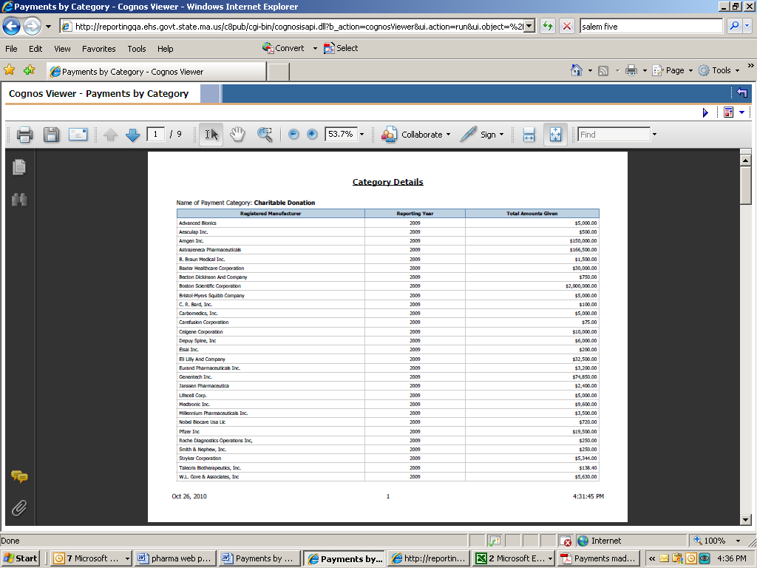

For easier viewing, you can increase or decrease the size of the image by increasing or decreasing the percent in the box in the middle of the toolbar across the top of the report. Or you can click on the “+” or “-“ signs beside that box.

In .pdf view, you can easily scroll through the pages of the report using the scroll bar on the right of the screen or the scroll wheel on your mouse.
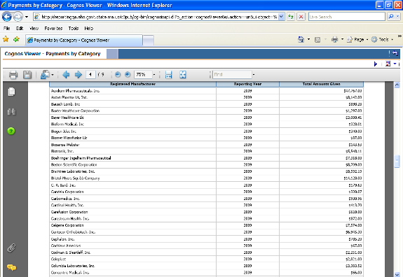

If you simply wish to view the report, but not save it, just click on the X in the upper right corner of the screen to close the window when you are done.

You can save the report by either clicking on the disk icon (between the printer and envelope icons) on the tool bar across the top of the report or using File -> Save As on your browser’s top menu.

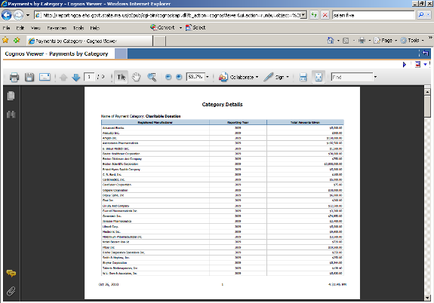

To view the report as a .csv (spreadsheet file):
- Click on the small box with a globe in it on the upper right of the white section of the screen. A new box will pop up under the globe.
- Move your mouse over the fourth line “View in Excel options”. Another box will pop up.
- Click on the fourth line “View in CSV format”. A new window will launch that will display your report. If an hourglass appears, wait a few seconds and it will disappear.

If you have problems viewing the .csv spreadsheet, make sure your internet browser’s security setting enables pop-ups and automatic prompting for file downloads.

For pop-ups, on your browser menu click on: Tools, Pop-Up Blocker, Pop-Up Blocker Settings and add these two websites to allow pop-ups from these sites:
https://reporting.hhs.state.ma.us
https://gateway.hhs.state.ma.us
.
For automatic prompting for file downloads, on your browser menu click on: Tools, Internet Options, Security, Custom, Downloads - Automatic prompting for file downloads – enable, and ok.

More explicit instructions for allowing pop-ups, with screen shots, are at the end of this document.

Note: We do not recommend using the other Excel options that appear above “View in CSV format” due to compatibility issues with some versions of certain internet browsers. The .csv file does not have these issues.

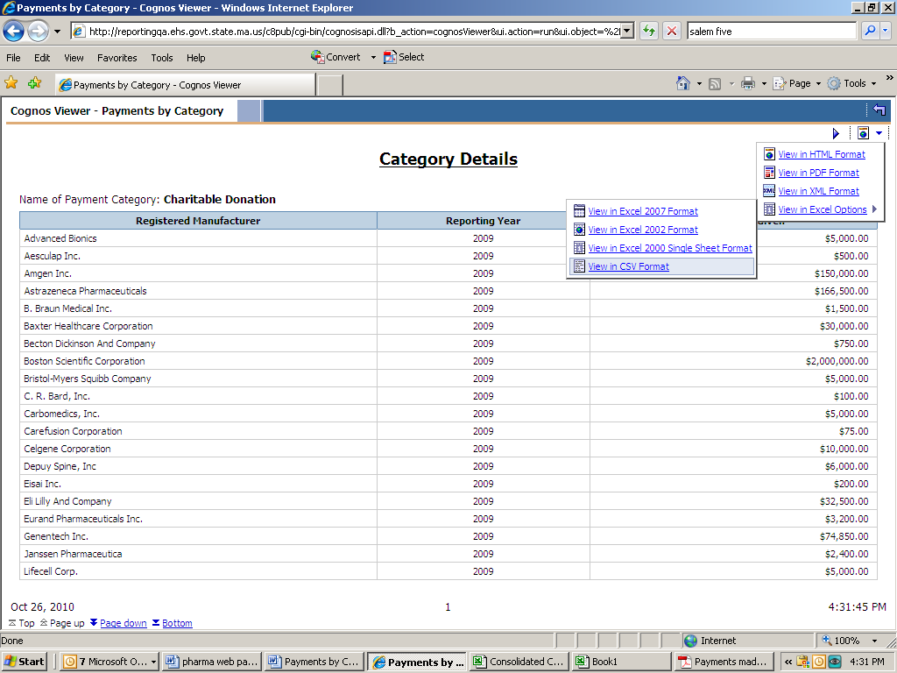
Your report will look like this. To expand the columns, move your cursor over the right side of the letter boxes until it changes. Then either double-click your mouse or hold down the left mouse button and drag it to the right until the column is as large as you would like it. Repeat this with the other columns.

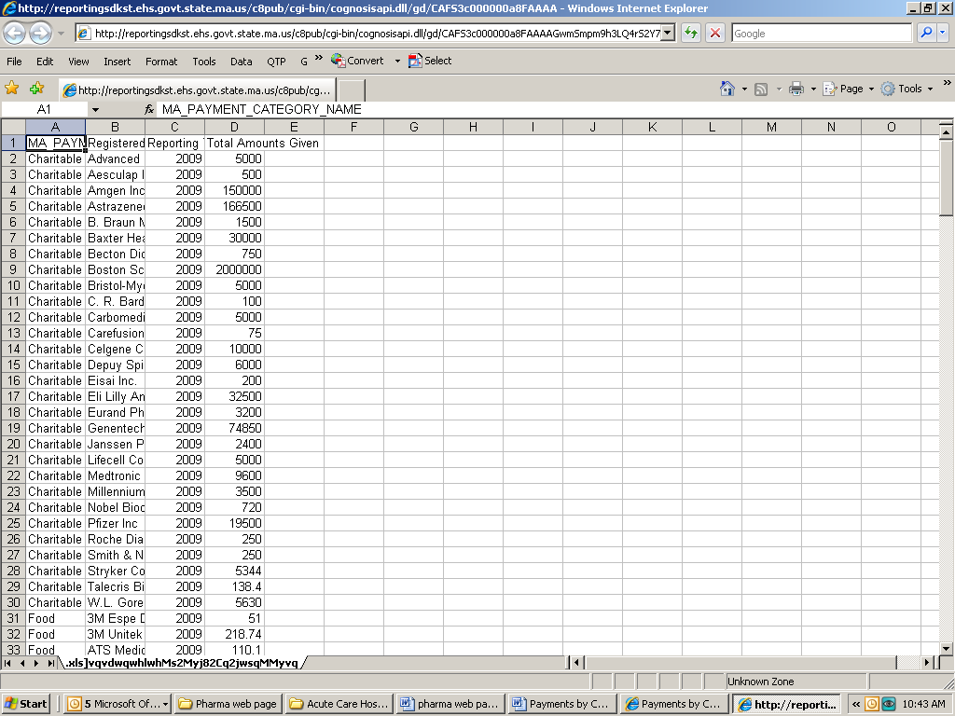

If you simply wish to view the report, but not save it, just click on the X in the upper right corner of the screen to close the window when you are done.

If you choose to save your report, click on File, then Save As and change the “file type” at the bottom of the box to .csv or .xls. This can be done by clicking in the “Save as type” box and typing the letter c, which will bring up the .csv option or m (for Microsoft Excel workbook), which will bring up .xls. Select it either by pressing “Enter” on the keyboard or clicking on it with your mouse. Make sure to rename your file before saving it.

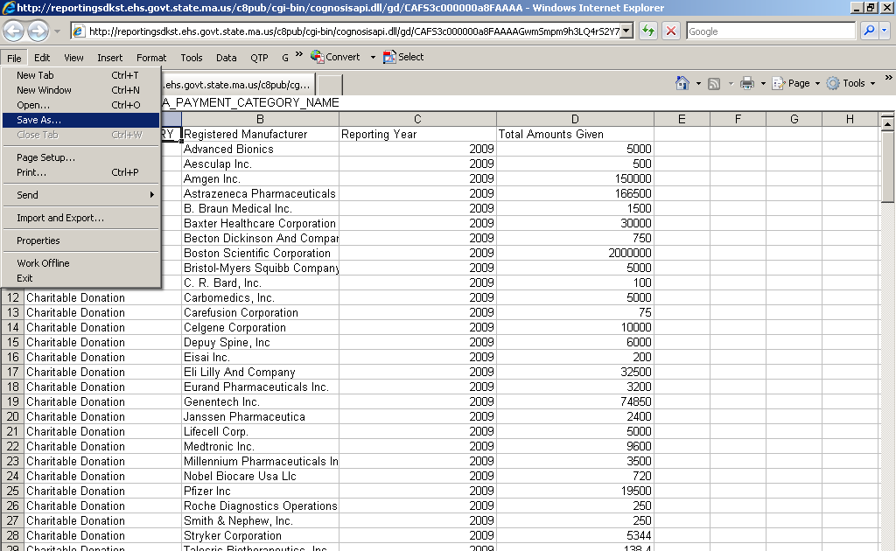

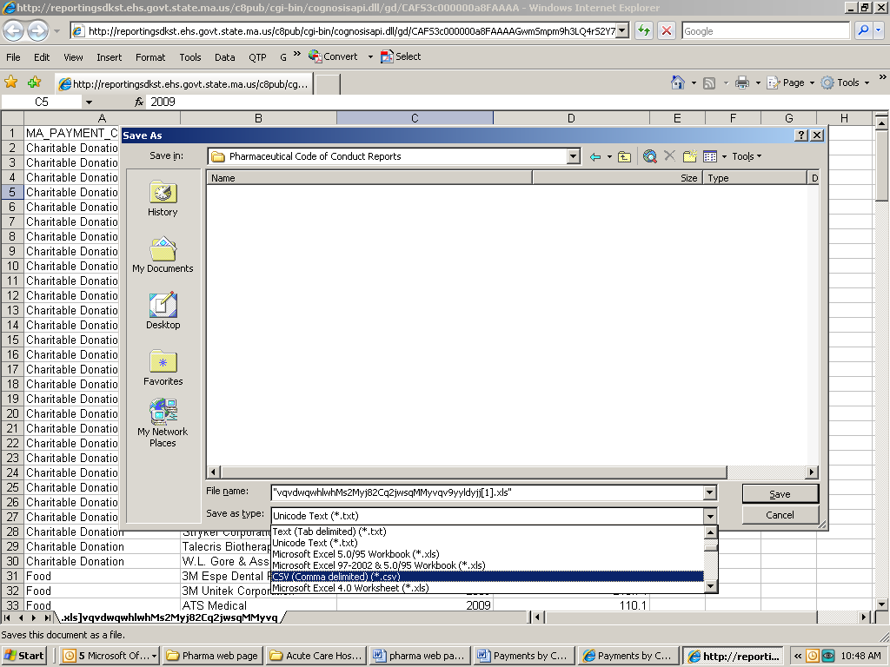
Rename the file
Choose .csv or .xls

Pop-up Blocking and Excel

Cognos, the software used to run this database, considers MS Excel a Pop-up. Therefore, the following steps must be taken in order to run and view reports in MS Excel.

- In Internet Explorer, navigate to Tools -> Internet Options, and click the Security Tab
- Highlight Trusted Sites, and click on the [Sites] button
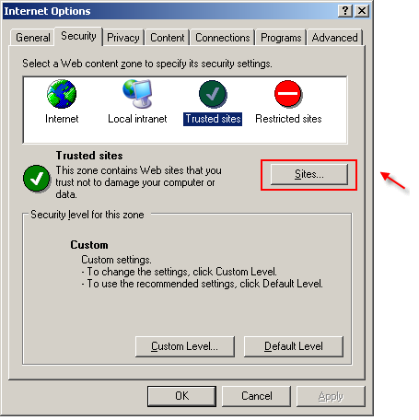

- Enter https://reporting.hhs.state.ma.us where it reads "Add this Web site to the zone"
- Click Add
- Enter https://gateway.hhs.state.ma.us where it reads "Add this Web site to the zone"
- Click Add

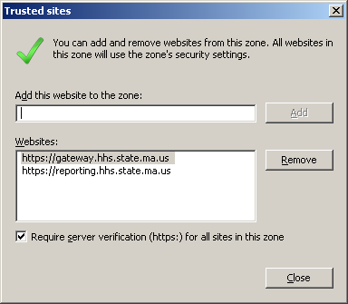

- Click ‘Close’
- Highlight Trusted Sites, and click on the [Custom level] button
- 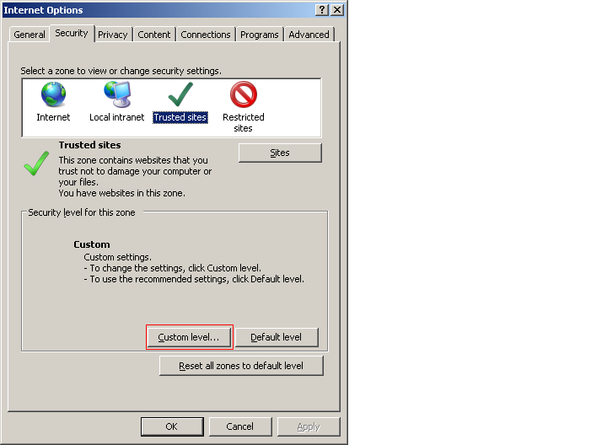
- Scroll to Downloads > Automatic prompting for file downloads and select Enable
- Click ‘OK’ twice.

