Payments Made by a Manufacturer

Important symbols used for running and viewing your report:

When viewing a report, this icon will allow you to return to the search selection screen and add to your search results
- Globe icon (HTML format) allows you to change the view format to see your report as a .pdf or .csv (spreadsheet) file
.pdf format icon
.csv (spreadsheet) format icon
Will take you completely out of the report (not back one page or to the previous screen view)

When creating a report, do not use the Back button on your browser; it will take you completely out of the report.

When you click on the link: Run Payments by Manufacturer Report on the Custom Reports page, you will see this screen containing several boxes:

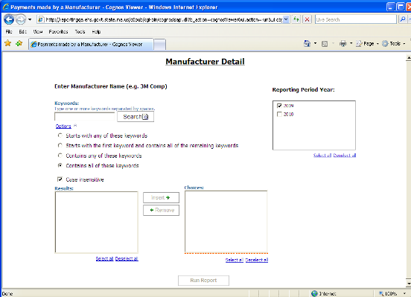

Choosing the company for which you want to run a report:

Type the name or part of a name of the company you wish to search for in the box under “Keywords”. If you are interested in searching for the maker of a particular drug, but do not know the company that makes that drug, you can use this FDA website to help find the manufacturer name: Drugs@FDA

When creating a report, do not use the Back button on your browser; it will take you out of the report.

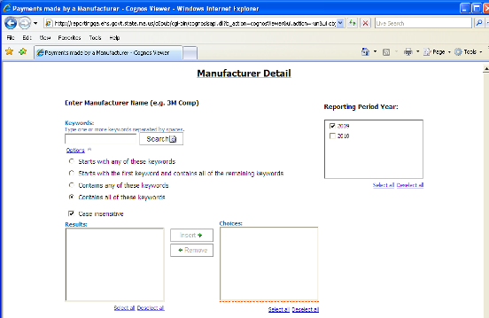

Underneath the Keywords box are “Options”, which provide instructions for how the program should search for your keyword(s). If you accept the options as they appear on the screen you will search with the default setting. The results will contain all of the keywords you have typed. The default setting is also “case insensitive”, so you do not need to capitalize the first letter of proper names. You have three other options listed for instructing the program how to search for your keywords. They are:

- Starts with any of these keywords
- Starts with the first keyword and contains all the remaining keywords
- Contains any of these keywords

If you do not want the default setting, click on the circle beside the option you prefer.

For example, you type in “ab” as a keyword and use the default options. When you click on the Search button located beside the keywords box, every company in the database that includes the letters ‘ab’ anywhere in its name appears in the “Results” box in the lower left of the page. The screen looks like this:

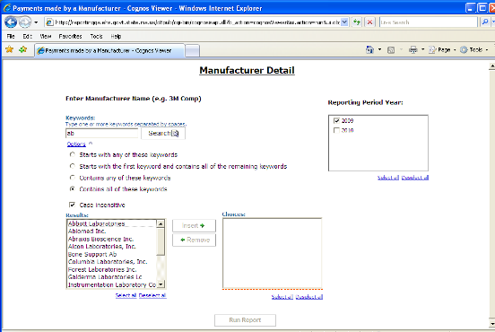

Additional results may be viewed by using the scroll bar.

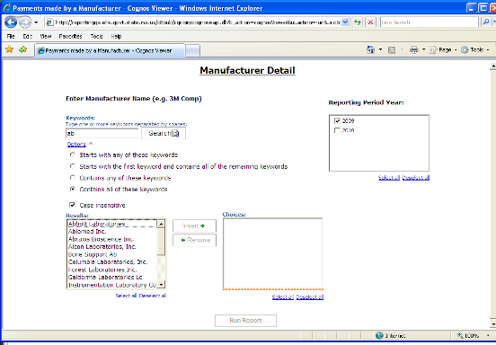

If you had chosen the Option “Starts with any of these keywords”, the results would be more limited. Only 3 results appear using that option:

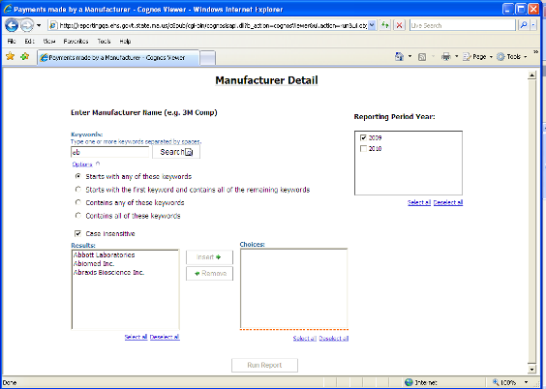

If after you enter a Keyword and select “Search” you see the following message under “Options”:
“Search complete. No results found.”
check your keyword spelling, add to your keyword(s), or change your options and select “Search” again.

For example, a search for “Astro” using the default options provides the following results:

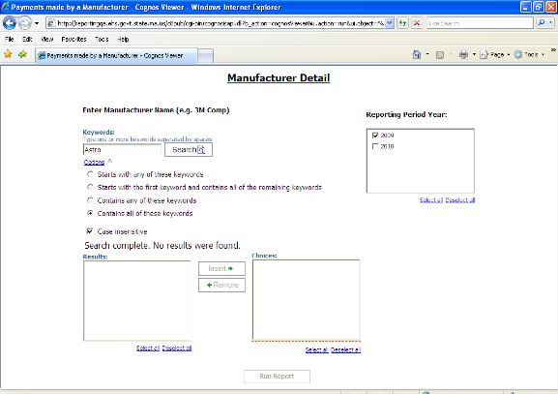

The search was completed but no results were found.
If you revise the search and, continuing with this example, enter the Keyword Astr instead of Astro, you receive three company names in the “Results” box in the lower left. Note that one of the results has “astr” in the middle of the company name. This result would not have appeared if the “Starts with any of these keywords” option had been selected.

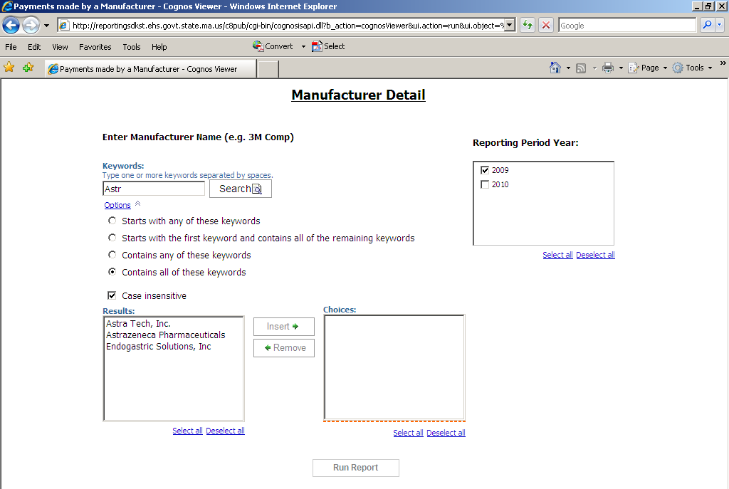

Within the Results box, showing the results of your search, select the company or companies for which you want to run a report by clicking on the name. If you wish to select more than one, hold the control (Ctrl) button on your keyboard as you click on the names. Or you can click on the “Select All” button and all the names will be highlighted.

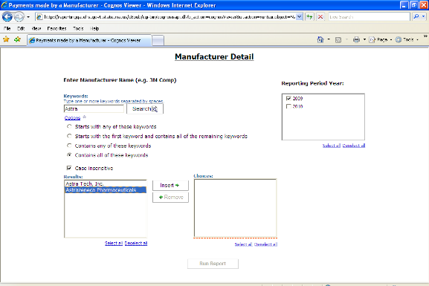

After you have selected names, you may change your selections. While holding the control (Ctrl) button, click on the highlighted names in the Results box that you want to deselect. The highlighting will disappear from those names.

Once you have decided which results to select, click on the “Insert ->” button between the “Results” and “Choices” boxes. The results that you highlighted will appear in the Choices box. You can delete a name from the Choices box by highlighting it and clicking on the “Remove” button located between the Results and Choices boxes.

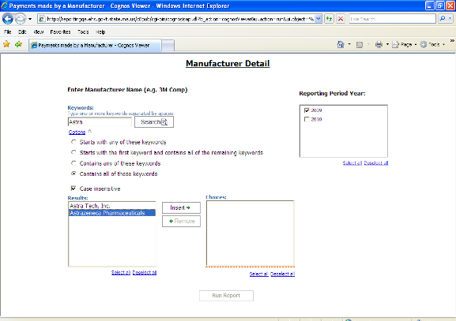

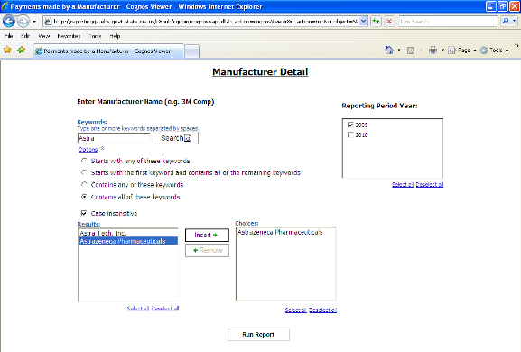

Tip: You can skip a step by double clicking on a name in the “Results” box. The name will appear in the “Choices” box without clicking on the “Insert ->” button.

Multiple searches for one report:
At this point, you can repeat these steps as many times as you like, entering different keywords, choosing the options, conducting a search and selecting the results to add to the “Choices” box. The report has not run yet.

For example: If you want to add another company to the Choices box, which now includes Astrazeneca Pharmaceuticals, you can. If you want to include Sanofi Aventis, type in “Sanofi” in the Keywords box at the top. If you use the default options, you do not need to change anything in the options section. When you click on the “Search” button beside the keyword box you will see this screen:

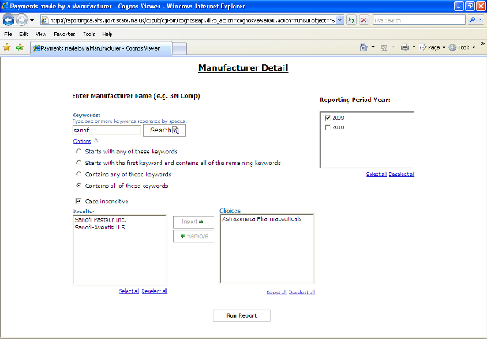

Two companies appear in the Results box. To select both of those companies and add them to your Choices, click on the “Select all” button below the box. Alternatively, you could hold the control (Ctrl) button on your keyboard and click on each company name. Both names will be highlighted.

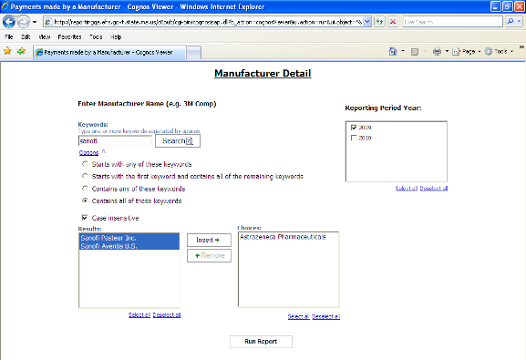

Click on the “Insert” button between the Results and Choices boxes to add those companies to your choices. The names will appear in the Choices box under the name of the company you had chosen previously (Astrazeneca).

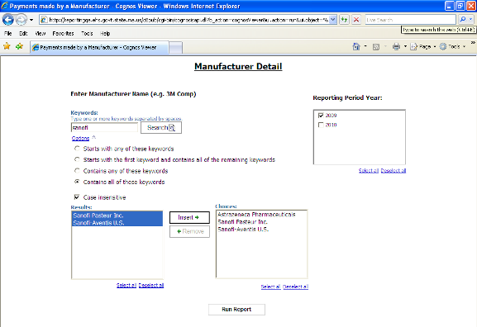

You can repeat this process until you have included in the Choices box all of the companies you wish to include in your report.

Tip: You can skip a step by double clicking on a name in the “Results” box. The name will appear in the “Choices” box without clicking on the “Insert ->” button.

“Reporting Period Year”
Select a reporting period in the “Reporting Period Year” box on the upper right. 2009 is the default selection.

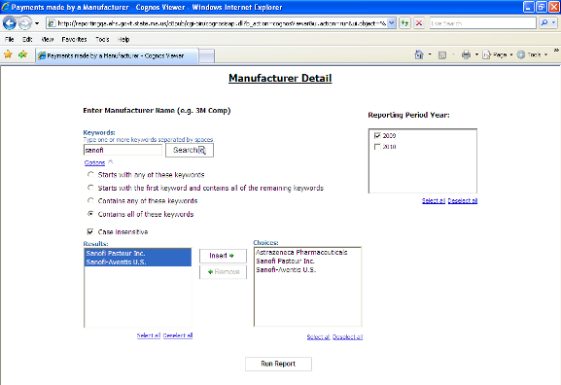

Running the Report

Once you have finished inserting your selected companies in the “Choices” box, you are ready to run your report.

Click on the “Run Report” button under the Result and Choices boxes.

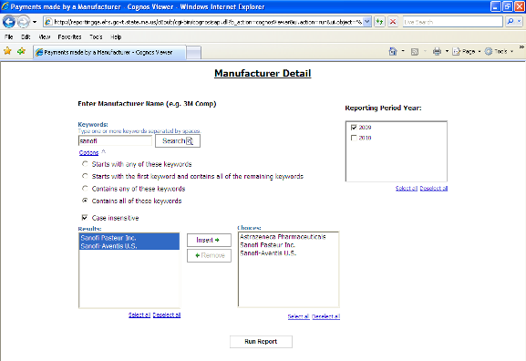

This screen will appear:

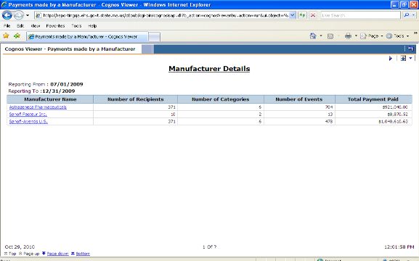

The company or companies you selected appear alphabetically in the first column on the left under “Manufacturer Name”. Across the page there are the following headings: “Number of Recipients”, “Number of Categories”, “Number of Events”, and “Total Payment Paid”. For each company, this page shows how many recipients (people, facilities or programs) the company paid, how many different types of payments were made, how many times it paid each recipient and the total dollar amount the company paid the recipient.

At this point if you would like to add a company to your search (or eliminate one), you can easily revise your search. Click on the purple triangle pointing at the globe in the upper right of the results screen. This will bring you back to the selection page where you can add or eliminate companies for your report.

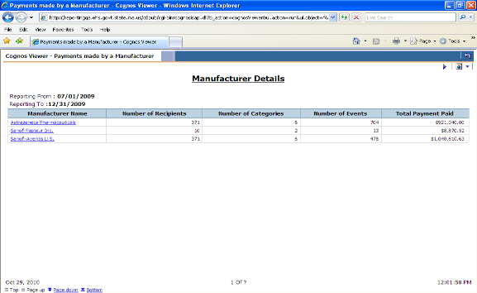

Do not click on the “left turn arrow” in the upper right corner of the page. It will take you completely out of your report and it will not take you back one page or to the previous screen view.
Do not use the Back button on your browser; it will take you completely out of the report.

A report may have multiple pages. If you want to scroll through the pages, use the “Page up” and “Page down” buttons in the lower left corner of the screen. (Our example has only one page.)

However, rather than having to click on “page up” or “page down” to view each page, we highly recommend viewing the reports in either a .pdf file or .csv file (spreadsheet) format, as it will be easier to scroll through the pages. If you are not planning to do any further analysis of the results, the .pdf format will be the easiest to use.

To view the report as a .pdf document:
- Click on the small box with a globe in it on the upper right of the white section of the screen. A box will pop up beneath the globe.
- Click on second line “View in pdf format”. A new window will open that will display your report. If an hourglass appears, wait a few seconds and it will disappear.

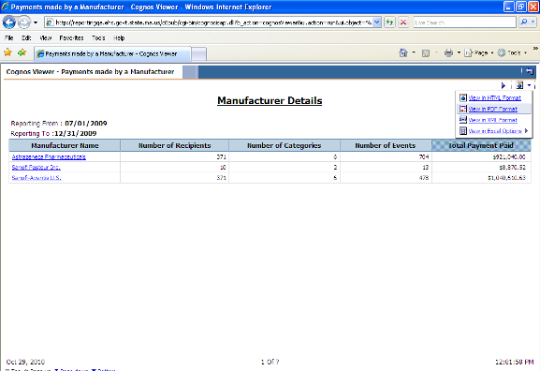

The report will look like this:

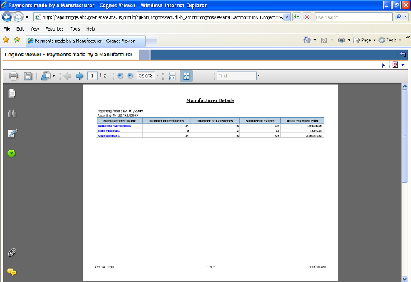

For easier viewing, you can increase or decrease the size of the image by increasing or decreasing the percent in the box in the middle of the toolbar across the top of the report. Or you can click on the “+” or “-“ signs beside that box.

In .pdf view, you can easily scroll through the pages of the report using the scroll bar along the right side of the screen or the scroll wheel on your mouse. (Our example only has one page.)

If you wish to return to the original HTML view, click on the .pdf icon in the upper right .

However, if you would like more detail about the company payments, you can find that information while still in the .pdf format (you can also find this detail when in the HTML format). Click on the company name and a new screen will appear. In our example, if you click on Astrazaneca Pharmaceuticals, a new screen will appear with the following headings: “Covered Recipient Name”, “License Type”, “Payment Categories”, “Number of Events”, and “Amounts”.
.
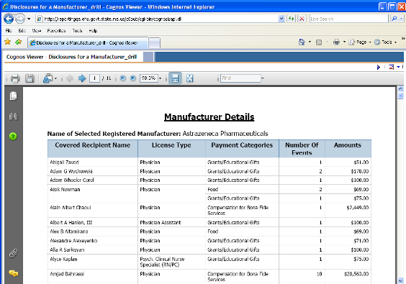

You will see each recipient, listed alphabetically by first name, what type of license the recipient holds in Massachusetts, what type of payment the recipient received, how many payments the recipient received and the total dollar amount of all payments.

For some reports, when you click on the company name for more detail you may receive a message that the company has no disclosures:

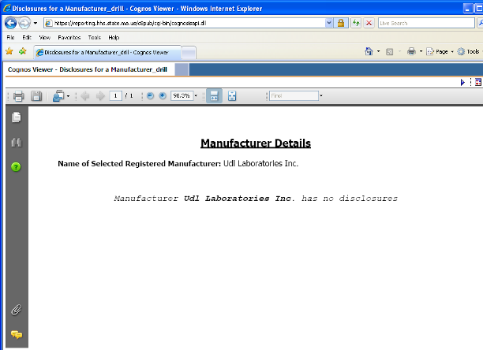

From this screen, click on the X in the upper right corner of the screen to close the detail about this manufacturer and return to the previous view containing all the results of your search.

If you simply wish to view the report, but not save it, just close the window by clicking on the X in the upper right corner of the screen when you are done.

You can save the summary and the detail reports by either clicking on the disk icon (between the printer and envelope icons) on the tool bar across the top of the report or using File -> Save As on your browser’s top menu. Each report must be saved separately.

To view the report as a .csv (spreadsheet file):
- Click on the small box with a globe in it on the upper right of the white section of the screen. A box will pop up beneath the globe.
- Move your mouse over the fourth line “View in Excel options”. Another box will pop up.
- Click on the fourth line “View in CSV format”. A new window will open that will display your report. If an hourglass appears, wait a few seconds and it will disappear.

If you have problems viewing the .csv spreadsheet, make sure your internet browser’s security setting enables pop-ups and automatic prompting for file downloads.

For pop-ups, on your browser menu click on: Tools, Pop-Up Blocker, Pop-Up Blocker Settings and add these two websites to allow pop-ups from these sites:
https://reporting.hhs.state.ma.us
https://gateway.hhs.state.ma.us

For automatic prompting for file downloads, on your browser menu click on: Tools, Internet Options, Security, Custom, Downloads - Automatic prompting for file downloads – enable, and ok.

More explicit instructions for allowing pop-ups, with screen shots, are at the end of this document.

Note: We do not recommend using the other Excel options that appear above “View in CSV format”, due to compatibility issues with some versions of certain internet browsers. The .csv file does not have these issues.

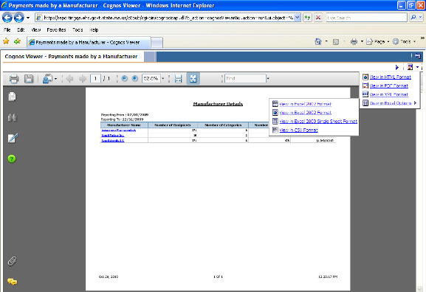

Your report will look like this. To expand the columns, move your cursor over the right side of the letter boxes until it changes. Then either double-click your mouse or hold down the left mouse button and drag it to the right until the column is as large as you would like it. Repeat this with the other columns.

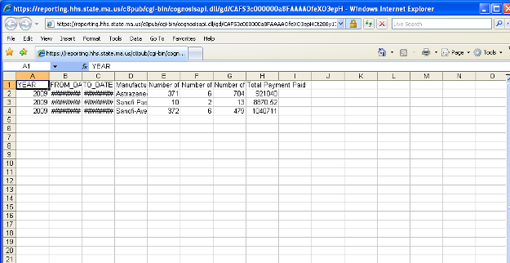

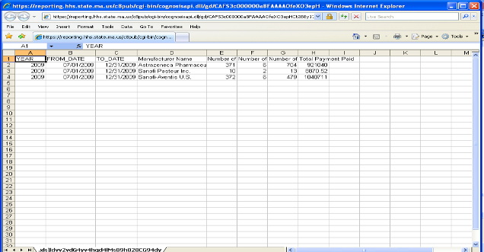

If you simply wish to view the report, but not save it, just click on the X in the upper right of your screen to close the window when you are done.

You can view the details for each company in this format as well.

If you choose to save your report, click on File, then Save As and change the “file type” at the bottom of the box to .csv or .xls. This can be done by clicking in the “Save as type” box and typing the letter c, which will bring up the .csv option. Select it either by pressing “Enter” on the keyboard or clicking on it with your mouse. Make sure to rename your file before saving it.

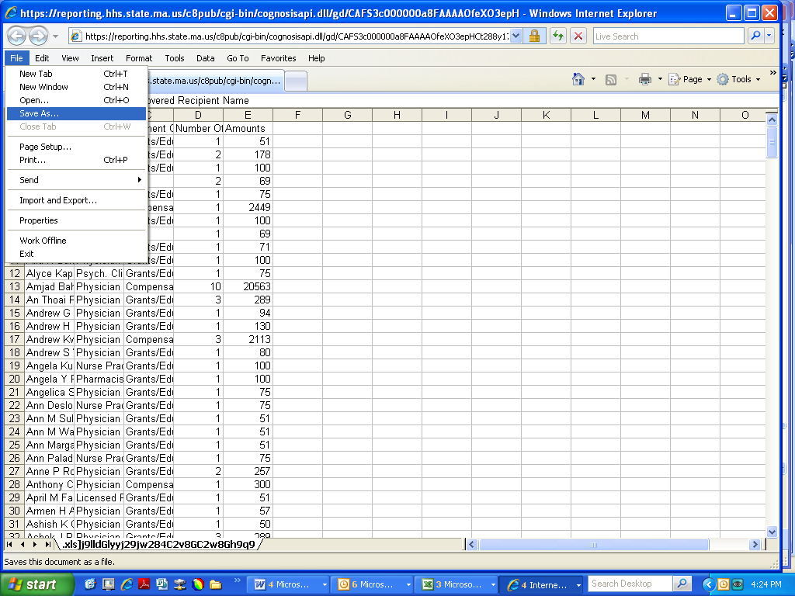

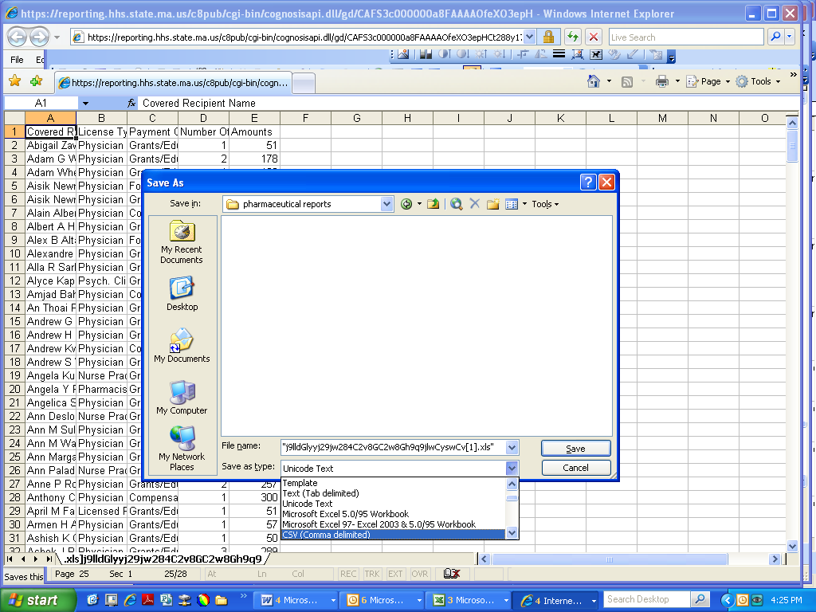
Rename the file
Choose .csv or .xls

You will need to save the summary reports and detail reports separately.

Pop-up Blocking and Excel

Cognos, the software used to run this database, considers MS Excel a Pop-up. Therefore, the following steps must be taken in order to run and view reports in MS Excel.

- In Internet Explorer, navigate to Tools -> Internet Options, and click the Security Tab
- Highlight Trusted Sites, and click on the [Sites] button
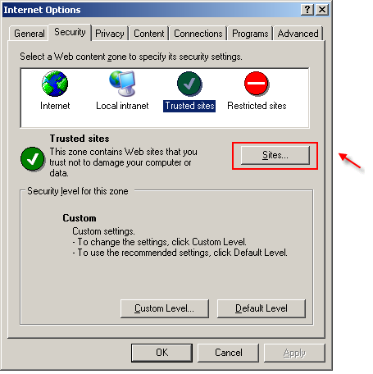

- Enter https://reporting.hhs.state.ma.us where it reads "Add this Web site to the zone"
- Click Add
- Enter https://gateway.hhs.state.ma.us where it reads "Add this Web site to the zone"
- Click Add

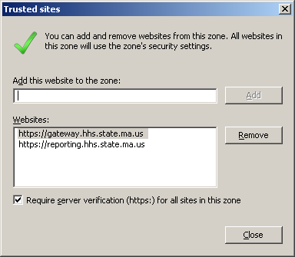

- Click ‘Close’
- Highlight Trusted Sites, and click on the [Custom level] button
- 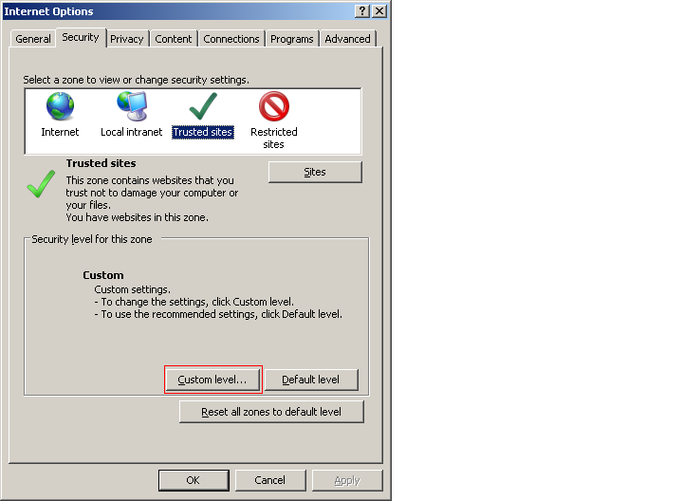
- Scroll to Downloads > Automatic prompting for file downloads and select Enable
- Click ‘OK’ twice.

