Payments Made to a Recipient

Important symbols used for running and viewing your report:

When viewing a report, this icon will allow you to return to the search selection screen and add to your search results
- Globe icon (HTML format) allows you to change the view format to see your report as a .pdf or .csv (spreadsheet) file
.pdf format icon
.csv (spreadsheet) format icon
Will take you completely out of the report (not back one page or to the previous screen view)

When creating a report, do not use the Back button on your browser; it will take you completely out of the report.

When you click on the link: Run Payments Made to Recipients Report on the Custom Report page, you will see this screen containing several boxes:

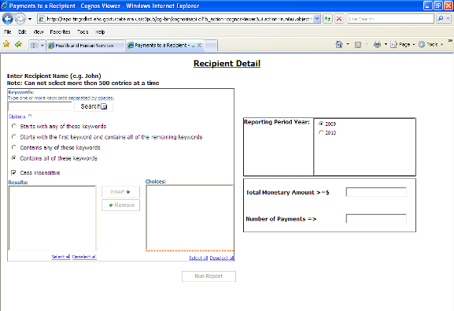

In the box on the left you will choose the Recipient for whom you want to search. In the boxes on the right you can limit your search to payments in excess of a certain dollar amount or number of payments.

When creating a report, do not use the Back button on your browser; it will take you out of the report.

Choosing the recipient for whom you want to run a report:

Type the name or part of a name of the Recipient (a person, institution or program) you wish to search for in the box under “Keywords”.

Underneath the Keywords box are “Options”, which provide instructions for how the program should search for your keyword(s). If you accept the options as they appear on the screen you will search with the default setting. The results will contain all of the keywords you have typed. The default setting is also “case insensitive”, so you do not need to capitalize the first letter of proper names. You have three other options for instructing the program how to search for your keywords. They are:

- Starts with any of these keywords
- Starts with the first keyword and contains all the remaining keywords
- Contains any of these keywords

If you do not want the default setting, click on the circle beside the option you prefer.

For example, type in “robert” as a keyword and use the default options. When you click on the Search button located beside the keywords box, every recipient in the database whose name includes robert anywhere in the name (whether as a first, middle, last name or within a longer surname, e.g., Robertson) appears in the “Results” box in the lower left of the page. The results look like this:

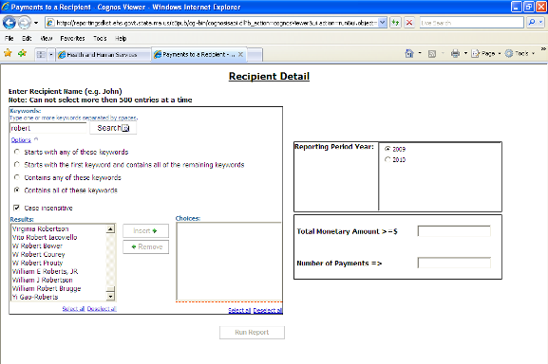

If after a “Search” you see the following message under “Options”: “Search complete. No results found.” check your keyword spelling, add to your keyword(s), or change your options and select “Search” again.

For example, we conducted a search using the keyword “Hirshfell” and the following results appeared:

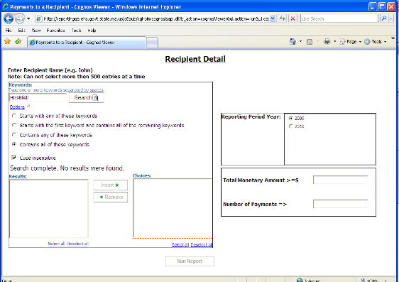

If we change one letter and conduct a search for “Hirshfeld” we receive the following results:

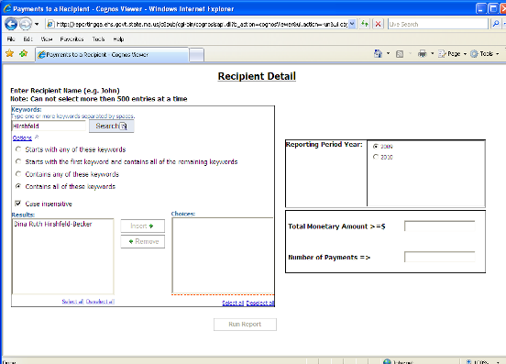

After you have conducted a search, within the Results box, you can select the recipient(s) for whom you want a report by clicking on the name(s). Hold the control (Ctrl) button on your keyboard to select more than one name. The names will be highlighted.

For example, if you conduct a search for “smith”, using the default options, you receive the following results, which appear alphabetically by first name:

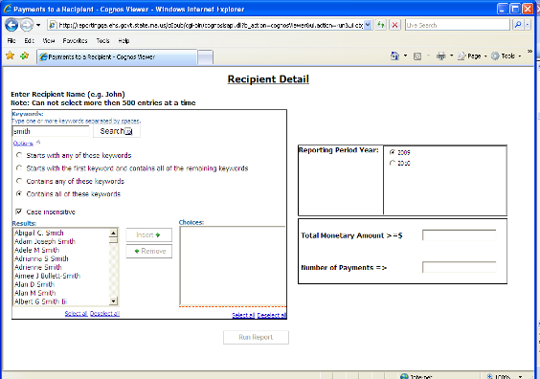

Note that if you had chosen to conduct your search with the “Starts with any of these keywords” option, you would not receive any of the recipients whose last name is Smith.

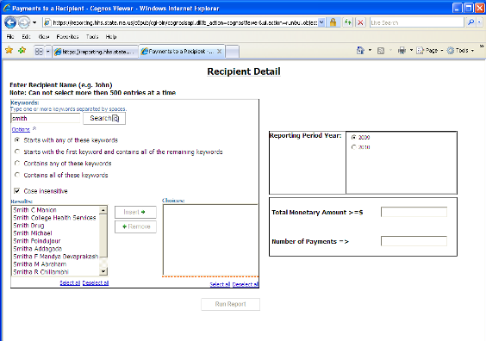

Click on the names in the “Results” box that you want to include in your report:

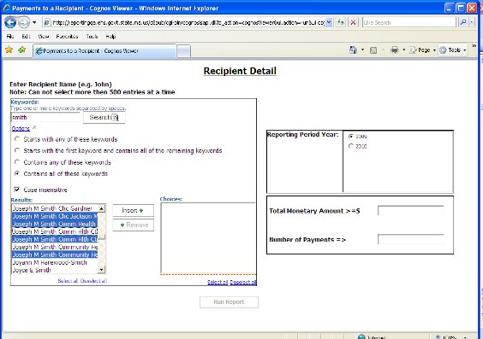

To deselect one or several of the names that you highlighted, hold the control (Ctrl) button, click on the name(s) you want to deselect and the highlighting will disappear. If you do not hold the control button, only the name you click on will remain highlighted.

You may also “Select All” of the names that appear in the results box by clicking on the “Select all” button located below the box. All of the names will be highlighted.

After you have selected names, you may change your selections. While holding the control (Ctrl) button, click on the highlighted names in the Results box that you want to deselect. The highlighting will disappear from those names.

Once you have decided which results to select, click on the “Insert ->” button between the “Results” and “Choices” boxes and the results that you highlighted will appear in the Choices box.

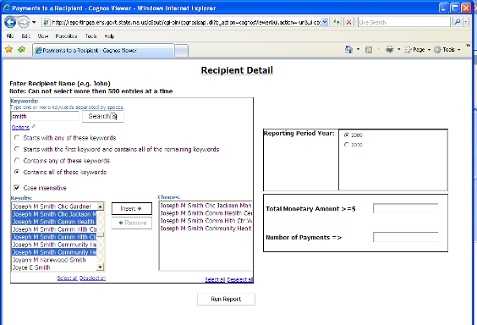

You can delete a name from the Choices box by highlighting it and clicking on the “Remove” button located between the Results and Choices boxes. You can delete all the names in the “Choices” box by clicking on “Select All” and then clicking on the “Remove” button.

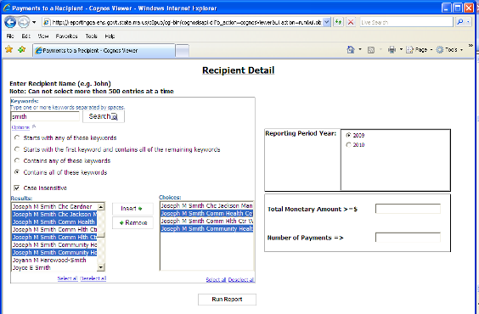

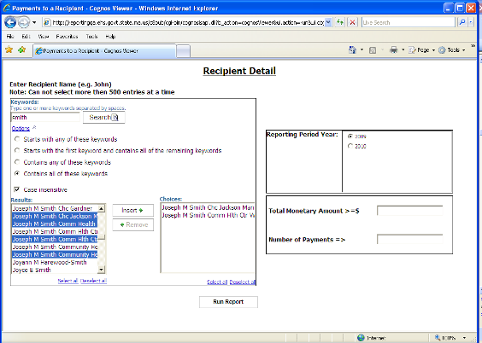

In another example, using the Keyword “Clark”, our search provided many results:

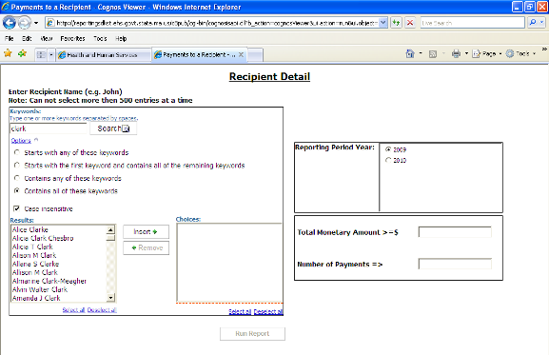

You can select all the results by clicking on the “Select all” button below the results. Or you can click on the names that you want a report for. The names will be highlighted.
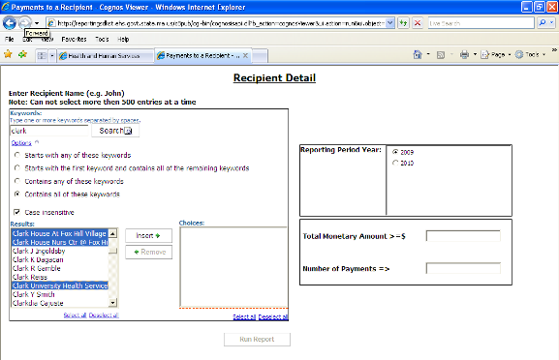
Once you have selected the results, click on the “Insert->” button between the “Results” and “Choices” boxes. The selected results will appear on the “Choices” box.

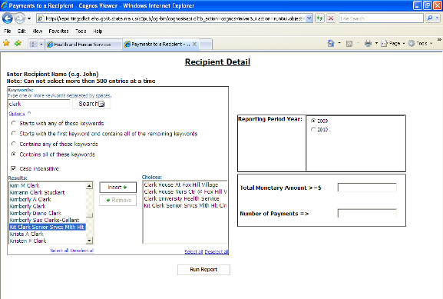

Tip: You can skip a step by double clicking on a name in the “Results” box. The name will appear in the “Choices” box without clicking on the “Insert ->” button.

Multiple searches for one report:
At this point, you can repeat these steps as many times as you like, entering different keywords, choosing the options, conducting a search and selecting the results to include in the “Choices” box. As noted at the top of the screen, there is a limit of 500 entries per report. If your search exceeds that limit you will receive one of these two messages:

1) A new screen will open that says “selection limit is exceeded, please narrow your selection”:

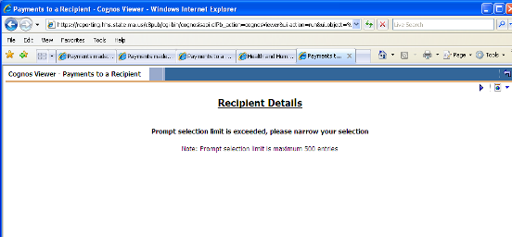

If you receive this message screen, click on the purple triangle pointing at the globe in the upper right of the screen. This will return you to the search selection screen.

Do not click on the “left turn arrow” in the upper right corner of the page. It will take you out of your report and it will not take you to the previous page or screen view.
Do not use the Back button on your browser; it will take you out of the report.

Or
2) You will see this box appear with the question, “Stop running this script?” Click on ‘yes’.

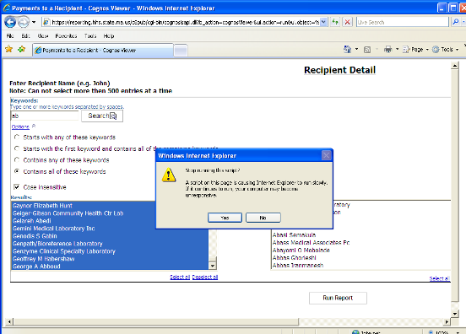
At this point you have not yet run the report.

In addition to the four choices above, you would like to add others. Return to the keyword box and conduct another search. Highlight the results that you want to include in your report. Click on the “Insert->” button and they will appear under the four names already in the “Choices” box. In our example, we want to search for Salem Hospital.

Tip: When searching for a hospital, it is better to use ‘hosp’ rather than ‘hospital’ as a keyword, in case the name is abbreviated in the database.

Using ‘salem hosp’ as keywords, the following results appear:

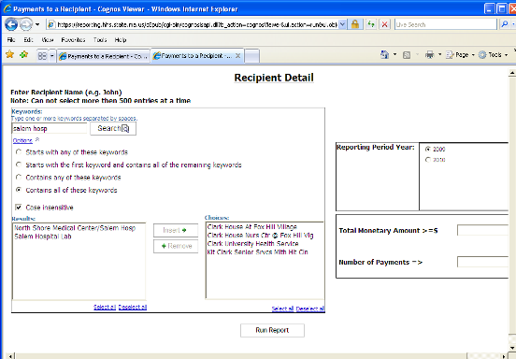

If you use the keywords ‘salem hospital’ for your search, the results do not include “North Shore Medical Center/Salem Hosp”:

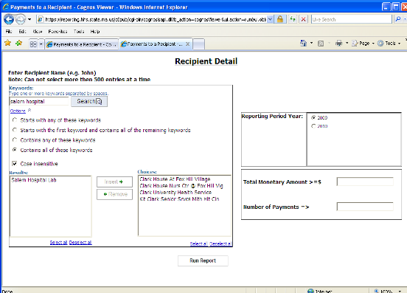

When you select the two results from the ‘salem hosp’ keyword search and click on “Insert->”, they will be added in the “Choices” box:

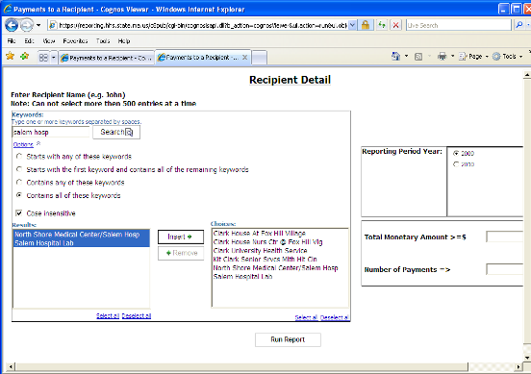

“Reporting Period Year”
Select a reporting period in the “Reporting Period Year” box on the upper right. 2009 is the default selection.

Limiting Your Results:

If you choose to run your report at this point, you will receive all results, including those recipients who received no payments. Or you can eliminate recipients who received no payments by using the additional boxes on the lower right of the screen.

Once you have selected your recipients and inserted them in the “Choices” box, you may also choose to only see results for recipients that have received payments. This can be done using the lower right box, which has two options:

- Total Monetary Amount >=$. If you enter 1 in this field, you will only be shown recipients who have total monetary amounts greater than or equal to $1. If you are interested only in recipients who have received at least a somewhat larger amount (for example, $1,000), you can enter $1,000 here and will only be shown recipients whose total monetary amounts are greater than or equal to $1,000.

- Number of Payments =>. If you enter 1 in this field, you will only be shown recipients who have at least one payment.

You can enter a number in either of these fields; you do not have to enter a number in both. If you do not enter anything in either field, your report will include the recipients who received $0.
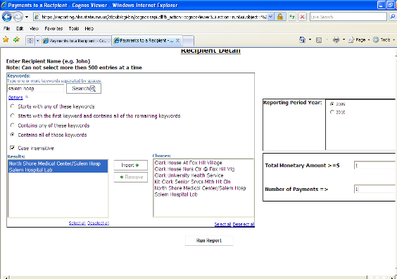

After you have selected the recipients you want to see, and defined any limits to the Total Monetary Amount or Number of Payments, click on the “Run Report” button in the lower middle of the screen. You may see an hourglass appear. Wait a few seconds and it will disappear.
Your results will then appear.

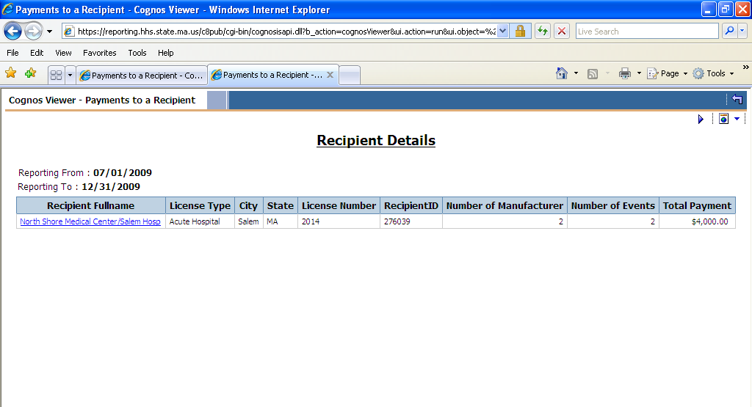

The following headings will appear across the screen: “Recipient Full Name”, “License Type”, “City”, “State”, “License Number”, “Recipient ID” “Number of Manufacturer”, “Number of Events” and “Total Payment”. In addition to the name of the recipient(s) you will see the type and number of the license the recipient holds, the city and state the recipient lives in as stated on the license (or if a facility or program, where it is located), the recipient ID number (a number assigned by the Department to the recipient for the purposes of this database), the number of manufacturers who made a payment to this recipient, the number of payments the recipient received and the total dollar amount of payments to this recipient.

If at this point you would like to choose additional recipients or eliminate some, you can easily revise your search. Click on the purple triangle pointing at the globe in the upper right of the results screen. This will take you back to the search selection screen, where you can add or eliminate recipients.

Do not click on the “left turn arrow” in the upper right corner of the page. It will take you out of your report and it will not take you to the previous page or screen view.

To continue with the above results, if you click on the recipient’s name, a new screen will appear with details of those payments. The headings include: “Manufacturer Name”, “Payment Categories”, “Number of Events” and “Payment Amount”.

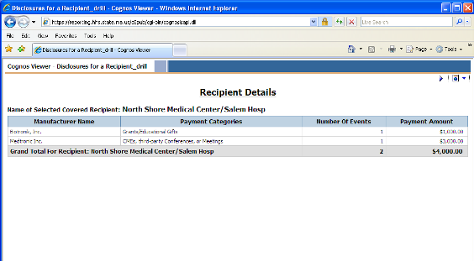

This page shows you which companies made a payment to the recipient (Salem Hospital), what type of payment, how many payments and the total dollar amount of the payments.

To close this detailed view window, click on the X in the upper right of your screen. You will return to this page listing North Shore Medical Center/ Salem Hosp as a recipient.

Running the same report, without limiting the dollar amount of payments and number of payments, provides the following results, where 6 of the 7 recipients had no disclosures:

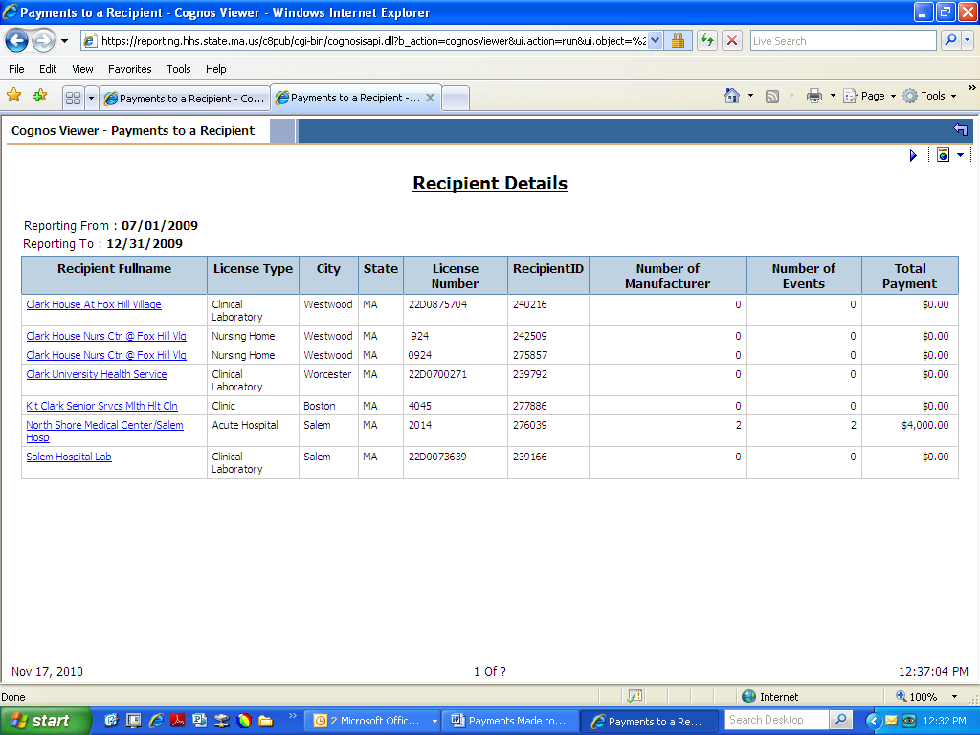

If you click on the name of a recipient who has received no payments, a new screen will appear with the message that the recipient has no disclosures, meaning no companies reported any payments to this recipient. For example, if you click on Kit Clark Senior Services, you will see this screen:

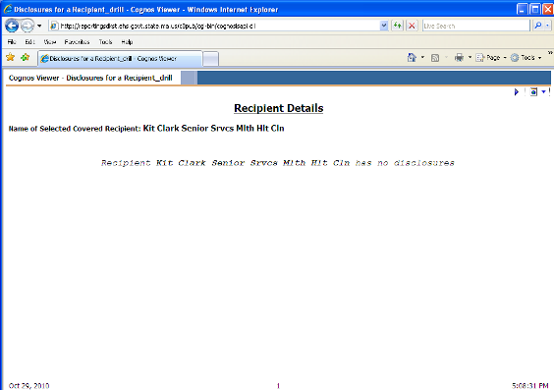

Click on the X in the upper corner of your screen to close this window and return to your search results.

A note about “No disclosures”
If you are unable to find a disclosed payment for an individual health care provider or other ‘covered recipient’, i.e., a search result indicates ‘Dr. X has no disclosures’, it means there were no disclosed payments made directly to the individual. However, a payment may be reported under a health care facility where the covered recipient works or with which the covered recipient is affiliated. Using a fictitious example:

Dr. Fine works at Get Better Hospital. A search under ‘Disclosures for a Recipient’ for Dr. Fine indicates “Dr. Fine has no disclosures”. However, a manufacturer may have disclosed payment(s) to Get Better Hospital for an event or events that Dr. Fine participated in.

We highly recommend viewing the report in either a .csv file (spreadsheet) or .pdf file format, as it will be easier to review the results. If you are not planning to do any further analysis of the results, the .pdf format will be the easiest to use.

To view the report as a .pdf document:
- Click on the small box with a globe in it on the upper right of the white section of the screen. A new box will pop up.
- Click on second line “View in pdf format”. A new window will open that will display your report. If an hourglass appears, wait a few seconds and it will disappear.

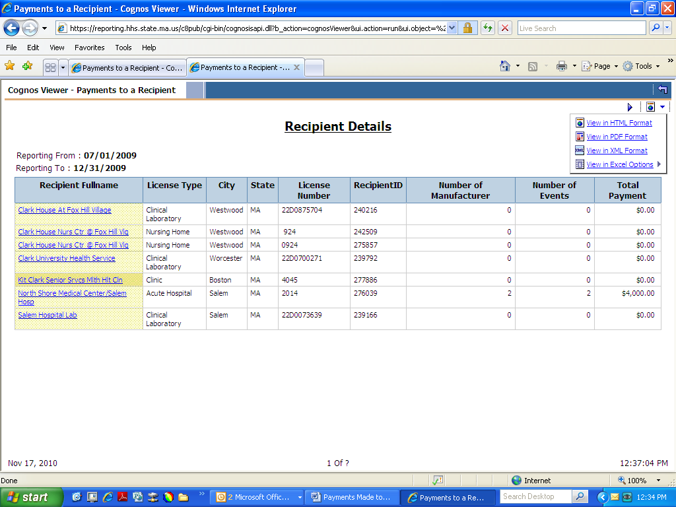
The report will look like this:

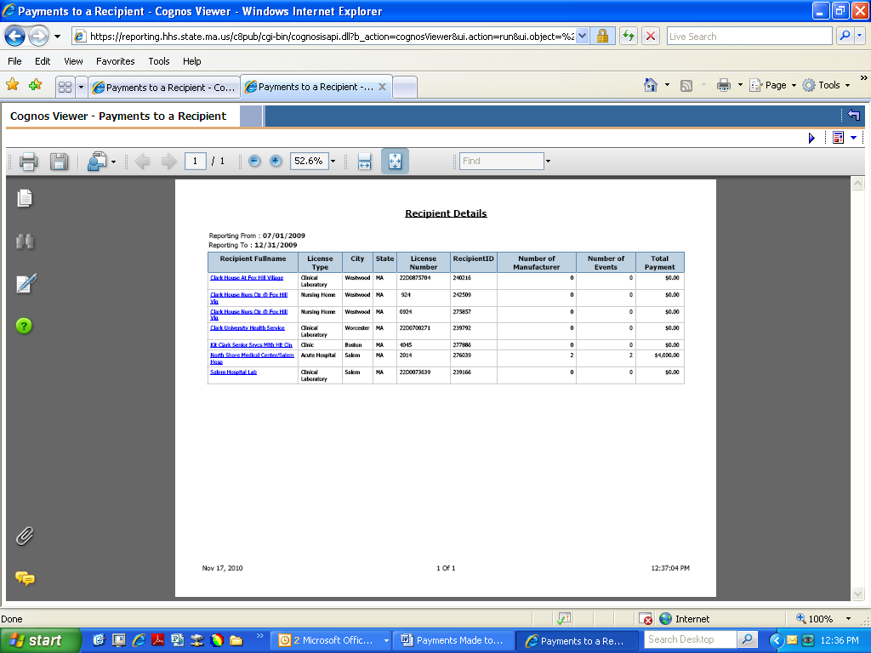

For easier viewing, you can increase or decrease the size of the image by increasing or decreasing the percent in the box in the middle of the toolbar across the top of the report. Or you can click on the “+” or “-“ signs beside that box.

In .pdf view, you can easily scroll through the pages of the report using the scroll bar along the right side of the screen or the scroll wheel on your mouse. (Our example only has one page.)

If you simply wish to view the report, but not save it, just close the window when you are done, by clicking on the X in the upper right of your screen.

To view the report as a .csv (spreadsheet file):
- Click on the small box with a globe in it on the upper right of the white section of the screen. A box will pop up.
- Move your mouse over the fourth line “View in Excel options”. Another box will pop up.
- Click on the fourth line “View in CSV format”.

If you have problems viewing the .csv spreadsheet, make sure your internet browser’s security setting enables pop-ups and automatic prompting for file downloads.

For pop-ups, on your browser menu click on: Tools, Pop-Up Blocker, Pop-Up Blocker Settings and add these two websites to allow pop-ups from these sites:
https://reporting.hhs.state.ma.us
https://gateway.hhs.state.ma.us
.
For automatic prompting for file downloads, on your browser menu click on: Tools, Internet Options, Security, Custom, Downloads - Automatic prompting for file downloads – enable, and ok.

More explicit instructions for allowing pop-ups, with screen shots, are at the end of this document.

Note: We do not recommend using the other Excel options that appear above “View in CSV format”, due to compatibility issues with some versions of certain internet browsers. The .csv file does not have these issues.

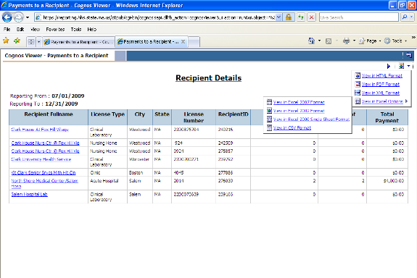

Your report will look like this. To expand the columns, move your cursor over the right side of the letter boxes until it changes. Then either double-click your mouse or hold down the left mouse button and drag it to the right until the column is as large as you would like it. Repeat this with the other columns.

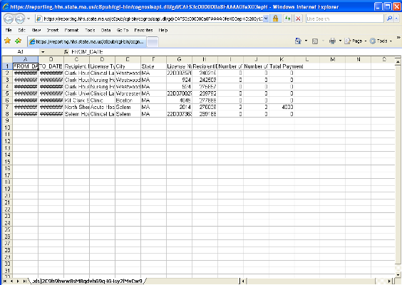

Then you will be able to see the contents of each cell.

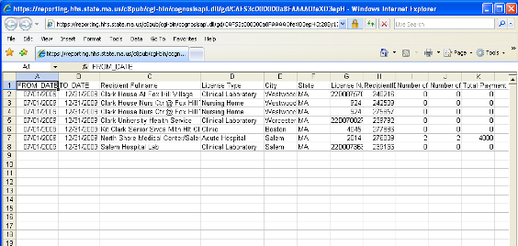

You can then save your report by going to File -> Save As and changing the “file type” at the bottom of the box to .csv or .xls. This can be done by clicking in the “Save as type” box and typing the letter c, which will bring up the .csv option and then you can select it either by pressing “Enter” on the keyboard or clicking on it with your mouse. Make sure to rename your file before saving it.

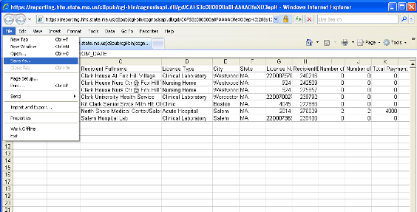

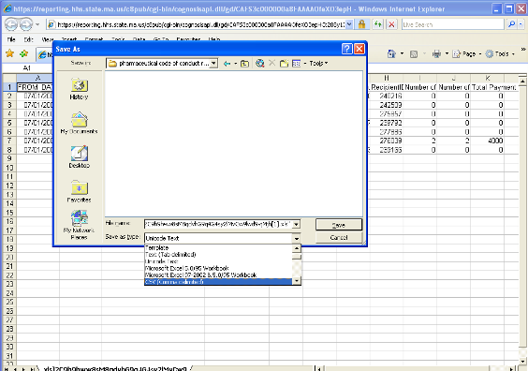
Rename the file
Choose .csv or .xls

You will need to save the summary reports and detail reports separately.
Pop-up Blocking and Excel

Cognos, the software used to run this database, considers MS Excel a Pop-up. Therefore, the following steps must be taken in order to run and view reports in MS Excel.

- In Internet Explorer, navigate to Tools -> Internet Options, and click the Security Tab
- Highlight Trusted Sites, and click on the [Sites] button
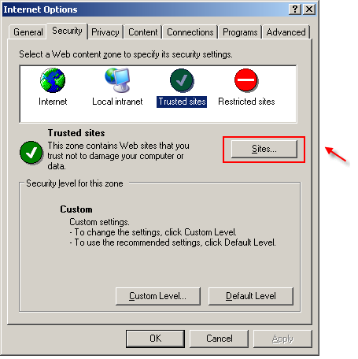

- Enter https://reporting.hhs.state.ma.us where it reads "Add this Web site to the zone"
- Click Add
- Enter https://gateway.hhs.state.ma.us where it reads "Add this Web site to the zone"
- Click Add

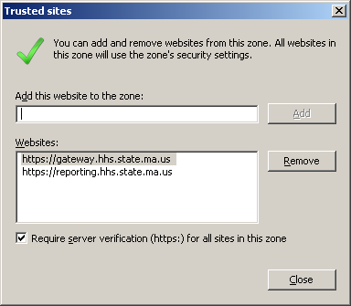

- Click ‘Close’
- Highlight Trusted Sites, and click on the [Custom level] button
- 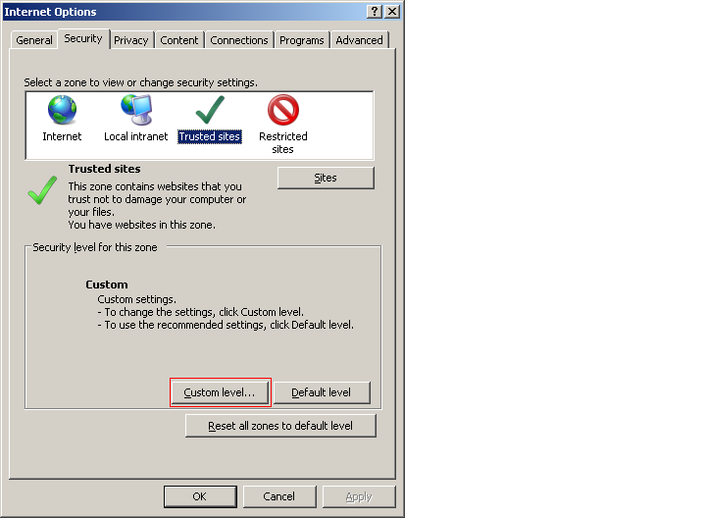
- Scroll to Downloads > Automatic prompting for file downloads and select Enable
- Click ‘OK’ twice.

