 | Massachusetts Department of Environmental Protection  Bureau of Resource Protection – Drinking Water  Determination of Threat to Public Water Supplies Due to Beaver and Muskrat  Massachusetts General Law Chapter 131 Section 80A
 | A. General Information
Important:  When filling out forms on the computer, use only the tab key to move your cursor - do not use the return key.  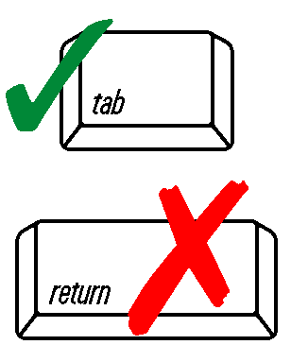 | 1. Applicant:
 | Applicant | E-mail Address
 | Mailing Address
 | City/Town | State |  |  | Zip Code
 | Phone Number | Fax Number (if applicable)
 | 2. Contact:
 | Name | E-mail Address
 | Mailing Address
 | City/Town | State |  |  | Zip Code
 | Phone Number | Fax Number (if applicable)
 | 3. Project Information:
 | Town | Public Water Supply (PWS) Name |  |  | PWS ID Number
 | Impacted Source Name | Impacted Source ID Number |  |  | Application Date
 | B. Request for Determination
 | Explain why the request for determination has been submitted (include information on control mechanisms already used and identify any changes in water levels or flow path). Attach additional information if needed.
 | Duration of Problem |  | Proposed Duration of Control
 | C. Site of Beaver and/or Muskrat Presence
 | 1. Location of effected areas where determination is requested. Attach a map identifying location of affected area.
 | 2. Is the presence in a previous Division of Fisheries and Wildlife sanctioned pathogen control zone?
 | Yes No
 | 3. Is the presence in a terminal reservoir or tributary within 400 feet of a terminal reservoir?
 | Yes No
 | 4. Is the presence within 400 feet of a PWS well or wellfield?
 | Yes No
 | 5. Is the presence within 200 feet of a PWS pump station?
 | Yes No
 | 6. Does the attached map show the location of effected area(s) and potentially impacted PWS sources or pump stations?
 | Yes No
 | 7. Are water quality results attached to demonstrate water quality degradation of the PWS?
 | Yes No
 | If yes, what parameters are being used?
 | D. Proposed Method for Eliminating Threat
 | 1. Will traps be used?
 | Yes No
 | If yes, specify the type of trap:
 | D. Proposed Method for Eliminating Threat (cont.)
 | 2. Will dams be breached with this request?
 | Yes No
 | If yes, please explain the work proposed?
 | 3. Will non-lethal management or water-flow devices be used?
 | Yes No
 | If yes, please provide more detail on what will be used?
 | Please attach additional information, if necessary.
 | E. Signature and Submittal Requirements
 | “I hereby certify that the information submitted in this application is true and accurate to the best of my knowledge.”
 | Signature |  |  | Date
 | Please submit the application to your appropriate DEP regional office (see http://www.mass.gov/dep/about/region/findyour.htm).

