Determining if an Individual Lives in a High-Poverty Area Based on Their Street Address.
There are two steps to this—first determining the Census tract in which the street address is located, and second determining the poverty rate of the Census tract. This will work with either a Microsoft Edge or Google Chrome browser.
1. For the first step of determining the Census tract in which the street address is located, click on https://geocoding.geo.census.gov/geocoder/geographies/address?form. There will be two choices: Find Locations Using… and Find Geographies Using… We want use the second choice Find Geographies, but Find Geographies is not clickable. Rather, under Find Geographies Click on Address.
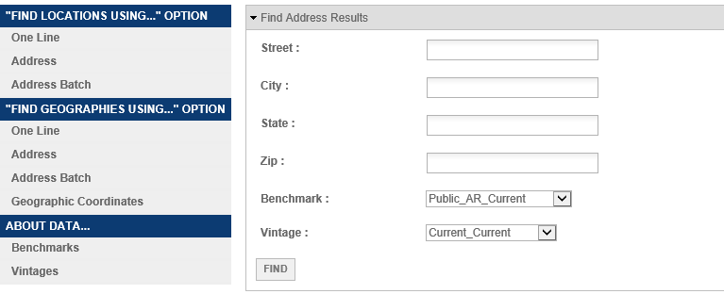

2. Type in the street address, city, and state. You don’t need to type in the zip code. The click on Find.
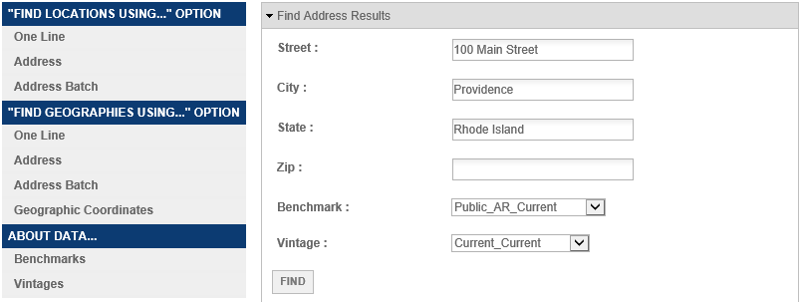

3. A list of geographic identifiers will appear by state, Census Block, County, and Census Tract. Scroll down to the list of geographic identifiers by Census Tract. In the middle of the information for Census Tracts there will be listed Name. This will give the Census tract number of the street address. The name of a Census Tract is its number.
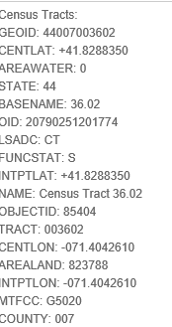

Sometimes it will not scroll down all the way to Census Tracts and you will get an error message that “Layer Query encountered an error, missing required element for GEO Look-up.” In which case all that you need to do is go back up to the top and there are dropdown menus for Benchmark and Vintage. Use the dropdown menus to change the Benchmark one step down to Public_AR_ACS2019. This will automatically change the Vintage to Current_ACS2019. Then click on Find and the Census Tract information will be available when you scroll down.
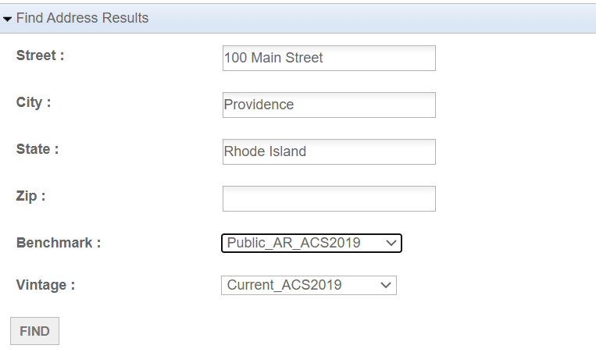

4. For the second step of determining the poverty rate of the Census tract, Go to: https://www.census.gov/acs/www/data/data-tables-and-tools/narrative-profiles/
5. There will options to select from various geographic types. Select Census Tracts and then select your state from the dropdown menu.
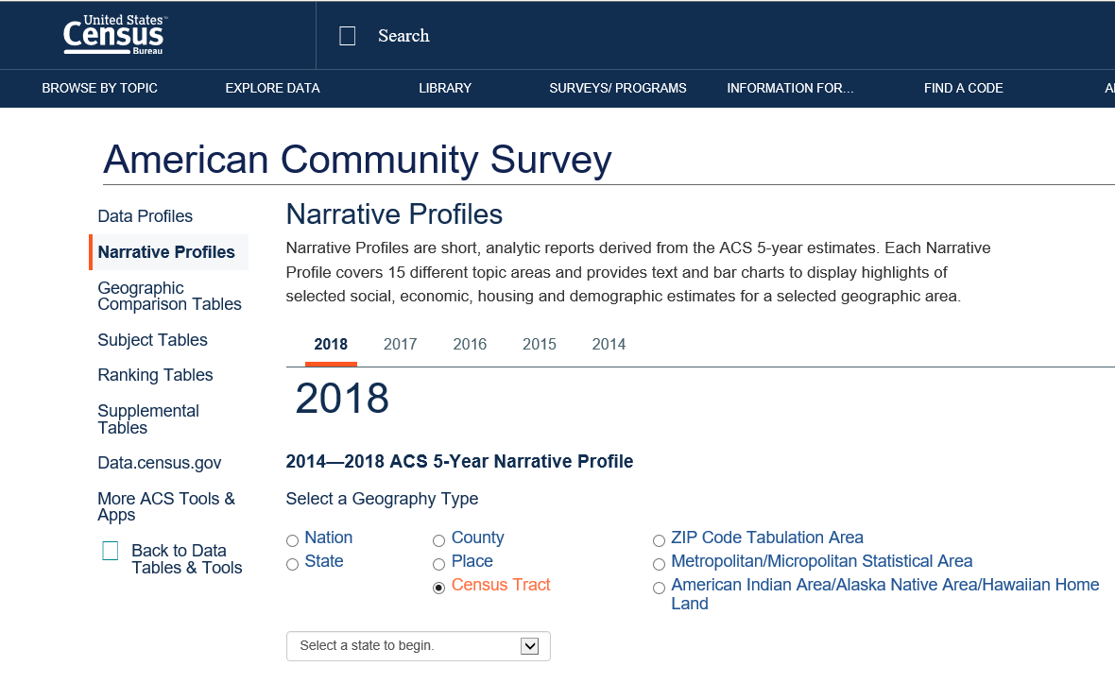
6. After you have selected your state you will then be asked to select your county, and then to select the Census tract within the county.
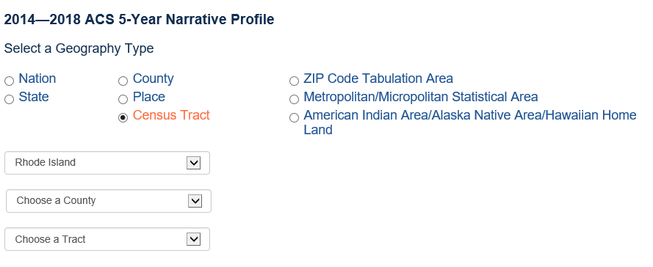
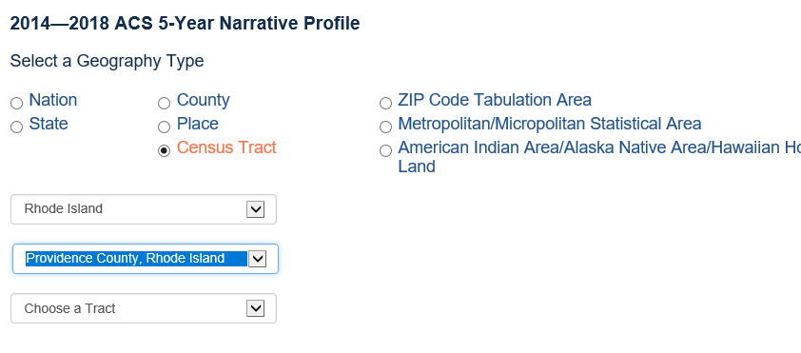
7. Once you have selected the Census Tract click on Get Narrative Profile in the green border. It will take about 10 seconds for the Narrative Profile to load.
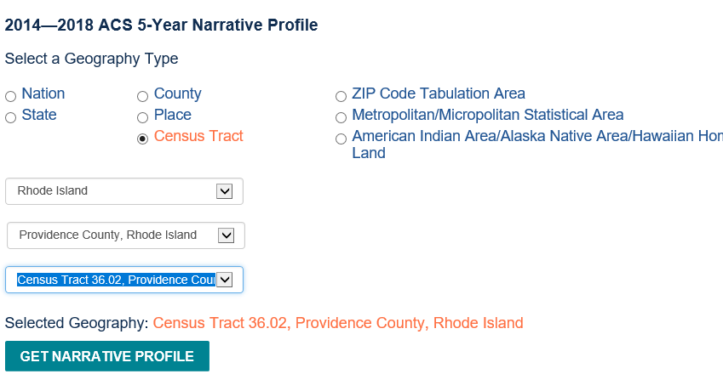
8. Once the Narrative Profile loads, scroll down to Poverty and Participation in Government Programs to see the Poverty Rate. Use the Poverty Rate shown first, People in Poverty.
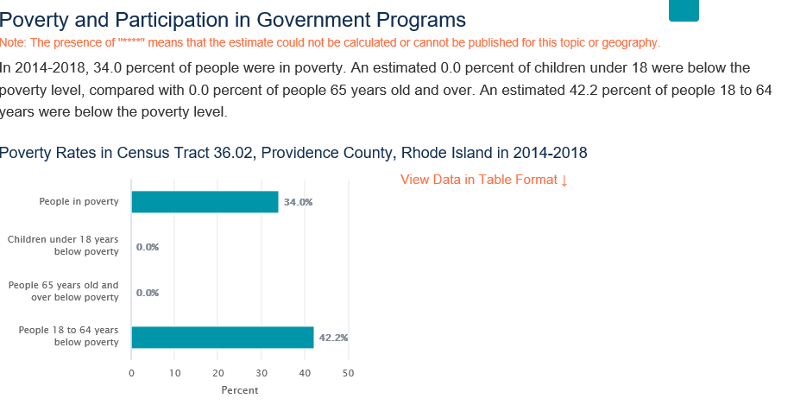
9. If the Census does not recognize the street address, you can get a map of Census Tracts of your county in Massachusetts by going to https://www2.census.gov/geo/maps/dc10map/tract/st25_ma/

o

