INDOOR AIR QUALITY ASSESSMENT

**DEVENS TOWN OFFICES**

33 Andrews Parkway

Devens, MA

**March 2025**

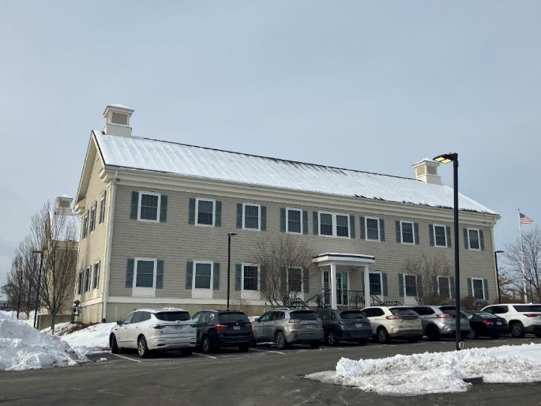

Prepared by:

Massachusetts Department of Public Health

Bureau of Climate and Environmental Health

Division of Environmental Health Regulations and Standards

Contents

EXECUTIVE SUMMARY 3

BACKGROUND 3

RESULTS AND DISCUSSION 4

Ventilation 4

HVAC System Maintenance 5

HVAC Types and Specific Conditions 6

Water Damage and Moisture Concerns 6

Sources of Respiratory Irritants/Possible Asthma Triggers 7

CONCLUSIONS AND RECOMMENDATIONS 8

REFERENCES 11

PICTURES 12

Ventilation Pictures 12

Water Damage pictures 14

Respiratory Irritants pictures 18

Table 1 23

Table 2A 28

Table 2B 29

Table 2C 30

Table 3 31

Table 4 33

# EXECUTIVE SUMMARY

The Massachusetts Department of Public Health’s (MDPH) Division of Environmental Health Regulations and Standards (EHRS) conducted an Indoor Air Quality (IAQ) assessment of the Devens town offices located at 33 Andrews Parkway, on February 11, 2025. This assessment was requested by the Mass Development Offices.

Any building can have IAQ issues. These issues can worsen through conditions common to marginalized communities (Environmental Justice communities or EJ) such as inequitable exposure to outdoor air pollution and a greater likelihood of poor building conditions leading to deterioration of IAQ, resulting in higher asthma rates. Devens town offices are located in Harvard, MA in a portion that contains EJ communities (<https://matracking.ehs.state.ma.us/Environmental-Data/ej-vulnerable-health/environmental-justice.html>).

The assessment was conducted by evaluating several key elements within the office building: a visual inspection of the heating, cooling, and ventilation (HVAC) systems, water/microbial damage, cleanliness, point sources of respiratory irritants such as chemicals, and electronic measurement of carbon dioxide (CO2), carbon monoxide (CO), temperature, relative humidity (RH), and small particulate matter (PM2.5), all taken with a Qtrak XP monitor. Data collected in this manner identifies potential asthma triggers, allergens, and other environmental factors that can cause IAQ symptoms. Please refer to the [Indoor Air Quality Manual](https://www.mass.gov/lists/indoor-air-quality-manual-and-appendices#indoor-air-quality-manual-) on the MDPH website for methods, sampling procedures, and interpretation of results.

As a result of this assessment, a number of primary recommendations are made to optimize existing systems and improve air exchange. (Conclusions and Recommendations)

* The fan setting on thermostats should be set to ON, instead of AUTO for continuous air distribution and to allow the filters to trap more dust and particles continuously circulating in the air.
* Remove vegetation from the outside of the building to allow walls to dry and reduce odors and potential pest harborage.
* Reduce clutter, including excess paper and other stored items. Move items periodically to allow for adequate cleaning.

(Conclusions and Recommendations)

Please note: this report contains a series of recommendations that should serve as Best Practices that apply to most buildings across the Commonwealth.

# BACKGROUND

|  |  |
| --- | --- |
| Building: | Devens Town Offices |
| Address: | 33 Andrews Parkway, Devens, Massachusetts |
| Reason for Request: | General indoor air quality (IAQ) issues |
| Date of Assessment: | February 11, 2025 |
| Massachusetts Department of Public Health/Bureau of Climate and Environmental Health, **Division of Environmental Health Regulations and Standards** (MDPH/BCEH/EHRS) Staff Conducting Assessment: | Ruth Alfasso, Environmental Engineer,  and Bharathi Patimalla-Dipali, Environmental Analyst, Division of Environmental Health Regulations and Standards |
| Building Description: | The Devens town offices are in large multiple story building with a brick façade that was built in the early 2000s. |
| Windows: | Windows in the building are openable. |

# RESULTS AND DISCUSSION

The following is a summary of indoor air testing results (Table 1)

|  |  |  |
| --- | --- | --- |
| * ***Carbon dioxide (CO2)*** | *a measure of the adequacy of ventilation* | Levels were mostly below the MDPH guideline of 800 parts per million (ppm), but some areas on the second floor were slightly above, indicating that these areas could use more fresh air. |
| * ***Temperature*** | *a measure of comfort* | Was within or close to the MDPH recommended range of 70°F to 78°F in occupied areas. |
| * ***Relative humidity*** | *a measure of comfort and, when in excess for an extended period, a way to reflect the potential for mold and fungal growth* | Was well below the MDPH recommended range of 40 to 60% in all areas tested. This is reflective of the current outdoor conditions and indoor heating. Relative humidity would be expected to be higher during hot, humid weather. Very low relative humidity can lead to irritation of skin or mucous membranes. |
| * ***Carbon monoxide***   ***(CO)*** | *a product of combustion that can result in acute and long term cardiovascular, respiratory, and neurological symptoms* | Levels were non-detect (ND) in all areas tested. |
| * ***Particulate matter (PM2.5)*** | *a way to measure inhalable particle distribution in the air* | Concentrations were non-detect (ND), in almost all areas tested and below the National Ambient Air Quality Standard (NAAQS) for PM2.5 of 35 micrograms per cubic meter (μg/m3) in all areas. |

## Ventilation

A heating, ventilating, and air conditioning (HVAC) system has several functions. First, it provides heating and, if equipped, cooling. Second, it is a source of fresh air. Finally, an HVAC system will dilute and remove normally occurring indoor environmental pollutants by not only introducing fresh air but also filtering the airstream and ejecting stale air to the outdoors via exhaust ventilation. Even if an HVAC system is operating as designed, point sources of respiratory irritation may exist and affect symptoms in sensitive individuals. The following analysis examines and identifies components of the HVAC system and likely sources of respiratory irritant/allergen exposure due to water damage, aerosolized dust, and/or chemicals found in the indoor environment.

Fresh air to this building is provided by air handling units (AHUs) located on the roof. Air from the AHUs is filtered, heated/cooled, and delivered to rooms via ducted supply vents (Picture 1). Air is drawn through exhaust vents (Picture 2) to be removed from the building.

The ventilation system should be on and operational to supply fresh air continuously during occupied periods. Without adequate fresh air supply and removal of stale air, common indoor air pollutants can build up and cause irritation. It is recommended that HVAC systems be re-balanced every five years to ensure adequate air systems function (SMACNA, 1994). It is not known when the last time these systems were balanced.

**Balancing**

To have proper ventilation with a mechanical supply and exhaust system, a system must be balanced to provide an adequate amount of fresh air to the interior of a room while also removing stale air from the room. It is recommended that HVAC systems be re-balanced every five years to ensure adequate air systems function (SMACNA, 1994).

Thermostats were present in various locations (Picture 3). As shown in Picture 3, thermostats were set to the “auto” or automatic setting. Thermostats should be set to have the fan *on* during occupied periods regardless of temperature settings. When the fan is set to *on,* the system provides a continuous source of air circulation and filtration. The *automatic* setting on the thermostat activates the HVAC system at a preset temperature. Once the preset temperature is reached, the HVAC system is deactivated. Therefore, no mechanical ventilation would be provided until the thermostat reactivates the system. Nights and weekends, temperature and ventilation setbacks can be used to save energy when the building is unoccupied.

The windows in the building are openable and in good condition. They can be used for additional fresh air during temperate weather, but should be closed during heavy rain, deep cold, or when the air conditioning is operating in the room.

The various types of ventilation components as well as devices that can move/redirect airflow that were identified in the building are listed in Table 2A, Table 2B and Table 2C.

### HVAC System Maintenance

* MDPH recommends that filters of at least a Minimum Efficiency Rating Value (MERV) 8 be used in the AHUs as these are adequate to filter out pollen, mold, and similar particulates (ASHRAE, 2012). MDPH recommends that filters be changed two to four times a year or as per the manufacturers’ recommendations. It was reported that the building AHU filters are replaced at a minimum of twice per year.

### HVAC Types and Specific Conditions

(see Ventilation pictures)

**Additional HVAC Conditions:**

* **Air purifiers** were found throughout the office space (Picture 4). High-efficiency particulate arrestance (HEPA) air purifiers remove up to 99% of airborne contaminants as small as 0.1 microns including airborne mold spores. These are good choices for use in occupied areas. Air purifiers that may produce ozone should not be used (EPA, 2003). All air purifiers should be cleaned and maintained in accordance with manufacturers’ instructions. They should also be placed away from walls and open doors to ensure proper air intake.
* **Electric radiators were found in some offices** (Picture 5) to provide additional heating. These work best if the space in front is free of obstructions, and need to be kept clean, or heated dust and debris can cause odors.

## Water Damage and Moisture Concerns

Please note that the MDPH does not recommend conducting mold testing in a typical water damage remediation. For details, please consult [Guidance Regarding Testing for Mold in Water-Damaged Public Buildings](https://www.mass.gov/info-details/guidance-regarding-testing-for-mold-in-water-damaged-public-buildings) | Mass.gov

The application of a mildewcide to moldy porous materials is not recommended.

Molds are found naturally in our environment both indoors and outdoors. Inside, mold growth may occur when items, particularly porous products such as paper or gypsum wallboard, are exposed to moisture. Typical water sources include leaks, floods, and condensation. To avoid mold growth, dry all water-damaged items and affected areas within 24-48 hours and reduce indoor humidity. Some people with chronic respiratory conditions, such as asthma, are more likely to experience health symptoms associated with molds, including allergic reactions and respiratory irritation. Controlling moisture is the key to preventing mold growth and potential health symptoms.

**Mold Growth**

Porous materials (e.g., gypsum wallboard, ceiling tiles and carpeting) can be dried with fans and heating within 24 to 48 hours of becoming wet (US EPA, 2008).

If porous materials are not dried within this time frame, mold growth may occur.

Hot humid summers are becoming more frequent due to climate change. Massachusetts has experienced hot, humid, and rainy summers in 2018, 2021, and 2023. July of 2021 was the wettest ever recorded in Massachusetts, and the three-month period from June through August, known as the meteorological summer, was the fourth wettest on record, according to the National Oceanic and Atmospheric Administration’s (NOAA) Centers for Environmental Information (NOAA, 2021). The summer of 2023 was also hot, and wet, being measured as the second rainiest on record (WBUR, 2023). The summer of 2024 has also had significant stretches of hot, humid weather. These conditions are challenging for buildings, particularly those without central air conditioning.

During these hot and wet summers, extended periods of outdoor relative humidity above 70% occurred. Under this weather, public buildings experienced extended periods of water vapor exposure from high relative humidity. When exposed to these conditions, porous materials such as gypsum wallboard, cardboard, and other materials may become prone to developing mold colonization, particularly if located in areas that are prone to developing condensation on floors and walls (e.g., below grade space).

Rooms were assessed for the presence of mold or visible water damage and an exterior evaluation was conducted to identify potential pathways for water penetraion. The following issues were noted.

* **Water-damaged ceiling tiles were found in several locations (Table 1 and Pictures 6 through 9).** These can indicate current or historic roof or plumbing leaks. Water-damaged ceiling tiles can provide a source of mold and should be replaced after a water leak is discovered and repaired. The area above ceiling tiles should be examined to ensure that additional water-damaged materials or ongoing leaks are not present.
* **Vegetation and shrubbery were noted next to the exterior of the building (Pictures 10 and 11).** These can negatively impact indoor air quality by trapping moisture, creating a breeding ground for mold and mildew spores which can then enter the building through open windows, potentially causing respiratory issues for occupants.
* **Indoor plants were noted in various locations in the offices (Table 1).** Some of these were in poor condition (Picture 12). A “living wall” (Pictures 13a and b) was noted in an office; this is a vertical garden of moss. This garden needs to be kept in good condition as well. Plants in poor condition can be a source of odors, mold, and pests. Plants should not be placed on porous materials or overwatered.

A list of water damage issues identified inside and outside the building is included as Table 3.

(see Water Damage Pictures)

## Sources of Respiratory Irritants/Possible Asthma Triggers

Asthma is a lung disease that can make breathing difficult. Without careful management of asthma, some people can have symptoms, like a tight feeling in the chest, shortness of breath, coughing, or wheezing. Although there is no cure for asthma, people with asthma can live healthy, active lives. A safe and healthy environment helps to reduce asthma symptoms.

* Even with a properly functioning ventilation system, it is necessary to **reduce the use of materials that can be a source of respiratory irritants** to prevent symptoms in individuals who have sensitivity to such pollutants. Use of air sanitizer sprays, plug-ins, or spray air fresheners (Pictures 14 and 15) can emit irritants into the air. **Exposure to low levels of total volatile organic compounds (TVOCs)** may produce eye, nose, throat, and/or respiratory irritation in some sensitive individuals. Testing for TVOCs was not conducted, however MDPH staff examined rooms for products containing VOCs. MDPH staff noted air fresheners, hand sanitizers, perfume odors, and dry erase materials (Table 1) in use within the building. Consult “[Clean Air Is Odor Free](https://www.mass.gov/doc/clean-air-is-odor-free-removing-fragrances-to-improve-indoor-air-quality-in-schools-and-offices-0/download)” for more information on fragrances in schools and other building.
* Dust, a common respiratory and eye irritant, can collect on surfaces and items**. Excess clutter or crowded items can make cleaning more difficult** (Pictures 16 through 20). Items should be sorted periodically to remove those that are no longer needed; consult records storage laws to determine which items can be discarded. Remaining items should be stored neatly on shelves or in cabinets, to allow for dust control.

Other possible asthma triggers and/or airborne pollutants exist in the building. These are listed below as well as in (Table 4).

(see Sources of Respiratory Irritant Pictures)

* **In some areas, supply/exhaust vents and personal fans were dusty (Table 1; Picture 21).** This dust can be aerosolized under certain conditions and can also be a medium for mold growth.
* **Most offices are carpeted (Table 1). Stains were observed in one area. (Picture 22)** Carpets and area rugs need to be cleaned regularly to remove dust, debris, odors, and stains.

# CONCLUSIONS AND RECOMMENDATIONS

Please note: this report contains a series of recommendations that should serve as *Best Practices* that apply to most buildings across the Commonwealth.

|  |  |  |  |
| --- | --- | --- | --- |
|  | **HVAC System** | | **Helpful Links** |
| 1. If | Ensure all AHUs are on and operating continuously during occupied periods. Set thermostats to the “fan on” setting. |  | |
|  | Use windows for fresh air unless outdoor conditions might cause problems. Such conditions may include heavy precipitation, extreme cold, poor outdoor air quality, high pollen counts, idling vehicles, or excessive noise. | <https://www.airnow.gov/> | |
|  | Ensure windows are closed tightly at the end of the day as well as during periods of elevated relative humidity (70%) and during freezing weather to prevent pipe bursts. |  | |
|  | Change HVAC filters 2-4 times a year using MERV 8 or the best MERV-rating that can work with current equipment. | [ANSI/ASHRAE Standard 52.2-2017](https://www.ashrae.org/File%20Library/Technical%20Resources/COVID-19/52_2_2017_COVID-19_20200401.pdf) | |
|  | During filter changes, clean dust and debris from the inside of HVAC cabinets. |  | |
|  | Clean dust and debris from vents, personal fans, and electric heaters periodically. |  | |
|  | Consider moving photocopiers and lamination machines closer to exhaust ventilation to remove access heat and odors. |  | |
|  | Have the HVAC system balanced if it has been more than 5 years since the last balancing. |  | |

|  |  |  |
| --- | --- | --- |
|  | **Water damage** | |
|  | Replace water-damaged suspended ceiling tiles. Check the extent of the damage above the ceiling tile system while replacing tiles. Repair sources of water. | <http://www.epa.gov/mold/mold-remediation-schools-and-commercial-buildings-guide> |
|  | Seal spaces in and around exterior doors with weatherstripping, to prevent drafts, moisture, and pest entry. |  |
|  | Trim trees, branches, and shrubbery at least 5 feet away from the building. |  |
|  | Keep indoor plants in good condition. Place on waterproof drip pans, and do not overwater. Avoid placing porous items underneath the “living wall”. |  |
|  | **Respiratory Irritants/Possible Asthma Triggers** | |
|  | Clean dust from surfaces frequently, using methods that do not aerosolize the dust, including HEPA-equipped vacuuming or wet wiping. Avoid using feather dusters or sweeping dust into the air. |  |
|  | Reduce clutter. Periodically remove unwanted items. Store the remaining items neatly and off the floor. Where rooms have a history of moisture issues, consider storing items in waterproof totes. |  |
|  | Reduce use of products and equipment that create irritating volatile organic compounds (VOCs) and only use in well-ventilated areas. Minimize the use of air fresheners (e.g., plug-ins or spray), deodorizers, and scented products. | [Clean Air Is Odor Free](https://www.mass.gov/doc/clean-air-is-odor-free-removing-fragrances-to-improve-indoor-air-quality-in-schools-and-offices-0/download) |
|  | Air purifiers that use HEPA filters, with or without carbon filters, are good choices for occupied areas. Units that may produce ozone should not be used. Maintain all in accordance with manufacturer’s instructions.  Place them so the filtered airstream is in the breathing zone of occupants and away from open doors. | <https://www.epa.gov/indoor-air-quality-iaq/ozone-generators-are-sold-air-cleaners> |
|  | Clean carpeting regularly using a HEPA-equipped vacuum. Deep cleaning should be conducted annually or semi-annually in soiled high traffic areas as per the recommendations of the Institute of Inspection, Cleaning and Restoration Certification (IICRC, 2012). |  |
|  | For buildings in New England, periods of low relative humidity during the winter are often unavoidable. Therefore, scrupulous cleaning practices should be adopted to minimize common indoor air contaminants whose irritant effects can be enhanced when the relative humidity is low. Drinking water during the day can help ease some symptoms associated with a dry environment (throat and sinus irritations). |  |
|  | **Other Recommendations to Improve Air Quality Conditions** | |
|  | Additional information on IAQ in buildings can be found on the Indoor Air Quality Outreach and Education Unit website. | <https://www.mass.gov/orgs/indoor-air-quality-outreach-and-education-unit> |

# 

# 

# REFERENCES

ASHRAE. 2012. American Society of Heating, Refrigeration and Air Conditioning Engineers (ASHRAE) Standard 52.2-2012 – Method of Testing General Ventilation Air-Cleaning Devices for Removal Efficiency by Particle Size (ANSI Approved).

IICRC. 2012. Institute of Inspection, Cleaning and Restoration Certification. Carpet Cleaning: FAQ.

NOAA. 2021. Summer 2021 neck and neck with Dust Bowl summer for hottest on record. National Oceanic and Atmospheric Administration, 1401 Constitution Avenue NW, Room 5128, Washington, DC 20230 <https://www.noaa.gov/news/summer-2021-neck-and-neck-with-dust-bowl-summer-for-hottest-on-record>

SMACNA. 1994. HVAC Systems Commissioning Manual. 1st ed. Sheet Metal and Air Conditioning Contractors’ National Association, Inc., Chantilly, VA.

US EPA. 2003. “Ozone Generators that are Sold as Air Cleaners: An Assessment of Effectiveness and Health Consequences”. United States Environmental Protection Agency, Office of Air and Radiation, Indoor Environments Division, Washington, DC. Last updated September, 2018. <https://www.epa.gov/indoor-air-quality-iaq/ozone-generators-are-sold-air-cleaners>

WBUR. 2023. “It’s been a summer of rain and flooding misery in Mass.” WBUR local news. September 12, 2023. <https://www.wbur.org/news/2023/09/12/summer-flooding-rain-massachusetts>

(Click to link back to report)

# PICTURES

## Ventilation Pictures

**Picture 1**

Supply vents from the AHUs on the roof


**Supply vent from the AHUs on the roof**

**Picture 2**

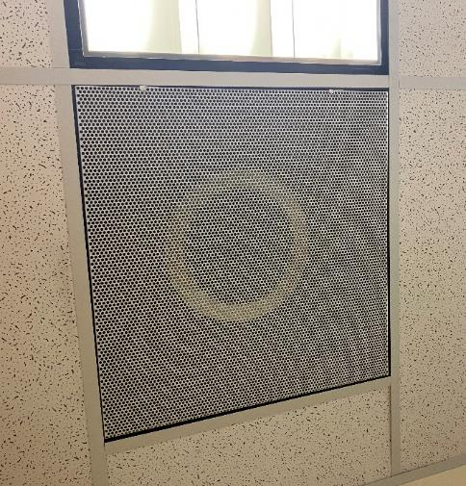

**Exhaust vent**

**Picture 3**

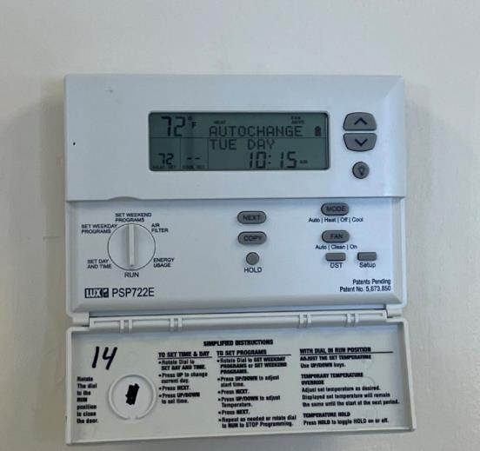

**Digital thermostat; note fan “auto” indicator (arrow) and buttons below to change mode**

**Picture 4**

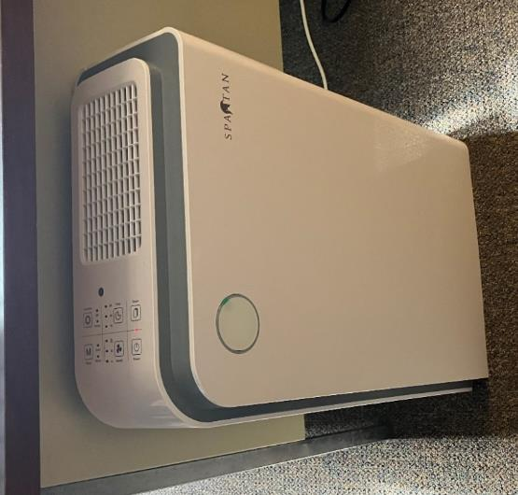

**An example of an air purifier being used in the office space**

**Picture 5**

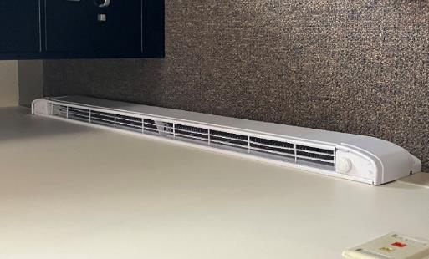

**Electric baseboard radiators**

## Water Damage pictures

**Picture 6**

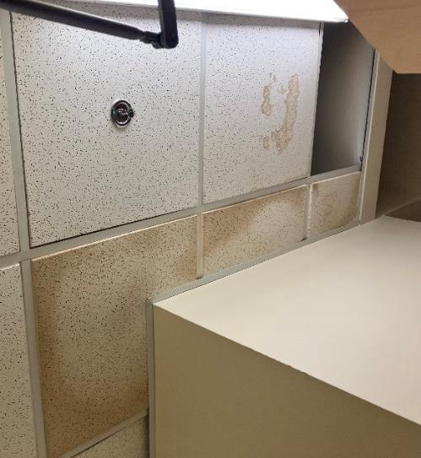

**Water-damaged ceiling tiles in the janitorial closet**

**Picture 7**

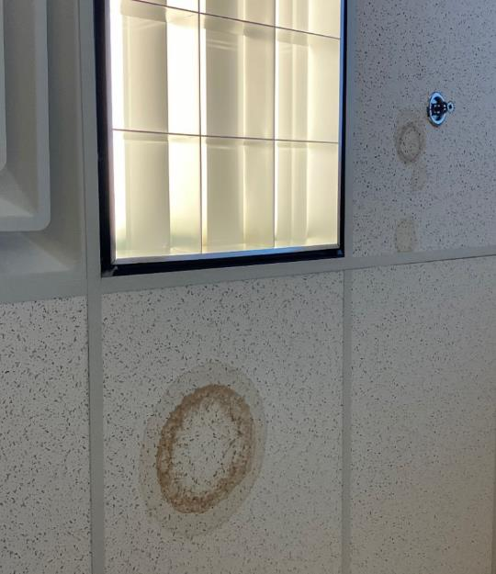

**Water-damaged ceiling tiles**

**Picture 8**

**Water-damaged ceiling tiles above stacks of paper rolls placed atop a cabinet 
**

**Water-damaged ceiling tiles above stacks of paper rolls placed atop a cabinet**

**Picture 9**

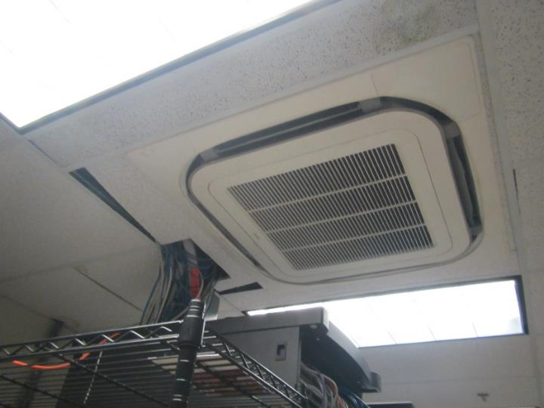

**Water-damaged ceiling tile next to ceiling-mounted mini-split air conditioner**

**Picture 10**

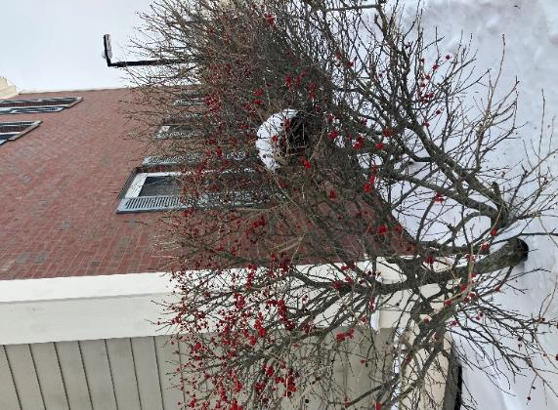

**Vegetation abutting the exterior of the building**

**Picture 11**

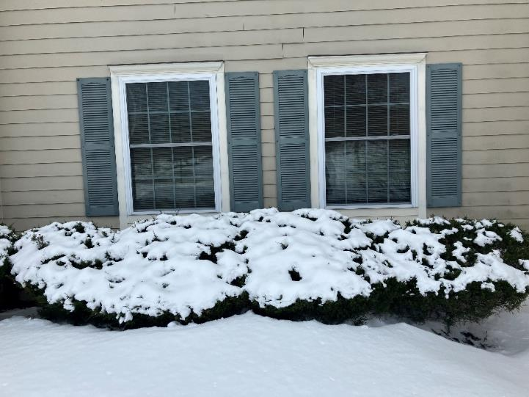

**Vegetation abutting the exterior of the building**

**Picture 12**

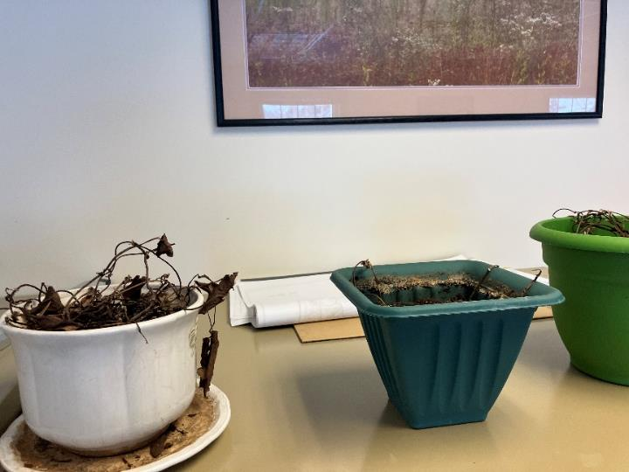

**Dead plants on top of cabinet**

**Picture 13a and 13b**

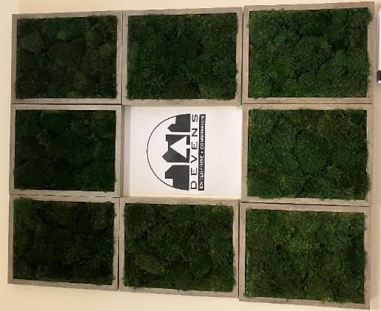 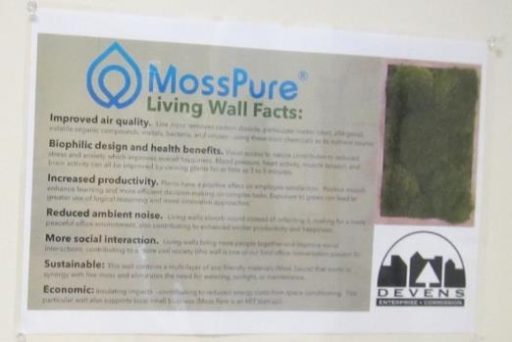

**Wall-mounted vertical garden and a placard noting the details of the garden**

## Respiratory Irritants pictures

**Picture 14**

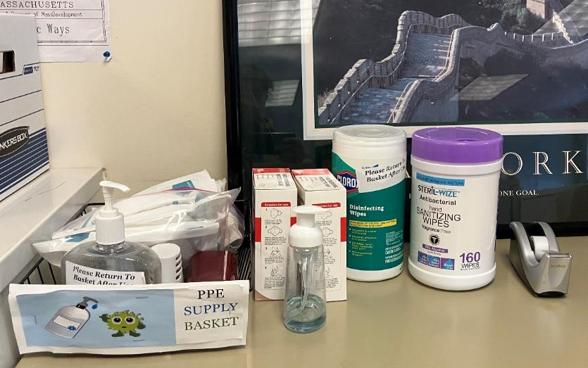

**Sanitizing wipes and pumps**

**Picture 15**

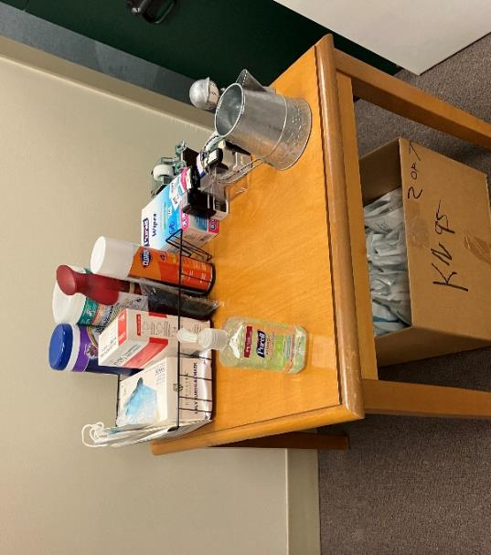

**Air sanitizing spray and cleaning supplies**

**Picture 16**

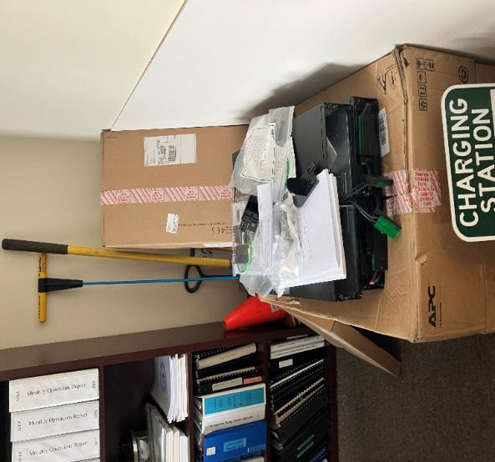

**Cluttered space with cardboard boxes and storage items**

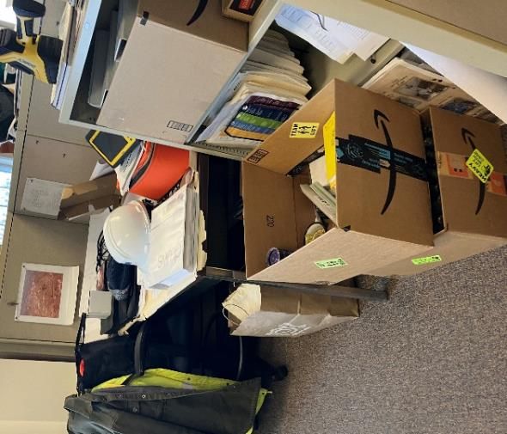**Picture 17**

**Cluttered space with cardboard boxes and paper**

**Picture 18**

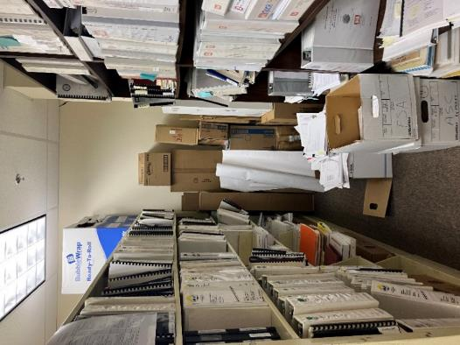

**Cluttered space with cardboard boxes and paper**

**Picture 19**

**Cluttered space with cardboard boxes and paper
**

**Cluttered space with cardboard boxes and paper**

**Picture 20**

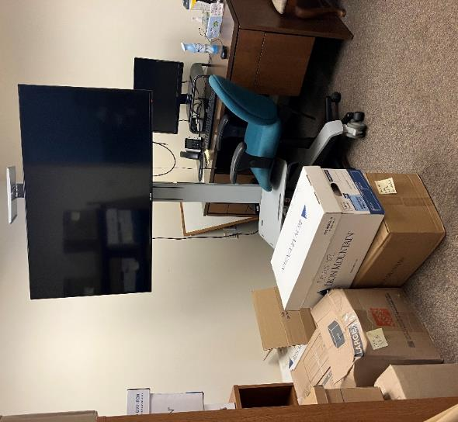

**Cluttered space with cardboard boxes**

**Picture 21**

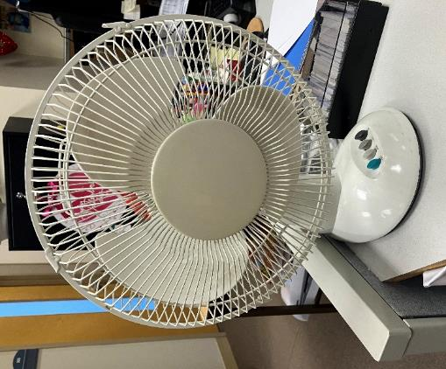

**Dusty portable fan**

**Picture 22**

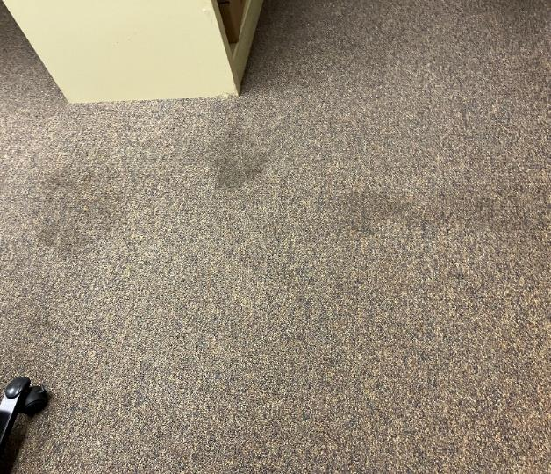

**Stained carpet**

Click to link back to report

# Table 1

| **Location** | **Carbon**  **Dioxide**  **(ppm)** | **Carbon Monoxide**  **(ppm)** | **Temp**  **(°F)** | **Relative**  **Humidity**  **(%)** | **PM2.5**  **(µg/m3)** | **Occupants**  **in Room** | **Windows**  **Openable** | **Ventilation** | | **Remarks** |
| --- | --- | --- | --- | --- | --- | --- | --- | --- | --- | --- |
| **Supply** | **Exhaust** |
| Background (outside) | 427 | ND | 37 | 28 | 7 |  |  |  |  | Partly sunny |
| Second Floor | | | | | | | | | | |
| 202 | 781 | ND | 72 | 16 | ND | 2 | Y | Y | Y | Fan |
| - conference rm | 818 | ND | 73 | 16 | ND | 0 | Y | Y | Y | Plant, items |
| - office | 797 | ND | 74 | 15 | ND | 0 | Y | Y | Y | DEM, worn carpet |
| 204 | 709 | ND | 73 | 15 | ND | 2 | Y | Y | Y | Electric baseboard heater |
| 206 | 783 | ND | 70 | 15 | ND | 0 | Y | Y | Y |  |
| - Server room |  |  |  |  |  | 0 | N | Y | Y | WD CTs, AP, ceiling-mounted ductless unit, CP |
| - inner office | 693 | ND | 71 | 15 | ND | 0 | Y | Y | Y |  |
| 201 | 779 | ND | 72 | 16 | ND | 1 | Y | Y | Y | Items, heater, AP |
| -inner cube area | 802 | ND | 71 | 16 | ND | 0 | Y | Y | Y | Maps/papers, dead plants, heater, AP |
| - inner left side | 910 | ND | 71 | 17 | ND | 1 | Y | Y | Y | Shredder, maps/papers |
| - inner office | 884 | ND | 70 | 17 | ND | 1 | Y | Y | Y | Heater, boxes on floor |
| - inner conference room | 888 | ND | 71 | 16 | ND | 0 | Y | Y | Y | Paper, WD CT, HS |
| - inner office | 902 | ND | 71 | 16 | ND | 1 | Y | Y | Y | AF |
| 208 library | 681 | ND | 72 | 15 | ND | 0 | Y | Y | Y | Paper and items on floor |
| Copy and mail | 656 | ND | 72 | 15 | ND | 0 | N | Y | N | PC, boxes, HS |
| Kitchen | 680 | ND | 72 | 15 | ND | 1 | Y | Y | Y | 3 fridges, sink, AP, microwave, toaster oven, stove and oven, food |
| 207 | 626 | ND | 71 | 15 | ND | 0 | N | Y | Y | Food, AP – on, dog |
| - HR | 621 | ND | 72 | 14 | ND | 0 | Y | Y | Y | Boxes on floor, electric baseboard heater |
| - Delorier | 648 | ND | 73 | 14 | ND | 1 | Y | Y | Y | AP, food |
| - Kalinowski | 627 | ND | 73 | 14 | ND | 0 | Y | Y | Y | DEM |
| - Gerlin | 650 | ND | 72 | 14 | ND | 0 | Y | Y | Y | WD CT |
| - Dowd | 656 | ND | 72 | 14 | ND | 3 | Y | Y | Y | Food, DEM, paper, WD CT |
| - Kimball | 704 | ND | 72 | 14 | ND | 1 | Y | Y | Y | DEM, WD CT |
| - cube area | 670 | ND | 71 | 14 | ND | 0 | N | Y | Y |  |
| - conference | 644 | ND | 72 | 14 | ND | 1 | N | Y | Y |  |
| - cube area | 688 | ND | 72 | 15 | ND | 2 | N | Y | Y | Boxes on floor, perfume odor, food |
| - Nicolson | 619 | ND | 71 | 14 | ND | 0 | Y | Y | Y | DEM, plants, HS |
| - Stevens | 617 | ND | 72 | 14 | ND | 0 | Y | Y | Y | DEM |
| - Wagner | 626 | ND | 72 | 14 | ND | 0 | Y | Y | Y | Plants, WD CT outside this office |
| - Bennet | 608 | ND | 72 | 15 | ND | 0 | Y | Y | Y | Food, gifts unopened since holidays |
| - Markevicius | 587 | ND | 71 | 15 | ND | 0 | Y | Y | Y | Plant, items |
| - Conference | 620 | ND | 71 | 15 | ND | 0 | N | Y | Y | AP, ripped carpet |
| - Abdou | 624 | ND | 70 | 15 | ND | 0 | Y | Y | Y | HS |
| First floor | | | | | | | | | | |
| 101 | 591 | ND | 69 | 15 | ND | 0 | Y | Y | Y |  |
| Legal office | 621 | ND | 68 | 15 | ND | 0 | Y | Y | Y |  |
| Board of Assessor | 600 | ND | 68 | 15 | ND | 0 | N | Y | Y |  |
| 109  - cube area | 608 | ND | 69 | 16 | ND | 3 | Y | Y | Y | Plants, road salt bags, microwave, APs |
| - Angus | 708 | ND | 69 | 16 | ND | 0 | Y | Y | Y | Plant |
| - Storage |  |  |  |  |  |  |  |  |  | WD CT |
| Women’s restroom |  |  |  |  |  |  |  |  |  | WD CT, AF |
| Men’s restroom |  |  |  |  |  |  |  |  |  | Small WD CT, AF |
| 106 | 683 | ND | 70 | 14 | ND | 0 | N | Y | Y |  |
| Conference | 710 | ND | 70 | 15 | ND | 12 | Y | Y | Y | AP |
| 110 office | 635 | ND | 68 | 16 | ND | 2 | Y | Y | Y | HS |
| 105 cube area | 662 | ND | 69 | 16 | 1 | 1 | Y | Y | Y | Boxes on floor |
| - Jenkins | 688 | ND | 71 | 16 | 2 | 1 | Y | Y | Y | Fake plant, food |
| - Michael | 701 | ND | 73 | 15 | 1 | 1 | Y | Y | Y | Items, HS |
| - Jeffreys | 701 | ND | 74 | 14 | 2 | 0 | N | Y | Y | Items |
| - Pope | 720 | ND | 74 | 14 | ND | 0 | Y | Y | Y | DEM |

(Click to link back to report)

# Table 2A

|  |  |  |  |  |  |
| --- | --- | --- | --- | --- | --- |
| **Equipment Present in Building**  **(X = Yes)** | **Type of Heating/Cooling Ventilation**  **Equipment** | **Fresh**  **Air**  **Supply**  **(X = Yes)** | **Type of Location(s)** | **Air Filters Installed**  **MERV Rating**  **(1-15, U*)**  **(X = Yes)** | **Comments** |
|  | Univents |  |  |  |  |
| X | Rooftop Air Handling Units | X | Offices |  |  |
|  | Outdoor, Ground-Installed Air Handling Units |  |  |  |  |
|  | Attic/Crawlspace Air Handling Units |  |  |  |  |
|  | Ceiling-Mounted Air Handling Units (including inside plenum) |  |  |  |  |
|  | Basement/Crawlspace-Installed Air Handling Units |  |  |  |  |
|  | Mechanical Room-installed Air Handling Units |  |  |  |  |
|  | Fan Coil Units |  |  |  |  |
|  | Window-Mounted Air Conditioners |  |  |  |  |
|  | Portable air conditioners |  |  |  |  |
|  | Wall Louver-Controlled Gravity Air Supply |  |  |  |  |
| X | Windows | X | Most rooms |  | Openable |
|  | Fan in window (blowing in) |  |  |  |  |
|  | Built in wall fan (switched) |  |  |  |  |
|  | Heat recovery ventilator unit |  |  |  |  |
|  | Energy recovery ventilator unit |  |  |  |  |
|  | Chilled Beam |  |  |  |  |
|  | Passive combustion supply vent in basement/boiler room |  |  |  |  |

*U = Filter Rating underdetermined due to inaccessibility during building visit

# Table 2B

|  |  |  |  |  |
| --- | --- | --- | --- | --- |
| **Equipment Present in Building**  **(X = Yes)** | **Type of Exhaust Ventilation**  **Equipment** | **Ducted**  **To Outdoors**  **(X = Yes)** | **Type of Location(s)** | **Comments** |
|  | Rooftop Motors/Fans |  |  |  |
|  | Unit Exhaust |  |  |  |
|  | Ceiling Return Vent |  |  |  |
|  | Ceiling Return Vent, Plenum |  |  |  |
|  | Wall Return Vent |  |  |  |
|  | Kitchen Stove Hood |  |  |  |
| X | Restroom Exhaust Vent | X |  | Functioning |
|  | Photocopier Exhaust Vent |  |  |  |
|  | Garage |  |  |  |
|  | Chemical Hood(s) |  |  |  |
|  | Locker Rooms |  |  |  |
|  | Showers |  |  |  |
|  | Clothes Dryers |  |  |  |
|  | Gas Water Heaters |  |  |  |
|  | Furnace-Flue to Chimney |  |  |  |
|  | Furnace/Boiler direct vent or power vent (no combustion air supply) |  |  |  |
|  | Kiln, Pottery |  |  |  |
|  | Dark Room |  |  |  |
|  | Generator Room |  |  |  |
|  | Wood Shop Dust Collector |  |  |  |
|  | Spray Paint Booths |  |  |  |
|  | Fan in window (blowing out) |  |  |  |

# Table 2C

|  |  |  |  |
| --- | --- | --- | --- |
| **Equipment Present in Building**  **(X = Yes)** | **Type of Equipment** | **Type of Location(s)** | **Comments** |
|  | Floor Fans, pedestal |  |  |
| X | Floor Fans, portable | Offices | Some dusty |
| X | Air Purifier (HEPA, other) | Offices |  |
|  | Floor heaters, portable |  |  |
| X | Refrigerators, Cold Beverage Vending Machines | Staff Room |  |
| X | Electric floorboard heating | Some rooms along exterior |  |
|  | Radiator, wall-mounted |  |  |
|  | Radiator, floor-mounted |  |  |
|  | Passive Vents (Wall/Door) |  |  |

(Click to link back to report)

# Table 3

| **Found in Building**  **X = Yes** | **Water-Damaged Materials, Building Components or Stored Materials** | **Location** | **Visible Microbial Growth?**  **X = Yes** | **Musty odor detected?**  **X = Yes** | **Comments** |
| --- | --- | --- | --- | --- | --- |
|  | Books-other bound materials |  |  |  |  |
|  | Brick walls – broken, missing mortar |  |  |  |  |
|  | Brick walls – blocked weep holes |  |  |  |  |
|  | Cardboard boxes |  |  |  |  |
|  | Carpet tiles |  |  |  |  |
| X | Carpet - Area rugs |  |  |  |  |
| X | Carpet wall-to-wall | Offices |  |  | Stained in at least one area |
|  | Ceiling tiles - affixed directly to ceiling surface |  |  |  |  |
|  | Ceiling tiles - bowing-in suspended ceiling |  |  |  |  |
|  | Ceiling tiles - water-stained in splined ceiling |  |  |  |  |
| X | Ceiling tiles - water-stained in suspended ceiling | Offices/  Storage areas | No | No |  |
|  | Chairs - laminated |  |  |  |  |
|  | Cloth |  |  |  |  |
|  | Countertops (around sinks) |  |  |  |  |
|  | Curtains |  |  |  |  |
|  | Dust/debris within AHU, uninvent, HVAC, chilled beam units, etc. (WD through condensation, humidity, or leaks) |  |  |  |  |
|  | Efflorescence (i.e., mineral deposits) |  |  |  |  |
|  | Engineered woods - particleboard, plywood, Masonite |  |  |  |  |
|  | Flooring – loosened tiles |  |  |  |  |
|  | Flooring - wooden |  |  |  |  |
|  | Furniture - laminated |  |  |  |  |
|  | Furniture - upholstered |  |  |  |  |
|  | Gypsum wallboard - ceiling |  |  |  |  |
|  | Gypsum wallboard - restroom wall |  |  |  |  |
|  | Gypsum wallboard - interior wall |  |  |  |  |
|  | Gypsum wallboard – located on exterior wall |  |  |  |  |
|  | HVAC drain pan – lack of draining |  |  |  |  |
|  | HVAC filters |  |  |  |  |
|  | Insulation- attic (paper-backed) |  |  |  |  |
|  | Insulation - inside air handling unit |  |  |  |  |
|  | Insulation - on pipe(s) fiberglass |  |  |  |  |
|  | Insulation - on pipe(s) other/plaster-like material |  |  |  |  |
|  | Insulation - wall cavity |  |  |  |  |
|  | Insulation – ceiling plenum |  |  |  |  |
|  | Modular furniture – walls/cloth partitions |  |  |  |  |
|  | Musical instrument cases |  |  |  |  |
|  | Plaster ceilings |  |  |  |  |
|  | Records/files |  |  |  |  |
|  | Refrigerator - door gasket |  |  |  |  |
|  | Refrigerator - drip pan |  |  |  |  |
|  | Refrigerator - Interior surfaces |  |  |  |  |
|  | Room divider - ceiling-mounted, sliding |  |  |  |  |
|  | Sink backsplash |  |  |  |  |
|  | Tables – laminated |  |  |  |  |
|  | Wallpaper |  |  |  |  |
|  | Wood - attic/roof materials |  |  |  |  |
|  | Wood - floor joists in basement ceiling |  |  |  |  |
|  | Wood - wall framing |  |  |  |  |
|  | Wood - window sills |  |  |  |  |
|  | Wood - window-mounted air conditioner framing |  |  |  |  |
|  | OTHER |  |  |  |  |

WHAT ARE ENVIRONMENTAL ASTHMA TRIGGERS?

Asthma triggers are any chemical, pollutant, or allergen that can make your asthma worse. Asthma triggers can also be strong chemical smells, dust, or pets. Your asthma triggers may be different from those of other people. Not all asthma triggers affect people the same way. Environmental asthma triggers are found both indoors and outdoors. DPH link: [Asthma and Your Environment (mass.gov)](https://www.mass.gov/doc/asthma-and-your-environment-english/download)

(click to link back to report)

# Table 4

| **Condition Present**  **X = Yes** | **Possible asthma symptom-inducing environmental pollutant** | **Recommendation to reduce or eliminate the pollutant** |
| --- | --- | --- |
| X | Water Damage and/or Mold  (allergen) | Identify water source and repair to eliminate.  Clean non-porous materials.  Remove and replace porous materials susceptible to mold growth.  Perform regular water damage assessments as a tool to ensure timely mitigation as needed.  Use NIOSH water damage assessment protocol as a guide: [NIOSH water damage assessment guideline](https://www.cdc.gov/niosh/docs/2019-115/pdfs/2019-115.pdf?id=10.26616/NIOSHPUB2019115&inf_contact_key=241b5c2ed98c27d94b530dedc36f1623f651f238aa2edbb9c8b7cff03e0b16a0). |
|  | Moistening of building components during hot, humid weather (>2 days in length) (mold, allergen) | Remove materials not dried in <2 days in a manner consistent with [US EPA Mold Removal in Commercial Buildings guideline](https://www.epa.gov/mold/pdf-version-checklist-mold-remediation-mold-remediation-schools-and-commercial-buildings).  Use dehumidification in occupied basement areas and other areas with chronic dampness. |
| X | Vegetation against exterior of building (water damage-mold) | Remove all vegetation preventing building exterior drying.  Remove all vegetation capable of falling onto a building or depositing debris onto the roof. |
|  | Personal humidifiers (lack of proper maintenance)  (pollutant and allergen) | Clean and maintain properly.  Use distilled water to eliminate metal and water treatment odors.  Maintain hydration by increasing water consumption. |
|  | Drains: Floor drains, Sink drains (abandoned use)  Water bubblers (abandoned use) | If in use, pour water into drain at least twice a week.  If not in use, seal the drain with an appropriate material in accordance with Massachusetts Plumbing Code (248 CMR 10.00). |
|  | Live Animals (turtles, gerbils, birds, rabbits, etc.) | Ensure cleanliness or remove animals from the location. |
|  | Improperly maintained aquariums and terrariums (allergen) | Maintain such equipment properly to eliminate odor.  Discontinue use. |
| X | Plants and flowers  (allergen and mold) | Keep indoor plants well maintained and not overwatered. Monitor for signs of mold and pests.  Ensure water for cut flowers does not become stagnant.  Ensure dried plant material is free of odors, mold, and pests and handled carefully  If asthma risks are high, eliminate plants and flowers. |
|  | HVAC system moisture issues  (mold, allergen) | Consult ASHRAE’s minimum standards for HVAC maintenance and inspection of commercial HVAC systems (<https://www.ashrae.org/technical-resources/bookstore/standards-180-and-211>). |
|  | HVAC system contaminant issues (allergen) | Consult ASHRAE’s minimum standards for HVAC maintenance and inspection of commercial HVAC systems (<https://www.ashrae.org/technical-resources/bookstore/standards-180-and-211>). |
|  | Indoor swimming pool odors outside of swimming pool (mold, chemical) | Maintain and operate pool HVAC systems to vent odors from building.  Ensure locker room exhaust vents are operating during building hours.  All doors leading to pool should be rendered airtight and be closed. |
|  | Pollen (allergen) | Recommend installation of MERV 8 or better filters if HVAC engineer confirms HVAC system can be so equipped without adversely affecting function.  Cut grass after hours.  Cut grass in a pattern to direct clippings away from exterior wall.  Remove trees and shrubs from in front of windows and air intakes. |
| X | Dry air | Maintain hydration.  Avoid overheating of air. |
| X | Dust mites  (allergen) | Recommendation to remove non-official upholstered furniture, area rugs, pillows, cushions, etc.  Cleaning with use of HEPA-filtered vacuum cleaner.  Eliminating clutter, storing items in dust and moisture-proof containers, and regularly removing dust through wet wiping. |
|  | Pests, including rodents and cockroaches  (allergen) | Use of integrated pest management guidelines, including:   * Proper disposal of food containers * Proper storage of food products in airtight containers * Elimination of use of food as art projects * Remove pest harborages/clutter * Regular monitoring for pests   [EPA IPM guideline link](https://www.epa.gov/ipm/introduction-integrated-pest-management) |
|  | Latex-containing materials | Remove tennis balls from furniture legs. |
| X | Fragrances  (chemical) | Eliminate point sources, such as:   * Plug-in air fresheners * Aroma/oil reed diffusers * Scented sprays * Discontinue use of other scented materials * Consult DPH fragrance guideline: [*Clean air is odor-free*](https://www.mass.gov/doc/clean-air-is-odor-free-removing-fragrances-to-improve-indoor-air-quality-in-schools-and-0/download) |
| X | Strong smells from /use of Chemicals (such as cleaning products)  (chemical) | Use building-issued cleaning products.  Use products in accordance with manufacturer’s instructions including dilution, application, and ventilation.  Avoid using products that are stronger than needed for the situation. |
|  | Strong odors from new building materials (carpeting/furniture)  (chemical) | Use low VOC-emitting materials.  Air out materials (outside or in unoccupied area) prior to installation. |
|  | Tobacco smoke  Secondhand Smoke  (pollutant) | Eliminate tobacco smoking.  Seal all shared wall penetrations. |
|  | Products with a strong odor such as paint, perfume, hairspray, air fresheners, bug-spray, laminators, candles, wax melters, dry erase markers and other VOC-containing products  (chemical) | If essential:   * Provide proper exhaust ventilation to eject aerosolized product directly outdoors. * Avoid/reduce use during occupied hours.   If not necessary, remove and eliminate. |
|  | Vehicle exhaust  (pollutant) | Enforce anti-idling regulations and post signs to give notice.  Relocate vehicles away from fresh air intakes.  Require cars to park face-in at building walls.  [MA anti-idling law FAQs](https://www.mass.gov/files/documents/2018/02/20/idling-faq.pdf#:~:text=The%20Massachusetts%20Anti-Idling%20Law%20The%20goal%20of%20the,sometime%20wonder%20when%20idling%20might%20be%20considered%20necessary.) |
|  | Vapors and or fumes from gas, oil, or kerosene stoves  (pollutant) | Operate stove hood when stove in use.  Install stove hood if not present.  Ensure equipment is in good working order. |
|  | Ozone (pollutant) | Eliminate use of ozone generating equipment. |
|  | Window Air Conditioners (if not properly maintained) (allergen) | Equip with proper filter and clean periodically.  Clean drip pans.  Install in window with weathertight, non-mold-growth sustaining material. |
|  | Pottery (pollutant) | Do not operate kiln during occupied hours.  Operate kiln with exhaust system activated.  Seal all seams and holes in kiln vent.  Ensure kiln exhaust discharge terminates outdoors. |
| X | Carpeting (allergen) | Clean carpeting in a manner consistent with IICRC standards, including regular vacuuming with a high efficiency particulate air (HEPA) filtered vacuum in combination with annual cleaning or semi-annual cleaning in soiled high traffic areas. |
|  | Sweeping/dusting vs HEPA vacuuming/wet wiping  (allergen or pollutant) | Refrain from using feather dusters or brooms.  Utilize HEPA vacuums and wet wiping to minimize aerosolizing particulate matter. |
|  | Lack of adequate air exchange/mechanical ventilation | Make repairs as necessary and ensure all HVAC system components are operating continuously when building is occupied. |
|  | Lack of local exhaust at source of pollution (vocational shop activities, kitchen exhaust hood) (all) | Recommend installation of exhaust ventilation to direct pollutants directly outdoors. |
|  | Renovating buildings while occupied  (chemical) | Use all SMACNA guidelines for Renovation While Buildings Are Occupied. For information, visit <https://www.mass.gov/service-details/construction-and-renovation-generated-pollutants-in-occupied-buildings>. |
|  | Chemistry program chemical storage  (chemical) | Repair (if needed) and operate chemical storeroom vents appropriately.  Reduce or eliminate unneeded or overstocked chemicals.  Store all chemicals in a manner to separate incompatible chemicals.  Keep chemical storerooms clean. |
| X | Photocopiers/duplicating machines | All machines should have dedicated exhaust vents. |