Drug Formulary Commission

Bureau of Health Professions Licensure Department of Public Health
May 17, 2018

Slide 1

Presentation Agenda

Review of March 15th meeting
- Cost Impact Presentation
- Draft Formulary Regulations
105 CMR 720: Drug Formulary Commission (FKA: List of Interchangeable Drug Products)

Schedule
  - Guidance
- Remarks
- Next Steps

Formulary Review and Evaluation

Draft Amended Formulary

Component 3: “Cross Walk” – Chemically Equivalent Substitutions

Component 2: Interchangeable Abuse Deterrent Opioids

Component 1: Opioids with a Heightened Public Health Risk

Drug Formulary Commission

Cost Impact Presentation

Slide 4

Substitution Cost Algorithm

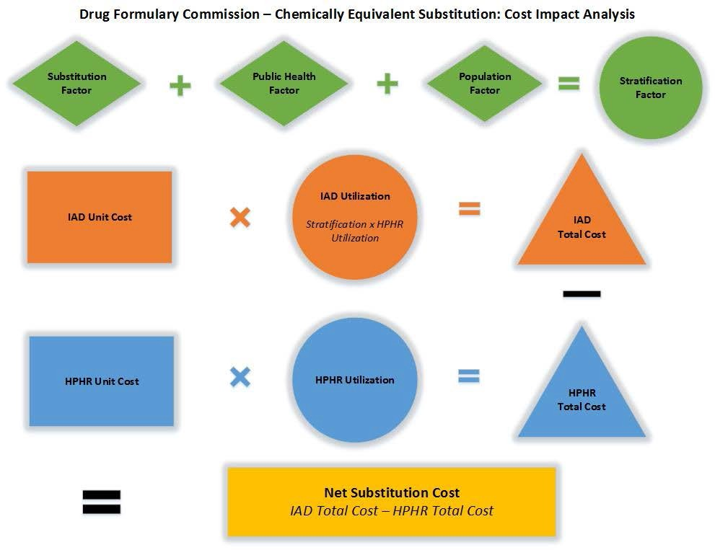

Chemically Equivalent Substitution Stratification Factors

 | Element | Element Score | Factor Score
Substitution Factor  IAD-specific calculation | IAD current market share
 | Length of approval
 | ADP efficacy
 | Routes of deterrence
 | Discounts available (Medicaid)
 | Generic available
 | HPHR of concern
 | ER or IR
Public Health Factor  Potential costs/ savings/benefit Applied to all crosswalks | Criminal Justice
 | Direct Healthcare (OUD treatment, OD/NFO response)
 | Ancillary Healthcare (first responders, NAS, disability)
 | Death
 | Prescribing/dispensing education
Population Factor  Risk/value assessment  Applied to all crosswalks | Medicaid/Medicare patient (2x scripts; 3-6x OUD)
 | First time script (36 months to OD/NFO)
 | Diversion (hospice/LTCF)
 | Co-morbid psych (opioid + benzo, etc.)
TOTAL |  |  | %

Promulgation of Regulation and Formulary

History
- Proposed 105 CMR 720, List of Interchangeable Drug Products, including draft formulary, as redrafted, to the Public Health Council (PHC) (11/9/2016)
- Public hearing held on proposed changes to regulation (1/19/2017)
- DPH staff reviewed comments and further amended, including the addition of several new DFC approved IADs.
- Public hearing held on proposed changes to regulation (7/7/2017)
- PHC promulgated 105 CMR 720, Drug Formulary Commission (fka List of Interchangeable Drug Products), including draft formulary (8/9/2017)
Next Steps
- Issue guidance, including special substitution considerations, and the requirements and process of substitution.
- Review by Secretary of State → Regulation becomes effective (TBD).
- Conduct prescriber education on abuse deterrent substitutes.

Formulary Guidance Background

This draft formulary is a tool for prescribers when continuing and initiating the treatment of pain.
  - Guidance will be issued approximately one month prior to the regulation, including the draft formulary, becoming effective.
  - “No Substitution”
  - The following items on a Schedule II prescription may not be changed by a pharmacist, pursuant to applicable DEA rules:
    - Name of Patient
    - Name of the Drug
    - Name of the Prescriber
    - Date of the Prescription

Prescriber unavailable

Membership Terms

Term Expires | Members
June 10, 2018 | 4
June 17, 2018 | 1
June 23, 2018 | 1
*July 27, 2018 | 4
August 6, 2018 | 1
August 14, 2018 | 1
August 17, 2018 | 1
Ex Officio  * Next Meeting - July 19, 2018 | 3

Meeting Schedule

Tentative 3rd Thursday Schedule
• June 21, 2018
• July 19, 2018
• August 16, 2018 **

** Optional if Non-opioid List update has not been completed. Update required by 8/30/18.

Meeting Summary

- Meeting Recap

- Next Steps

- Next Meeting

– July 19, 2018

– 9:00AM to 12:00PM
– @ 250 Washington Street (Boston, MA)

