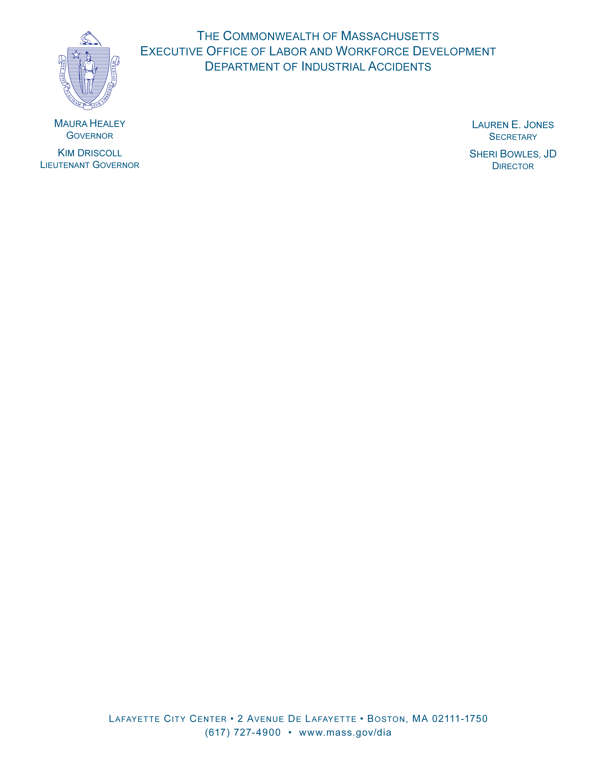

MEMORANDUM

TO: ALL INTERESTED PERSONS
FROM: ERIN MUSCHETTE, DIRECTOR/OEVR

RE: VOCATIONAL REHABILITATION PROVIDERS APPROVED BY THE OFFICE OF EDUCATION AND VOCATIONAL REHABILITATION TO PROVIDE VOCATIONAL REHABILITATION SERVICES TO INJURED EMPLOYEES UNDER THE WORKERS' COMPENSATION ACT (G.L. c. 152, AS AMENDED)

DATE: July 1.2025

ATTACHED ARE THE NAMES OF THOSE PROVIDERS WHO HAVE BEEN APPROVED TO FURNISH VOCATIONAL REHABILITATION SERVICE UNDER THE WORKERS' COMPENSATION ACT THROUGH JUNE 30,2026.

THE PROVIDER LIST IS AVAILABLE ON THE DIA WEB SITE.

FY'2025 CERTIFIED PROVIDERS

Vocational Rehabilitation Services

- CRC Services, LLC
813 Williams Street, Suite 212
Longmeadow, MA 01116-1148
Phone: (413) 567-5871
Contact Person: David M. Soja, CRC/LRC, ABVE
President

- CorVel Rehabilitation Services, Inc 1920 Main Street
Suite 900
Irvine, CA 92614
Phone: (949)851-1473
Contact Person: Jack Ormsby, MS, CRC, LCPC

- Diane Durr Case Management
4 Nuovo Drive
Sagamore Beach, MA 02562 Phone: (508) 989-7590
Contact Person: Diane Durr, MA, CRC

- Faith Johnson Case Management
P.O. Box 1345
Concord, MA 01742
Phone: (978) 505-9463
Contact Person: Faith A. Johnson, M.Ed, CAGS, CRC, CCM

- Fitzpatrick Rehab
P.O. Box 1057
Windham, Maine 04062-1057
Phone: (207) 838-7914
Contact Person: Martin J. Fitzpatrick, CDMS, CVRP

- GENEX Services, LLC
440 East Swedesford Road, Suite 1000
Wayne, PA 19087
Phone: (610) 964-5100
Contact Person: Kathryn S. Shaw, MS, CRC
Assistant Branch Manager Cell: (978)495-0801

- Greylock Placement Services
20 Chestnut Street
Williamstown, MA 01267
Phone: (413) 387-9637
Contact Person: Timothy R. Andenmatten, M.Ed, CRC, CVE, IPEC

- Hampden Rehabilitation Services
42 Melbourne Road
West Hyannisport, MA 02601 Phone: (508) 790-1049
Contact Person: Courtney S. Olds, M.Ed., CRC, LRC

- Joseph Young Consulting 4209 Taylor Pond Lane Bedford, MA 01730
Phone: (781) 363-2689
Contact Person: Joseph Young, MS, CRC, LRC

10. Managed Care Network, Inc
3000 Alt Boulevard
Grand Island, NY 14042
Phone: 716-285-5710
Contact Person: Melissa Cunningham, MA, CRC, CVE

11. Medical and Life Care Consulting Services. Inc
23 Main Street
Belchertown, MA 01007
Phone: 413-323-9705
Contact Person: Kerry A. Skillin, CRC. ABVE/D
12. New Horizon Wellness Group, LLC
P. O. Box 1159
Randolph, MA 02368
Phone: (617)405-0980
Contact Person: Desiree Etienne, MS, CRC, SCLA, LADC-1, MBA

13. Occupational Resource Network,Inc
290 Merrimack Street, Suite 182
Lawrence, MA 01843
Phone: 978-247-6086
Contact Person: Nancy L. Segrave, MA, CRC, CCM

14. Paradigm Management Services, LLC 1277 Treat Boulevard
Suite 800
Walnut Creek, CA 94597 Phone: (800)676-6777
Contact Person: Dawn Daley, MS, CRC
15. Rhonda Jellenik Case Management
P.O. Box 197
Mansfield, MA 02048
Phone: (508) 339-0555
Contact Person: Rhonda L. Jellenik, MA, CRC, LRC

16. The Process of Restoration
3015 E. New York St., A2-170
Aurora, IL 60504
Phone: (630) 423-6209
Contact Person: Anita Johnson, CRC

17. Tandem Workforce Collaborative
P.O. Box 404
Middleburg, VT 05753
Phone: 802-989-8994
Contact Person: Donna Curtin

18. VRS Disability Management
P.O. Box 186
Waterbury Center, VT 05677 Phone: (603) 566-5827
Contact Person: Laurie Martin, Manager

19. Windham Injury Management Group, Inc.
500 North Commercial Street, Suite 301
Manchester, NH 03101
Phone: (800) 898-0386
Contact Person: Sebastian Grasso

