INDOOR AIR QUALITY REASSESSMENT

Dighton Public Library
395 Main Street
Dighton, MA

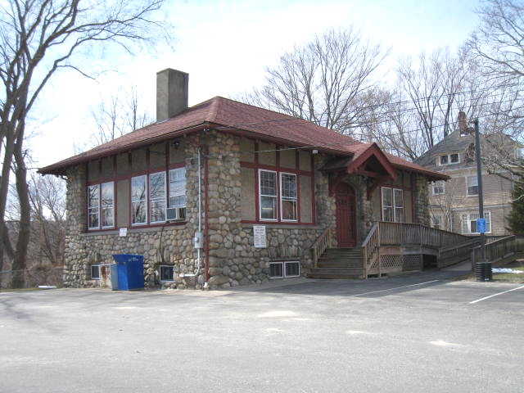

Prepared by:
The Massachusetts Department of Public Health
Bureau of Environmental Health
Indoor Air Quality Program
April 2013

Background/Introduction
At the request of Ms. Jocelyn Tavares, Director, Dighton Public Library (DPL), the Massachusetts Department of Public Health (MDPH), Bureau of Environmental Health (BEH) conducted an indoor air quality (IAQ) reassessment at the DPL located at 395 Main Street, Dighton, Massachusetts. The request was prompted by concerns about carpeting located in the basement.
On March 15, 2013, Mr. Cory Holmes, Environmental Analyst/Inspector in BEH’s IAQ Program, conducted a visit to the DPL to conduct the current assessment, accompanied by Ms. Tavares. Mr. Holmes had previously visited the building in September of 2003 to investigate mold/water damage concerns and issued a report based on observations made at that time, with recommendations to improve air quality (MDPH, 2003). Actions taken on recommendations made in that report are listed in Appendix A.
It was reported by Ms. Tavares that future building improvement projects are planned, including rerouting drainage along the peaked roof, and chimney repairs.

Methods
Air tests for carbon monoxide, carbon dioxide, temperature and relative humidity were conducted with the TSI, Q-Trak, IAQ Monitor, Model 7565. Air tests for airborne particle matter with a diameter less than 2.5 micrometers were taken with the TSI, DUSTTRAK™ Aerosol Monitor, Model 8520. BEH/IAQ staff also performed visual inspection of building materials for water damage and/or microbial growth. Test results are listed in Table 1.

Results
The DPL has approximately five employees with up to 50 visitors on a daily basis. The tests were taken under normal operating conditions. Test results appear in Table 1.

Discussion

Ventilation
It can be seen from Table 1 that carbon dioxide levels were below 800 parts per million (ppm) in all areas surveyed indicating adequate air exchange the day of assessment. It is important to note, however, that the DPL does not have a mechanical means to introduce outside air/exhaust. Temperature/comfort control is achieved with an air-handling unit (AHU) in the basement that recirculates air to provide heating and cooling (Picture 1). Conditioned air is ducted to occupied areas and distributed via ceiling or floor-mounted supply vents (Pictures 2 and 3), and ducted back to the unit via return vents (Picture 4). Upon inspection BEH/IAQ staff noted several breaches in ductwork near the AHU (Pictures 5 and 6), that can allow heated/cooled air to escape, decreasing the efficiency of the system. This system is supplemented by using windows to introduce fresh air, and portable air-conditioning (AC) units and dehumidifiers for additional cooling/moisture control.
Minimum design ventilation rates are mandated by the Massachusetts State Building Code (MSBC). Until 2011, the minimum ventilation rate in Massachusetts was higher for both occupied office spaces and general classrooms, with similar requirements for other occupied spaces (BOCA, 1993). The current version of the MSBC, promulgated in 2011 by the State Board of Building Regulations and Standards (SBBRS), adopted the 2009 International Mechanical Code (IMC) to set minimum ventilation rates. Please note that the MSBC is a minimum standard that is not health-based. At lower rates of cubic feet per minute (cfm) per occupant of fresh air, carbon dioxide levels would be expected to rise significantly. A ventilation rate of 20 cfm per occupant of fresh air provides optimal air exchange resulting in carbon dioxide levels at or below 800 ppm in the indoor environment in each area measured. MDPH recommends that carbon dioxide levels be maintained at 800 ppm or below. This is because most environmental and occupational health scientists involved with research on IAQ and health effects have documented significant increases in indoor air quality complaints and/or health effects when carbon dioxide levels rise above the MDPH guidelines of 800 ppm for schools, office buildings and other occupied spaces (Sundell, J. et al., 2011). The ventilation must be on at all times that the room is occupied. Providing adequate fresh air ventilation with open windows and maintaining the temperature in the comfort range during the cold weather season is impractical. Mechanical ventilation is usually required to provide adequate fresh air ventilation.
Carbon dioxide is not a problem in and of itself. It is used as an indicator of the adequacy of the fresh air ventilation. As carbon dioxide levels rise, it indicates that the ventilating system is malfunctioning or the design occupancy of the room is being exceeded. When this happens, a buildup of common indoor air pollutants can occur, leading to discomfort or health complaints. The Occupational Safety and Health Administration (OSHA) standard for carbon dioxide is 5,000 parts per million parts of air (ppm). Workers may be exposed to this level for 40 hours/week, based on a time-weighted average (OSHA, 1997).
The MDPH uses a guideline of 800 ppm for publicly occupied buildings. A guideline of 600 ppm or less is preferred in schools due to the fact that the majority of occupants are young and considered to be a more sensitive population in the evaluation of environmental health status. Inadequate ventilation and/or elevated temperatures are major causes of complaints such as respiratory, eye, nose and throat irritation, lethargy and headaches. For more information concerning carbon dioxide, consult Appendix B.
Temperatures measured during the assessment ranged from 64°F to 77°F, which were below the MDPH recommended comfort range in a few areas (Table 1). The MDPH recommends that indoor air temperatures be maintained in a range of 70°F to 78°F in order to provide for the comfort of building occupants. In many cases concerning indoor air quality, fluctuations of temperature in occupied spaces are typically experienced, even in a building with an adequate fresh air supply.
The relative humidity measured ranged from 24 to 31 percent, which was below the MDPH recommended comfort range (Table 1). The MDPH recommends a comfort range of 40 to 60 percent for indoor air relative humidity. Relative humidity levels in the building would be expected to drop during the winter months due to heating. The sensation of dryness and irritation is common in a low relative humidity environment. Low relative humidity is a very common problem during the heating season in the northeast part of the United States.

Microbial/Moisture Concerns
In order for building materials to support mold growth, a source of water exposure is necessary. Identification and elimination of the source of water moistening porous materials is necessary to control mold growth. Although no visible water damage or mold growth was observed, including the basement carpeting which prompted this assessment, a potential source of water infiltration was observed in the form of spaces around the metal bulkhead door (Pictures 7 and 8). These spaces can serve as a source for drafts and/or water penetration into the building, causing water damage and potentially leading to mold growth. In addition, these spaces can serve as pathways for insects, rodents and other pests to enter into the building.

Other Indoor Air Evaluations
Indoor air quality can be negatively influenced by the presence of respiratory irritants, such as products of combustion. The process of combustion produces a number of pollutants. Common combustion emissions include carbon monoxide, carbon dioxide, water vapor, and smoke (fine airborne particle material). Of these materials, exposure to carbon monoxide and particulate matter with a diameter of 2.5 micrometers (μm) or less (PM2.5) can produce immediate, acute health effects upon exposure. To determine whether combustion products were present in the indoor environment, BEH/IAQ staff obtained measurements for carbon monoxide and PM2.5.

Carbon Monoxide
Carbon monoxide is a by-product of incomplete combustion of organic matter (e.g., gasoline, wood and tobacco). Exposure to carbon monoxide can produce immediate and acute health affects. Several air quality standards have been established to address carbon monoxide and prevent symptoms from exposure to these substances. The MDPH established a corrective action level concerning carbon monoxide in ice skating rinks that use fossil-fueled ice resurfacing equipment. If an operator of an indoor ice rink measures a carbon monoxide level over 30 ppm, taken 20 minutes after resurfacing within a rink, that operator must take actions to reduce carbon monoxide levels (MDPH, 1997).
The American Society of Heating Refrigeration and Air-Conditioning Engineers (ASHRAE) has adopted the National Ambient Air Quality Standards (NAAQS) as one set of criteria for assessing indoor air quality and monitoring of fresh air introduced by HVAC systems (ASHRAE, 1989). The NAAQS are standards established by the US EPA to protect the public health from six criteria pollutants, including carbon monoxide and particulate matter (US EPA, 2006). As recommended by ASHRAE, pollutant levels of fresh air introduced to a building should not exceed the NAAQS levels (ASHRAE, 1989). The NAAQS were adopted by reference in the Building Officials & Code Administrators (BOCA) National Mechanical Code of 1993 (BOCA, 1993), which is now an HVAC standard included in the Massachusetts State Building Code (SBBRS, 2011). According to the NAAQS, carbon monoxide levels in outdoor air should not exceed 9 ppm in an eight-hour average (US EPA, 2006).
Carbon monoxide should not be present in a typical, indoor environment. If it is present, indoor carbon monoxide levels should be less than or equal to outdoor levels. Outdoor carbon monoxide concentrations were non-detect (ND) at the time of assessment (Tables 1). No measurable levels of carbon monoxide were detected inside the building during the assessment (Tables 1).

Particulate Matter
The US EPA has established NAAQS limits for exposure to particulate matter. Particulate matter includes airborne solids that can be irritating to the eyes, nose and throat. The NAAQS originally established exposure limits to PM with a diameter of 10 μm or less (PM10). In 1997, US EPA established a more protective standard for fine airborne particulate matter with a diameter of 2.5 μm or less (PM2.5). The NAAQS has subsequently been revised, and PM2.5 levels were reduced. This more stringent PM2.5 standard requires outdoor air particle levels be maintained below 35 μg/m³ over a 24-hour average (US EPA, 2006). Although both the ASHRAE standard and BOCA Code adopted the PM10 standard for evaluating air quality, MDPH uses the more protective PM2.5 standard for evaluating airborne PM concentrations in the indoor environment.
Outdoor PM2.5 concentrations the day of the assessment were measured at 7 μg/m³. PM2.5 levels measured inside the building ranged from 4 to 7 μg/m³ (Table 1). Both indoor and outdoor PM2.5 levels were below the NAAQS PM2.5 level of 35 μg/m³. Frequently, indoor air levels of particulates (including PM2.5) can be at higher levels than those measured outdoors. A number of mechanical devices and/or activities that occur indoors can generate particulate during normal operations. Sources of indoor airborne particulates may include but are not limited to particles generated during the operation of fan belts in the HVAC system, use of stoves and/or microwave ovens in kitchen areas; use of photocopiers, fax machines and computer printing devices; operation of an ordinary vacuum cleaner and heavy foot traffic indoors.

Other Conditions
Other conditions that can affect indoor air quality were observed during the assessment. AHUs are typically equipped with air filters that should be cleaned or changed per the manufacturer’s instructions to avoid the reaerosolization of dusts and particulates. DPL staff had no information on the frequency of filter changes for the AHU. The AHU was opened to observe the conditions of filters. The unit was outfitted with one filter that was found to be ill-fitting, saturated with dust/debris and appeared not to have been changed/cleaned in some time (Picture 1).
In order to decrease aerosolized particulates, disposable filters with an appropriate dust spot efficiency should be installed. The dust spot efficiency is the ability of a filter to remove particulates of a certain diameter from air passing through the filter. Filters that have been determined by ASHRAE to meet its standard for a dust spot efficiency of a minimum of 40 percent would be sufficient to reduce many airborne particulates (Thornburg, D., 2000; MEHRC, 1997; ASHRAE, 1992). Pleated filters with a Minimum Efficiency Reporting Value (MERV) dust-spot efficiency of 9 or higher are recommended. Note that increasing filtration can reduce airflow (called pressure drop), which can subsequently reduce the efficiency of the unit due to increased resistance. Prior to any increase of filtration, the AHU should be evaluated by an HVAC engineer to ascertain whether it can maintain function with more efficient filters.
Dust and cobwebs were noted in the basement and other areas. Flammable materials and accumulated items were noted stored in the custodial closet. Flammable materials should be removed from the closet and stored items should be reduced.
Open utility holes in the ceiling and floor of the restroom were observed (Table 1 and noted previously per Appendix A). Open utility holes can provide a means of transport for odors, fumes, dusts and vapors between rooms and floors.
Finally, the carpeting in the building appeared to be past its useful lifespan, with some areas observed to be damaged, worn or soiled. Since the average lifespan of a carpet is approximately eleven years (Bishop, 2002), MDPH recommends removal of carpeting on both the ground floor and basement and replacement with an alternative flooring material. It is important to note that in general MDPH does not recommend carpeting in below-grade areas due to chronic dampness and condensation issues. Carpeting is a porous material that will absorb water and grow mold if wetted repeatedly.

Conclusions/Recommendations
In view of the findings at the time of the visit, the following recommendations are made:
- Replace carpeting as it is at end of its useful lifespan with carpet squares (ground floor) or a non-porous surface such as tile (ground floor/basement). The MDPH does not recommend carpeting in below-grade areas.
- Until carpets can be removed/replaced, clean annually or semi-annually in soiled high traffic areas as per the recommendations of the Institute of Inspection, Cleaning and Restoration Certification (IICRC). Copies of the IICRC fact sheet can be downloaded at: http://1.cleancareseminars.net/?page_id=185 (IICRC, 2005).
- Seal holes/breaches in HVAC ductwork, shown in Pictures 5 and 6, inspect remaining ductwork for similar breaches and repair as needed.
- Have an HVAC firm evaluate the AHU for filter upgrade options. Ensure filters fit flush in their racks to prevent filter bypass. Change filters per manufacturer’s instructions or more frequently if needed.
- Clean/change filters for portable AC’s and dehumidifiers as per the manufacture’s instructions. Clean and maintain dehumidifiers as per the manufactures instructions.
- Use openable windows where available in conjunction with HVAC system to facilitate air exchange, with the exception of periods when the AC system is in operation with outdoor relative humidity over 70%.
- Increase cleaning efforts throughout the building.
- Remove flammable materials and reduce accumulated items from ground floor custodial closet.
- For buildings in New England, periods of low relative humidity during the winter are often unavoidable. Therefore, scrupulous cleaning practices should be adopted to minimize common indoor air contaminants whose irritant effects can be enhanced when the relative humidity is low. To control dusts, use of a vacuum cleaner equipped with a HEPA filter in conjunction with wet wiping of all surfaces is recommended. Drinking water during the day can help ease some symptoms associated with a dry environment (throat and sinus irritation).
- Seal utility holes in ceilings, walls and floors (e.g., restroom) to eliminate potential pollutant paths of migration.
- Refer to resource manual and other related indoor air quality documents located on the MDPH’s website for further building-wide evaluations and advice on maintaining public buildings. These documents are available at: http://mass.gov/dph/iaq.

References
ASHRAE. 1989. Ventilation for Acceptable Indoor Air Quality. American Society of Heating, Refrigeration and Air Conditioning Engineers. ANSI/ASHRAE 62-1989.
ASHRAE. 1992. Gravimetric and Dust-Spot Procedures for Testing Air-Cleaning Devices Used in General Ventilation for Removing Particulate Matter. American Society of Heating, Refrigeration and Air Conditioning Engineers. ANSI/ASHRAE 52.1-1992.
Bishop. 2002. Bishop, J. & Institute of Inspection, Cleaning and Restoration Certification. A Life Cycle Cost Analysis for Floor Coverings in School Facilities.
BOCA. 1993. The BOCA National Mechanical Code/1993. 8th ed. Building Officials and Code Administrators International, Inc., Country Club Hill, IL.
IICRC. 2005. Carpet Cleaning FAQ 4 Institute of Inspection, Cleaning and Restoration Certification. Institute of Inspection Cleaning and Restoration, Vancouver, WA.
MDPH. 1997. Requirements to Maintain Air Quality in Indoor Skating Rinks (State Sanitary Code, Chapter XI). 105 CMR 675.000. Massachusetts Department of Public Health, Boston, MA.
MDPH. 2003. Indoor Air Quality Assessment. Mold/Water Damage Investigation. Dighton Public Library, Dighton, MA. Massachusetts Department of Public Health, Center for Environmental Health, Boston, MA. October 2003.
MEHRC. 1997. Indoor Air Quality for HVAC Operators & Contractors Workbook. MidAtlantic Environmental Hygiene Resource Center, Philadelphia, PA.
OSHA. 1997. Limits for Air Contaminants. Occupational Safety and Health Administration. Code of Federal Regulations. 29 C.F.R 1910.1000 Table Z-1-A.
SBBRS. 2011. Mechanical Ventilation. State Board of Building Regulations and Standards. Code of Massachusetts Regulations, 8th edition. 780 CMR 1209.0
Sundell, J., H. Levin, W. W. Nazaroff, W. S. Cain, W. J. Fisk, D. T. Grimsrud, F. Gyntelberg, Y. Li, A. K. Persily, A. C. Pickering, J. M. Samet, J. D. Spengler, S. T. Taylor, and C. J. Weschler. 2011. Ventilation rates and health: multidisciplinary review of the scientific literature. Indoor Air, Volume 21: pp 191–204.
Thornburg, D. 2000. Filter Selection: a Standard Solution. Engineering Systems 17:6 pp. 74-80.
US EPA. 2006. National Ambient Air Quality Standards (NAAQS). US Environmental Protection Agency, Office of Air Quality Planning and Standards, Washington, DC. http://www.epa.gov/air/criteria.html.
Picture 1

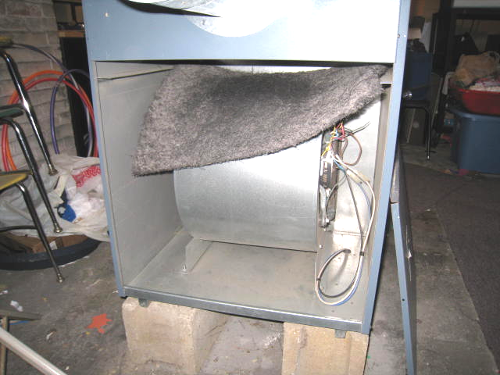

Air handling unit located in basement, note ill-fitting filter saturated with dust/debris

Picture 2

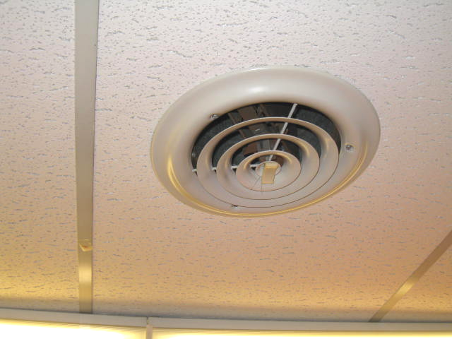

Ceiling-mounted supply vent

Picture 3

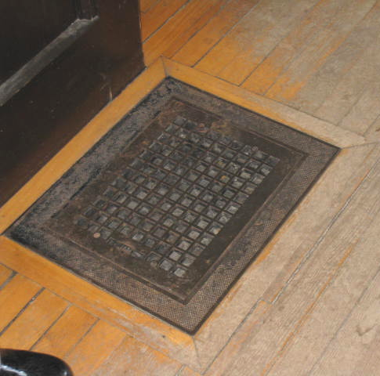

Floor-mounted supply vent

Picture 4

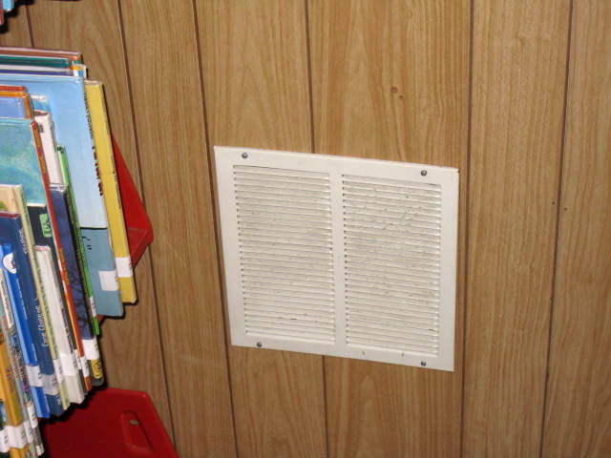

Return vent

Picture 5

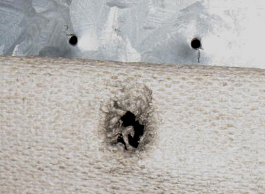

Holes/breaches in ductwork

Picture 6

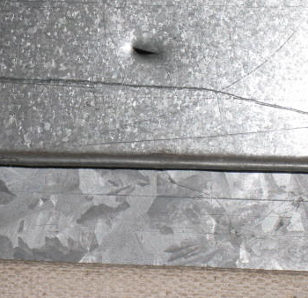

Hole/breach in ductwork

Picture 7

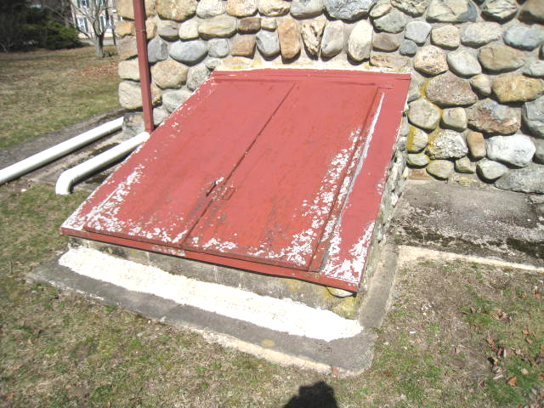

Exterior view of metal bulkhead

Picture 8

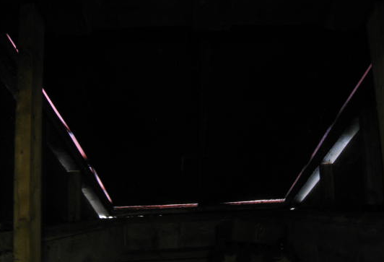

Interior view of metal bulkhead, note light penetration through breaches
Location | Carbon  Dioxide  (*ppm) | Carbon Monoxide  (*ppm) | Temp  (°F) | Relative  Humidity  (%) | PM2.5  (ug/m³) | Occupants  in Room | Windows  Openable | Ventilation |  |  | Remarks
 |  |  |  |  |  |  |  | Intake | Exhaust |  | Remarks
Background | 389 | ND | 46 | 14 | 7 |  |  |  |  |  | Cold, mostly sunny, winds West 8-15 mph, gusts up to 24 mph
Director’s Office | 713 | ND | 64 | 31 | 4 | 1 | Y | N |  | N | Worn/soiled carpet, some windows sealed for drafts
Restroom |  |  |  |  |  |  | Y | N |  | N | Open utility holes ceiling/floor
Main Circulation Area | 789 | ND | 72 | 28 | 6 | 1 | Y | N |  | N
Stacks 600’s | 731 | ND | 71 | 27 | 4 | 0 | Y | N |  | N
Stacks A-H | 708 | ND | 71 | 26 | 4 | 0 | Y | N |  | N | Peeling paint on wall
Stacks N-R | 775 | ND | 71 | 27 | 5 | 0 | Y | N |  | N
Broom/Custodial Closet |  |  |  |  |  |  |  |  |  |  | Flammable materials-excess items stored, recommend cleaning out
Reading Room | 734 | ND | 77 | 24 | 5 | 1 | Y | N |  | N | Accumulated items, window AC-sealed with plastic
Basement
Young Adult Area | 733 | ND | 72 | 24 | 5 | 1 | Y | N |  | N | Wall-to-wall carpet
Mechanical Room | 715 | ND | 72 | 26 | 7 | 0 | Y | N |  | N | Holes in ductwork, filter failing/saturated with dust/debris
Children’s Library | 728 | ND | 64 | 29 | 5 | 3 | Y | N |  | N | Dehumidifier, portable AC

Actions on MDPH Recommendations, Dighton Public Library, Dighton, MA

The following is a status report of action(s) taken on MDPH recommendations made in the 2003 MDPH report (in bold) based on reports from maintenance staff, documents, photographs and MDPH staff observations.
- Remove and replace any mold contaminated/water-damaged gypsum wallboard and wooden baseboard/trim.
- Action: Water-damaged gypsum wallboard and wooden baseboard/trim was removed/replaced.
- Consider removing basement carpets with replacing an alternative sound attenuating floor tile.
- Action: Basement carpeting was not replaced, however replacing it is currently under consideration.
- Consider repairing/replacing damaged wooden window frames to prevent water penetration. Replace broken windowpanes.
- Action: Damaged window frames at the ground level have been filled with caulk; more work is needed. Broken windows were replaced.
- Repair drainage system. Consider installing gutters/downspouts on the main entrance peaked roof to direct rainwater away from the building.
- Action: Gutters/downspouts were repaired/installed. At the time of the assessment one downspout/elbow extension was in need of repair.
- Repair breaches in the building envelope including cracks in walls and tarmac, missing/damaged flashing, and spaces around bulkheads. Consider replacing damaged wooden bulkhead with metal.
- Action: The wooden bulkhead was removed and replaced with a new above-ground entryway. Other breaches were sealed.
- Consider consulting a building engineer about options to further improve drainage and prevent future flooding of the basement.
- Action: Drainage was reportedly improved around the building, no further flooding events over the past several years were reported.
- Keep windows closed during hot, humid weather to maintain indoor temperatures and avoid condensation problems.
- Action: Additional window air conditioner units were added, giving the ability to keep windows closed during hot, humid weather.
- Consider discontinuing use of the ozone generator.
- Action: The ozone generator is no longer in use.
- Seal utility holes and openings in the restroom, as well as in the common wall shared between the boiler room and children’s area to eliminate pathways for movement of odors into occupied areas.
- Action: This recommendation was not implemented.
- Seal hole in ductwork for oil burner.
- Action: This recommendation was implemented.
- Consider installing a local exhaust fan in the restroom to remove excess moisture and odors.
- Action: This recommendation was not implemented.

