Disable Persons Protection
Commission
Sexual Assault Response Unit

Empowering and Inspiring
Survivors and Service Providers

Increasing Accessibility to Trauma Services

What are the Benefits of Having a Service Focused Sexual Assault Unit within APS?

CONNECTIONS EQUAL INCREASED ACCESS

- It is important for survivors with disabilities and providers to have access to services and consultations as soon as possible.
- Statewide Partnerships with:
  - Rape Crisis Centers
  - Department of Developmental Services
  - Civil Legal Aid Lawyers
  - Sexual Assault Nurse Examiners
  - Trauma Clinicians
- Consistent Outreach & Education for Persons with Disabilities

Sexual Assault
Response Unit
DPPC
Increasing Access to Trauma Services for
survivors with disabilities

Sexual Assault Response Unit

- The team includes Navigators & Peer Support Leaders

- Our team offers these statewide services:
- Regional Navigators
- Peer Support Services
- Consultation
- Emergent Case Intervention
- Outreach
- State-Wide Collaborations

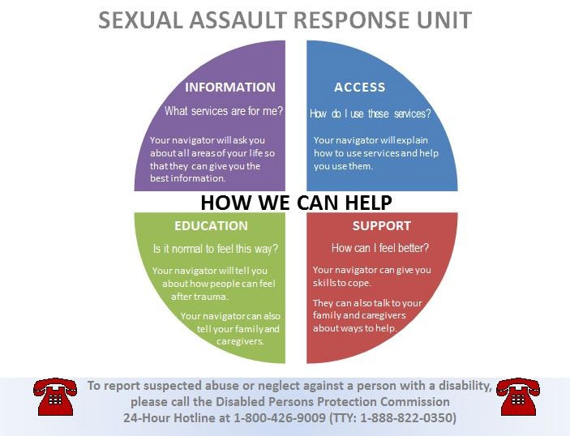

Sexual Assault Response Unit
Who are the navigators?

Navigators are here to help!

Bonnie Crehan wants all survivors of sexual assault to know that WE BELIEVE YOU!

Navigators are advocate for survivors. We want to make sure your voice and choice are heard. We work together with you, your providers and others to help you get what you want and need. Navigators can help you access medical care such as SANE, legal services, counseling, peer support, and any other services you may need. We are her to work with you as a team. We believe you!

If you would like to speak with Bonnie about how she can help you, please call: 617-727-6465 extension 304. You, your family, or providers can call me.

My work hours are Monday through Friday 8:30 a.m. to 4:30 p.m. If you call me after my work hours, you can leave me a message and I will call you back during my worktime.

My office is located at 300 Granite Street, Braintree, MA. I can meet you at my office or we can find a location that you feel comfortable meeting.

I can talk with your support people to help make this feel safe for you.

When We Work With Clients

- We use a team approach.
- Issue Spotting
- We inform and support clients, families and teams
- We help create connections between clients and families

Challenges

- Access to survivors
- Working through systems
- Supporting providers in making sure there are accessible services
- Access for clients to Healthy Relationship and Sexuality training

Peer Support

- Accessibility – Promoting Inclusiveness
- Education – How to best help persons with disabilities
Start by believing
- Empowerment – Peer to Peer Support
- Path to Healing – Sharing struggles and strengths

Peer Support Program

Peer Support Leaders promote empowerment, education and accessibility for sexual assault survivors with disabilities through peer support leadership.
- As a Peer Support Leader, I connect with my peers to make sure they do not feel alone. I share my experiences to make them heal.
- I outreach to other professionals to educate them on different ways they can work with my peers.
- I advocate for inclusiveness within our community through advocacy and national networking to make sure my peers gave access to the services they need.

Meet Leigh Ann

- I am a sexual assault survivor
- I am a self-advocate
- As a Peer Support Leader, I talk to survivors of sexual assault who have disabilities. I listen to them.
- I like to share positive quotes with survivors because I want to make them feel better.
- I enjoy talking with my peers about self-care activities. It is important for us to find new ways to take care of ourselves.
- It is important for survivors to know they are not alone and what they feel is ok.

Leigh-Ann
Peer Support Leader

- I put together outreach materials for DPPC/SARU events
- I host tables for the DPPC and network in the community
- I am on the DPPC Teamwork Committee, and started DPPC’s first coat drive.
- I created a Self-Care BINGO Game
- I train rape crisis center counselors, and others, on how to work with individuals who have a disability and have had trauma

Leigh-Ann
Peer Support Leader

- I have been to many programs to talk about the Sexual Assault Response Unit
- I have trained staff at the Department of Developmental Services on what services the Sexual Assault Response Unit can offer
- I share my survivor story through public speaking at events, conferences, and trainings throughout the state of Massachusetts

Leigh-Ann
Peer Support Leader

- I meet with survivors of sexual assault that have a disability
- I am creating a Survivor Skills Group at the DPPC for my peers
- I am working with my State Senator and Representatives to come and visit the DPPC

Leigh-Ann’s
Self-Care Bingo
- I have created a Self-Care Bingo game because I like to talk to my peers about new ways to take care of themselves.
- Self-care is important to me because it helps me stay calm when I am feeling stressed.
- My Bingo game includes both words and pictures.

Self-Care Bingo
- I do my own outreach. I call and email organizations that advocate for all people with disabilities and their families, such as The Arc of Cape Cod in Massachusetts.
- I go to these organizations to play Self-Care Bingo.

- When I play with my peers, I ask the individuals what their favorite self-care activities are and I explain why self-care is important to me.

Self-Care Bingo
- I keep track of my outreach data by using an Excel spread sheet that contains contact information including addresses, emails and phone numbers of the organizations.
- I stay in touch with these organizations by sending “follow-up emails” within a week to thank them for letting me come and play Bingo.
- If you are interested in hearing more about my Self- Care Bingo, please feel free to reach out to me. I will pass around my business card.

Leigh Ann’s Self-Care Bingo
Sing | Talk to Friends | Talk to Someone You Trust
Read | FREE SPACE | Take A Nap
Adult Coloring Book | Listen To Music | Yoga

My Self-Care Plan

My Self-Care Web is to think of new ideas to take care of you. Add an activity that you enjoy to each circle

Leigh-Ann’s Message

- Being a survivor has taught me to SPEAK UP for myself as well as ADVOCATE for myself and others. I help others as much as I can. By doing this, I am a stronger person because I am less angry and less afraid.
- My message today to all survivors is SPEAK UP, SPEAK OUT, AND KEEP GOING. Don’t let others make decisions for you. Tell them how you feel and what you want. TAKE CONTROL, IT’S YOUR LIFE!

Working Together
Navigators and Peer Support Leaders work together to address challenges and work towards success by providing:
- Support for survivors

- Outreach to Community

- Cross-Training within our team and the DPPC

- Support and encouragement to each other

Disabled Persons Protection Commission (DPPC) Sexual Assault Response Unit (SARU)

Thank you! Questions?

