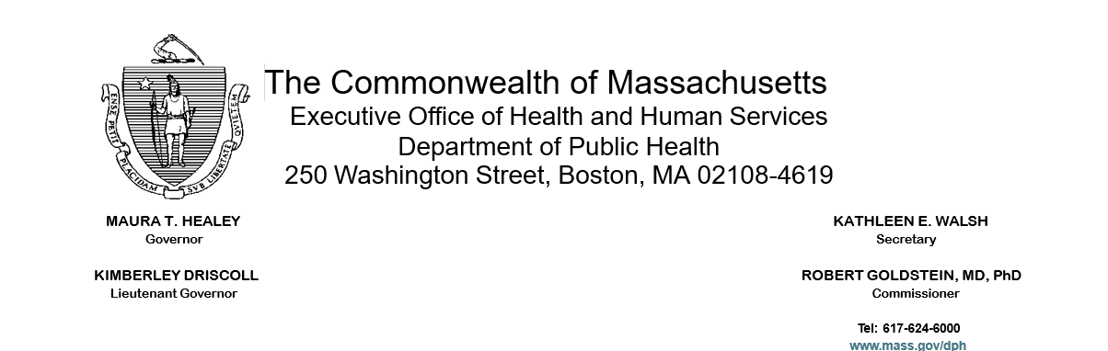

To: BSAS Licensed or Approved Substance Use Disorder Programs

From: Deirdre Calvert, Director, Bureau of Substance Addiction Services

Re: Dispensation of Opioid Antagonists for Overdose Reversal Upon Treatment Discharge

Date: July 9, 2025

Background and Purpose

Effective July 1, 2025, Section 5 of Chapter 285 of the Acts of 2024 established requirements for the dispensing of opioid antagonists for overdose reversal, as defined in section 19B of Chapter 94C (collectively Opioid Antagonists), to certain patients upon discharge from substance use disorder treatment facilities.

The purpose of this memo is to notify substance use disorder (SUD) treatment programs of these dispensing requirements and clarify the Department of Public Health’s Bureau of Substance Addiction Services’ (BSAS) expectations with regard to this requirement. As described in this guidance, substance use disorder treatment programs shall dispense Opioid Antagonists at discharge to patients who have a history of or are actively using opioids, been diagnosed with an opioid use disorder, or experienced an opioid-related overdose.

Requirements for Dispensation of Opioid Antagonists by Substance Use Disorder Treatment Programs

Pursuant to Section 5 of Chapter 285 of the Acts of 2024, upon discharge of a patient with an opioid use disorder, history of using opioids and/or prior opioid-related overdose(s), SUD treatment programs are required to educate the patient on the use of Opioid Antagonists, such as naloxone, and dispense not less than 2 doses of an Opioid Antagonist to the patient or a legal guardian. All programs licensed or approved by BSAS are expected to comply with this requirement.

The requirements under 105 CMR 164.072 and 164.572 specify that information related to history of overdose and history of substance use must be collected as part of the patient/resident assessment. In determining whether a patient/resident has an opioid use disorder, a history of using opioids, and/or prior opioid related overdoses, the Department expects providers to exercise their best clinical judgment and provide Opioid Antagonists at discharge in accordance with the law. Additionally, 105 CMR 164.075 (A)(3) requires a written discharge summary within the patient/resident record documenting patient's/resident's substance use at discharge, including risk of overdose and recommendations for follow-up services; documentation of the provision of Opioid Antagonists or a prescription of Opioid Antagonists must be included in the discharge summary.

As defined in M.G.L. c. 94C § 1, “dispense” means “to deliver a controlled substance to an ultimate user or research subject or to the agent of an ultimate user or research subject by a practitioner or pursuant to the order of a practitioner, including the prescribing and administering of a controlled substance and the packaging, labeling, or compounding necessary for such delivery.”

The applicable Opioid Antagonists to be dispensed to certain individuals upon discharge are defined in M.G.L. c. 94C § 19B and include naloxone and any other drug approved by the federal Food and Drug Administration as a competitive narcotic antagonist used in the reversal of overdoses caused by opioids.

BSAS clarifies that SUD treatment programs shall not utilize the Community Naloxone Program (CNP) to meet the requirements to dispense Opioid Antagonists upon discharge. Any changes to the existing CNP policies will be communicated to programs through the release of new program policies, available on the Community Naloxone Program (CNP) webpage.

Resource Documents and Training

Wherever possible, SUD treatment programs should utilize a patient’s pharmacy or medical benefit to bill for Opioid Antagonists. BSAS has worked with vendors to develop resource guides on how to bill for Opioid Antagonists in emergency departments with a hospital pharmacy, ambulatory sites with a collocated outpatient or retail pharmacy, and ambulatory and inpatient treatment sites without a collocated outpatient or retail pharmacy.

All resource documents can be found on the Massachusetts Substance Use Helpline, including:
- Training and resources for inpatient healthcare settings without an on-site pharmacy, including withdrawal management services; clinical stabilization services; transitional support services; residential support services; and freestanding psychiatric hospitals. Training covers workflow and protocols, methods to implement requirements in a financially sustainable way, and documentation requirements. The training is intended for program directors, clinical directors, and medication specialists.
- An overview of payment opportunities for substance use disorder services furnished to MassHealth Members in hospital settings.
- Guidance for Emergency Departments (ED) with a hospital pharmacy; ambulatory sites with a collocated outpatient or retail pharmacy; and ambulatory sites without a collocated outpatient or retail pharmacy.

Additional Resources

Individuals may purchase Opioid Antagonists at a pharmacy or store. Pharmacy and retail Opioid Antagonists can be billed to an individual’s insurance. Individuals with an active Massachusetts residential address who experience barriers to purchasing Opioid Antagonists are eligible to receive one no-cost Opioid Antagonist kit a year through the YouCan Save a Life webpage.

Resources on overdose prevention trainings and additional information about Opioid Antagonists can be found on the BSAS website.

For information on recommended harm reduction services and supports for healthcare providers please see the guidance entitled, “Harm Reduction Services in Healthcare Settings for People Who Use Drugs (PWUD)”.

Information on Substance Use Disorder Treatment Program Requirements 105 CMR 164.000: https://www.mass.gov/info-details/information-for-licensed-substance-use-disorder-treatment-programs

Regulation - Licensure of substance use disorder treatment programs: https://www.mass.gov/regulations/105-CMR-16400-licensure-of-substance-use-disorder-treatment-programs

For questions or additional information, please contact Therese Claxton at Therese.M.Claxton@mass.gov.

“Substance use disorder treatment facility”, a facility licensed or approved by the department or the department of mental health to offer treatment for substance use disorder, including, but not limited to: (i) withdrawal management services; (ii) clinical stabilization services; (iii) transitional support services; (iv) residential support services; (v) community behavioral health center services; (vi) office-based opioid or addiction treatment services; or (vii) inpatient or outpatient substance use disorder services. Chapter 285 of the Acts of 2024.

