 | Commonwealth of Massachusetts  City/Town of  Disposal System Construction Permit  Form 2A |  | Number
 | DEP has provided this form for use by local Boards of Health. Other forms may be used, but the information must be substantially the same as that provided here. Before using this form, check with the local Board of Health to determine the form they use.
 | Permission is hereby granted to:
Important: When filling out forms on the computer, use only the tab key to move your cursor - do not use the return key.  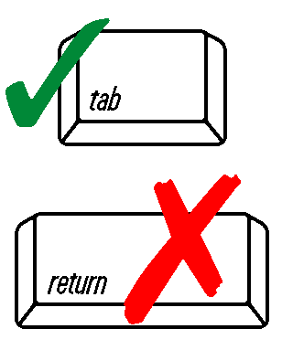 | Name | Name of Company
 | Address
 | City/Town | State |  | Zip Code
 | to perform the following work on an on-site sewage disposal system:
Construction
Repair or replacement
Repair or replacement of system components
Facility Address

State

 | City/Town | State |  | Zip Code
 | Owner | Telephone Number
 | The work to be performed is further described in the Application for Disposal System Construction Permit. The applicant recognizes his/her duty to comply with Title 5 and the following local provisions or special conditions:
 | All construction must be completed within three years of the date below.
 | Approved by | Date
 | Title

