Division 6.2 Infectious
Substance Shipping Guide: Classification, Packing, Marking and Labeling



Massachusetts Department of Public Health

William A. Hinton State Laboratory Institute

The information in this booklet is current as of July, 2012
Introduction

This booklet is designed to provide general information and guidance re- garding the packaging and shipping of Division 6.2 Infectious substances. It is not a comprehensive list of all regulations. Consult the Department of Transportation (DOT), International Air Transport Association (IATA) and United States Postal Service (USPS) regulations for current policies and procedures.

The companies your facility uses for shipping or courier services may have additional documentation requirements for airway bills or shipper’s decla- rations that are not covered in this guide. Please contact your shipping partners for specific requirements.



The information in this booklet is current as of July, 2012
Regulatory Agencies

Department of Transportation (DOT)
In the United States, the Department of Transportation is the regulatory authority for hazardous materials sent by all modes of transport, except the U.S. Mail. DOT is the U.S. authority for assuring compliance with the transportation regulations.

Website: http://hazmat.dot.gov
Contains links to the regulations, free publications, and DOT training schedules. The Office of Hazardous Materials Safety website formulates, issues, and revises Hazard- ous Materials Regulations (HMR) under the Federal Hazardous Materials Transporta- tion Law.

Hazardous Materials INFO LINE: 1-800-HMR49-22 (1-800-467-4922)
1-202-366-4488 (Washington, D.C.)

International Air Transport Association (IATA) / International Civil Aviation Or- ganization (ICAO)
ICAO governs the international transport of dangerous goods or hazardous materials by air. The professional airline regulatory document, IATA Dangerous Goods Regula-
tions takes the ICAO regulations and adds additional industry requirements. A shipper who follows IATA regulations is also in compliance with ICAO.

Main Website: http://www.iata.org
Website: http://www.iata.org/whatwedo/cargo/dangerous_goods/index.htm Contains Packing Instructions 620, 650, up-to-date checklists for dry-ice and non- radioactive shipments, and addenda to the most current edition of the Dangerous Goods Regulations.

Dangerous Goods Information HOTLINE: Phone: 1-514-390-6770
Email: dangood@iata.org

United States Postal Service (USPS or U.S. Mail)
The USPS is an independent federal agency that provides mail service in the United States. Regulations affecting the transport of hazardous materials in the US mail, in- cluding Division 6.2 materials, are codified in the Code of Federal Register, 38 CFR and published in the Domestic Mail Manual.

Website: http://pe.usps.gov/text/dmm300/601.htm#1_0
This contains the 601 Mailability section of the Domestic Mail Manual. See section
10.17 for regulations regarding Infectious Substances (Hazard Class 6, Division 6.2). See section 10.20 for regulations regarding Dry Ice.

The information in this booklet is current as of July, 2012
Classification of Division 6.2 Infectious Substances

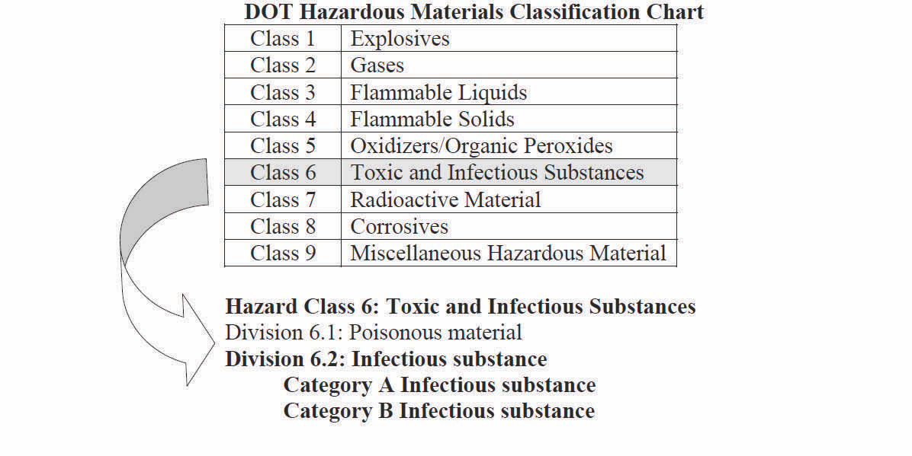
Source: DOT, IATA, USPS

Division 6.2 Infectious Substance:
A material known or reasonably expected to contain a pathogen, such as bacteria, viruses, rickettsiae, parasites, fungi or prions, that can cause disease in humans or animals.

Category A An infectious substance transported in a form capable of causing permanent disability or life-threatening or fatal disease in otherwise healthy humans or animals when exposure occurs.

Category B An infectious substance not in a form capable of causing permanent disability or life- threatening or fatal disease in otherwise healthy humans or animals when exposure occurs.

Exempt Human Specimen or Exempt Animal Specimen Exempt Human Specimen or Exempt Animal Specimen
DOT does not have this category in their regulations! According to DOT exempt human or animal speci- mens are not subject to requirements as Division 6.2 material. Please refer directly to IATA and USPS regulations, as well as your own facility guidelines to determine what is acceptable to be sent in this cate-
gory. DOT does not have this category in their regulations! According to DOT exempt human or ani- mal specimens are not subject to requirements as Division 6.2 material. Please refer directly to IATA and USPS regulations, as well as your own facility guidelines to determine what is acceptable to be sent in this category.

Culture: An infectious substance containing a pathogen that is intentionally propagated. A cul- ture does not include a human or animal patient specimen as defined below, regardless of how it is transported (with OR without transport media).
Note: The definition of cultures refers to any infectious substance containing a pathogen that has been intentionally amplified or propagated. This includes laboratory stock culture AND presumptive positive cultures intended for diagnos- tic and clinical purposes.
Patient Specimen: Human or animal materials collected directly from human or animals and transported for research, diagnosis, investigational activities, or disease treatment or preven- tion. Patient specimens include excreta, secreta, blood and its components, tissues and tissue swabs, body parts, and specimens in transport media (transwabs, culture media, blood culture bottles).

The information in this booklet is current as of July, 2012
Required Packing

The Department of Transportation (DOT), International Air Transport Association (IATA), and the U.S. Postal Service (USPS or U.S. Mail) require regulated division 6.2 material to be trans- ported in triple packaging. The primary and secondary packaging for Category A and Cate- gory B infectious substances must be enclosed in a rigid outer shipping container.

Primary receptacle(s) and/or secondary packaging(s):

Must be leak proof and sift proof.

For liquids: Include enough absorbent material to absorb the total amount of liquid should the primary receptacle leak or break.

For fragile or multiple receptacles: Cushion to prevent damage in transport.

For air transport, which includes the U.S. Mail, the primary receptacle or secondary packag- ing must be capable of withstanding, without leakage, an internal pressure producing a pressure differential of not less than 95 kPa.

Place an international biohazard symbol on any inner packaging that contains blood or is contaminated with human blood. Additionally, affix the label to all secondary containers of packages being transported by U.S. Mail.
International Biohazard Symbol: 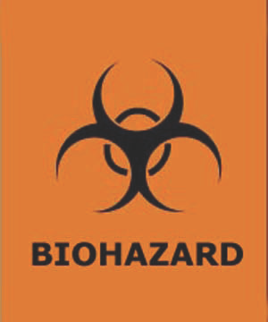

The information in this booklet is current as of July, 2012
Required Markings for Category A Substances

1. Division 6.2 Infectious substance hazard label
2. Proper shipping name and UN/ID number
“Infectious substance, affecting humans UN2814” OR “Infectious substance, affecting animals UN2900”
3. Responsible person: name and phone number, must be available 24/7 (see page 7 for additional information)
4. UN packaging specification number
5. Air transport / Cargo Only handling label (if necessary, see page 10 for additional information)

1.

2. Infectious substances, affecting humans
UN2814

3. Responsible person: Name, phone # (available 24/7)
4.

Orientation arrows are required for packages containing Cate- gory A infectious substances (UN2814 and UN2900) with more than


50 mL (1.7 fl. oz). Place arrows on TWO opposite sides of the box. The rectangular border around the arrows is optional.

The information in this booklet is current as of July, 2012
Required Markings for Category B Substances

1. UN3373 marking
2. Proper shipping name: “Biological substance, category B”
3. Responsible person: Name and phone number; available during business hours
(see below for additional details)

1.

2. Biological Substance, category B
3. Responsible person: Name, phone # (available during business hours)

Responsible Person Contact Information:

The responsible person must be knowledgeable of the package contents and must be able to provide comprehensive emergency response information and incident mitigations information for the material.
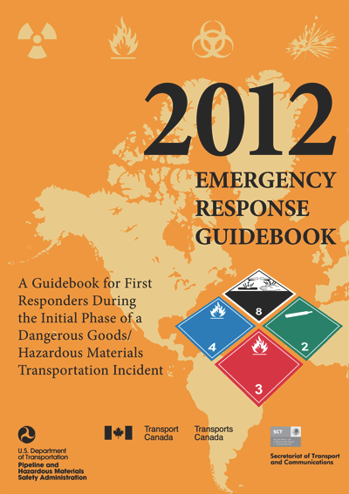

Go to:

http://www.phmsa.dot.gov/hazmat/erg2012

The information in this booklet is current as of July, 2012

Required Markings for Dry Ice

Markings and hazard labels for dry ice are required when sent by air or water. In addi- tion, these markings and labels may be required on packages transported by commer- cial carriers and couriers by land.

The labels and markings required for dry ice are used in addition to any other labels and markings required for other hazardous materials in the package.

1. Class 9 Miscellaneous hazard label
2. Proper shipping name and UN/ID Number: “Carbon dioxide, solid” or “Dry ice” and UN1845
3. Net quantity of dry ice

1.

2.

3.

Or 2. & 3.
Carbon dioxide, solid
(Dry ice) UN1845

kg.

The information in this booklet is current as of July, 2012

Required Overpack Markings

Overpack markings are required when the overpack obscures the markings and labels of inner packages.

Use the “Overpack” marking in addition to duplicating all markings and inner la- bels that are not visible through the overpack. UN package specification mark- ings are not required to be duplicated.

Inner Packagings

UUNN33337733
UN3373

Biological Substance, Category B
Responsible Person:
Biological Substance, Category B
Responsible Person:

UN3373 Overpack

Biological Substance, Category B Responsible Person:
Name, phone #

Net weight: _g / kg

The information in this booklet is current as of July, 2012

Cargo Only Handling Label

Use the “Cargo Only” handling label for air transport and on packages that exceed the quantity limits for transport by passenger aircraft. This label would only be used for Category A shipments.

1. Affix in addition to other required markings or hazard labels.

2. Affix to the same surface of package and near the required hazard labels.

3. This label should never be used on packages transported by U.S. Mail.

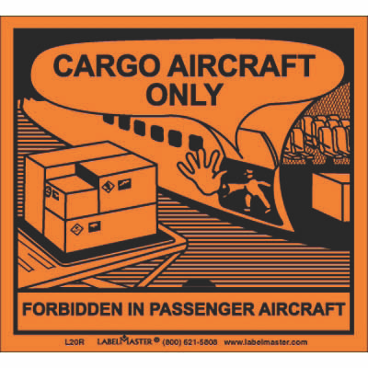

The information in this booklet is current as of July, 2012

MDPH State Laboratory Institute Contact Information

If you have any questions regarding the material in this publication or general packaging and shipping questions, please contact the Massachusetts Department of Public Health State Laboratory Institute Packaging and Shipping liaison.

Deborah Carter, MT(ASCP)
Laboratory Response Network Coordinator
Bioterrorism Response Laboratory
William A. Hinton State Laboratory Institute
305 South Street, Jamaica Plain, MA 02130

Telephone: 617-983-6675
Fax: 617-983-6887
Email: deborah.carter@state.ma.us

The State Laboratory Institute also offers “Packaging and Shipping: Division 6.2 Hazardous Materials” courses on a regional basis several times per year. Please contact Deborah Carter for more details.



Massachusetts Department of Public Health
William A. Hinton State Laboratory Institute
305 South Street, Jamaica Plain, MA 02130

Website: http://www.mass.gov/dph/bls

The information in this booklet is current as of July, 2012

