Background

INDOOR AIR QUALITY
WATER DAMAGE ASSESSMENT

Division of Administrative Law Appeals
14 Summer Street
Malden, MA

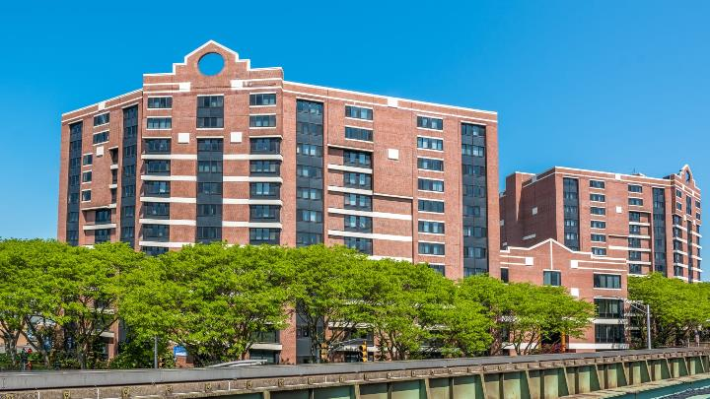

Prepared by:
Massachusetts Department of Public Health
Bureau of Environmental Health
Indoor Air Quality Program
October 2021
Building: | Division of Administrative Law Appeals (ALA)
Address: | 14 Summer Street, floors 2 and 4, Malden, MA
Assessment Requested by:: | Edward B. McGrath  Chief Administrative Magistrate  Division of Administrative Law Appeals
Reason for Request: | Water damage and possible condensation impact
Date of Assessment: | September 3, 2021
Massachusetts Department of Public Health/Bureau of Environmental Health (MDPH/BEH) Staff Conducting Assessment: | Mike Feeney, Director, Indoor Air Quality (IAQ) Program

Introduction
The IAQ Program conducted an assessment of the ALA on September 3, 2021, to assess reports of IAQ concerns, with a focus on whether the office was adversely impacted by the extended hot, humid weather experienced in New England during the summer of 2021 as well as identify other conditions that may impact IAQ.
The ALA occupies portions of the second and fourth floor of a multi-story mixed use commercial/residential building constructed in the 1980s. The building has a brick façade and a flat roof. It is located in downtown Malden near the Malden Center Orange Line station. Other office tenants occupy space in the building, which also contain residential apartments. There is a parking garage behind/below the building. Prior to occupancy, the IAQ Program conducted an assessment of the ALA, which is included as Appendix A of the report.

Methods
Air tests for temperature, relative humidity and dew point were taken with the TSI, Q-Trak, IAQ Monitor 7565. Surface temperatures of floors, walls and fresh air diffusers were measured using a laser thermometer. BEH/IAQ staff also performed a visual inspection of building materials for water damage and/or microbial growth and examined the space for the presence of odors or other environmental concerns. Please refer to the IAQ Manual for methods, sampling procedures, and interpretation of results (MDPH, 2015).

Results and Discussion
The following is a summary of testing results (Table 1):
- Temperature was within or very close to the MDPH recommended range of 70°F to 78°F in areas tested.
- Relative Humidity IAQ staff visited the ALA when outdoor relative humidity was measured at 50% (Table 1). Relative humidity indoors ranged from 50-55% which was within the MDPH IAQ comfort level of 40 % to 60%. In general, with a functioning HVAC system operating in chiller mode, indoor relative humidity would be expected to be equal to or less than outdoor relative humidity.

Ventilation
Fresh air is supplied by an air handling unit (AHU) located on the roof. The building uses ducted supply vents and a plenum return system. The heating, ventilation and air conditioning (HVAC) system was balanced prior to this IAQ assessment.

Microbial/Moisture Concerns
It is important to note that Massachusetts has experienced extended periods of relative humidity during the summer of 2021. This July was the wettest ever recorded in Massachusetts, and the three-month period from June through August, known as the meteorological summer, was tied for the warmest on record across the United States (HG, 2021), and is the fourth-wettest on record, according to the National Oceanic and Atmospheric Administration’s Centers for Environmental Information. The three-month period was also the third warmest (NOAA, 2021) and New England experienced repeated heavy rainstorms during this time. Water-damaged ceiling tiles were noted in the hallway near the hearing rooms. This water damage is attributed to a roof leak during a heavy rainstorm.

Building Materials Prone to Condensation
The key to managing condensation in hot, humid weather indoors is understanding dew point. When warm, moist air passes over a cooler surface, condensation can form. Condensation is the collection of moisture on a surface at or below the dew point. The dew point is the temperature that air must reach for saturation to occur. If a building material/component has a temperature below the dew point, condensation will accumulate on that material. Over time, condensation can collect and form water droplets.
A method to locate areas in a building prone to condensation (floors and walls in direct contact with soil on the ground floor) is to measure air and building material temperatures using a laser thermometer (Table 1). If a wide temperature range exists between measurements, the building materials at the colder end of the range may be prone to moistening with condensation if exposed to hot, humid weather for extended periods of time. According to the test results in Table 1, all areas or building components (floors, walls or HVAC system fresh air diffusers) had surface temperatures that were above the dew point. No section of the ALA has floors or walls in direct contact with soil, which is where buildings are most likely to have components moistened by condensation. It is important to note that if fresh air supply vents are equal to or below dew point temperatures, the vents will gather condensation. No visible water stains or condensation was noted on any fresh air diffusers at the time of this assessment.
According to American Society of Heating, Refrigerating and Air-Conditioning Engineers (ASHRAE), if relative humidity exceeds 70% for extended periods of time, mold growth may occur due to wetting of building materials even in the absence of liquid water droplets (ASHRAE, 1989). It is recommended that porous material be dried with fans and heating within 24 to 48 hours of becoming wet (US EPA, 2008, ACGIH, 1989). If porous materials are not dried within this time frame, mold growth may occur. Water-damaged porous materials cannot be adequately cleaned to remove mold growth.
Aside from the water damage noted previously in the hallway near hearing rooms, no water-damaged or moist materials were observed during the assessment, including ceiling tiles.

Conclusions/Recommendations
It is important to note that the extreme relative humidity and rain of this summer can make management of buildings in such weather challenging. The following documents can provide guidance that can be used to reduce the impact of hot, humid weather in buildings.
- Mold growth Prevention during Hot, Humid Weather https://www.mass.gov/service-details/preventing-mold-growth-in-massachusetts-schools-during-hot-humid-weather
- Remediation and Prevention of Mold Growth and Water Damage in Public Schools https://www.mass.gov/service-details/remediation-and-prevention-of-mold-growth-and-water-damage-in-public-schools-and
- Methods for Increasing Comfort in Non-air-conditioned Schools https://www.mass.gov/doc/methods-for-increasing-comfort-in-non-air-conditioned-schools/download

In view of the findings at the time of assessment, the following recommendations are made:

Ventilation Recommendations
- Examine whether the set point for chilling should be raised in order to avoid condensation in concert with limiting the introduction of unconditioned air into the building.
- Have the HVAC system balanced every 5 years in accordance with SMACNA recommendations (SMACNA, 1994).

Water Damage Recommendations
- Work with an HVAC contractor to determine if the HVAC system can be operated or modified to provide additional dehumidification while in chilling mode.
- Use dehumidifiers in the building until outdoor conditions are cooler and drier and building heating is being used. Maintain all dehumidifiers and regularly remove water and clean receptacles to avoid stagnant water, odors, and the potential for leaks.
- Avoid storing porous materials (such as cardboard) in direct airflow of fresh air supplies or on the floor to avoid potential moistening through condensation.
- Identify the source of water damage to ceiling tiles and gypsum wallboard and repair as needed. Once repaired, replace ceiling tiles in accordance with the EPA guideline “Mold Remediation in Schools and Commercial Buildings” (US EPA, 2008).

REFERENCES
ACGIH. 1989. Guidelines for the Assessment of Bioaerosols in the Indoor Environment. American Conference of Governmental Industrial Hygienists, Cincinnati, OH.
ASHRAE. 1989. Ventilation for Acceptable Indoor Air Quality. American Society of Heating, Refrigeration and Air Conditioning Engineers. ANSI/ASHRAE 62-1989
HG. 2021. Mold keeps South Hadley High School shuttered. Hampshire Gazette. https://www.gazettenet.com/South-Hadley-High-School-still-closed-amid-mold-remediation-42413519
MDPH. 2015. Massachusetts Department of Public Health. Indoor Air Quality Manual: Chapters I-III. Available at: https://www.mass.gov/lists/indoor-air-quality-manual-and-appendices
NOAA. 2021. Summer 2021 neck and neck with Dust Bowl summer for hottest on record. National Oceanic and Atmospheric Administration, 1401 Constitution Avenue NW, Room 5128, Washington, DC 20230 https://www.noaa.gov/news/summer-2021-neck-and-neck-with-dust-bowl-summer-for-hottest-on-record
SMACNA. 1994. HVAC Systems Commissioning Manual. 1st ed. Sheet Metal and Air Conditioning Contractors’ National Association, Inc., Chantilly, VA.
US EPA. 2008. “Mold Remediation in Schools and Commercial Buildings”. Office of Air and Radiation, Indoor Environments Division, Washington, DC. EPA 402-K-01-001. September 2008. Available at: http://www.epa.gov/mold/mold-remediation-schools-and-commercial-buildings-guide.

Background

INDOOR AIR QUALITY
PRE-OCCUPANCY ASSESSMENT

Division of Administrative Law Appeals
14 Summer Street
Malden, MA

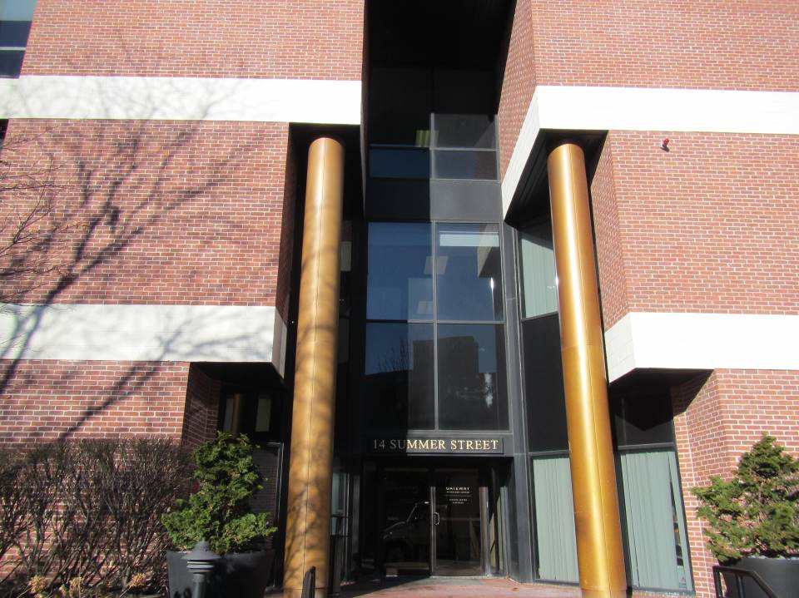

Prepared by:
Massachusetts Department of Public Health
Bureau of Environmental Health
Indoor Air Quality Program
January 2019
Building: | Division of Administrative Law Appeals (ALA)
Address: | 14 Summer Street, floors 2 and 4, Malden, MA
Division of Capital Asset Management and Maintenance (DCAMM) Project Manager: | Lorna J. Moritz, Project Manager,  Division of Capital Asset Management & Maintenance
Date of Pre-Occupancy Assessment: | January 11, 2019
Massachusetts Department of Public Health/Bureau of Environmental Health (MDPH/BEH) Staff Conducting Assessment: | Ruth Alfasso, Environmental Engineer/Inspector, Indoor Air Quality (IAQ) Program
Building/Ventilation:
This office will be occupying portions of the second and fourth floor of a multi-story mixed use commercial/residential building originally constructed in the 1980s. The building has a brick façade and a flat roof. It is located in downtown Malden near the Malden Center Orange Line station. Other office tenants occupy spaces in this building which also contains residential apartments. There is a parking garage behind/below the building.
The spaces were vacant for approximately two years prior to this tenancy. A full gut renovation was conducted prior to the ALA tenancy including heating, ventilation and air conditioning systems (HVAC). The space assessed is approximately 8,700 square feet on the two floors and approximately 50 employees will occupy the space.
Fresh air is supplied by an air handling unit (AHU) located on the roof. The building uses ducted supply vents and a plenum return system. The HVAC system was balanced prior to this IAQ assessment.

Previous Relevant Environmental History:
No current/active Massachusetts Contingency Plan projects for this building or property were found in the Massachusetts Department of Environmental Protection database.

Methods
Air tests for carbon monoxide, temperature and relative humidity were taken with the TSI, Q-Trak, IAQ Monitor 7565. Air tests for airborne particle matter with a diameter less than 2.5 micrometers were taken with the TSI, DUSTTRAK II Aerosol Monitor Model 8532. Screening for volatile organic compounds (VOCs) was conducted using a MiniRAE Lite Photo Ionization Detector. BEH/IAQ staff also performed a visual inspection of building materials for water damage and/or microbial growth and examined the space for the presence of odors or other environmental concerns.

Air Testing Results
Media sampled |  | MDPH Guideline/  Comparison Value |  | Measured Range |  |  | Comments
 |  |  |  | Outdoors/  Background |  | Indoors
Carbon Dioxide (CO₂) |  | < 800 parts per million (ppm) is preferred |  | 404 |  | 446 – 785 | HVAC system operating in occupied mode
Total Volatile Organic Compounds (TVOCs) |  | Equal to or below background level measured |  | ND |  | ND – 1.0 | Cleaning and other activities (e.g., carpet square installation) were occurring
Carbon Monoxide (CO) |  | Non-detectable (ND) or equal to or below background level measured |  | ND |  | ND
Particulate Matter 2.5 (PM2.5) |  | US EPA National Ambient Air Quality Standards (NAAQS) 35 μg/m³ or less |  | 9 |  | 8-14 | Cleaning and minor construction activities were occurring
Temperature |  | 70 to 78ºF |  | <32 ºF |  | 64-71 | HVAC set to 68 ºF at most thermostats
Relative Humidity (RH) |  | 40% to 60% |  | 15 |  | 11-22
ppm = parts per million | µg/m³ = microgram per cubic meter |  | ND = non-detectable

Discussion/Visual Observations
At the time of the assessment, the space was built out with some finishing activity taking place. New lighting, ceiling tiles, carpet squares, and vinyl flooring had been installed during the remodel. New cubicle furniture had been installed.
Some construction-related dust and debris was present on floors and other surfaces. The MDPH typically recommends wet-wiping surfaces and high-efficiency particulate arrestance (HEPA) vacuuming multiple times prior to occupancy. Additional cleaning once files, materials and furniture have been transported into the building will help remove any dust, debris and moisture brought in from outside during the move.
No water-damaged or moist materials were observed during the assessment, including ceiling tiles. There were two rooms with sinks on the 4th floor. One of these rooms was carpeted. There was also a water cooler in a carpeted area. Leaks/spills from sinks, refrigerators, and water dispensers can moisten carpeting and lead to microbial growth. It is recommended that these items be located in areas without carpeting or outfitted with a waterproof mat.
In a few offices, sunlight was seen streaming in the windows and solar heating or glare may be an issue during certain times of the year. Adjustable blinds had not yet been installed – these should be used as needed.
In some of the conference and hearing rooms, there were carbon dioxide sensors installed next to the thermostats, presumably to increase fresh air flow when levels rise. These items need to be calibrated or replaced periodically in accordance with manufacturer’s instructions.
The second floor elevator lobby opens directly to the top (outside) floor of the parking garage. This door should be kept closed with tight weather-stripping to ensure that automobile exhaust is not brought into the building.

Recommendations
In view of the findings at the time of assessment, the following recommendations are made:
- Set thermostats to the fan “on” setting (not “auto”), throughout the space to provide continuous filtration and ventilation during occupied hours.
- Use filters with a Minimum Efficiency Reporting Value (MERV) 8 or better in the AHU and ensure they are changed a minimum of twice per year.
- Consider balancing the HVAC system every five years (SMACNA, 1994).
- Have the carbon dioxide sensors calibrated or replaced in accordance with manufacturer’s instructions.
- Ensure that adjustable blinds and the location/setpoints of thermostats are able to provide comfortable temperatures throughout the year. Adjust as needed.
- Upon completion of renovations and moving, perform a final, thorough cleaning of the office space including wet-wiping of all surfaces and use of a HEPA vacuum of all carpeting prior to staff moving into the space.
- Consider placing refrigerators and water dispensers in areas without carpeting, or use a waterproof mat beneath them.
- Ensure that the door to the parking lot on the second floor elevator lobby is kept closed and has adequate weather-stripping to prevent vehicle exhaust from entering.
- Consistent with previously established protocol, once the space has been occupied for a minimum of three weeks, contact the BEH/IAQ Program to conduct a follow-up assessment of the space.

References
SMACNA. 1994. HVAC Systems Commissioning Manual. 1st ed. Sheet Metal and Air Conditioning Contractors’ National Association, Inc., Chantilly, VA.

