|  |
| --- |
| INDOOR AIR QUALITY ASSESSMENT  **Massachusetts Division of Banks**  **10 Riverside Drive**  **Lakeville, Massachusetts**  Prepared by:  Massachusetts Department of Public Health  Bureau of Environmental Health  Indoor Air Quality Program  November 2019 |

# Background

|  |  |
| --- | --- |
| **Building:** | Massachusetts Division of Banks (DOB) |
| **Address:** | 10 Riverside Drive, Lakeville, MA |
| **Assessment Requested by:** | Jamie Merrill-Blood, Project Manager, DCAMM |
| **Date of Assessment:** | November 5, 2019 |
| **Indoor Air Quality (IAQ) Program Staff Conducting Assessment:** | Cory Holmes, Environmental Analyst/Inspector, Indoor Air Quality (IAQ) Program |
| **Date of Building Construction:** | 1989 |
| **Reason for Request:** | General IAQ assessment, cleaning chemical concerns |
| **Building Type:** | Office building with two stories, red brick exterior and a peaked metal roof |
| **Building Population:** | Approximately 15 employees work in the DOB offices |
| **Windows:** | Unopenable |

# IAQ Testing Results

Please refer to the IAQ Manual for methods, sampling procedures, and interpretation of results (MDPH, 2015). The following is a summary of indoor air testing results (Table 1).

* ***Carbon dioxide*** levels were above the MDPH guideline of 800 parts per million (ppm) in all areas surveyed, indicating a lack of air exchange.
* ***Temperature*** was within or close to the recommended range of 70°F to 78°F in all areas tested.
* ***Relative humidity*** was within the recommended range of 40 to 60% in all areas tested.
* ***Carbon monoxide*** was non-detectable (ND) in all areas tested.
* ***Total volatile organic compounds (TVOCs)*** were ND in all areas tested.
* ***Fine particulate matter (PM2.5)*** concentrations measured were below the NAAQS limit of 35 μg/m3 in all areas tested.

## Ventilation

A heating, ventilating and air conditioning (HVAC) system has several functions. First it provides heating and, if equipped, cooling. Second, it is a source of fresh air. Finally, an HVAC system will dilute and remove normally-occurring indoor environmental pollutants by not only introducing fresh air, but by filtering the airstream and ejecting stale air to the outdoors via exhaust ventilation. Even if an HVAC system is operating as designed, point sources of respiratory irritation may exist and cause symptoms in sensitive individuals.

Mechanical ventilation in the DOB is provided by heat pumps located above the ceiling (Picture 1). Outside air is reportedly drawn from an exterior wall vent (Picture 2), supplied to the heat pumps through ducts, heated or cooled, and delivered to occupied areas via ducted supply diffusers (Picture 3). Return air is drawn via ceiling-mounted vents into the ceiling plenum (Picture 4). As demonstrated by the elevated carbon dioxide levels, the HVAC system should be adjusted to bring in more fresh air and or increase exhaust capabilities. Without proper supply/exhaust ventilation, normally-occurring environmental pollutants can build up and lead to indoor air/comfort complaints.

The HVAC system is controlled by digital thermostats. Thermostats examined had a fan switch with two settings, *on* and *auto*. When the fan is set to *on,* the system provides a continuous source of air circulation and filtration. The *automatic* setting on the thermostat activates the HVAC system at a pre-set temperature. Once the pre-set temperature is reached, the HVAC system is deactivated. Therefore, no mechanical ventilation is provided until the thermostat re-activates the system. At the time of assessment, two of the three thermostats were in the fan “auto” position (Picture 5). This thermostat setting can limit airflow. The MDPH typically recommends that thermostats be set to the fan *on* setting during occupied hours to provide continuous air circulation and filtration.

The BEH/IAQ Program recommends filters of a Minimum Efficiency Reporting Value (MERV) of 8, which are adequate in filtering out pollen and mold spores (ASHRAE, 2012). The filters in use at the DOB are reportedly MERV 8 and changed three times per year.

Also of note were local exhaust vents installed in bathroom ceilings (Picture 6). These vents were functional; however they were being ducted into the ceiling plenum. Restroom exhaust vents should be ducted directly to the outdoors (and not into the ceiling plenum or general HVAC system) to remove excess moisture and odors.

## Microbial/Moisture Concerns

It was reported that the building had several leaks, which have been repaired, including one in the DOB. No active leaks or water-damaged materials were observed or reported at the time of the assessment.

## Other IAQ Evaluations

### Volatile Organic Compounds (VOCs) and other respiratory irritants

Exposure to low levels of total VOCs (TVOCs) may produce eye, nose, throat, and/or respiratory irritation in some sensitive individuals. While levels of TVOCs were non detect, IAQ staff examined rooms for products containing VOCs and noted air fresheners, scented hand sanitizers, cleaners, and other materials within the building (Table 1). These products have the potential to be irritants to the eyes, nose, throat, and respiratory system of sensitive individuals and their use should be minimized. Hand sanitizer products may contain ethyl alcohol and/or isopropyl alcohol, which are highly volatile and may be irritating to the eyes and nose. These products may also contain fragrances to which some people may be sensitive.

It was reported that a recent complaint occurred after the use of a bleach product used to clean a restroom. Bleach products can be irritating, particularly if not diluted properly and/or used without proper ventilation (e.g., improperly ducted restroom exhaust). At the time of assessment no lingering odors were detected.

### Other Conditions

Most occupied areas had carpet squares. The Institute of Inspection, Cleaning and Restoration Certification (IICRC), recommends that carpeting be cleaned annually (or semi-annually in soiled high traffic areas) (IICRC, 2012). Regular cleaning with a high efficiency particulate air (HEPA) filtered vacuum in combination with an annual cleaning will help to reduce accumulation and potential aerosolization of materials from carpeting.

# Conclusions/Recommendations

In view of the findings at the time of the visit, the following recommendations are made:

1. Set thermostats to the fan “on” position to provide *continuous* air circulation/filtration during business hours.
2. Contact HVAC engineer to evaluate configuration of fresh air intake. Make adjustments to increase fresh air exchange as needed.
3. Duct restroom exhaust vents directly to the outdoors.
4. Consider adopting a balancing schedule of every 5 years for all mechanical ventilation systems, as recommended by ventilation industrial standards (SMACNA, 1994).
5. Consider limiting the use of hand sanitizers, dry erase materials, air fresheners/deodorizers and harsh/scented cleaning products, which can cause eye, nose and throat irritation in sensitive individuals.
6. Regularly vacuum carpeting with a HEPA-filtered vacuum cleaner. Clean carpeting at least once per year according to IICRC recommendations (IICRC, 2012).
7. Ensure appropriate training for use of cleaning products and other chemicals including dilution of products and ventilation requirements. Ensure Material Safety Data Sheets (MSDSs) for cleaning products and other chemicals are kept on file at a central location for easy access.
8. For buildings in New England, periods of low relative humidity during the winter are often unavoidable. Therefore, scrupulous cleaning practices should be adopted to minimize common indoor air contaminants whose irritant effects can be enhanced when the relative humidity is low. To control for dusts, a high efficiency particulate arrestance (HEPA) filter equipped vacuum cleaner in conjunction with wet wiping of all surfaces is recommended. Avoid the use of feather dusters. Drinking water during the day can help ease some symptoms associated with a dry environment (throat and sinus irritations).
9. Refer to resource manual and other related indoor air quality documents located on the MDPH’s website for further building-wide evaluations and advice on maintaining public buildings. These documents are available at <http://mass.gov/dph/iaq>.

# References

ASHRAE. 2012. American Society of Heating, Refrigeration and Air Conditioning Engineers. Standard 52.2-2012 -- Method of Testing General Ventilation Air-Cleaning Devices for Removal Efficiency by Particle Size (ANSI Approved).

IICRC. 2012. Carpet Cleaning FAQ 4 Institute of Inspection, Cleaning and Restoration Certification. Institute of Inspection Cleaning and Restoration. Vancouver, WA.

MDPH. 2015. Massachusetts Department of Public Health. “Indoor Air Quality Manual: Chapters I-III”. Available at: <http://www.mass.gov/eohhs/gov/departments/dph/programs/environmental-health/exposure-topics/iaq/iaq-manual/>

SMACNA. 1994. Sheet Metal and Air Conditioning Contractors’ National Association, Inc. HVAC Systems Commissioning Manual. 1st ed. Sheet Metal and Air Conditioning Contractors’ National Association, Inc., Chantilly, VA.

**Picture 1**

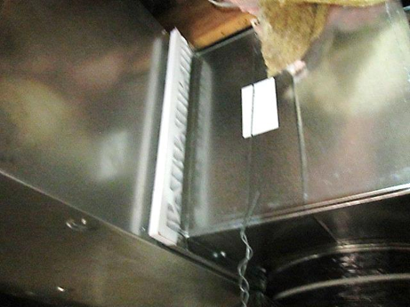

**Heat pump located above the ceiling**

**Picture 2**

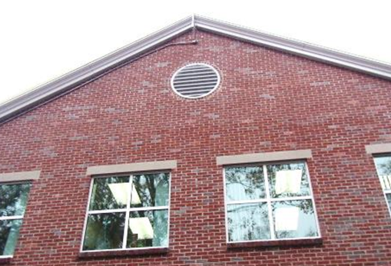

**Fresh air intake vent**

**Picture 3**

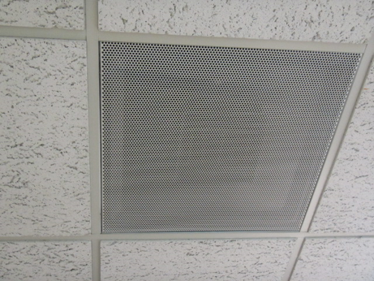

**Supply diffuser**

**Picture 4**

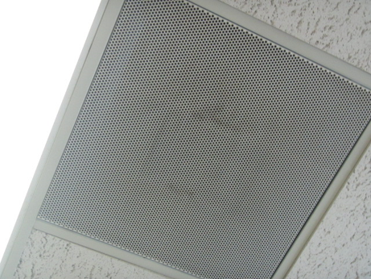

**Ceiling-mounted return vent**

**Picture 5**

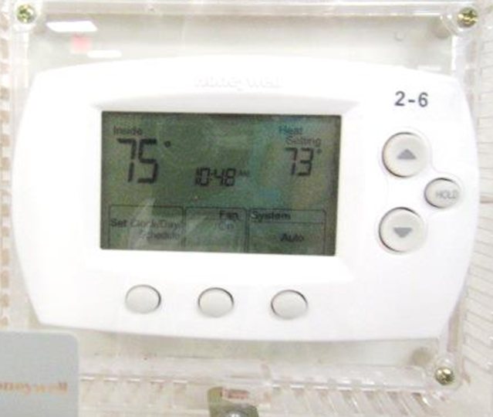

**Digital thermostat, note fan in “Auto” setting (arrow)**

**Picture 6**

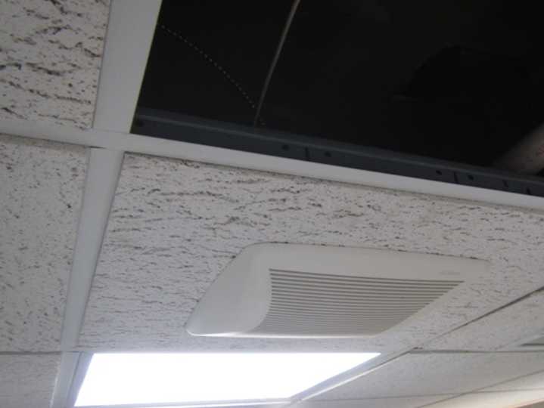

**Non-ducted restroom exhaust vent emptying into ceiling plenum**

| Location | Carbon  Dioxide  (ppm) | Carbon Monoxide  (ppm) | Temp  (°F) | Relative  Humidity  (%) | PM2.5  (µg/m3) | TVOC  (ppm) | Occupants  in Room | Windows  Openable | Ventilation | | Remarks |
| --- | --- | --- | --- | --- | --- | --- | --- | --- | --- | --- | --- |
| Supply | Exhaust |
| Background (outside) | 416 | ND | 59 | 100 | 6 | ND |  |  |  |  | Light to moderate rain, cool/cloudy |
| Gill Office | 1106 | ND | 69 | 54 | 2 | ND | 0 | N | Y | N | Plug-in air freshener |
| Copy Area | 1138 | ND | 70 | 51 | 2 | ND | 0 | N | Y | N |  |
| Conference Room | 1132 | ND | 72 | 47 | 2 | ND | 0 | N | Y | Y |  |
| Main Work Area (Right) | 1107 | ND | 73 | 46 | 2 | ND | 4 | N | Y | Y |  |
| Main Work Area (Left) | 1101 | ND | 72 | 46 | 3 | ND | 0 | N | Y | Y |  |
| Kelly’s Corner | 1170 | ND | 73 | 46 | 3 | ND | 1 | N | Y | Y |  |
| Quirk Office | 1060 | ND | 74 | 44 | 2 | ND | 0 | N | Y | N | Hand sanitizer |
| Rear Work Area | 1233 | ND | 74 | 45 | 3 | ND | 12 | N | Y | Y | Thermostat Fan “Auto” |
| Rear Conference Room | 1367 | ND | 75 | 45 | 3 | ND | 4 | N | Y | Y |  |
| Dixon Office | 1220 | ND | 75 | 43 | 2 | ND | 1 | N | Y | N |  |
| Kitchen | 1107 | ND | 75 | 41 | 3 | ND | 0 | N | Y | N |  |
| Wood-Grazulis | 1041 | ND | 75 | 41 | 2 | ND | 1 | N | Y | Y | Plant |
| Women’s Restroom |  |  |  |  | 5 | ND | 0 | N | Y | Y | Exhaust not ducted to outdoors |
| Men’s Restroom |  |  |  |  | 4 | ND | 0 | N | Y | Y |  |