INDOOR AIR QUALITY ASSESSMENT
Post-Occupancy Assessment

Division of Banks
10 State Street
Woburn, Massachusetts

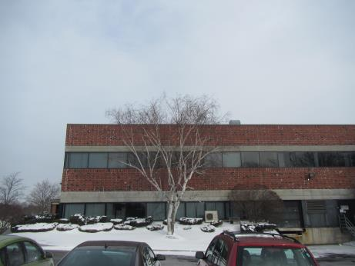

Prepared by:
Massachusetts Department of Public Health
Bureau of Environmental Health
Indoor Air Quality Program
January 2018

Background
Building: | Massachusetts Division of Banks (DOB)
Address: | 10 State Street, Woburn, MA
DCAMM Project Manager: | Jamie Merrill Blood, Project Manager, Division of Capital Asset Management and Maintenance (DCAMM)
Reason for Request: | Post-occupancy assessment
Date of Assessment: | December 29, 2017
Massachusetts Department of Public Health/Bureau of Environmental Health (MDPH/BEH) Staff Conducting Assessment: | Jason Dustin, Environmental Analyst/Inspector, Indoor Air Quality (IAQ) Program
Building Description: | The DOB space is located in a two-story brick veneer building constructed in 1989. The space is composed of private offices, open work areas and conference rooms. Most areas have carpet tile and dropped ceiling tiles.
Windows: | Windows are not openable.

Methods
Please refer to the IAQ Manual for methods, sampling procedures, and interpretation of results (MDPH, 2015).

Results
The following is a summary of indoor air testing results (Table 1).
- Carbon dioxide levels were below 800 parts per million (ppm) in all areas assessed.
- Temperature was within the recommended range of 70°F to 78°F in all areas.
- Relative humidity was below the recommended range of 40% to 60% in all areas as is typical during the heating season in the Northeast.
- Carbon monoxide levels were non-detectable (ND) in all indoor areas assessed.
- Fine particulate matter (PM2.5) concentrations measured were below the National Ambient Air Quality Standard (NAAQS) level of 35 micrograms per cubic meter (μg/m³) in all occupied areas.
- Total Volatile Organic Compounds (TVOCs) were ND in all areas.

Discussion

Ventilation
A heating, ventilating, and air conditioning (HVAC) system has several functions. First it provides heating and, if equipped, cooling. Second, it is a source of fresh air. Finally, an HVAC system will dilute and remove normally occurring indoor environmental pollutants by not only introducing fresh air, but by filtering the airstream and ejecting stale air to the outdoors via exhaust ventilation. Even if an HVAC system is operating as designed, point sources of respiratory irritation may exist and cause symptoms in sensitive individuals.
The HVAC system in this space consists of large rooftop air handling units (AHUs) that draw in fresh air from intakes on the roof. Supply air is ducted to ceiling-mounted supply diffusers throughout the space (Picture 1). Return air is brought back to the AHUs through a ceiling plenum return system (Picture 2).
To maximize air exchange, the MDPH recommends that both supply and exhaust ventilation operate continuously during periods of occupancy. In order to have proper ventilation with a mechanical supply and exhaust system, the systems must be balanced to provide an adequate amount of fresh air to the interior of a room while removing stale air from the room. It is recommended that HVAC systems be re-balanced every five years to ensure adequate air systems function (SMACNA, 1994).

Microbial/Moisture Concerns
No areas of active or historic water damage were noted in the office space. The kitchen sink area appeared to be missing caulking between the backsplash and counter (Picture 3). This condition may allow water to penetrate this small gap and moisten building materials which may lead to microbial growth.

Other Conditions
IAQ staff noted that PM 2.5 levels in the common area outside of the DOB space were slightly elevated. Construction in a nearby office suite is most likely the cause (Picture 4 and 5). Continued efforts should be made to contain any construction related pollutants and prevent them from entering occupied or common areas. This may include installing walk off mats, sealing pathways, and depressurizing the work zone.
Hand sanitizers and scented cleaning products were also noted in some areas of the office space. These products can also cause irritation of the eyes, nose and respiratory system of some people.
Most flooring is covered with carpet tile. The Institute of Inspection, Cleaning and Restoration Certification (IICRC), recommends that carpeting be cleaned annually (or semi-annually in soiled high traffic areas) (IICRC, 2012).

Conclusions/Recommendations
Based on the observations made during the visit, the following is recommended:
- Continue to operate the HVAC system to provide for continuous fresh air ventilation during occupied hours.
- Ensure property management/contractors are implementing proper containment methods during the renovation of adjacent office suite. Consult the MDPH guideline on preventing construction/renovation pollutants located at: http://www.mass.gov/eohhs/docs/dph/environmental/iaq/appendices/renovation.pdf
- Reduce or eliminate the use of scented cleaners, hand sanitizers, personal air fresheners and humidifiers.
- Apply caulking between backsplash and counter in kitchen area.
- Clean carpeting at least once per year according to IICRC recommendations (IICRC 2012).
- Consider setting up a balancing schedule to have the HVAC system balanced every five years.
- For buildings in New England, periods of low relative humidity during the winter are often unavoidable. Therefore, scrupulous cleaning practices should be adopted to minimize common indoor air contaminants whose irritant effects can be enhanced when the relative humidity is low. To control for dusts, a high efficiency particulate arrestance (HEPA) filter equipped vacuum cleaner in conjunction with wet wiping of all surfaces is recommended. Avoid the use of feather dusters. Drinking water during the day can help ease some symptoms associated with a dry environment (throat and sinus irritations).
- Refer to resource manuals and other related IAQ documents for further building-wide evaluations and advice on maintaining public buildings. Copies of these materials are located on the MDPH’s website: http://mass.gov/dph/iaq.

References
IICRC. 2012. Institute of Inspection Cleaning and Restoration Certification. Institute of Inspection, Cleaning and Restoration Certification. Carpet Cleaning: FAQ. Retrieved from http://www.iicrc.org/consumers/care/carpet-cleaning.
MDPH. 2015. Massachusetts Department of Public Health. “Indoor Air Quality Manual: Chapters I-III”. Available at: http://www.mass.gov/eohhs/gov/departments/dph/programs/environmental-health/exposure-topics/iaq/iaq-manual/.
SMACNA. 1994. HVAC Systems Commissioning Manual. 1st ed. Sheet Metal and Air Conditioning Contractors’ National Association, Inc., Chantilly, VA.
Picture 1
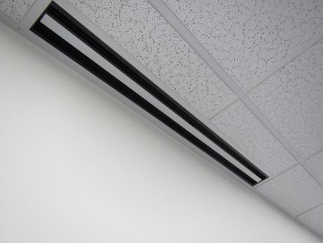
Ceiling-mounted supply diffuser
Picture 2
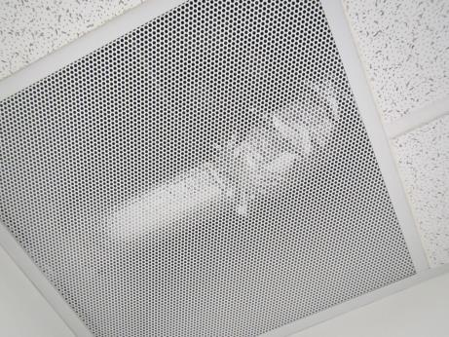
Ceiling plenum return grate
Picture 3
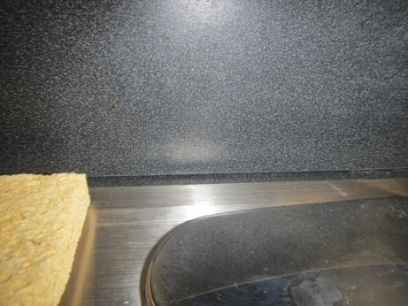
Small gap between back splash and counter missing caulking
Picture 4
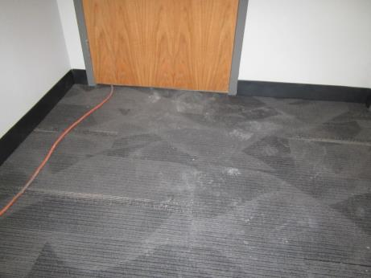
Common hall/foyer showing dust/debris from adjacent construction
Picture 5
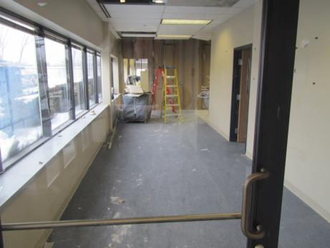
Active renovations in adjacent office space

Location | Carbon  Dioxide  (ppm) | Carbon Monoxide  (ppm) | Temp  (°F) | Relative  Humidity  (%) | PM2.5  (µg/m³) | TVOCs  (ppm) | Occupants  in Room | Windows  Openable | Ventilation |  |  | Remarks
 |  |  |  |  |  |  |  |  | Intake | Exhaust
Background (outside) | 344 | ND | 12 | 5 | 3 | ND | - | - | - |  | - | Extreme cold
Break room | 456 | ND | 70 | 10 | 7 | ND | 0 | N | Y |  | Y | No local exhaust, small gap beneath backsplash, NC
Front cubes- 30 | 396 | ND | 70 | 6 | 4 | ND | 2 | N | Y |  | Y | Carpet
36 | 409 | ND | 71 | 5 | 5 | ND | 0 | N | Y |  | Y
37 | 406 | ND | 71 | 5 | 4 | ND | 0 | N | Y |  | Y
Main open area front -near 18 | 429 | ND | 70 | 5 | 5 | ND | 5 | N | Y |  | Y | CPs
38 office | 419 | ND | 70 | 5 | 5 | ND | 0 | N | Y |  | Y
Main open area – middle near 14 | 396 | ND | 70 | 5 | 3 | ND | 2 | N | Y |  | Y | HS
Main open area- rear | 460 | ND | 70 | 5 | 2 | ND | 3 | N | Y |  | Y
Rear conference | 391 | ND | 73 | 4 | 2 | ND | 0 | N | Y |  | Y
Near copier area- front | 470 | ND | 72 | 5 | 3 | ND | 3 | N | Y |  | Y | PC
Common foyer (outside of DOB office area) | 470 | ND | 72 | 5 | 74 | ND | 0 | N | N |  | Y | Construction in adjacent office area, dust/debris on carpet

