INDOOR AIR QUALITY REASSESSMENT

Department of Children and Families
24 Farnsworth Street
Boston, Massachusetts

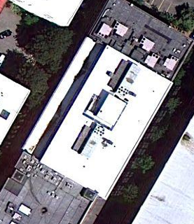

Prepared by:
Massachusetts Department of Public Health
Bureau of Environmental Health
Indoor Air Quality Program
December 2010

Background/Introduction
In response to a request from the Massachusetts Department of Public Health (MDPH), Bureau of Health Information, Statistics, Research and Evaluations, Occupational Health Surveillance Program (OHSP), the MDPH’s Bureau of Environmental Health (BEH) conducted an indoor air quality (IAQ) reassessment at the Massachusetts Department of Children and Families (DCF) offices located at 24 Farnsworth Street, Boston, Massachusetts. The request was prompted by a physician diagnosis of work-related asthma that was reported to the OHSP. Reporting of occupational injuries and diseases to the MDPH is required by 105 CMR 300.180.
The building was previously visited by BEH staff in 2005 and 2006 and reports were issued detailing conditions observed in the building at that time with recommendations to improve IAQ (MDPH, 2005; MDPH, 2006). This most recent request for an assessment was to observe current conditions and document progress made by implementing previous MDPH recommendations. On September 22, 2010, a visit to conduct an IAQ reassessment was made by Cory Holmes, Environmental Analyst/Regional Inspector in BEH’s IAQ Program. Mr. Holmes was accompanied by Jim Freer, Services Manager, DCF, during the reassessment. It was also reported by Mr. Freer that the DCF offices were planning to relocate to alternative office space within the next year.

Actions on MDPH Recommendations
As mentioned, MDPH staff had previously visited the building and issued reports with recommendations to improve indoor air quality. A summary of actions taken on previous recommendations is included as Appendix A.

Methods
Air tests for carbon dioxide, carbon monoxide, temperature and relative humidity were taken with the TSI, Q-Trak, IAQ Monitor 7565. Air tests for airborne particle matter with a diameter less than 2.5 micrometers were taken with the TSI, DUSTTRAK™ Aerosol Monitor Model 8520. BEH staff also performed visual inspection of building materials for water damage and/or microbial growth.

Results
The DCF has an employee population of approximately 500 and can be visited by up to 100 individuals daily. The tests were taken during normal operations. Test results appear in Table 1.

Discussion
Ventilation
It can be seen from Table 1 that carbon dioxide levels were below 800 parts per million (ppm) in all sixty-two areas surveyed on the day of the assessment, indicating optimal air exchange. These readings were a marked improvement over the results measured in the MDPH, 2005 general indoor air quality assessment, where fifty-five of seventy-two areas were found above 800 ppm indicating poor air exchange.
To maximize air exchange, the MDPH recommends that both supply and exhaust ventilation operate continuously during periods of occupancy. In order to have proper ventilation with a mechanical supply and exhaust system, the systems must be balanced to provide an adequate amount of fresh air to the interior of a room, while removing stale air from the room. It is recommended that HVAC systems be re-balanced every five years (SMACNA, 1994). Balancing of the system is an on-going effort with DCF staff input, building management and their HVAC engineering firm.
The Massachusetts Building Code requires that each room have a minimum ventilation rate of 20 cubic feet per minute (cfm) per occupant of fresh outside air or openable windows (SBBRS, 1997; BOCA, 1993). The ventilation must be on at all times that the room is occupied. Providing adequate fresh air ventilation with open windows and maintaining the temperature in the comfort range during the cold weather season is impractical. Mechanical ventilation is usually required to provide adequate fresh air ventilation.
Carbon dioxide is not a problem in and of itself. It is used as an indicator of the adequacy of the fresh air ventilation. As carbon dioxide levels rise, it indicates that the ventilating system is malfunctioning or the design occupancy of the room is being exceeded. When this happens, a buildup of common indoor air pollutants can occur, leading to discomfort or health complaints. The Occupational Safety and Health Administration (OSHA) standard for carbon dioxide is 5,000 parts per million parts of air (ppm). Workers may be exposed to this level for 40 hours/week, based on a time-weighted average (OSHA, 1997).
The MDPH uses a guideline of 800 ppm for publicly occupied buildings. A guideline of 600 ppm or less is preferred in schools due to the fact that the majority of occupants are young and considered to be a more sensitive population in the evaluation of environmental health status. Inadequate ventilation and/or elevated temperatures are major causes of complaints such as respiratory, eye, nose and throat irritation, lethargy and headaches. For more information concerning carbon dioxide, please see Appendix B.
Temperature readings ranged from 70º F to 76 º F, which were within the MDPH recommended comfort guidelines the day of the assessment. The MDPH recommends that indoor air temperatures be maintained in a range of 70 º F to 78 º F in order to provide for the comfort of building occupants. In many cases concerning indoor air quality, fluctuations of temperature in occupied spaces are typically experienced, even in a building with an adequate fresh air supply. Although temperatures were within the MDPH recommended comfort range on the day of the assessment, complaints of uneven heating and cooling were expressed in some areas of the building. Chronic heat complaints were reported in IT/help desk area, area 241 and 514. Areas 241 and 514 reportedly absorb solar heat over the course of the day. It is also important to note that the blinds were broken in area 241, further contributing to heat gain. Chronic cold complaints were expressed in area 128; Mr. Freer reported that attempts were being made by MCOR, the building’s HVAC vendor, to address these comfort issues.
The relative humidity measurements in the building ranged from 39 to 47 percent, which were within or very close to the lower end of the MDPH recommended comfort range the day of the assessment. The MDPH recommends a comfort range of 40 to 60 percent for indoor air relative humidity. Relative humidity levels in the building would be expected to drop during the winter months due to heating. The sensation of dryness and irritation is common in a low relative humidity environment. Low relative humidity is a very common problem during the heating season in the northeast part of the United States.

Microbial/Moisture Concerns
Several areas had water-damaged ceiling tiles, many of which were reported to be from historic leaks that have been repaired (Table 1). Water-damaged ceiling tiles can provide a source for mold and should be replaced after a moisture source or leak is discovered and repaired. Occupants reported mold concerns above water-damaged ceiling tiles in the Adoption Subsidy Unit on the fourth floor (Picture 1). BEH staff removed ceiling tiles in this area to inspect the ceiling plenum and found the area to be dry with no signs of visible mold growth. In subsequent correspondence with Mr. Freer these ceiling tiles had reportedly been replaced.
The US Environmental Protection Agency (US EPA) and the American Conference of Governmental Industrial Hygienists (ACGIH) recommends that porous materials be dried with fans and heating within 24 to 48 hours of becoming wet (US EPA, 2001; ACGIH, 1989). If porous materials are not dried within this time frame, mold growth may occur. Water-damaged porous materials cannot be adequately cleaned to remove mold growth. The application of a mildewcide to moldy porous materials is not recommended.
Several areas contained a number of plants. Plants, soil and drip pans can serve as sources of mold growth, and thus should be properly maintained. Plants should have drip pans to prevent wetting and subsequent mold colonization of window frames. Plants should also be located away from ventilation sources to prevent aerosolization of dirt, pollen or mold. A plant in one area was noted on a paper towel in standing water that was black with mold (Picture 2).

Other Indoor Air Evaluations
Indoor air quality can be negatively influenced by the presence of respiratory irritants, such as products of combustion. The process of combustion produces a number of pollutants. Common combustion emissions include carbon monoxide, carbon dioxide, water vapor, and smoke (fine airborne particle material). Of these materials, exposure to carbon monoxide and particulate matter with a diameter of 2.5 micrometers (μm) or less (PM2.5) can produce immediate, acute health effects upon exposure. To determine whether combustion products were present in the indoor environment, BEH staff obtained measurements for carbon monoxide and PM2.5.

Carbon Monoxide
Carbon monoxide is a by-product of incomplete combustion of organic matter (e.g., gasoline, wood and tobacco). Exposure to carbon monoxide can produce immediate and acute health affects. Several air quality standards have been established to address carbon monoxide and prevent symptoms from exposure to these substances. The MDPH established a corrective action level concerning carbon monoxide in ice skating rinks that use fossil-fueled ice resurfacing equipment. If an operator of an indoor ice rink measures a carbon monoxide level over 30 ppm, taken 20 minutes after resurfacing within a rink, that operator must take actions to reduce carbon monoxide levels (MDPH, 1997).
The American Society of Heating Refrigeration and Air-Conditioning Engineers (ASHRAE) has adopted the National Ambient Air Quality Standards (NAAQS) as one set of criteria for assessing indoor air quality and monitoring of fresh air introduced by HVAC systems (ASHRAE, 1989). The NAAQS are standards established by the US EPA to protect the public health from six criteria pollutants, including carbon monoxide and particulate matter (US EPA, 2006). As recommended by ASHRAE, pollutant levels of fresh air introduced to a building should not exceed the NAAQS levels (ASHRAE, 1989).
The NAAQS were adopted by reference in the Building Officials & Code Administrators (BOCA) National Mechanical Code of 1993 (BOCA, 1993), which is now an HVAC standard included in the Massachusetts State Building Code (SBBRS, 1997). According to the NAAQS, carbon monoxide levels in outdoor air should not exceed 9 ppm in an eight-hour average (US EPA, 2006).
Carbon monoxide should not be present in a typical, indoor environment. If it is present, indoor carbon monoxide levels should be less than or equal to outdoor levels. On the day of the assessment, outdoor carbon monoxide concentrations were non-detect (ND) (Table 1). No measureable levels of carbon monoxide were detected in the building during the assessment (Table 1).

Particulate Matter
The US EPA has established NAAQS limits for exposure to particulate matter. Particulate matter is airborne solids that can be irritating to the eyes, nose and throat. The NAAQS originally established exposure limits to particulate matter with a diameter of 10 μm or less (PM10). According to the NAAQS, PM10 levels should not exceed 150 micrograms per cubic meter (μg/m³) in a 24-hour average (US EPA, 2006). These standards were adopted by both ASHRAE and BOCA. Since the issuance of the ASHRAE standard and BOCA Code, US EPA established a more protective standard for fine airborne particles. This more stringent PM2.5 standard requires outdoor air particle levels be maintained below 35 μg/m³ over a 24-hour average (US EPA, 2006). Although both the ASHRAE standard and BOCA Code adopted the PM10 standard for evaluating air quality, MDPH uses the more protective PM2.5 standard for evaluating airborne particulate matter concentrations in the indoor environment.
Outdoor PM2.5 was measured at 22 μg/m³ (Table 1). PM2.5 levels measured indoors ranged from 8 to 12 μg/m³ (Table 1), which were below the NAAQS PM2.5 level of 35 μg/m³. Frequently, indoor air levels of particulates (including PM2.5) can be at higher levels than those measured outdoors. A number of mechanical devices and/or activities that occur in buildings can generate particulate during normal operations. Sources of indoor airborne particulates may include but are not limited to particles generated during the operation of fan belts in the HVAC system, use of stoves and/or microwave ovens in kitchen areas; use of photocopiers, fax machines and computer printing devices; operation of an ordinary vacuum cleaner and heavy foot traffic indoors.

Other Conditions
Several other conditions that can potentially affect indoor air quality were identified. A number of supply and return/exhaust vents had accumulated dust (Picture 3). If exhaust vents are not functioning, backdrafting can occur, which can aerosolize dust particles. In addition, these materials can accumulate on flat surfaces (e.g., desktops, shelving and carpets) in occupied areas and subsequently be re-aerosolized causing further irritation. Dust can be irritating to eyes, nose and respiratory tract. Accumulated dust/stains were also observed in a consistent pattern on walls above radiant heat vents throughout the space (Picture 4).

Conclusions/Recommendations
DCF officials, working in conjunction with DCF staff, building management and private contractors have improved indoor environmental conditions in the building by implementing the majority of MDPH’s previous recommendations. As indicated in Appendix A, several of these recommendations still warrant further attention, particularly the excessive amounts of stored items (e.g., papers, boxes, files) on floors and flat surfaces throughout the DCF office space that make it difficult to clean and maintain dust control. In view of the findings at the time of this visit, the following additional recommendations are made to further improve indoor air quality:
- Continue to implement recommendations in Appendix A which have not yet been addressed.
- Continue to work with ventilation engineer concerning balancing of the ventilation systems. Industrial standards recommend that mechanical ventilation systems be balanced every five years (SMACNA, 1994).
- Encourage DCF staff to report any temperature control/preventive maintenance issues to the facilities department in order to help HVAC engineer make adjustments/repairs to the system for thermal comfort. Particular attention should be made to address cold complaints in area 128 and excessive heat in the IT/help desk area.
- In order to reduce temperature complaints ensure blinds are in proper working order, repair/replace as necessary (Area 241) and consider applying solar (tinted) film to windows as needed to reduce solar gain/excess heat (Areas 241 and 514).
- For buildings in New England, periods of low relative humidity during the winter are often unavoidable. Therefore, scrupulous cleaning practices should be adopted to minimize common indoor air contaminants whose irritant effects can be enhanced when the relative humidity is low. To control for dusts, a high efficiency particulate arrestance (HEPA) filter equipped vacuum cleaner in conjunction with wet wiping of all surfaces is recommended. Drinking water during the day can help ease some symptoms associated with a dry environment (e.g. throat and sinus irritations).
- Continue to replace water-damaged ceiling tiles and monitor for further leaks to report to building management for prompt remediation, particularly in the 4th floor Adoption Subsidy Unit.
- Avoid over watering of plants. Ensure flat surfaces around plants are free of potting soil and other plant debris. Examine drip pans periodically for mold growth and disinfect with an appropriate antimicrobial where necessary. Do not place plants on porous materials (e.g., paper/cardboard).
- Relocate or consider reducing the amount of materials stored in cubicles, offices and common areas to allow for more thorough cleaning. Clean items regularly with a wet cloth or sponge to prevent excessive dust build-up. Explore the options of additional storage space, cabinets and/or off-site storage options.
- Clean supply and return/exhaust vents periodically of accumulated dust. Screens should be removed to gain access to vents; vents should be wiped/cleaned and screens should be soaked and cleaned. Consider cleaning on regular schedule quarterly or semi-annually as needed.
- Clean/wash accumulated dust/debris on walls above radiant heat units (Picture 4) throughout the DCF area.
- Refer to resource manuals and other related indoor air quality documents for additional building-wide evaluations and advice on maintaining public buildings. These materials are located on the MDPH’s website: http://mass.gov/dph/iaq.

References
ACGIH. 1989. Guidelines for the Assessment of Bioaerosols in the Indoor Environment. American Conference of Governmental Industrial Hygienists, Cincinnati, OH.

ASHRAE. 1989. Ventilation for Acceptable Indoor Air Quality. American Society of Heating, Refrigeration and Air Conditioning Engineers. ANSI/ASHRAE 62-1989.

BOCA. 1993. The BOCA National Mechanical Code/1993. 8th ed. Building Officials and Code Administrators International, Inc., Country Club Hill, IL.

MDPH. 1997. Requirements to Maintain Air Quality in Indoor Skating Rinks (State Sanitary Code, Chapter XI). 105 CMR 675.000. Massachusetts Department of Public Health, Boston, MA.

MDPH. 2005. Indoor Air Quality Assessment. Department of Social Services, 24 Farnsworth St., Boston, MA. Massachusetts Department of Public Health, Bureau of Environmental Health, Boston, MA.

MDPH. 2006. Mold/Water Damage Investigation. Department of Social Services, 24 Farnsworth St., Boston, MA. Massachusetts Department of Public Health, Bureau of Environmental Health, Boston, MA.

OSHA. 1997. Limits for Air Contaminants. Occupational Safety and Health Administration. Code of Federal Regulations. 29 C.F.R 1910.1000 Table Z-1-A.

SBBRS. 1997. Mechanical Ventilation. State Board of Building Regulations and Standards. Code of Massachusetts Regulations. 780 CMR 1209.0

SMACNA. 1994. HVAC Systems Commissioning Manual. 1st ed. Sheet Metal and Air Conditioning Contractors’ National Association, Inc., Chantilly, VA.

US EPA. 2001. Mold Remediation in Schools and Commercial Buildings. US Environmental Protection Agency, Office of Air and Radiation, Indoor Environments Division, Washington, D.C. EPA 402-K-01-001. March 2001.

US EPA. 2006. National Ambient Air Quality Standards (NAAQS). US Environmental Protection Agency, Office of Air Quality Planning and Standards, Washington, DC. http://www.epa.gov/air/criteria.html.
Picture 1

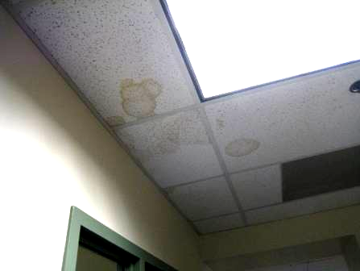

Water-Damaged Ceiling Tiles in 4th Floor Adoption Subsidy Unit

Picture 2

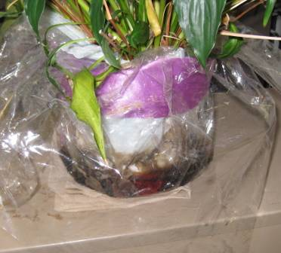

Plant on Paper Towel in Standing Water Black with Mold

Picture 3

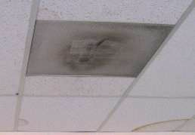

Accumulated Dust and Debris on Vents and Vent Screens

Picture 4

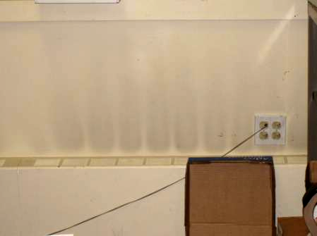

Dust/Debris Pattern on Walls above Radiant Heat Units
Location/ Room | Occupants  in Room | Temp  (°F) | Relative  Humidity  (%) | Carbon  Dioxide  (ppm) | Carbon Monoxide  (ppm) | PM2.5  (µg/m³) | Windows  Openable | Ventilation |  | Remarks
 |  |  |  |  |  |  |  | Supply | Exhaust | Remarks
Outside (Background) |  | 74 | 62 | 332 | ND | 22 |  |  |  | Clear skies, warm, breezy
5th Floor
514 | 3 | 75 | 43 | 614 | ND | 10 | N | Y | Y | Chronic solar heat complaints
521/548 | 2 | 70 | 47 | 618 | ND | 9 | N | Y | Y | 1 WD CT (small stain)
530 | 2 | 74 | 42 | 561 | ND | 10 | N | Y | Y | 1 WD CT
536 | 0 | 75 | 41 | 513 | ND | 10 | N | Y | Y
538/539 | 1 | 75 | 40 | 561 | ND | 9 | N | Y | Y | Vent blocked
541/542 | 1 | 73 | 42 | 593 | ND | 8 | N | Y | Y | 2 WD CT (historic leak)
543 | 0 | 72 | 45 | 602 | ND | 8 | N | Y | Y | 1 MT/1 WD CT
545/555 | 2 | 71 | 46 | 636 | ND | 8 | N | Y | Y
552/559 | 2 | 73 | 42 | 593 | ND | 9 | N | Y | Y
4th Floor
402 | 3 | 72 | 46 | 684 | ND | 10 | N | Y | Y | 6 WD CTs, dusty vents
409 | 1 | 73 | 42 | 592 | ND | 10 | N | Y | Y | 4 WD CTs (hallway), dusty vents
407 | 1 | 73 | 42 | 647 | ND | 11 | N | Y | Y | 2 WD CTs, dusty vents
405 | 0 | 73 | 43 | 599 | ND | 9 | N | Y | Y
403 | 1 | 73 | 44 | 658 | ND | 10 | N | Y | Y | 9 WD CTs
424 | 1 | 74 | 43 | 572 | ND | 10 | N | Y | Y
428/429 | 0 | 71 | 46 | 586 | ND | 10 | N | Y | Y
430 | 0 | 71 | 45 | 571 | ND | 9 | N | Y | Y
439 File Room | 1 | 74 | 41 | 609 | ND | 10 | N | Y | Y | Dusty vents
443/444 | 2 | 74 | 41 | 583 | ND | 9 | N | Y | Y
446 | 1 | 75 | 41 | 556 | ND | 10 | N | Y | Y
447/448 | 0 | 75 | 41 | 556 | ND | 10 | N | Y | Y
450/452 | 0 | 75 | 42 | 608 | ND | 10 | N | Y | Y | 1 WD CT
454/455 | 1 | 74 | 42 | 582 | ND | 10 | N | Y | Y | 1 WD CT, dusty supply vents
456/457 | 2 | 74 | 43 | 601 | ND | 10 | N | Y | Y
3rd Floor
300/343 | 6 | 73 | 44 | 596 | ND | 10 | N | Y | Y
302/361 | 3 | 74 | 44 | 595 | ND | 11 | N | Y | Y
307/357 | 2 | 73 | 42 | 622 | ND | 11 | N | Y | Y
319/330 | 2 | 73 | 45 | 641 | ND | 10 | N | Y | Y
325/327 | 2 | 73 | 45 | 589 | ND | 10 | N | Y | Y
332/336 | 4 | 72 | 46 | 651 | ND | 10 | N | Y | Y
337/338 | 2 | 72 | 43 | 598 | ND | 10 | N | Y | Y | Dusty vents
339/341 | 4 | 73 | 44 | 597 | ND | 10 | N | Y | Y | Dusty vents
344/345 | 3 | 73 | 44 | 593 | ND | 10 | N | Y | Y
354/355 | 0 | 73 | 42 | 593 | ND | 11 | N | Y | Y
356/360 | 2 | 73 | 42 | 603 | ND | 11 | N | Y | Y
363/364 | 2 | 73 | 42 | 566 | ND | 10 | N | Y | Y
2nd Floor
200/201 | 1 | 74 | 41 | 617 | ND | 11 | N | Y | Y | 1 WD CT
208 | 1 | 74 | 39 | 677 | ND | 11 | N | Y | Y | Soot/stains wall/vent
215 | 0 | 72 | 41 | 595 | ND | 11 | N | Y | Y
221 | 1 | 73 | 42 | 666 | ND | 10 | N | Y | Y
225/226 | 3 | 74 | 41 | 627 | ND | 11 | N | Y | Y
228/229 | 2 | 73 | 42 | 619 | ND | 11 | N | Y | Y
231/233 | 4 | 73 | 42 | 640 | ND | 11 | N | Y | Y
235 | 1 | 73 | 42 | 632 | ND | 11 | N | Y | Y
239 | 1 | 73 | 43 | 622 | ND | 11 | N | Y | Y
240 Conf Room | 0 | 73 | 39 | 560 | ND | 10 | N | Y | Y | 2 MT
241 | 2 | 76 | 42 | 680 | ND | 11 | N | Y | Y | Heat complaints from solar glare-blinds reportedly broken, dusty vents,
246/248 | 3 | 75 | 41 | 685 | ND | 11 | N | Y | Y
250/251 | 0 | 75 | 39 | 640 | ND | 12 | N | Y | Y
254/257 | 2 | 74 | 39 | 624 | ND | 11 | N | Y | Y
1st Floor
Copy Center/ Mail Room | 4 | 72 | 44 | 643 | ND | 12 | N | Y | Y | Dusty vents
108 | 2 | 74 | 42 | 688 | ND | 11 | N | Y | Y
110 | 5 | 73 | 41 | 673 | ND | 11 | N | Y | Y
112 Conf Room | 0 | 73 | 39 | 606 | ND | 11 | N | Y | Y | Dusty wall/radiator vents
117/118 | 3 | 73 | 40 | 630 | ND | 11 | N | Y | Y
121/122 | 2 | 73 | 40 | 608 | ND | 12 | N | Y | Y
123/124 | 1 | 74 | 43 | 614 | ND | 11 | N | Y | Y | 2 WD CTs
127 | 0 | 73 | 42 | 593 | ND | 11 | N | Y | Y
128 | 0 | 72 | 43 | 573 | ND | 10 | N | Y | Y | Chronic cold complaints, investigated by HVAC eng.
129 | 0 | 72 | 44 | 606 | ND | 10 | N | Y | Y
132 | 2 | 73 | 44 | 608 | ND | 11 | N | Y | Y

Actions on MDPH Recommendations
Department of Children and Families, 24 Farnsworth Street, Boston, MA

The following is a status report of action(s) taken on MDPH recommendations (in bold) based on reports from DCF officials, building/maintenance staff, photographs and MDPH staff observations.
- Repair breaches in rooftop ductwork to prevent loss of conditioned air.
- Action: Rooftop ductwork was sealed (Picture A-1).
- Consult a ventilation engineer concerning re-balancing of the ventilation systems. The Ventilation industrial standards recommend that mechanical ventilation systems be balanced every five years (SMACNA, 1994).
- Action: Building management has reportedly instituted a preventative maintenance (PM) program with a private HVAC engineering firm, to adjust temperature ventilation control throughout the DCF space. This work is reportedly on-going.
- Encourage staff to report any complaints concerning temperature control/preventive maintenance issues to the facilities department in order to help HVAC engineer make adjustments/repairs to the system for thermal comfort. Particular attention should be made to reducing heat in the IT/Help Desk area on the third floor.
- Action: See above.
- For buildings in New England, periods of low relative humidity during the winter are often unavoidable. Therefore, scrupulous cleaning practices should be adopted to minimize common indoor air contaminants whose irritant effects can be enhanced when the relative humidity is low. To control for dusts, a high efficiency particulate arrestance (HEPA) filter equipped vacuum cleaner in conjunction with wet wiping of all surfaces is recommended. Drinking water during the day can help ease some symptoms associated with a dry environment (e.g. throat and sinus irritations).
Action: Cleaning and dust control is problematic at the DCF due to the excessive amount of materials stored in the space coupled with the lack of storage (Pictures A-2 through A-4). In open work areas/cubicles, common areas and private offices alike, large amounts of papers, boxes, files, etc., are piled on desks, tables, floors and other flat surfaces which provides a source for dusts to accumulate. These accumulated items make it difficult to clean. Dust can be irritating to eyes, nose and respiratory tract and may be the most obvious source of IAQ issues at the DCF.
- Replace water-damaged ceiling tiles. Examine the non-porous surface beneath the removed ceiling tiles and disinfect with an appropriate antimicrobial. Appropriate measures should also be taken to minimize the aerosolization of particulates from tile removal/replacement.
Action: This work is reportedly on-going.
- Change filters for HVAC equipment as per the manufacturer’s instructions or more frequently if needed. Examine HVAC equipment periodically for maintenance and function.
Action: As stated an HVAC PM program has been instituted, which includes the regular changing of filters.
- Consider consulting with an architect, masonry firm or general contractor regarding the integrity of the building envelope, primarily concerning water penetration through the fifth floor roof deck. Ensure proper drainage, make repairs as needed.
- Action: A water impermeable membrane was installed over the roof deck on the fifth floor, which has reportedly reduced leakage (Picture A-5).
- Relocate or consider reducing the amount of materials stored in cubicles, office and common areas to allow for more thorough cleaning. Clean items regularly with a wet cloth or sponge to prevent excessive dust build-up.
- Action: As stated previously, more work is needed in this area.
- Clean supply and return/exhaust vents periodically of accumulated dust.
- Action: More work is needed in this area. Many vents and vent screens were observed with accumulated dust and debris. Screens should be removed to gain access to vents; vents should be wiped/cleaned and screens should be soaked and cleaned. Consider cleaning on regular schedule quarterly or semi-annually as needed.
Picture A-1

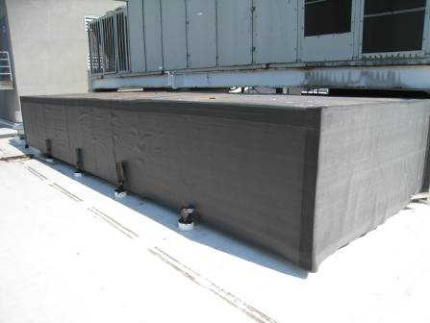

Exterior of Ductwork Sealed with Waterproofed Material

Picture A-2

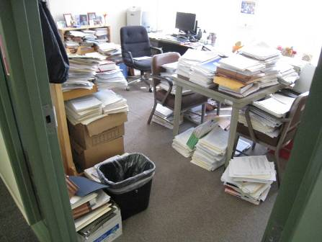

Accumulated Items in Private Office

Picture A-3

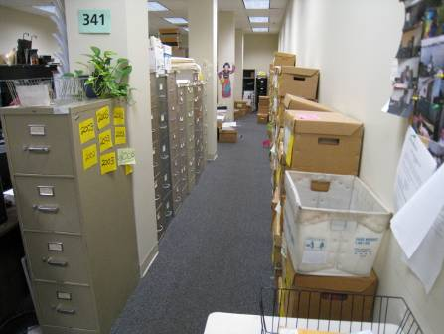

Accumulated Items in Common Area

Picture A-4

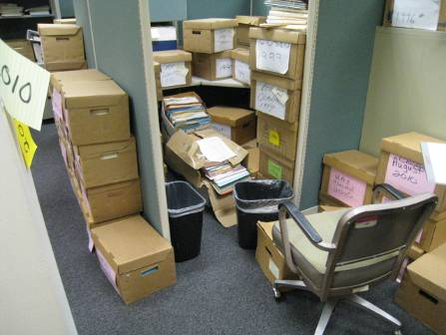

Accumulated Items in Work/Common Area

Picture A-5

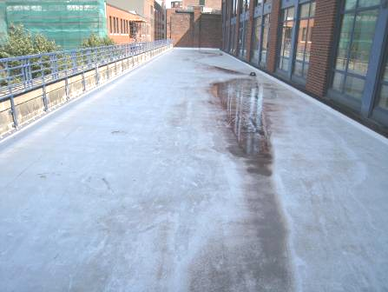

Water Impermeable Membrane Installed over 5th Floor Roof Deck

