INDOOR AIR QUALITY
POST-OCCUPANCY ASSESSMENT

Division of Fisheries and Wildlife
100 Hartwell Street
West Boylston, MA

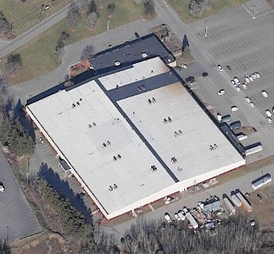

Prepared by:
Massachusetts Department of Public Health
Bureau of Environmental Health
Indoor Air Quality Program
December 2012

Background/Introduction
In response to a request from Bruce Tebo, Project Manager, Division of Capital Asset Management (DCAM), the Massachusetts Department of Public Health (MDPH), Bureau of Environmental Health (BEH) conducted post-occupancy indoor air quality (IAQ) testing at the temporary location for the Massachusetts Division of Fisheries and Wildlife (DFW) Field Office, located at 100 Hartwell Street, West Boylston, Massachusetts. This evaluation was conducted as part of enhanced efforts to assess the air quality of office space leased by Massachusetts state agencies pre and post-occupancy. On November 16, 2012, a visit to conduct an IAQ assessment was made by Cory Holmes, Environmental Analyst/Regional Inspector within BEH’s IAQ Program.
The DFW Field Office occupies a portion of the second floor of a two-story building that also houses private storage areas and a private daycare/school. DFW staff will reportedly occupy this space for one to two years while their permanent Field Office is being constructed.

Methods
Air tests for carbon dioxide, carbon monoxide, temperature and relative humidity were taken with the TSI, Q-Trak, IAQ Monitor 7565. Air tests for airborne particle matter with a diameter less than 2.5 micrometers were taken with the TSI, DUSTTRAK™ Aerosol Monitor Model 8520. Screening for volatile organic compounds (VOCs) was conducted using a Thermo Environmental Instruments Inc., Model 580 Series Photo Ionization Detector (PID). BEH/IAQ staff also performed visual inspection of building materials for water damage and/or microbial growth and examined the space for the presence of odors or other environmental concerns.

Results
The DFW Field Office has an employee population of 85 and is visited by an average of 10 people during a typical day. Tests were taken during normal operations. Results appear in Table 1.

Discussion

Ventilation
It can be seen from Table 1 that carbon dioxide levels were below 800 parts per million (ppm) in all areas, with the exception of Conference Room A, indicating optimal air exchange at the time of assessment. Elevated carbon dioxide levels in Conference Room A can be attributed to increased occupancy. It was reported that a training with 40+ occupants had just been concluded.
Fresh air is provided by air-handling units (AHUs) located above the ceiling tile system. Fresh air is drawn into the AHUs via fresh air intakes on the exterior of the building. Air is then drawn through a bank of filters, heated or cooled, and delivered to occupied areas via ducted supply diffusers (Picture 1). Return air is drawn into ceiling-mounted vents and ducted back to the AHUs (Picture 2). It was reported by building management that the AHUs for the reception area and Conference Room A do not provide heat; therefore heat is provided by electric baseboard heating units in these areas.
AHUs are controlled by digital thermostats, which have fan settings of “on” and “auto” (Picture 3). The automatic setting on the thermostat activates the system at a preset temperature. Once a preset temperature is measured by the thermostat, the HVAC system is deactivated. Therefore, no mechanical ventilation is provided until the thermostat reactivates the system. At the time of assessment, the thermostat located in reception area was deactivated; therefore no mechanical air exchange was occurring.
In order to have proper ventilation with a mechanical supply and exhaust system, the systems must be balanced to provide an adequate amount of fresh air to the interior of a room while removing stale air from the room. It is recommended that HVAC systems be re-balanced every five years to ensure adequate air systems function (SMACNA, 1994). It was reported that the system was recently balanced prior to occupancy.
Minimum design ventilation rates are mandated by the Massachusetts State Building Code (MSBC). Until 2011, the minimum ventilation rate in Massachusetts was higher for both occupied office spaces and general classrooms, with similar requirements for other occupied spaces (BOCA, 1993). The current version of the MSBC, promulgated in 2011 by the State Board of Building Regulations and Standards (SBBRS), adopted the 2009 International Mechanical Code (IMC) to set minimum ventilation rates. Please note that the MSBC is a minimum standard that is not health-based. At lower rates of cubic feet per minute (cfm) per occupant of fresh air, carbon dioxide levels would be expected to rise significantly. A ventilation rate of 20 cfm per occupant of fresh air provides optimal air exchange resulting in carbon dioxide levels at or below 800 ppm in the indoor environment in each area measured. MDPH recommends that carbon dioxide levels be maintained at 800 ppm or below. This is because most environmental and occupational health scientists involved with research on IAQ and health effects have documented significant increases in indoor air quality complaints and/or health effects when carbon dioxide levels rise above the MDPH guidelines of 800 ppm for schools, office buildings and other occupied spaces (Sundell et al., 2011). The ventilation must be on at all times that the room is occupied. Providing adequate fresh air ventilation with open windows and maintaining the temperature in the comfort range during the cold weather season is impractical. Mechanical ventilation is usually required to provide adequate fresh air ventilation.
Carbon dioxide is not a problem in and of itself. It is used as an indicator of the adequacy of the fresh air ventilation. As carbon dioxide levels rise, it indicates that the ventilating system is malfunctioning or the design occupancy of the room is being exceeded. When this happens, a buildup of common indoor air pollutants can occur, leading to discomfort or health complaints. The Occupational Safety and Health Administration (OSHA) standard for carbon dioxide is 5,000 parts per million parts of air (ppm). Workers may be exposed to this level for 40 hours/week, based on a time-weighted average (OSHA, 1997).
The MDPH uses a guideline of 800 ppm for publicly occupied buildings. A guideline of 600 ppm or less is preferred in schools due to the fact that the majority of occupants are young and considered to be a more sensitive population in the evaluation of environmental health status. Inadequate ventilation and/or elevated temperatures are major causes of complaints such as respiratory, eye, nose and throat irritation, lethargy and headaches. For more information concerning carbon dioxide, please see Appendix A.
Indoor temperatures ranged from 67°F to 77°F (Table 1), which were within or close to the lower end of the MDPH recommended comfort range at the time of assessment. The MDPH recommends that indoor air temperatures be maintained in a range of 70°F to 78°F in order to provide for the comfort of building occupants. In many cases concerning indoor air quality, fluctuations of temperature in occupied spaces are typically experienced, even in a building with an adequate fresh air supply.
The relative humidity measured during the assessment ranged from 18 to 34 percent, which was below the MDPH recommended comfort range at the time of assessment. The MDPH recommends a comfort range of 40 to 60 percent for indoor air relative humidity. Relative humidity levels in the building would be expected to drop during the winter months due to heating.

Microbial/Moisture Concerns
In order for building materials to support mold growth, a source of water exposure is necessary. Water-damaged ceiling tiles were observed in two areas of the building: the break room and the Deputy Director’s office (Table 1). Water-damaged ceiling tiles indicate leaks from either the roof or plumbing system and can provide a source for mold growth. Water-damaged ceiling tiles should be replaced after a water leak is discovered and repaired.

Other IAQ Evaluations
Indoor air quality can be negatively influenced by the presence of respiratory irritants, such as products of combustion. The process of combustion produces a number of pollutants. Common combustion emissions include carbon monoxide, carbon dioxide, water vapor, and smoke (fine airborne particle material). Of these materials, exposure to carbon monoxide and particulate matter with a diameter of 2.5 micrometers (μm) or less (PM2.5) can produce immediate, acute health effects upon exposure. To determine whether combustion products were present in the indoor environment, BEH/IAQ staff obtained measurements for carbon monoxide and PM2.5.

Carbon Monoxide
Carbon monoxide is a by-product of incomplete combustion of organic matter (e.g., gasoline, wood and tobacco). Exposure to carbon monoxide can produce immediate and acute health affects. Several air quality standards have been established to address carbon monoxide and prevent symptoms from exposure to these substances. The MDPH established a corrective action level concerning carbon monoxide in ice skating rinks that use fossil-fueled ice resurfacing equipment. If an operator of an indoor ice rink measures a carbon monoxide level over 30 ppm, taken 20 minutes after resurfacing within a rink, that operator must take actions to reduce carbon monoxide levels (MDPH, 1997).
The American Society of Heating Refrigeration and Air-Conditioning Engineers (ASHRAE) has adopted the National Ambient Air Quality Standards (NAAQS) as one set of criteria for assessing indoor air quality and monitoring of fresh air introduced by HVAC systems (ASHRAE, 1989). The NAAQS are standards established by the US EPA to protect the public health from six criteria pollutants, including carbon monoxide and particulate matter (US EPA, 2006). As recommended by ASHRAE, pollutant levels of fresh air introduced to a building should not exceed the NAAQS levels (ASHRAE, 1989). The NAAQS were adopted by reference in the Building Officials & Code Administrators (BOCA) National Mechanical Code of 1993 (BOCA, 1993), which is now an HVAC standard included in the Massachusetts State Building Code (SBBRS, 1997). According to the NAAQS, carbon monoxide levels in outdoor air should not exceed 9 ppm in an eight-hour average (US EPA, 2006).
Carbon monoxide should not be present in a typical, indoor environment. If it is present, indoor carbon monoxide levels should be less than or equal to outdoor levels. Outdoor carbon monoxide concentrations were non-detectable (ND) the day of assessment (Table 1). No measureable levels of carbon monoxide were detected in the building (Table 1).

Particulate Matter
The US EPA has established NAAQS limits for exposure to particulate matter. Particulate matter is airborne solids that can be irritating to the eyes, nose and throat. The NAAQS originally established exposure limits to particulate matter with a diameter of 10 μm or less (PM10). According to the NAAQS, PM10 levels should not exceed 150 micrograms per cubic meter (μg/m³) in a 24-hour average (US EPA, 2006). These standards were adopted by both ASHRAE and BOCA. Since the issuance of the ASHRAE standard and BOCA Code, US EPA established a more protective standard for fine airborne particles. This more stringent PM2.5 standard requires outdoor air particle levels be maintained below 35 μg/m³ over a 24-hour average (US EPA, 2006). Although both the ASHRAE standard and BOCA Code adopted the PM10 standard for evaluating air quality, MDPH uses the more protective PM2.5 standard for evaluating airborne particulate matter concentrations in the indoor environment.
On the day of assessment, outdoor PM2.5 was measured at 8 μg/m³ (Table 1). PM2.5 levels measured indoors ranged from 2 to 5 μg/m³ (Table 1), which were below the NAAQS PM2.5 level of 35 μg/m³. Frequently, indoor air levels of particulates (including PM2.5) can be at higher levels than those measured outdoors. A number of mechanical devices and/or activities that occur in buildings can generate particulate during normal operations. Sources of indoor airborne particulates may include but are not limited to particles generated during the operation of fan belts in the HVAC system, use of stoves and/or microwave ovens in kitchen areas; use of photocopiers, fax machines and computer printing devices; operation of an ordinary vacuum cleaner and heavy foot traffic indoors.

Volatile Organic Compounds
Indoor air can be greatly impacted by the use of products containing volatile organic compounds (VOCs). VOCs are carbon-containing substances that have the ability to evaporate at room temperature. Frequently, exposure to low levels of total VOCs (TVOCs) may produce eye, nose, throat and/or respiratory irritation in some sensitive individuals. For example, chemicals evaporating from a paint can stored at room temperature would most likely contain VOCs. In an effort to determine whether VOCs were present in the building, air monitoring for TVOCs was conducted. An outdoor air sample was taken for comparison. Outdoor TVOC concentrations were ND. No measureable levels of TVOCs were detected inside the building during the assessment (Table 1). Please note, that the TVOC air measurements are only reflective of the indoor air concentrations present at the time of sampling.

Other Conditions
Other conditions that can affect indoor air quality were observed during the assessment. A broken ceiling tile was observed in an office (French) exposing fiberglass insulation (Picture 4). Fiberglass insulation can provide a source of skin, eye and respiratory irritation. Missing/damaged ceiling tiles can allow pollutants from above the ceiling to enter into occupied spaces or travel from one area to another.

Conclusions/Recommendations
In view of the findings at the time of the visit, the following recommendations are made:
- Work with building management and HVAC vendor to regulate/adjust fresh air intake in Conference Room A, during use by large groups.
- For continuous air exchange, set the thermostat for the ventilation system to the fan “on” position during business hours.
- For buildings in New England, periods of low relative humidity during the winter are often unavoidable. Therefore, scrupulous cleaning practices should be adopted to minimize common indoor air contaminants whose irritant effects can be enhanced when the relative humidity is low. To control for dusts, a high efficiency particulate arrestance (HEPA) filter equipped vacuum cleaner in conjunction with wet wiping of all surfaces is recommended. Avoid the use of feather dusters. Drinking water during the day can help ease some symptoms associated with a dry environment (throat and sinus irritations).
- Ensure leaks are repaired and replace water-damaged ceiling tiles. Examine the area above and around these areas for mold growth. Disinfect areas of water leaks with an appropriate antimicrobial as needed.
- Replace damaged/broken ceiling tiles.
- Refer to resource manual and other related indoor air quality documents located on the MDPH’s website for further building-wide evaluations and advice on maintaining public buildings. These documents are available at: http://mass.gov/dph/iaq

References
ASHRAE. 1989. Ventilation for Acceptable Indoor Air Quality. American Society of Heating, Refrigeration and Air Conditioning Engineers. ANSI/ASHRAE 62-1989.
BOCA. 1993. The BOCA National Mechanical Code/1993. 8th ed. Building Officials and Code Administrators International, Inc., Country Club Hill, IL.
IMC, 2009. 2009 International Mechanical Code. International Code Council Inc., Country Club Hills, IL.
MDPH. 1997. Requirements to Maintain Air Quality in Indoor Skating Rinks (State Sanitary Code, Chapter XI). 105 CMR 675.000. Massachusetts Department of Public Health, Boston, MA.
OSHA. 1997. Limits for Air Contaminants. Occupational Safety and Health Administration. Code of Federal Regulations. 29 C.F.R 1910.1000 Table Z-1-A.
SBBRS. 2011. Mechanical Ventilation. State Board of Building Regulations and Standards. Code of Massachusetts Regulations, 8th edition. 780 CMR 1209.0
SMACNA. 1994. HVAC Systems Commissioning Manual. 1st ed. Sheet Metal and Air Conditioning Contractors’ National Association, Inc., Chantilly, VA.
Sundell. 2011. Sundell, J., H. Levin, W. W. Nazaroff, W. S. Cain, W. J. Fisk, D. T. Grimsrud, F. Gyntelberg, Y. Li, A. K. Persily, A. C. Pickering, J. M. Samet, J. D. Spengler, S. T. Taylor, and C. J. Weschler. Ventilation rates and health: multidisciplinary review of the scientific literature. Indoor Air, Volume 21: pp 191–204.
US EPA. 2006. National Ambient Air Quality Standards (NAAQS). US Environmental Protection Agency, Office of Air Quality Planning and Standards, Washington, DC. http://www.epa.gov/air/criteria.html
Picture 1

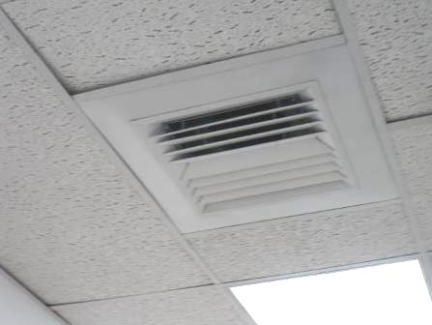

Supply diffuser

Picture 2

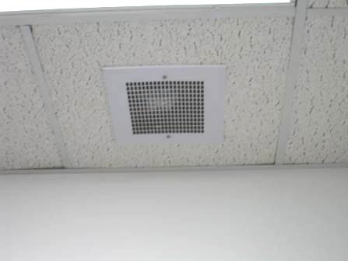

Return vent

Picture 3

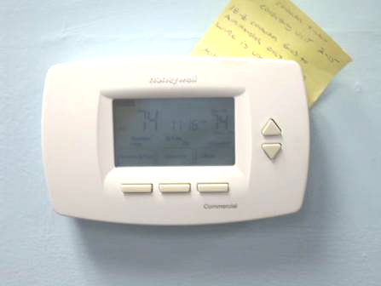

Digital thermostat

Picture 4

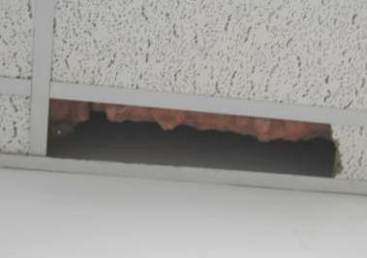

Broken ceiling tile in office (French) exposing fiberglass insulation
Location/ Room | Occupants  in Room | Temp  (°F) | Relative  Humidity  (%) | Carbon  Dioxide  (ppm) | Carbon Monoxide  (ppm) | TVOCs  (*ppm) | PM2.5  (µg/m³) | Windows  Openable | Ventilation |  | Remarks
 |  |  |  |  |  |  |  |  | Supply | Exhaust | Remarks
Background |  | 53 | 27 | 350 | ND | ND | 8 |  |  |  | Cool, scattered clouds
Receptionist | 4 | 67 | 34 | 790 | ND | ND | 2 | N | Y | Y | Thermostat off, fan-auto heat provided by baseboards
Area 1 (North) | 1 | 74 | 22 | 582 | ND | ND | 4 | N | Y | Y
Hagerty | 0 | 74 | 21 | 600 | ND | ND | 4 | N | Y | N
File Room | 0 | 74 | 20 | 564 | ND | ND | 4 | N | Y | Y
Area 1 (Center) | 1 | 75 | 21 | 570 | ND | ND | 4 | N | Y | Y
117-A | 0 | 75 | 20 | 561 | ND | ND | 4 | N | Y | N
MacCallum | 0 | 75 | 20 | 555 | ND | ND | 4 | N | Y | Y
Area 1 (South) | 3 | 76 | 19 | 550 | ND | ND | 4 | N | Y | Y
Buckley Office | 0 | 76 | 19 | 544 | ND | ND | 4 | N | Y | N
Deputy Director Office | 0 | 75 | 19 | 531 | ND | ND | 4 | N | Y | Y | 1 WD CT
Regosin | 0 | 75 | 18 | 539 | ND | ND | 4 | N | Y | N
French | 0 | 76 | 20 | 545 | ND | ND | 4 | N | Y | N | Exposed fiberglass insulation, broken ceiling tile
Copy Area | 2 | 76 | 20 | 646 | ND | ND | 4 | N | Y | Y | Open ended area (two open doorways)
Area 2 (North) | 4 | 76 | 18 | 520 | ND | ND | 4 | N | Y | N
106 | 1 | 76 | 20 | 552 | ND | ND | 4 | N | Y | N
O’Shea | 2 | 77 | 20 | 640 | ND | ND | 4 | N | Y | Y
Area 2 (Center) | 4 | 77 | 20 | 600 | ND | ND | 5 | N | Y | Y
Area 2 (South) | 3 | 75 | 20 | 611 | ND | ND | 4 | N | Y | Y
Store Room | 0 | 75 | 19 | 534 | ND | ND | 4 | N | Y | Y
Larson | 0 | 75 | 19 | 560 | ND | ND | 4 | N | Y | Y
Break Room | 3 | 74 | 20 | 543 | ND | ND | 4 | N | Y | Y | 1 WD CT
Conference Room A | 7 | 73 | 25 | 966 | ND | ND | 4 | N | Y | Y | ~ 40 people gone ~5 minutes-training, heat provided by baseboards
Conference Room B | 0 | 74 | 22 | 707 | ND | ND | 4 | N | Y | Y
Conference Room C | 0 | 74 | 23 | 734 | ND | ND | 4 | N | Y | Y

