INDOOR AIR QUALITY
POST-OCCUPANCY ASSESSMENT

Department of Industrial Accidents
2 Avenue de Lafayette
Boston

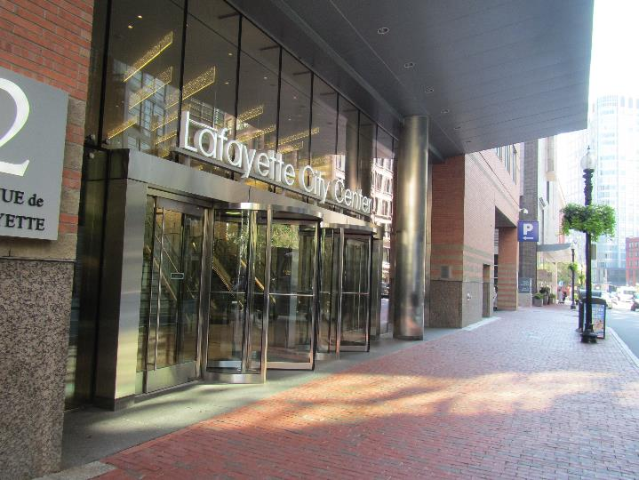

Prepared by:
Massachusetts Department of Public Health
Bureau of Environmental Health
Indoor Air Quality Program
October 2019

Background
Building: | Department of Industrial Accidents (DIA)
Address: | 2 Avenue de Lafayette, Boston
Assessment Requested by: | Lorna Moritz, Senior Project Manager,  Division of Capital Asset Management & Maintenance (DCAMM)
Reason for Request: | Post-occupancy indoor air quality (IAQ) assessment
Date of Assessment: | September 25, 2019
Massachusetts Department of Public Health/Bureau of Environmental Health (MDPH/BEH) Staff Conducting Assessment: | Ruth Alfasso, Environmental Engineer, IAQ Program  Jason Dustin, Environmental Analyst, IAQ Program
Building Description: | These offices are on the first floor of a multi-story building in Downtown Crossing, Boston. The building, known as Lafayette City Center, was originally constructed as a hotel and shopping mall in 1984. The space contains offices, workstations, conference/meeting/hearing rooms and auxiliary spaces. There are other tenants in the building and spaces that will be built out for offices in the future.
Windows: | Not openable

Methods
Please refer to the IAQ Manual for methods, sampling procedures, and interpretation of results (MDPH, 2015).

IAQ Testing Results
The following is a summary of indoor air testing results (Table 1).
- Carbon dioxide levels were below the MDPH guideline of 800 parts per million (ppm) in most of the areas surveyed, and above in a few areas of the building. This is discussed further below.
- Temperature was within the MDPH recommended range of 70°F to 78°F in all areas tested.
- Relative humidity was within the MDPH recommended range of 40 to 60% in all areas.
- Carbon monoxide levels were non-detectable (ND) in all areas tested.
- Fine particulate matter (PM2.5) concentrations measured were below the National Ambient Air Quality Standard (NAAQS) limit of 35 μg/m³ in all areas tested.
- Total volatile organic compounds (TVOCs) were ND in almost all areas tested, with the exception of the mailroom.

Ventilation
A heating, ventilating, and air conditioning (HVAC) system has several functions. First it provides heating and, if equipped, cooling. Second, it is a source of fresh air. Finally, an HVAC system will dilute and remove normally-occurring indoor environmental pollutants by not only introducing fresh air, but by filtering the airstream and ejecting stale air to the outdoors via exhaust ventilation. Even if an HVAC system is operating as designed, point sources of respiratory irritation may exist and cause symptoms in sensitive individuals.
The HVAC system consists of air handling units (AHUs) located on the roof, which draw in outside air and heat/cool it. Air from the rooftop is ducted to multiple distribution units located in the ceiling. Tempered air is then delivered to spaces via ceiling-mounted supply vents (Picture 1). Other ceiling-mounted vents return air to the AHUs. The vent style for supply and returns is the same (Picture 1), so it is difficult to tell at a glance when rooms have both a supply and return vent.
Ceiling-mounted AHUs have filters. During the pre-occupancy visit, a mesh type filter with low removal efficiency was found to be significantly covered in dust and debris. These filters were reportedly replaced during the move-in process. While the AHUs were not accessed during this visit, boxes of filters of the appropriate size for these interior AHUs were found, which have a Minimum Efficiency Reporting Value (MERV) rating of 8 (Picture 2). This rating is recommended to remove particles such as pollen and mold spores. Note that the AHUs on the rooftop which draw fresh air into the system are equipped with High Efficiency Particulate Arrestance (HEPA) filters which are designed to remove 99.97% of particulate matter with diameters greater than 0.3 µm (USEPA, 2019).
Fresh air circulation should be on and operating during all occupied periods. Since the HVAC system has a central computerized control, occupancy settings could not be checked during the visit. As noted above, levels of carbon dioxide were above the MDPH recommended levels of 800 ppm in the main waiting room, some hearing rooms, meeting rooms and the hallway in that area (Table 1). These locations had numerous occupants, and the elevated levels of carbon dioxide indicate that more fresh air is needed for the occupancy. Adjustments to HVAC system settings or to the fresh air supply louvers can help reduce carbon dioxide and any associated indoor air quality complaints in these areas.
In some rooms, such as the conference rooms and the IT training room, there were unlabeled units on the wall next to thermostats (Picture 3). It is likely these are carbon dioxide sensors, designed to activate additional fresh air or exhaust when carbon dioxide levels rise in these rooms due to high occupancy. If these are sensors, they need to be calibrated or maintained periodically to ensure proper function.
Note that thermostats are designed to allow occupants to change the set temperature in a small range of degrees (Picture 4). While all temperatures measured were within the BEH/IAQ recommended range, in some areas occupants reported that temperatures were frequently too warm or too cold. In some cases, the applicable thermostat was located in an unoccupied office or other area that is not representative of occupancy. Occupants should work with building management to address temperature control issues.
In order to have proper ventilation with a mechanical ventilation system, the systems must be balanced after installation to provide an adequate amount of fresh air to the interior of a room while removing stale air from the room. It is recommended that HVAC systems be re-balanced every five years to ensure adequate air systems function (SMACNA, 1994). These systems were reportedly balanced before the occupants moved in.

Microbial/Moisture Concerns
No water-damaged materials, water stains or musty odors were observed during the visit. Water dispensers and refrigerators were found in carpeted areas (Picture 5; Table 1). These appliances can spill or leak and moisten carpeting. These should be placed in areas with non-porous flooring where possible or on a waterproof mat to protect carpeting.
Plants were noted in some areas (Pictures 6 and 7; Table 1). Plants should be properly maintained and equipped with drip pans and should be located away from airflow to prevent the aerosolization of dirt, pollen, and mold. Plants should not be placed on porous surfaces. An aquarium was noted in one area. Aquariums also need to be kept clean to prevent odors.

Other Concerns
Exposure to low levels of total volatile organic compounds (TVOCs) may produce eye, nose, throat, and/or respiratory irritation in some sensitive individuals. To determine if VOCs were present, BEH/IAQ staff took measurements for TVOCs, which were all ND apart from the mailroom, where TVOC readings were approximately 1 ppm. There was also a slight unidentifiable odor in this room. Several stored products in here could be the source of the odor and TVOCs, including open boxes of glossy printed materials which can be sources of odors. There were also stores of cleaning products and hand sanitizers, and mailroom equipment. Boxes of materials should be kept closed when not in use. Containers of cleaners/hand sanitizers should also be kept tightly closed.
BEH/IAQ examined other areas for products containing VOCs. BEH/IAQ staff noted hand sanitizers, air fresheners, fragrance products, cleaners, and dry erase materials in the office space (Picture 8; Table 1). All of these products have the potential to be irritants to the eyes, nose, throat, and respiratory system of sensitive individuals. Several offices had bags of dry-cleaned judges’ robes (Picture 9). Dry cleaning chemicals (e.g. tetrachloroethylene) can linger on dry cleaned clothes. Dry cleaned clothing should be stored in a well-ventilated area where possible.
Occupants reported strong sewer odors in the men’s restroom. BEH/IAQ staff detected a strong sewer odor during this assessment. This is typically the result of a dry floor drain trap due to evaporation. Without a wet trap, this condition would allow sewer gases to enter the restroom area since there is no water in the drain trap to block the gases. The restroom fans should also be checked regularly for proper function.
In some offices and common areas, accumulated items were on the floor or surfaces such as desks and windowsills (Table 1). These items make it more difficult for custodial staff to clean. Items should be relocated and/or be cleaned periodically to avoid excessive dust build up.
Food and food preparation equipment, including microwaves and toasters, were observed in offices and common areas. In one open area, IAQ staff noted an odor of popcorn (Table 1). Kitchen areas lack doors, and it could not be determined if they were equipped with direct-vented exhaust. Without exhaust, odors can be distributed to other areas of the office. Care should be taken to keep food preparation equipment clean to prevent smoke, odors and pests.
Most of the offices are carpeted. Carpets should be cleaned annually (or semi-annually in soiled/high traffic areas) in accordance with Institute of Inspection, Cleaning and Restoration Certification (IICRC) recommendations, (IICRC, 2012).

Conclusions/Recommendations
Based on observations at the time of assessment, the following is recommended:
- Operate supply and exhaust ventilation continuously in all areas during occupied periods. Ensure all HVAC equipment is cleaned/maintained in accordance with manufacturer’s instructions.
- To address elevated carbon dioxide in heavily occupied areas, adjust HVAC system settings or open louvers to bring in more fresh air.
- Recalibrate or replace carbon dioxide sensors and other sensors in accordance with manufacturer’s instructions.
- Change filters for HVAC equipment 2-4 times a year. Use pleated filters of MERV 8 (or higher), which are adequate in filtering out pollen and mold spores (ASHRAE, 2012).
- Regularly pour water down all floor drains (e.g., men’s restroom) to prevent dry drain traps and associated sewer odors.
- Regularly check restroom exhaust fans for proper functioning and make repairs as necessary.
- Occupants should work with facility staff to address temperature issues.
- Balance the HVAC system every 5 years in accordance with Sheet Metal and Air Conditioning Contractors’ National Association (SMACNA) recommendations (SMACNA, 1994).
- Consider placing refrigerators and water dispensers in areas without carpeting, or use a waterproof mat to protect carpeting.
- Keep plants and flowers in good condition, avoid overwatering, and remove from the airstream of heating and ventilation equipment.
- Keep aquariums clean to prevent odor and microbial growth.
- Reduce the use of cleaning products, sanitizers, and other items that contain VOCs. Keep containers sealed when not in use.
- Keep dry-cleaned clothing in well-ventilated areas where possible.
- Store printed materials in closed boxes when not in use.
- For buildings in New England, periods of low relative humidity during the winter are often unavoidable. Therefore, scrupulous cleaning practices should be adopted to minimize common indoor air contaminants whose irritant effects can be enhanced when the relative humidity is low. To control for dusts, a high efficiency particulate arrestance (HEPA) filter equipped vacuum cleaner in conjunction with wet wiping of all surfaces is recommended. Avoid the use of feather dusters. Drinking water during the day can help ease some symptoms associated with a dry environment (throat and sinus irritations).
- Ensure all dusty surfaces are cleaned periodically, including supply and return vents, personal fans and flat surfaces.
- Keep food preparation equipment clean, and clean out refrigerators, including the gaskets, regularly.
- Clean carpeting in accordance with IICRC recommendations (IICRC, 2012).
- Refer to resource manual and other related IAQ documents located on the MDPH’s website for further building-wide evaluations and advice on maintaining public buildings. These documents are available at: http://mass.gov/dph/iaq.

References
ASHRAE. 2012. American Society of Heating, Refrigeration and Air Conditioning Engineers (ASHRAE) Standard 52.2-2012 -- Method of Testing General Ventilation Air-Cleaning Devices for Removal Efficiency by Particle Size (ANSI Approved). 2012.
IICRC. 2012. Institute of Inspection, Cleaning and Restoration Certification. Carpet Cleaning: FAQ.
MDPH. 2015. Massachusetts Department of Public Health. Indoor Air Quality Manual: Chapters I-III. Available at: http://www.mass.gov/eohhs/gov/departments/dph/programs/environmental-health/exposure-topics/iaq/iaq-manual/.
SMACNA. 1994. HVAC Systems Commissioning Manual. 1st ed. Sheet Metal and Air Conditioning Contractors’ National Association, Inc., Chantilly, VA.
US EPA. 2019. What is a HEPA filter? US Environmental Protection Agency, Office of Air and Radiation, Indoor Environments Division, Washington, D.C. EPA. Accessed at: https://www.epa.gov/indoor-air-quality-iaq/what-hepa-filter-1.
Picture 1
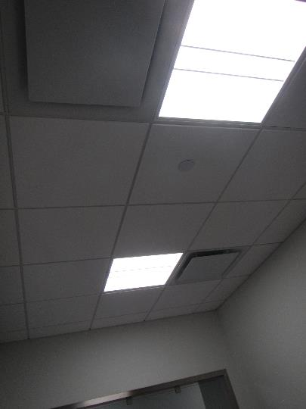
Supply and return vent in an office, note they are the same style
Picture 2
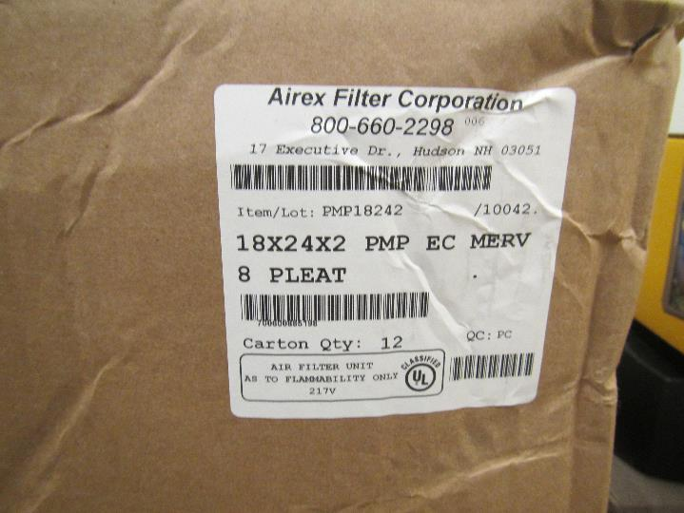
Box full of new filters, pleated type with MERV rating of 8
Picture 3
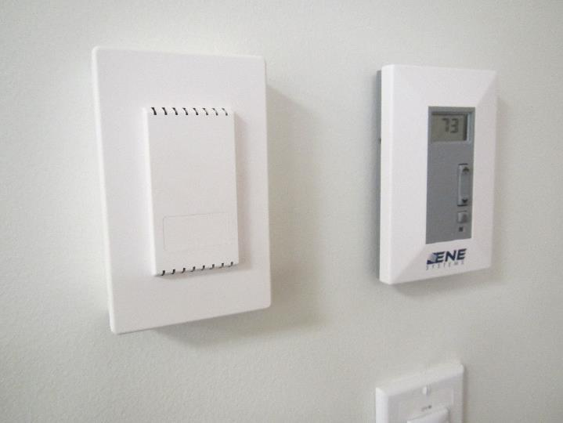
Unlabeled unit next to a thermostat which is likely a carbon dioxide sensor
Picture 4
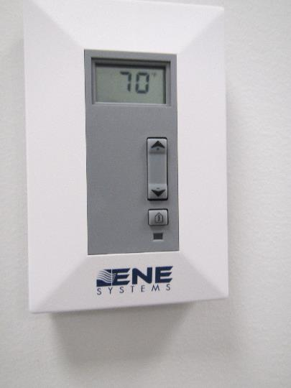
Thermostat showing adjustment toggle which can change temperature setpoint by a few degrees
Picture 5
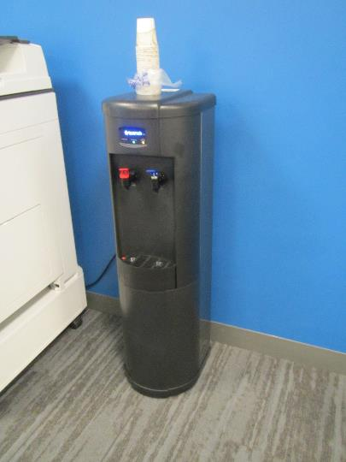
Water cooler on carpet
Picture 6
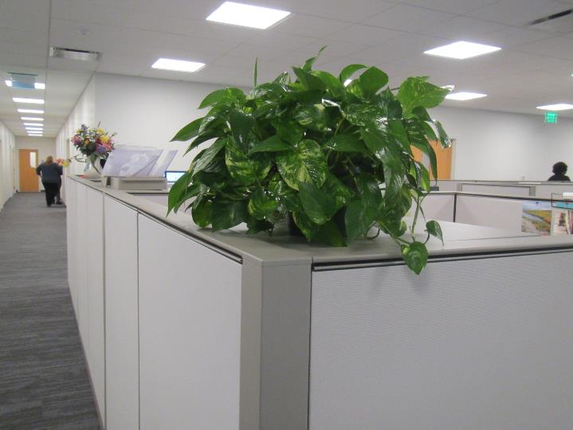
Office plant
Picture 7
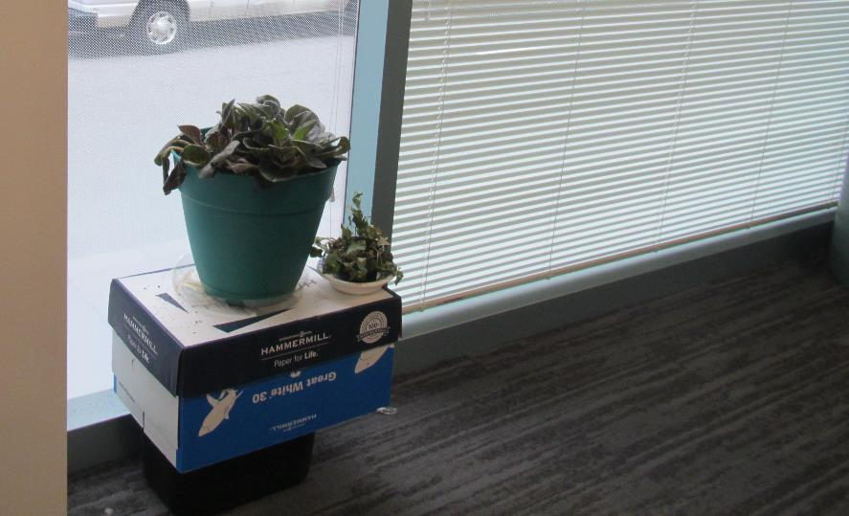
Plant on a cardboard box
Picture 8
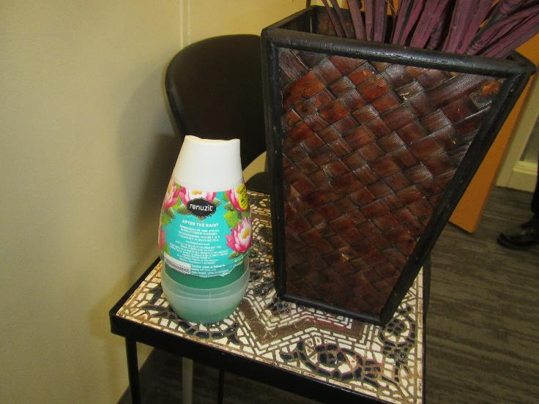
Pop-up air freshener
Picture 9
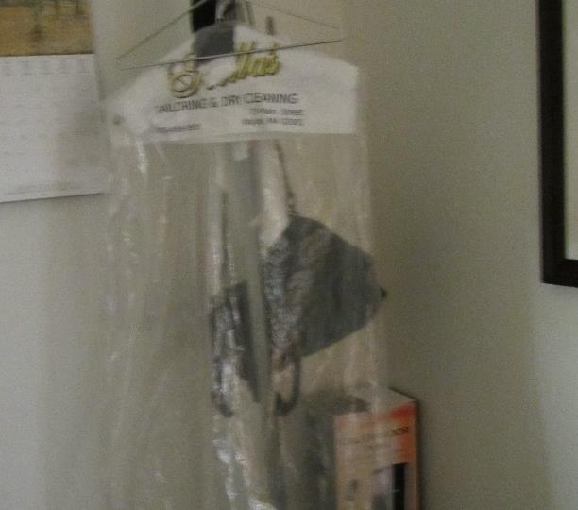
Bag from dry-cleaned robes

Location | Carbon  Dioxide  (ppm) | Carbon Monoxide  (ppm) | Temp  (°F) | Relative  Humidity  (%) | PM2.5  (µg/m³) | TVOC  (ppm) | Occupants  in Room | Windows  Openable | Ventilation |  | Remarks
 |  |  |  |  |  |  |  |  | Supply | Exhaust
Background | 441 | ND | 64 | 60 | 12 | ND | - | - | - | -
Main reception | 886 | ND | 70 | 56 | 6 | ND | 14 | N | Y | Y
1129 conference | 561 | ND | 71 | 55 | 6 | ND | 3 | N | Y | Y
Open cube #59 | 670 | ND | 73 | 52 | 5 | ND | 5 | N | Y | Y
Open cube #80 | 681 | ND | 73 | 51 | 4 | ND | 3 | N | Y | Y
Open cube #48 | 733 | ND | 73 | 50 | 4 | ND | 6 | N | Y | Y
1023 | 762 | ND | 72 | 50 | 3 | ND | 1 | N | Y | Y
1024 | 800 | ND | 71 | 51 | 4 | ND | 3 just left | N | Y | Y
1029 | 743 | ND | 71 | 53 | 3 | ND | 0 | N | Y | Y | PF
Open cube #35 | 816 | ND | 71 | 51 | 3 | ND | 1 | N | Y | Y | PC
Open cube #36 | 802 | ND | 70 | 51 | 3 | ND | 2 | N | Y | Y
1017 | 801 | ND | 71 | 52 | 3 | ND | 1 | N | Y | Y | HS
Cube area | 787 | ND | 71 | 52 | 3 | ND | 1 | N | Y | Y | HS, AF, Plant, PC
Hearing Hallway | 1063 | ND | 72 | 52 | 4 | ND | 11 | N | Y | Y
1010 | 1020 | ND | 71 | 53 | 6 | ND | 0 | N | Y | Y
1009 | 984 | ND | 72 | 53 | 4 | ND | 1 | N | Y | Y
1037 | 913 | ND | 71 | 55 | 1 | ND | 2 | N | Y | Y
1045 | 715 | ND | 71 | 51 | 2 | ND | 0 | N | Y | Y
1044 | 747 | ND | 72 | 54 | 3 | ND | 0 | N | Y | Y | AI
1042 | 742 | ND | 72 | 54 | 2 | ND | 0 | N | Y | Y
Open cube #1 | 731 | ND | 72 | 55 | 3 | ND | 0 | N | Y | Y
1060 | 702 | ND | 72 | 51 | 2 | ND | 0 | N | Y | Y | Upholstered furniture
1051 | 686 | ND | 71 | 50 | 2 | ND | 0 | N | Y | Y | DEM, small fridge on carpet
Open cube-phillips | 675 | ND | 72 | 51 | 4 | ND | 0 | N | Y | Y
Open cube #19 | 642 | ND | 73 | 50 | 4 | ND | 1 | N | Y | Y | PF, HS
Open cube #17 | 629 | ND | 72 | 49 | 4 | ND | 0 | N | Y | Y
Open cube #31 | 642 | ND | 72 | 49 | 5 | ND | 1 | N | Y | Y
Open cube #42 | 641 | ND | 72 | 50 | 4 | ND | 1 | N | Y | Y
Galley kitchen | 623 | ND | 72 | 49 | 5 | ND | 1 | N | Y | Y | Vinyl flooring, popcorn odor
1060 | 601 | ND | 71 | 48 | 3 | ND | 0 | N | Y | Y
1058 | 695 | ND | 71 | 49 | 4 | ND | 1 | N | Y | Y
Main kitchen | 649 | ND | 72 | 51 | 2 | ND | 1 | N | Y | Y | Vinyl flooring, food odor
1077 | 650 | ND | 73 | 50 | 2 | ND | 0 | N | Y | Y | DEM
Open cube #48 | 681 | ND | 73 | 50 | 2 | ND | 0 | N | Y | Y
Open cube #64 | 705 | ND | 73 | 50 | 3 | ND | 3 | N | Y | Y
Open cube #80 | 700 | ND | 73 | 50 | 2 | ND | 1 | N | Y | Y
Open cube #91 | 705 | ND | 73 | 50 | 3 | ND | 1 | N | Y | Y
1124 | 704 | ND | 73 | 50 | 3 | ND | 2 | N | Y | Y
1125 | 681 | ND | 73 | 50 | 3 | ND | 1 | N | Y | Y
1110 | 724 | ND | 73 | 50 | 2 | ND | 1 | N | Y | Y | AI
1111 | 711 | ND | 73 | 50 | 2 | ND | 1 | N | Y | Y
1112 | 713 | ND | 73 | 50 | 2 | ND | 1 | N | Y | Y
1106 | 738 | ND | 73 | 48 | 3 | ND | 1 | N | Y | Y | Plants
1108 | 739 | ND | 73 | 49 | 2 | ND | 1 | N | Y | Y
1104 | 736 | ND | 73 | 50 | 2 | ND | 0 | N | Y | Y
1103 | 682 | ND | 73 | 50 | 2 | ND | 0 | N | Y | Y | AI
1102 | 658 | ND | 73 | 50 | 2 | ND | 0 | N | Y | Y
1101 | 688 | ND | 73 | 51 | 3 | ND | 1 | N | Y | Y | AF
1097 | 603 | ND | 73 | 49 | 2 | ND | 0 | N | Y | Y
Lounge area | 641 | ND | 73 | 50 | 3 | ND | 0 | N | Y | Y
Men’s room | - | - | - | - | - | - | - | - | - | Y | Strong sewer odor; dry drain trap??
Claims records | 658 | ND | 72 | 50 | 2 | ND | 0 | N | Y | Y
IT | 582 | ND | 73 | 47 | 1 | ND | 0 | N | Y |  | Room has no separate cooling facility, DEM
1131 | 740 | ND | 73 | 48 | 1 | ND | 1 | N | Y
1025 | 780 | ND | 71 | 46 | 2 | ND | 1 | N | Y |  | PF
1026 | 851 | ND | 71 | 48 | 1 | ND | 1 | N | Y | Y | Fake plant, flowers
1027 | 761 | ND | 71 | 48 | ND | ND | 0 | N | Y | Y | Vacant
1028 | 737 | ND | 70 | 50 | 1 | ND | 0 | N | Y | Y
Interior of hearing reception office | 790 | ND | 70 | 49 | ND | ND | 1 | N | Y | Y | Supply vent is loud and blows directly on occupant
Conciliation hallway | 836 | ND | 70 | 51 | 1 | ND | 8 | N | Y | Y
1018 | 792 | ND | 70 | 51 | 1 | ND | 0 | N | Y | Y
1019 | 785 | ND | 70 | 51 | 1 | ND | 1 | N | Y |  | Sweet odor (AF or food)
1020 | 792 | ND | 71 | 50 | 2 | ND | 1 | N | Y | Y
1027 | 760 | ND | 73 | 47 | 1 | ND | 0 | N | Y | Y | AI, refrigerator and microwave, plant
1126 | 714 | ND | 73 | 46 | 2 | ND | 0 | N | Y | Y
1119 | 711 | ND | 73 | 45 | 3 | ND | 1 | N | Y | Y
1117 | 701 | ND | 73 | 46 | 5 | ND | 1 | N | Y | Y | PF – on, books
1116 | 736 | ND | 73 | 45 | 4 | ND | 0 | N | Y | Y | AI – papers, PF
1113 | 691 | ND | 73 | 46 | 2 | ND | 0 | N | Y | Y
1107 | 705 | ND | 73 | 45 | 1 | ND | 0 | N | Y | Y
1114 | 766 | ND | 73 | 46 | 1 | ND | 0 | N | Y | Y | Conference room
1092 | 759 | ND | 73 | 47 | 1 | ND | 1 | N | Y | Y | Temperature complaints
1093 | 684 | ND | 72 | 46 | 1 | ND | 0 | N | Y | Y
1094 | 671 | ND | 72 | 47 | 1 | ND | 1 | N | Y | Y
1095 | 647 | ND | 71 | 46 | 1 | ND | 0 | N | Y | Y | AI – papers
1096 | 636 | ND | 71 | 46 | 1 | ND | 0 | N | Y | Y
1115 | 621 | ND | 72 | 49 | 2 | ND | 0 | N | Y | Y
1030 | 821 | ND | 72 | 50 | 1 | ND | 0 | N | Y | Y
1033 | 797 | ND | 72 | 51 | 1 | ND | 0 | N | Y | Y | Hearing room
1014 | 930 | ND | 72 | 48 | 3 | ND | 2 | N | Y | Y | PC
1034 | 931 | ND | 72 | 48 | 2 | ND | 2 | N | Y | Y | Hearing room, fan/heater
Women’s room | 967 | ND | 71 | 47 | 5 | ND | 0 | N |  |  | AF - pop-up
1038 | 1015 | ND | 72 | 51 | 4 | ND | 5 | N | Y | Y | Hearing
1008 | 992 | ND | 72 | 48 | 2 | ND | 1 | N | Y | Y | attorney/client room
1048 | 784 | ND | 71 | 46 | 1 | ND | 0 | N | Y | Y
Cubes across from 1048 | 792 | ND | 71 | 49 | 4 | ND | 0 | N | Y | Y | AI
1047 | 754 | ND | 71 | 48 | 1 | ND | 1 | N | Y | Y | Fridge on carpet
1046 | 765 | ND | 71 | 48 | 1 | ND | 0 | N | Y | Y | DO, fan/heater, dry cleaning hanging
7305 cubes | 759 | ND | 71 | 51 | 1 | ND | 1 | N | Y | Y | PF, scent
7387 cubes | 765 | ND | 71 | 53 | 1 | ND | 1 | N | Y | Y | PF, CP
1041 | 759 | ND | 71 | 51 | 1 | ND | 0 | N | Y | Y
1040 | 770 | ND | 71 | 50 | 1 | ~1 | 0 | N | Y | Y | Mailroom, odor – possibly printed matter or CP stored here, HS
7309 cubes | 701 | ND | 72 | 48 | 2 | ND | 1 | N | Y | Y
1051 | 711 | ND | 71 | 47 | 1 | ND | 1 | N | Y | Y
1053 | 728 | ND | 72 | 48 | 1 | ND | 0 | N | Y | Y
1054 | 687 | ND | 73 | 47 | 2 | ND | 1 | N | Y | Y | Fridge on carpet
1056 | 660 | ND | 73 | 47 | 2 | ND | 0 | N | Y | Y | Books
1057 | 687 | ND | 72 | 45 | 2 | ND | 1 | N | Y | Y | Plants
1063 | 656 | ND | 74 | 46 | 1 | ND | 0 | N | Y | Y | Files, NC
MDF | 639 | ND | 75 | 46 |  | ND | 0 | N |  | Y
1065 | 640 | ND | 74 | 43 | 3 | ND | 0 | N | Y | Y | PC
1066 | 749 | ND | 74 | 44 | 2 | ND | 0 | N | Y | Y
1070 | 625 | ND | 73 | 44 | 2 | ND | 0 | N | Y | Y
1069 | 651 | ND | 73 | 44 | 2 | ND | 1 | N | Y | Y
1068 | 648 | ND | 73 | 45 | 2 | ND | 1 | N | Y | Y | PF
1067 | 701 | ND | 73 | 45 | 2 | ND | 1 | N | Y | Y
1054 | 628 | ND | 72 | 42 | 1 | ND | 0 | N | Y | Y | Heater, fake plant
1072 | 680 | ND | 72 | 47 | 2 | ND | 0 | N | Y | Y | Conference, Possible carbon dioxide sensor
1078 IT training | 730 | ND | 73 | 47 | 1 | ND | 0 | N | Y | Y | Lots of computer equipment in piles, some dusty, possible carbon dioxide sensor
7421 cubes | 622 | ND | 73 | 47 | 2 | ND | 4 | N | Y | Y | PFs, plants, food
1076 | 656 | ND | 74 | 46 | 1 | ND | 1 | N | Y | Y | PC, DO
7333 cubes | 687 | ND | 73 | 45 | 1 | ND | 3 | N | Y | Y | Plants
1132 | 683 | ND | 73 | 46 | 1 | ND | 0 | N | Y | Y
1130 | 665 | ND | 73 | 46 | 2 | ND | 0 | N | Y | Y | Food, plant
Women’s restroom |  |  |  |  |  |  |  | N | Y |  | AF odor
Wellness room | 677 | ND | 72 | 47 | 4 | ND | 0 | N | Y |  | sink

