**INDOOR AIR QUALITY/ODOR ASSESSMENT**

**Department of Transitional Assistance**

**100 Front Street**

**Holyoke**

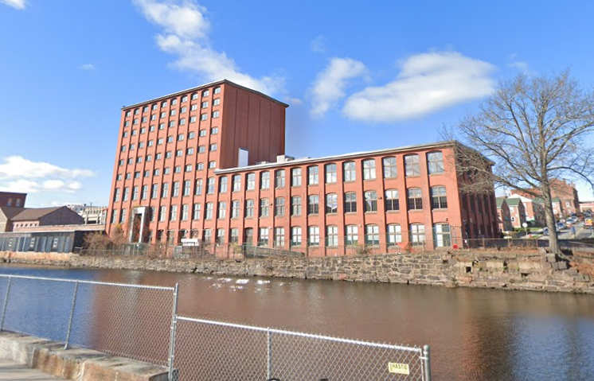

Prepared by:

Massachusetts Department of Public Health

Bureau of Climate and Environmental Health

Division of Environmental Health Regulations and Standards

December 2024

# BACKGROUND

|  |  |
| --- | --- |
| Building: | Department of Transitional Assistance (DTA) |
| Address: | 100 Front Street, Holyoke |
| Assessment Requested by: | Pedro Batista, Project Coordinator, Executive Office of Health and Human Services (EOHHS) |
| Reason for Request: | EOHHS staff received a complaint from DTA staff about a musty/mildew odor and general indoor air quality (IAQ) concerns in the basement office |
| Date of Assessment: | December 6, 2024 |
| Massachusetts Department of Public Health/Bureau of Climate and Environmental Health (MDPH/BCEH) Staff Conducting Assessment: | Thomas Murphy, Environmental Analyst, Division of Environmental Health Regulations and Standards (DEHRS) |
| Building Description: | The DTA office is in the basement of a former brick mill building built in the 1960s. It is located directly next to the First Level Canal. Other offices and a lobby area for the public to access DTA services occupy the rest of the multi-story building. |
| Building Population: | DTA staff come into the office once a week so there are about 10 employees daily but there used to be about 40 prior to a hybrid work environment. |
| Windows: | Windows are not openable. |

# EXECUTIVE SUMMARY

MDPH staff conducted a general IAQ/odor assessment of the DTA basement office after EOHHS received a complaint from DTA staff regarding a musty/mildew odor. No musty/mildew odors were observed while walking through the office and restrooms, however an odor was immediately detected after MDPH staff opened a mini refrigerator in cubicle 39. This mini fridge displayed evidence of mold as well as food/liquid stains. Another mini refrigerator in the conference room also displayed evidence of mold and food/liquid stains. A microwave with food/liquid stains was also discovered in that same conference room. All sources of possible odors were immediately brought to the attention of EOHHS and DTA staff during the assessment.

# METHODS

Please refer to the IAQ Manual for methods, sampling procedures, and interpretation of results (MDPH, 2015).

# RESULTS AND DISCUSSION

The following is a summary of indoor air testing results (Table 1).

* ***Carbon dioxide*** measurements were below the MDPH guideline of 800 parts per million (ppm) in all areas tested indicating adequate air exchange at the time of assessment. However, the space was minimally occupied at the time of testing. Carbon dioxide levels would be expected to be higher with increased occupancy.
* ***Temperature*** was within or slightly below the recommended range of 70°F to 78°F in all areas.
* ***Relative humidity*** was below the recommended range of 40% to 60% in all areas examined which is typical during heating season in New England.
* ***Carbon monoxide*** levels were non-detectable (ND) in all indoor areas tested.
* ***Fine particulate matter (PM2.5)*** concentrations were below the National Ambient Air Quality Standard (NAAQS) level of 35 μg/m3 in all areas tested.

## Ventilation

A heating, ventilating, and air conditioning (HVAC) system has several functions. First, it provides heating and, if equipped, cooling. Second, it is a source of fresh air. Finally, an HVAC system will dilute and remove normally occurring indoor environmental pollutants by not only introducing fresh air, but also filtering the airstream and ejecting stale air to the outdoors via exhaust ventilation. Even if an HVAC system is operating as designed, point sources of respiratory irritation may exist and affect symptoms in sensitive individuals.

The HVAC system consists of air handling units (AHUs) which draw in outside air. Air from the AHUs is filtered, heated/cooled, and delivered to rooms via ducted supply vents (Picture 1). Air is drawn through exhaust vents (Picture 2) to return to the AHU. Due to the layout of the DTA cubicles, some cubicles such as the one with the odor from the mini fridge are not located close to an exhaust vent. When the mini fridge is open, the odor is drawn through other cubicles/aisles and into the closest ceiling mounted exhaust vents. Given the layout of cubicles in the DTA, consideration should be given to add more supply and exhaust vents to filter odors and stale air especially if more employees return to office on a more frequent basis.

The AHUs for this building were not assessed during this visit. The MDPH/BCEH recommends that AHU filters be changed 2-4 times a year (or per the manufacturer’s recommendations) and be at least minimum efficiency reporting value (MERV) 8, or higher if the equipment can handle them without a degradation in airflow, as these are adequate to filter out pollen, mold, and similar particulates (ASHRAE, 2012). EOHHS staff reported the filters are at least a MERV 8.

Restrooms are equipped with ceiling mounted exhaust vents that appeared to be functioning when tested (Picture 3). These should be on during all occupied periods to remove odors and moisture from the restrooms.

According to DTA and EOHHS staff, employees do not have the ability to control thermostats, only the landlord does. To maximize air exchange, the MDPH recommends that both supply and exhaust ventilation operate continuously during periods of occupancy. To have proper ventilation with a mechanical supply and exhaust system, the systems must be balanced to provide an adequate amount of fresh air to the interior of a room while removing stale air from the room. It is recommended that HVAC systems be re-balanced every five years and whenever significant changes are made to the layout of the building to ensure adequate air systems function (SMACNA, 1994). According to EOHHS staff, the HVAC system was last balanced prior to DTA occupancy in November 2019, which is just over five years previously. EOHHS reported communication has been sent out to the landlord to have the next balancing done.

## Odor Concerns

As previously noted, evidence of mold was observed on at least two mini refrigerators in the DTA. After opening one mini refrigerator, which was on top of filing cabinets in cubicle 39, a foul odor was identified, and visible mold and liquid/food stains were observed. (Pictures 4 through 6; Table 1). An air purifier and personal fan were observed on the desk in front of where DTA staff sit in the cubicle (Picture 7). It is likely that when the air purifier is turned on, particularly while the refrigerator is open, the odor from the mini refrigerator is pulled across the breathing zone of DTA staff sitting in the cubicle. The personal fan could also circulate the odor. Also note that the nearest ceiling-mounted exhaust vents are not directly over cubicle 39, and may draw odors across other cubicles. Visible mold growth was also observed on top of and inside a mini refrigerator in the conference room (Picture 8). Food/liquid stains were discovered inside it (Picture 9). All refrigerators in the DTA should be kept clean to prevent microbial growth and odors.

Food/liquid stains were observed in a microwave in the conference room (Picture 10). The staff kitchenette, which is located amongst cubicles, has appliances such as a refrigerator, toaster, microwave, and other equipment. Food/liquid stains were also observed in this refrigerator (Picture 11). Food preparation equipment should be kept clean to prevent odors, water damage, and pests.

Note that in some areas, cubicles abut exterior walls, creating narrow gaps. Pieces of trash such as food wrappers were observed against the wall (Picture 12). All trash should be properly disposed of, and these areas should not be used for storage. These areas should be cleaned consistently to reduce odors and dust and discourage pests.

A fragrance spray can was found in the men’s restroom (Picture 13). These types of fragrance sprays can be irritants to the respiratory system, and only cover up odors, not remove them.

## Microbial/Moisture Concerns

### Sources of moisture

Water-damaged ceiling tiles were noted in several areas (Picture 14; Table 1). All the water-damaged ceiling tiles were found away from windows, indicating the cause could be from roof leaks, leaks from floors above, plumbing, HVAC, or sprinkler system leaks, or condensation on components. Water-damaged ceiling tiles should be replaced when they are found. During replacement, the area above the ceiling tiles should be examined for additional water-damaged materials and sources of water, such as plumbing leaks, uninsulated pipes or ducts, or other issues.

More than one mini fridge was observed on or above a carpeted area (Picture 15, Table 1). Refrigerators can spill or leak and moisten carpeting. Moving them to a non-carpeted area, can help prevent water damage.

At least one plant was noted in a cubicle (Picture 16; Table 1). Plants, soil, and drip pans can serve as sources of mold/bacterial growth, which can be respiratory irritants to some individuals. Plants should be properly maintained, over-watering of plants should be avoided, and drip pans should be inspected periodically for mold growth.

Plants and shrubbery were observed in contact with and near the exterior foundation (Picture 17). Plants near the building can cause water damage to brickwork and mortar. In addition, plants and small trees shading exterior walls can slow drying. Water can eventually penetrate the brick, subsequently freezing and thawing during the winter. This freezing/thawing action can weaken and damage bricks and mortar.

Another possible source of moisture is water penetration through below-grade windows (Picture 18) and/or migration through below-grade brick and mortar. In addition, several mulch-covered areas were observed in direct contact with the base of the DTA exterior walls. Mulch can hold water against the building and prevent drying of wall and foundation seams which may lead to water penetration. Removal of mulch and routine examining of the exterior of the building for any seams/cracks/openings is recommended.

The US Environmental Protection Agency (US EPA) and the American Conference of Governmental Industrial Hygienists (ACGIH) recommend that porous materials (e.g., ceiling tiles, carpet) be dried with fans and heating within 24 to 48 hours of becoming wet (US EPA, 2008; ACGIH, 1989). If not dried within this time frame, mold growth may occur. Once mold has colonized porous materials such as cardboard, books or ceiling tiles, they are difficult to clean and should be discarded. Frequently solid/non-porous items can be cleaned to remove water stains and microbial growth.

### Building materials prone to condensation/water damage

Although this assessment was done during winter weather, the DTA is still susceptible to condensation during hot, humid weather. The key to managing condensation in hot, humid weather indoors is understanding dew point. Condensation is the collection of moisture on a surface at or below the dew point. The dew point is the temperature that air must reach for saturation to occur. If a building material/component has a temperature below the dew point, condensation will accumulate on that material. Over time, condensation can collect and form water droplets.

Even though the DTA can provide chilled air, the basement could still experience condensation on below grade floors and walls, particularly in areas where walls and floors have direct contact with soil, or where plumbing pipes with chilled water are present without adequate insulation. MDPH staff did not observe any visual evidence of condensation on the DTA basement floor during the time of the assessment.

In general, any material that is porous and capable of supporting mold growth should not be stored on floors and against walls capable of becoming moistened by condensation. Such materials include: cardboard, cloth, paper, books, soft plastics (e.g., polyurethane), leather, upholstered furniture, and jute or latex-backed carpeting.

In several areas of the DTA, efflorescence on interior brickwork was noted (Picture 19). Efflorescence is made up of minerals from the brick and mortar that have dissolved and then deposited on the interior surface of the wall. While efflorescence is not mold, it indicates water penetration and may eventually result in a weakened building envelope. Damage to the exterior of the building can eventually lead to water infiltration inside. It is also important to note that no elevated levels of PM2.5 were measured in the breathing zone, indicating that this debris consists of larger particles that are not suspended in the air (i.e., an inhalation exposure) therefore this should be considered an ongoing cleaning issue. Efflorescence and dust from the brick had accumulated on surfaces in the DTA (Picture 20) and should be removed by using a HEPA-equipped vacuum cleaner and/or wet wiped.

## Other IAQ Issues

Almost the entire DTA has wall to wall carpeting except for a small area where the kitchenette is. Carpets should be cleaned annually (or semi-annually in soiled/high traffic areas) in accordance with Institute of Inspection, Cleaning and Restoration Certification (IICRC) recommendations, (IICRC, 2012). Dirt was observed on the carpet in one area of the DTA (Picture 21). All carpeting should be routinely vacuumed and cleaned to ensure proper removal of dirt and debris. Regular cleaning with a high efficiency particulate air (HEPA) filtered vacuum in combination with an annual cleaning will help to reduce accumulation and potential aerosolization of materials from carpeting.

Large amounts of cardboard boxes and other items were observed including on floors, desks, and other surfaces (Picture 22; Table 1). Too many items can make it difficult for custodial staff to clean and may become attractive to pests as harborage. Items should be stored neatly, off the floor, and be moved periodically for cleaning. Items that have been in long term storage or that are brought from home should be inspected to ensure they do not carry dust, pet hair, or odors.

Personal fans were also noted in the DTA (Table 1). If dust is accumulated on the blades, it can be aerosolized during use. Fans should be checked and cleaned periodically to remove any dust.

Air purifiers were observed in at least one cubicle. These should be maintained, including filter changes, in accordance with manufacturer’s instructions. Air purifiers that may produce ozone should not be used in any occupied areas (EPA, 2003).

# CONCLUSIONS/RECOMMENDATIONS

In view of the findings at the time of the visit, the following recommendations are made:

## Short-term Recommendations

### Ventilation recommendations

1. Ensure that all restroom exhaust vents are on and operating during occupied hours.
2. Consult a ventilation engineer (or similar) to determine if adding additional exhaust and supply vents to the DTA would improve airflow and reduce the potential for odors and stale air to be drawn into employee spaces.
3. Air handling units should be equipped with MERV 8-rated filters (or higher), which are adequate to filter out pollen and mold spores. Filters should be changed 2-4 times a year, or as per the manufactures’ recommendations.
4. Operate the HVAC system (supply/exhaust) to provide for *continuous* fresh air ventilation during occupied hours.
5. Balance the mechanical ventilation system every five years, as recommended by ventilation industry standards (SMACNA, 1994)

### Odor recommendations

1. Clean and remove all potential sources of odors such as mold and food/liquid stains from all microwaves, refrigerators, and other food storage/preparation equipment.
2. Move the air purifier and fan to a different location in cubicle 39 to prevent odors from travelling across breathing zones.
3. Remove all trash and check/clean the perimeter of all cubicles on a consistent basis to remove dust and debris.
4. Remove fragrance sprays being used in the restrooms.

### Water damage recommendations

1. Replace all water-damaged ceiling tiles. Disinfect areas of water leaks with an appropriate antimicrobial, as needed. Check surrounding areas for additional water-damaged materials and sources of water leaks.
2. Remove all refrigerators on or elevated above carpeted areas to non-carpeted areas to help prevent leaks/spills/moistening from causing water damage.
3. Trim plants, bushes, and small trees at least 5 feet away from the building.
4. Remove mulch-covered areas in direct contact with exterior walls and routinely examine exterior of the DTA for any openings or deterioration.
5. Consideration should be given to replacing the wall to wall carpeting in the basement with a non-porous material to prevent condensation during hot, humid weather.
6. Remove all porous materials capable of supporting mold growth from floors and against walls.
7. Clean efflorescence and brick dust from walls, floors and other flat surfaces with a HEPA-equipped vacuum cleaner or wet wiping method as needed.

### Other recommendations

1. Consistently clean carpeting with a HEPA-equipped vacuum cleaner to prevent the aerosolization of dust and debris on the floor.
2. Clean carpeting in accordance with IICRC recommendations (IICRC, 2012) annually (or semi-annually in soiled/high traffic areas).
3. Ensure cardboard boxes and other items are stored off the floor and in appropriate locations as soon as possible, to make thorough cleaning easier.
4. Periodically check and clean the blades of personal fans.
5. Maintain air purifiers in accordance with manufacturer's instructions. Avoid using any air purifiers that may produce ozone (e.g., ionizers). Consider locating air purifiers so the outlet of the units is in the breathing zone of occupants.
6. Refer to resource manual and other related IAQ documents located on the MDPH’s website for further building-wide evaluations and advice on maintaining public buildings. These documents are available at: <http://mass.gov/dph/iaq>.

# REFERENCES

ACGIH.1989. Guidelines for the Assessment of Bioaerosols in the Indoor Environment. American Conference of Governmental Industrial Hygienists, Cincinnati, OH.

ASHRAE. 2012. American Society of Heating, Refrigeration and Air Conditioning Engineers (ASHRAE) Standard 52.2-2012 -- Method of Testing General Ventilation Air-Cleaning Devices for Removal Efficiency by Particle Size (ANSI Approved).

IICRC. 2012. Institute of Inspection, Cleaning and Restoration Certification. Carpet Cleaning: FAQ.

MDPH. 2015. Massachusetts Department of Public Health. Indoor Air Quality Manual: Chapters I-III. Available at: <https://www.mass.gov/lists/indoor-air-quality-manual-and-appendices>.

SMACNA. 1994. HVAC Systems Commissioning Manual. 1st ed. Sheet Metal and Air Conditioning Contractors’ National Association, Inc., Chantilly, VA.

US EPA. 2003. “Ozone Generators that are Sold as Air Cleaners: An Assessment of Effectiveness and Health Consequences”. United States Environmental Protection Agency, Office of Air and Radiation, Indoor Environments Division, Washington, DC. Last updated September, 2018. <https://www.epa.gov/indoor-air-quality-iaq/ozone-generators-are-sold-air-cleaners>.

US EPA. 2008. “Mold Remediation in Schools and Commercial Buildings”. Office of Air and Radiation, Indoor Environments Division, Washington, DC. EPA 402-K-01-001. September 2008. Available at: <http://www.epa.gov/mold/mold-remediation-schools-and-commercial-buildings-guide>.

**Picture 1**

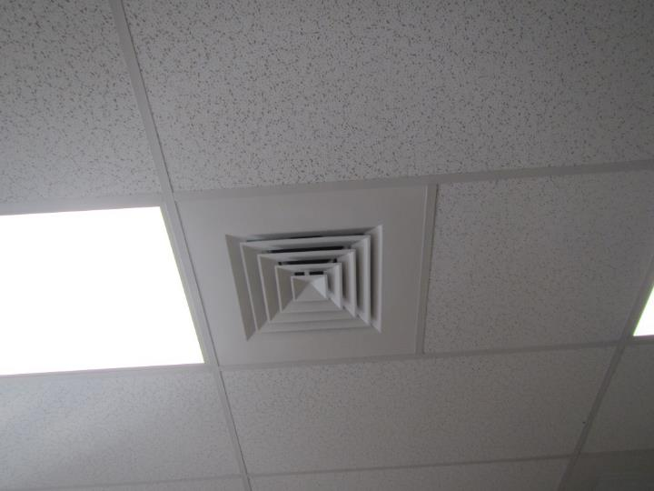

**Ceiling-mounted supply vent**

**Picture 2**

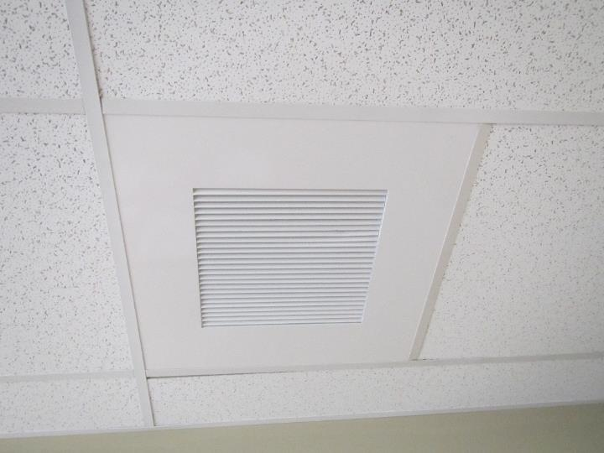

**Ceiling-mounted return vent**

**Picture 3**

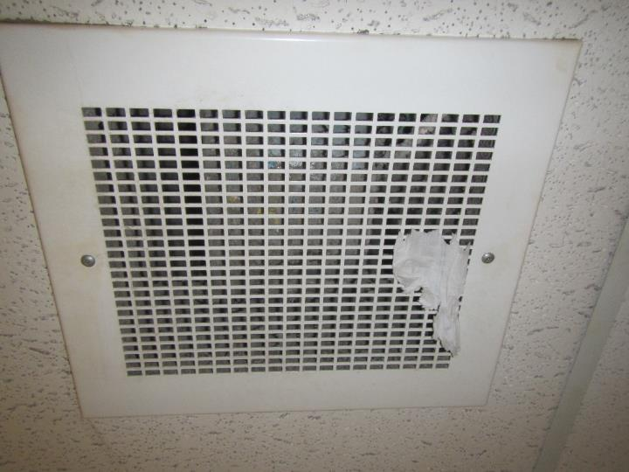

**Restroom exhaust vent, note piece of toilet paper attached to vent indicating suction**

**Picture 4**

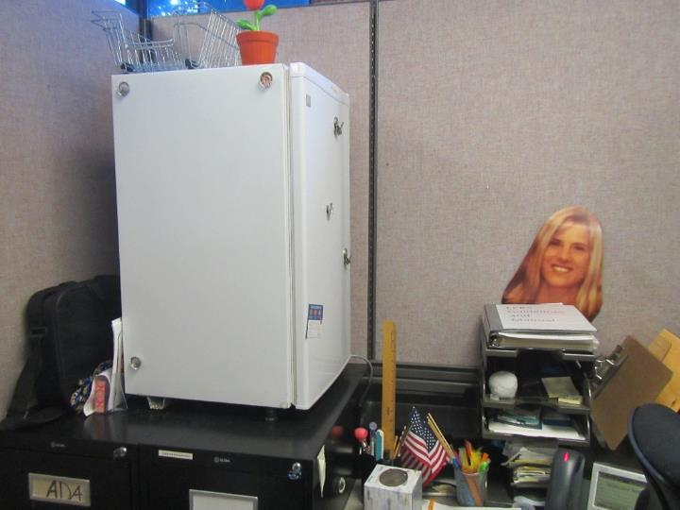

**Elevated mini fridge on filing cabinets on carpet in cubicle 39**

**Picture 5**

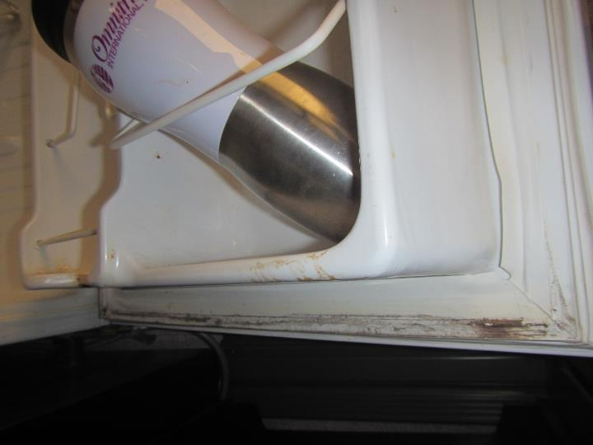

**Mold on gasket of mini fridge in cubicle 39**

**Picture 6**

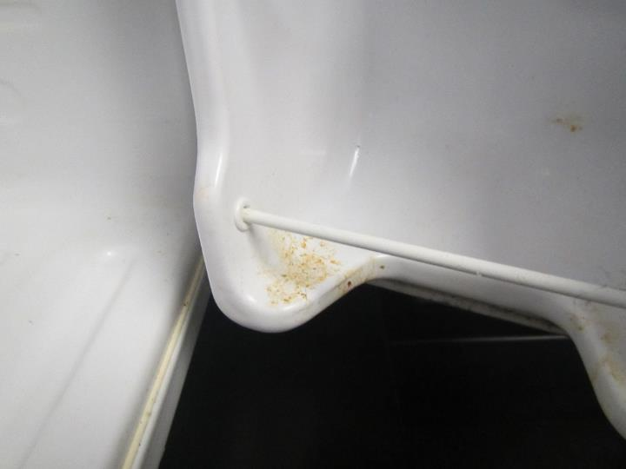

**Food/liquid stains inside mini fridge in cubicle 39**

**Picture 7**

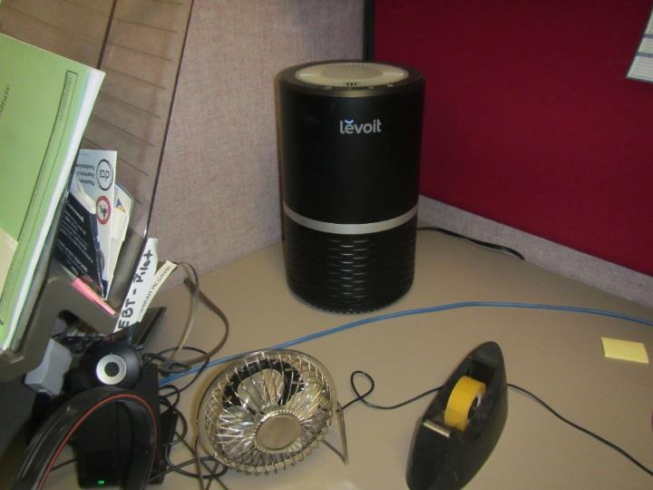

**Air purifier and personal fan on desk in front of where DTA staff sit in cubicle 39**

**Picture 8**

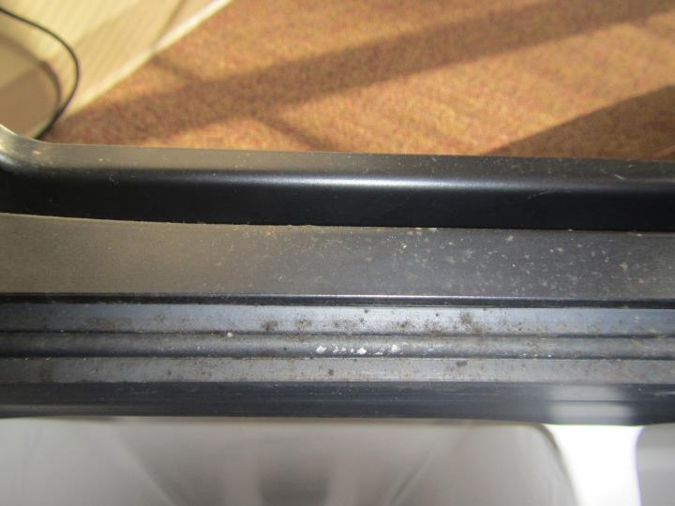

**Mold on top of and inside mini fridge in conference room**

**Picture 9**

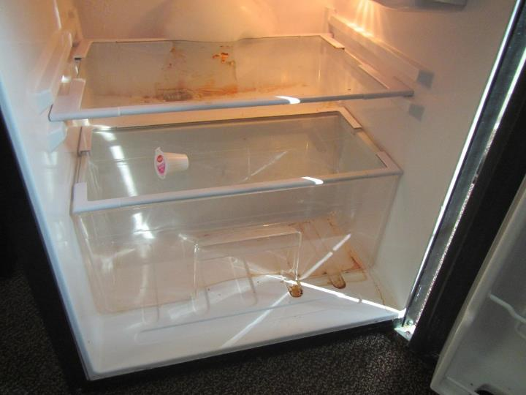

**Food/liquid stains inside mini fridge in conference room**

**Picture 10**

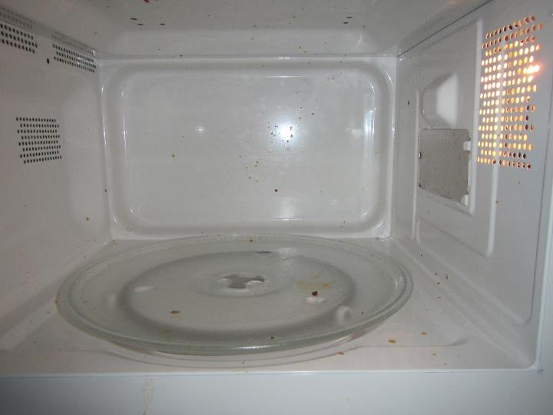

**Food/liquid stains inside microwave in conference room**

**Picture 11**

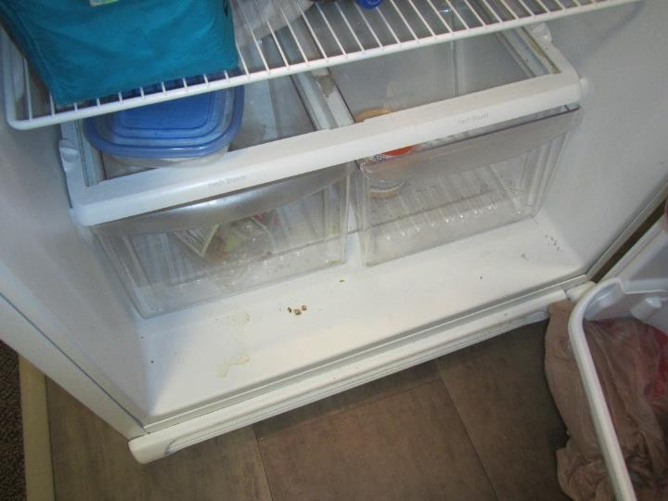

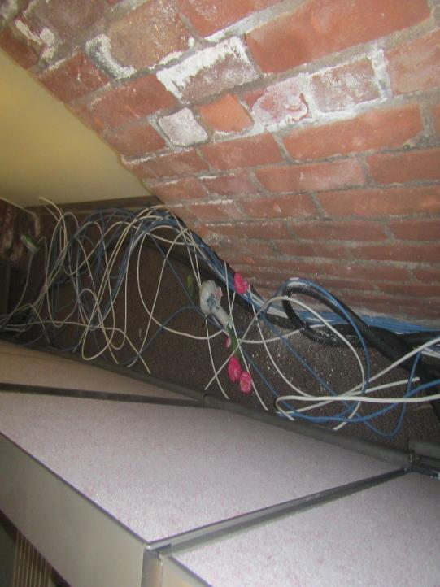**Food/liquid stains inside refrigerator in kitchenette**

**Picture 12**

**Trash along perimeter of cubicle, note arrow pointing to food wrapper**

**Picture 13**

**Fragrance spray in men’s restroom
**

**Fragrance spray in men’s restroom**

**Picture 14**

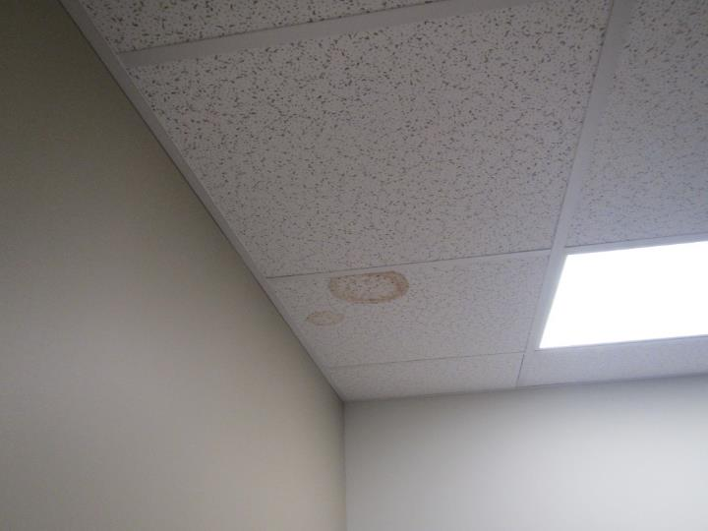

**Water-damaged ceiling tile**

**Picture 15**

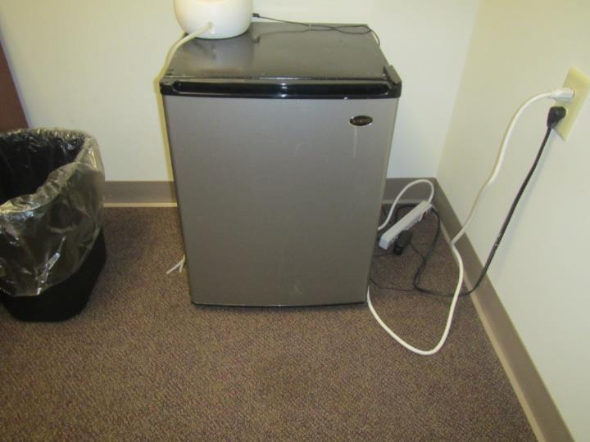

**Mini fridge on carpet**

**Picture 16**

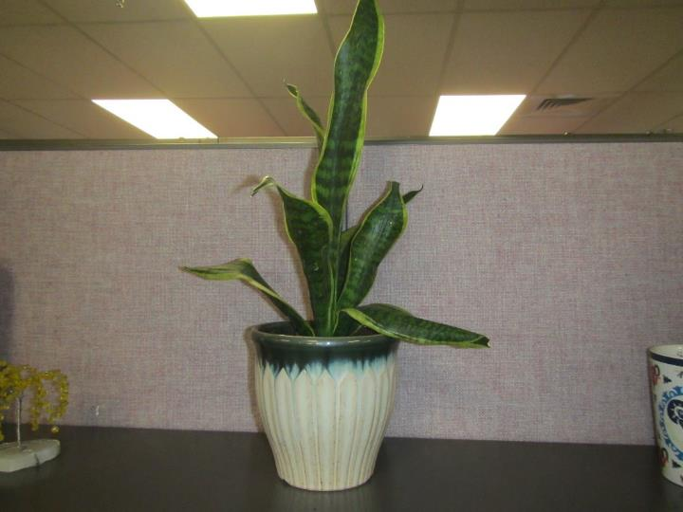

**Plant in a cubicle**

**Picture 17**

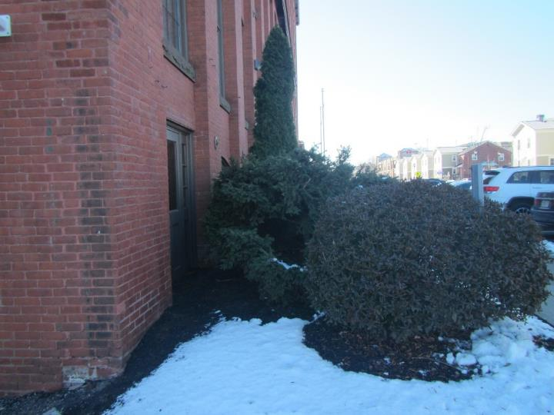

**Plants and shrubbery in close contact with building**

**Picture 18**

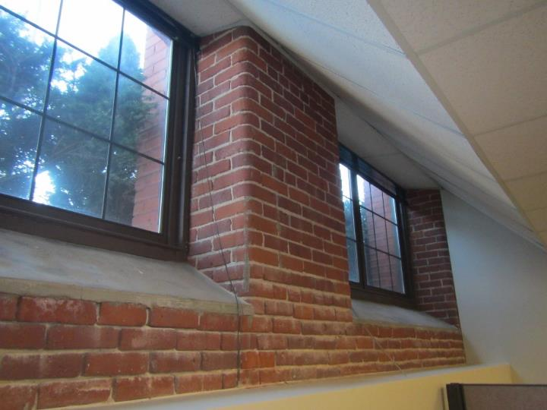

**Below grade windows in DTA**

**Picture 19**

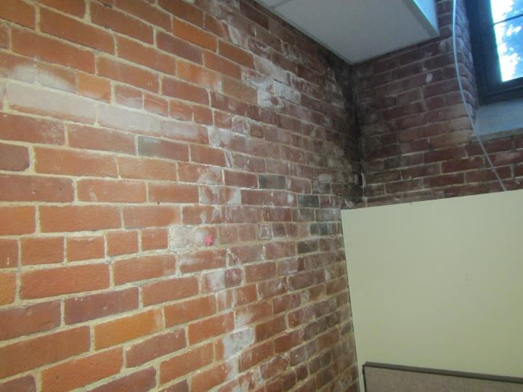

**Efflorescence on interior brick**

**Picture 20**

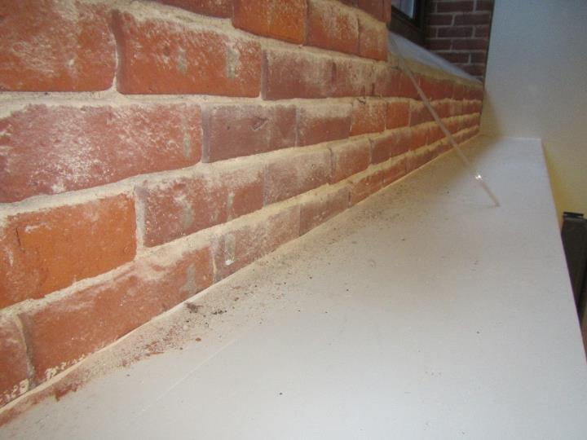

**Brick dust and efflorescence (mineral deposits) accumulated on surface**

**Picture 21**

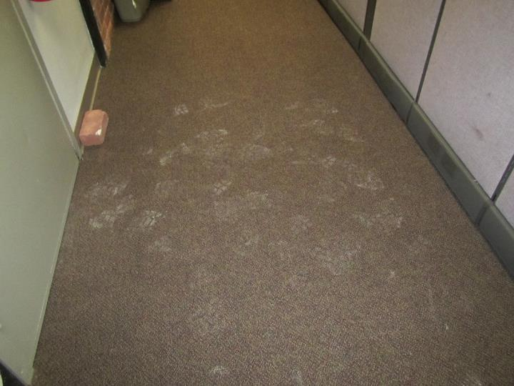

**Dirt on carpet**

**Picture 22**

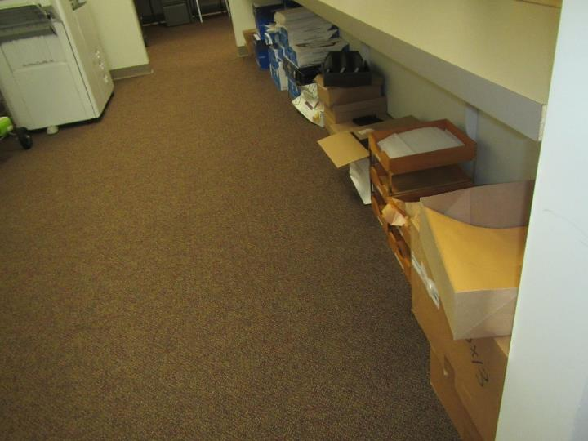

**Cardboard boxes and paper on carpet**

| **Location** | **Carbon**  **Dioxide**  **(ppm)** | **Carbon Monoxide**  **(ppm)** | **Temp**  **(°F)** | **Relative**  **Humidity**  **(%)** | **PM2.5**  **(µg/m3)** | **Occupants**  **in Room** | **Windows**  **Openable** | **Ventilation** | | **Remarks** |
| --- | --- | --- | --- | --- | --- | --- | --- | --- | --- | --- |
| **Supply** | **Exhaust** |
| Background (outside) | 484 | ND | 33 | 17 | ND |  |  |  |  | Sunny, recent snowfall, canal behind building |
| Copy Station Area | 664 | ND | 74 | 23 | ND | 0 | N | N | Y | Large number of cardboard boxes and paper stored on floor |
| Cubicles 1 & 2 | 636 | ND | 75 | 23 | ND | 0 | N | Y | N |  |
| Cubicles 3 & 4 | 795 | ND | 75 | 24 | ND | 1 | N | Y | N |  |
| Cubicles 5 & 6 | 619 | ND | 75 | 23 | ND | 1 | N | Y | N | Cardboard boxes on floor |
| Cubicles 7 & 8 | 696 | ND | 74 | 25 | ND | 2 | N | Y | N |  |
| Cubicles 9 & 10 | 594 | ND | 73 | 23 | ND | 0 | N | Y | N | Water-damaged ceiling tile |
| Cubicles 11 & 12 | 689 | ND | 71 | 24 | ND | 0 | N | Y | N |  |
| Cubicles 13 & 14 | 627 | ND | 72 | 25 | ND | 0 | N | Y | N | Water-damaged ceiling tile |
| Cubicles 15 & 16 | 625 | ND | 74 | 23 | ND | 0 | N | Y | N | Personal fan |
| Cubicles 17 & 18 | 794 | ND | 75 | 24 | ND | 0 | N | Y | N |  |
| Cubicle 19 | 677 | ND | 75 | 23 | ND | 0 | N | Y | N |  |
| Office 20 | 632 | ND | 75 | 21 | ND | 1 | N | Y | N |  |
| Cubicle 22 | 608 | ND | 69 | 23 | ND | 0 | N | Y | N |  |
| Cubicles 23 & 24 | 568 | ND | 69 | 23 | ND | 0 | N | N | Y |  |
| Cubicles 25 & 26 | 540 | ND | 70 | 23 | ND | 0 | N | Y | Y |  |
| Cubicles 28 & 29 | 555 | ND | 70 | 24 | ND | 0 | N | N | N |  |
| Cubicles 30 & 31 | 601 | ND | 69 | 24 | ND | 0 | N | N | Y | Plant |
| Cubicles 32 & 33 | 537 | ND | 69 | 22 | ND | 0 | N | N | Y |  |
| Cubicle 34 | 504 | ND | 69 | 22 | ND | 1 | N | Y | Y | Cardboard boxes on floor |
| Cubicles 35 & 36 | 513 | ND | 69 | 23 | ND | 0 | N | Y | Y |  |
| Cubicles 37 & 38 | 490 | ND | 70 | 23 | ND | 0 | N | Y | Y | Cardboard boxes on floor |
| Cubicle 39 | 674 | ND | 70 | 23 | ND | 0 | N | Y | N | Odor coming from mini fridge when opened, mold & food/liquid stains in mini fridge, elevated mini fridge on filing cabinets on carpet, personal fan, air purifier, cardboard boxes on floor |
| Cubicles 40 - 42 | 530 | ND | 70 | 23 | ND | 2 | N | Y | N | Trash behind cubicles |
| Cubicle 44 | 545 | ND | 69 | 25 | ND | 0 | N | Y | N |  |
| Cubicle 45 | 518 | ND | 71 | 22 | ND | 0 | N | Y | Y |  |
| Office 46 | 636 | ND | 71 | 23 | ND | 1 | N | Y | Y | Cardboard boxes on floor, water-damaged ceiling tile in office and in hallway outside office |
| Conference Room 48 | 583 | ND | 74 | 22 | ND | 0 | N | Y | Y | Microwave dirty, mold & food/liquid stains in mini fridge, mini fridge on carpet |
| Office 49 | 484 | ND | 71 | 25 | ND | 3 | N | Y | Y | Cardboard boxes on floor, |
| Cubicles 50 - 52 | 590 | ND | 73 | 24 | ND | 0 | N | Y | Y |  |
| Cubicles 53 - 55 | 620 | ND | 73 | 24 | ND | 0 | N | Y | Y |  |
| Cubicles 56 & 57 | 564 | ND | 73 | 24 | ND | 0 | N | Y | Y |  |
| Cubicles 58 & 59 | 584 | ND | 73 | 24 | ND | 0 | N | Y | Y | Personal fan |
| Cubicles 60 & 61 | 563 | ND | 71 | 23 | ND | 0 | N | Y | Y | Dusty personal fan |
| Cubicles 62 - 64 | 683 | ND | 72 | 23 | ND | 0 | N | Y | Y | Efflorescence on brick |
| Office 65 | 590 | ND | 73 | 24 | ND | 0 | N | Y | Y | Cracks in brick |
| Office 66 | 588 | ND | 73 | 23 | ND | 0 | N | Y | Y | Water-damaged ceiling tile |
| Wellness Room 67 | 554 | ND | 71 | 23 | ND | 0 | N | Y | Y | Mini fridge on carpet |
| Kitchenette | 609 | ND | 70 | 23 | ND | 0 | N | Y | Y | Food/liquid stains in refrigerator, microwave, toaster, not carpeted |
| Restroom (Men’s) | 601 | ND | 68 | 31 | ND | 0 | N | N | Y | Fragrance spray, exhaust vent operating |
| Restroom (Women’s) | 590 | ND | 70 | 29 | ND | 0 | N | N | Y | Water-damaged ceiling tile, exhaust vent operating |
| Side Parking Lot Exit Area | 527 | ND | 74 | 21 | ND | 0 | N | Y | Y |  |