INDOOR AIR QUALITY ASSESSMENT

Massachusetts Department of Transitional Assistance
Worcester Regional Office
9 Walnut Street
Worcester, Massachusetts

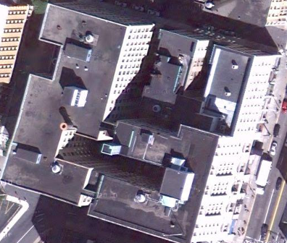

Prepared by:
Massachusetts Department of Public Health
Bureau of Environmental Health
Indoor Air Quality Program
April 2011

Background/Introduction
At the request of the Mr. Peter Sasso, Director, Customer Service and Community Relations, Massachusetts Department of Transitional Assistance (DTA), the Massachusetts Department of Public Health (MDPH), Bureau of Environmental Health (BEH) conducted an indoor air quality (IAQ) assessment at the DTA office located at 9 Walnut Street, Worcester, Massachusetts. Lisa Hébert, Environmental Analyst/Regional Inspector for BEH’s Indoor Air Quality (IAQ) Program, visited the building on October 21, 2010 to conduct air testing. On November 5, 2010, Ms. Hébert returned to the DTA with Michael Feeney, Director of BEH’s IAQ Program to conduct further evaluation. On December 17, 2010, a letter was issued (MDPH, 2010) in response to mold/moisture concerns as well as those related to exposure to pollutants generated during construction on the fifth floor of the building. The purpose of this report is to address general indoor air quality concerns.
The DTA is located on the fourth floor of a multi-story high rise that was constructed during the 1930s to 1940s. The building was renovated into office space, and DTA has occupied this space since 1996. Windows are openable throughout the building.
To address IAQ concerns, the building owner hired an environmental consultant, ATC Associates, in October 2010 to conduct an evaluation of the DTA, including mold sampling. At that time, indoor mold growth was not indicated, and no recommendations were made (ATC, 2010).

Actions on MDPH Recommendations
The building was previously visited by BEH staff in August 2006 in response to concerns regarding cancer and general indoor air quality. A report was issued detailing conditions observed at that time with recommendations to improve indoor air quality (MDPH, 2006). Prior to this most recent assessment, BEH staff requested information relative to the improvements implemented in response to MDPH recommendations listed in the 2006 report, but to date have not received the requested information. A summary of previous recommendations based on BEH staff observations is included as Appendix A.

Methods
Air tests for carbon monoxide, carbon dioxide, temperature and relative humidity were conducted with the TSI, Q-Trak, IAQ Monitor, Model 7565. Air tests for airborne particle matter with a diameter less than 2.5 micrometers were taken with the TSI, DUSTTRAK™ Aerosol Monitor Model 8520. BEH staff also performed visual inspection of building materials for water damage and/or microbial growth. Moisture content of porous building materials was measured with a Delmhorst, BD-2100 Model, Moisture Detector equipped with a Delmhorst Standard Probe.

Results
The DTA houses approximately 82 staff and can be visited by up to 100 members of the general public daily. Tests were taken during normal operations and results appear in Table 1.

Discussion

Ventilation
It can be seen from Table 1 that carbon dioxide levels were below 800 parts per million (ppm) in 12 of 22 areas indicating adequate air exchange in just over half of the areas surveyed. It is important to note that a number of areas were empty or sparsely populated, which can greatly reduce carbon dioxide levels. Therefore, carbon dioxide levels would be expected to be higher with full occupancy.
Mechanical ventilation is provided by a series of heating, ventilation and air conditioning (HVAC) air handling units (AHUs) located in closets throughout the floor. Fresh air is drawn through vents located above selected window frames (Picture 1). Ductwork connects the AHUs to ceiling-mounted supply diffusers. By design, air diffusers are equipped with fixed louvers that direct air along the ceiling to flow down walls and create airflow. Air is returned to the AHUs through the fixed louvers in the doors of the AHU closets (Picture 2). Several supply diffusers were found obstructed with manila folders reportedly by occupants in an attempt to obtain thermal comfort (Picture 3). Louvers in AHU closet doors were blocked by an insulating material, likely in an attempt to reduce sound generated by AHUs (Picture 4).
To maximize air exchange, the MDPH recommends that both supply and exhaust ventilation operate continuously during periods of occupancy. In order to have proper ventilation with a mechanical supply and exhaust system, the systems must be balanced to provide an adequate amount of fresh air to the interior of a room while removing stale air from the room. It is recommended that HVAC systems be re-balanced every five years to ensure adequate air systems function (SMACNA, 1994). The date of the last system balancing was unknown at the time of the assessment.
The Massachusetts Building Code requires that each room have a minimum ventilation rate of 20 cubic feet per minute (cfm) per occupant of fresh outside air or openable windows (SBBRS, 1997; BOCA, 1993). The ventilation must be on at all times that the room is occupied. Providing adequate fresh air ventilation with open windows and maintaining the temperature in the comfort range during the cold weather season is impractical. Mechanical ventilation is usually required to provide adequate fresh air ventilation.
Carbon dioxide is not a problem in and of itself. It is used as an indicator of the adequacy of the fresh air ventilation. As carbon dioxide levels rise, it indicates that the ventilating system is malfunctioning or the design occupancy of the room is being exceeded. When this happens, a buildup of common indoor air pollutants can occur, leading to discomfort or health complaints. The Occupational Safety and Health Administration (OSHA) standard for carbon dioxide is 5,000 parts per million parts of air (ppm). Workers may be exposed to this level for 40 hours/week, based on a time-weighted average (OSHA, 1997).
The MDPH uses a guideline of 800 ppm for publicly occupied buildings. A guideline of 600 ppm or less is preferred in schools due to the fact that the majority of occupants are young and considered to be a more sensitive population in the evaluation of environmental health status. Inadequate ventilation and/or elevated temperatures are major causes of complaints such as respiratory, eye, nose and throat irritation, lethargy and headaches. For more information concerning carbon dioxide, consult Appendix B.
Indoor temperatures ranged from 70º F to 74º F, which were within the MDPH recommended comfort range at the time of the assessment (Table 1). The MDPH recommends that indoor air temperatures be maintained in a range of 70º F to 78º F in order to provide for the comfort of building occupants. In many cases concerning indoor air quality, fluctuations of temperature in occupied spaces are typically experienced, even in a building with an adequate fresh air supply.
The relative humidity measured in the building ranged from 30 to 46 percent, which was within the MDPH recommended comfort range in 12 of 22 areas surveyed during the assessment (Table 1). The MDPH recommends a comfort range of 40 to 60 percent for indoor air relative humidity. Relative humidity levels in the building would be expected to drop during the winter months due to heating. The sensation of dryness and irritation is common in a low relative humidity environment. Low relative humidity is a very common problem during the heating season in the northeast part of the United States.

Microbial/Moisture Concerns
In addition to moisture issues previously outlined (MDPH letter, December, 2010), several other sources were observed. Water coolers were located directly on carpets. In addition, stagnant water was observed in one water cooler’s overflow reservoir (Pictures 5 and 6). Overflow of the water basin or spills that often occur can moisten carpeting, which can lead to mold growth. It is important that the catch basin of a water cooler be cleaned regularly as stagnant water can be a source of odors, and materials (i.e., dust) collected in the water can provide a medium for mold growth.
Numerous porous materials such as magazines, paper/paper towels as well as dried plant debris were observed within the exterior wall cavity adjacent to radiators and heating pipes (Pictures 7 and 8). If these materials become wet from condensation or pipe leakage, they have the ability to support mold colonization. These areas should be cleared of this debris.
The US Environmental Protection Agency (US EPA) and the American Conference of Governmental Industrial Hygienists (ACGIH) recommend that porous materials be dried with fans and heating within 24 to 48 hours of becoming wet (US EPA, 2001; ACGIH, 1989). If not dried within this time frame, mold growth may occur. Once mold has colonized porous materials, they are difficult to clean and should be removed and discarded.
Numerous plants/soil/debris was observed on windowsills. Some windowsills exhibited cracked/peeling paint, likely due to water spillage from watering plants. Some plants were resting on porous materials (e.g., paper plates). Plants can be a source of pollen and mold which can be respiratory irritants to some individuals. Plants should be properly maintained and equipped with drip pans. Drip pans should be regularly cleaned.

Other IAQ Evaluations
Indoor air quality can be negatively influenced by the presence of respiratory irritants, such as products of combustion. The process of combustion produces a number of pollutants. Common combustion emissions include carbon monoxide, carbon dioxide, water vapor, and smoke (fine airborne particle material). Of these materials, exposure to carbon monoxide and particulate matter with a diameter of 2.5 micrometers (μm) or less (PM2.5) can produce immediate, acute health effects upon exposure. To determine whether combustion products were present in the building environment, BEH staff obtained measurements for carbon monoxide and PM2.5.

Carbon Monoxide
Carbon monoxide is a by-product of incomplete combustion of organic matter (e.g., gasoline, wood and tobacco). Exposure to carbon monoxide can produce immediate and acute health effects. Several air quality standards have been established to address carbon monoxide and prevent symptoms from exposure to these substances. The MDPH established a corrective action level concerning carbon monoxide in ice skating rinks that use fossil-fueled ice resurfacing equipment. If an operator of an indoor ice rink measures a carbon monoxide level over 30 ppm, taken 20 minutes after resurfacing within a rink, that operator must take actions to reduce carbon monoxide levels (MDPH, 1997).
The American Society of Heating Refrigeration and Air-Conditioning Engineers (ASHRAE) has adopted the National Ambient Air Quality Standards (NAAQS) as one set of criteria for assessing indoor air quality and monitoring of fresh air introduced by HVAC systems (ASHRAE, 1989). The NAAQS are standards established by the US EPA to protect the public health from six criteria pollutants, including carbon monoxide and particulate matter (US EPA, 2006). As recommended by ASHRAE, pollutant levels of fresh air introduced to a building should not exceed the NAAQS levels (ASHRAE, 1989). The NAAQS were adopted by reference in the Building Officials & Code Administrators (BOCA) National Mechanical Code of 1993 (BOCA, 1993), which is now an HVAC standard included in the Massachusetts State Building Code (SBBRS, 1997). According to the NAAQS, carbon monoxide levels in outdoor air should not exceed 9 ppm in an eight-hour average (US EPA, 2006).
Carbon monoxide should not be present in a typical, indoor environment. If it is present, indoor carbon monoxide levels should be less than or equal to outdoor levels. Outdoor carbon monoxide concentrations were non-detect (ND) at the time of the assessment (Table 1). No measureable levels of carbon monoxide were detected inside the building during the assessment (Table 1).

Particulate Matter
The US EPA has established NAAQS limits for exposure to particulate matter. Particulate matter is airborne solids that can be irritating to the eyes, nose and throat. The NAAQS originally established exposure limits to particulate matter with a diameter of 10 μm or less (PM10). According to the NAAQS, PM10 levels should not exceed 150 micrograms per cubic meter (μg/m³) in a 24-hour average (US EPA, 2006). These standards were adopted by both ASHRAE and BOCA. Since the issuance of the ASHRAE standard and BOCA Code, US EPA established a more protective standard for fine airborne particles. This more stringent PM2.5 standard requires outdoor air particle levels to be maintained below 35 μg/m³ over a 24-hour average (US EPA, 2006). Although both the ASHRAE standard and BOCA Code adopted the PM10 standard for evaluating air quality, MDPH uses the more protective PM2.5 standard for evaluating airborne particulate matter concentrations in the indoor environment.
Outdoor PM2.5 concentrations ranged from 1 to 2 μg/m³ (Table 1). It should be noted that the outdoor concentrations were taken after a moderate, but brief rainfall, which can reduce airborne particulates. PM2.5 levels measured indoors ranged from 10 to 16 μg/m³ (Table 1), which were below the NAAQS PM2.5 level of 35 μg/m³. Frequently, indoor air levels of particulates (including PM2.5) can be at higher levels than those measured outdoors. A number of activities that occur indoors and/or mechanical devices can generate particulate during normal operations. Sources of indoor airborne particulates may include but are not limited to particles generated during the operation of fan belts in the HVAC system, use of stoves and/or microwave ovens in kitchen areas; use of photocopiers, fax machines and computer printing devices; operation of an ordinary vacuum cleaner and heavy foot traffic indoors.

Volatile Organic Compounds
Indoor air concentrations can be greatly impacted by the use of products containing volatile organic compounds (VOCs). VOCs are carbon-containing substances that have the ability to evaporate at room temperature. Frequently, exposure to low levels of total VOCs (TVOCs) may produce eye, nose, throat and/or respiratory irritation in some sensitive individuals. For example, chemicals evaporating from a paint can stored at room temperature would most likely contain VOCs. In an effort to determine whether VOCs were present in the building, BEH staff conducted VOC screening. Outdoor air samples were taken for comparison. Outdoor VOC concentrations were non-detect (ND) at the time of the assessment (Table 1). No measureable levels of VOCs were detected in the building during the assessment (Table 1). BEH staff also examined DTA offices for products that may contain these respiratory irritants.
Reed diffusers/fragrance sticks were observed in the women’s room (Picture 9). Air fresheners/deodorizers contain chemicals that can be irritating to the eyes, nose and throat of sensitive individuals. Many air fresheners contain 1,4-dichlorobenzene, a VOC that can cause reductions in lung function (NIH, 2006). Furthermore, deodorizing agents do not remove materials causing odors, but rather mask odors that may be present in the area.

Other Conditions
Other conditions that can affect indoor air quality were observed during the assessment. Damaged/deteriorated fiberglass insulation was observed on numerous AHUs. Fiberglass insulation can provide a source of skin, eye and respiratory irritation. Dusts, particulate and peeling/chipping paint were observed in several AHU closets, likely due to previous demolition of walls and ceilings (Pictures 10 through 13). If these particulates become aerosolized, they can cause respiratory irritation in sensitive individuals. Some AHU filters appeared to be ill-fitting, which can create filter bypass and lead to particulates being drawn into the AHUs and distributed to occupied areas. Paper, cardboard, plastic bags and various debris were also found stored in these closets. These materials provide surfaces on which dusts settle and accumulate. These items should be properly disposed of. Missing ceiling tiles were observed in some areas. This condition allows dusts, odors, vapors and particulates to impact the occupied space.
A dead rodent was observed on a sticky trap beneath an AHU; a dead cockroach was observed in an AHU closet (Pictures 14 and 15). To penetrate the exterior of a building, rodents require a minimal breach of ¼ inch (MDFA, 1996). The most likely route for pests to enter the DTA offices is via holes in the floors, walls and ceilings of AHU closets. Rodent and insect infestation results from easy access to food and water in a building. Rodent infestation can result in indoor air quality related symptoms due to materials in rodent wastes. Mouse urine and cockroach fragments contain a protein that is a known sensitizer (US EPA, 1992). A sensitizer is a material that can produce symptoms in exposed individuals, including runny nose or skin rashes. A three-step approach is necessary to eliminate pest infestation:
- removal of the insects and rodents;
- cleaning of waste products from the interior of the building; and
- reduction/elimination of pathways/food sources that are attracting pests.
To eliminate exposure to allergens, rodents and cockroaches must be removed from the building. Please note that removal, even after cleaning, may not provide immediate relief since allergens can exist in the interior for several months after these pests are eliminated (Burge, 1995). A combination of cleaning, increase in ventilation and filtration should serve to reduce rodent and cockroach associated allergens once the infestation is eliminated.
Fluorescent light bulbs were stored in a closet in a manner that could subject them to damage (Picture 16). Breakage of these glass bulbs can cause injuries and may release mercury and/or other hazardous compounds.

Conclusions/Recommendations
In view of the findings at the time of the visit, the following recommendations are provided:
- Implement recommendations made in MDPH 2006 report if not already implemented.
- Implement recommendations made in MDPH 2010 letter if not already implemented.
- Operate all ventilation systems throughout the building continuously during periods of occupancy independent of thermostat control to maximize air exchange.
- Examine fresh air supply as needed.
- Ensure ventilation components are operational and free from obstructions/ accessible for maintenance and repairs.
- Consider adopting a balancing schedule of every 5 years for all mechanical ventilation systems, as recommended by ventilation industrial standards (SMACNA, 1994). This will eliminate the need for occupants to adjust airflow in the office environment to address thermal comfort issues. Remove insulating material from louvered AHU doors as needed if balancing not effective.
- Use openable windows in conjunction with mechanical ventilation to facilitate air exchange. Care should be taken to ensure windows are properly closed at night and weekends to avoid the freezing of pipes and potential flooding.
- Install filters in AHU that fit appropriately and ensure gaps between filters that currently allow filter bypass have been eliminated.
- For buildings in New England, periods of low relative humidity during the winter are often unavoidable. Therefore, scrupulous cleaning practices should be adopted to minimize common indoor air contaminants whose irritant effects can be enhanced when the relative humidity is low. To control dusts, a high efficiency particulate arrestance (HEPA) filter equipped vacuum cleaner in conjunction with wet wiping of all surfaces is recommended. Avoid the use of feather dusters. Drinking water during the day can help ease some symptoms associated with a dry environment (throat and sinus irritations).
- Consult with an engineering firm to develop a plan to address drainage and building envelope concerns (e.g., damaged brick/mortar) in order to eliminate water infiltration into the building.
- Provide impervious mats beneath water coolers, to eliminate/reduce the possibility of moistening carpeted areas.
- Periodically empty and clean water cooler reservoirs.
- Remove and dispose of magazines, paper and debris that have fallen into the wall cavity surrounding the radiators.
- Ensure plants are equipped with drip pans. Examine drip pans periodically for mold growth and disinfect with an appropriate antimicrobial, as needed. Ensure plants are not located on porous materials, and ensure that any spillage that occurs during plant watering is promptly dried in order to prevent water damage to windowsills. Repaint water-damaged window sills.
- Repair any existing water leaks.
- Replace water-damaged ceiling tiles as needed.
- Refrain from using reed diffusers, fragrance sticks or other air deodorizers.
- Repair/replace all damaged, missing fiberglass on AHU ducts.
- Remove all paint chips, dust and particulate and stored materials from the interior of AHU closets.
- Consult with a licensed pest control agency regarding insect and rodent infestation. Use the principles of integrated pest management (IPM) to prevent infestation of pests, including appropriate food handling storage in the DTA office. A copy of the IPM recommendations from the Massachusetts Department of Food and Agriculture (MDFA, 1996) can be obtained at the following website: http://www.state.ma.us/dfa/pesticides/publications/IPM_kit_for_bldg_mgrs.pdf .
- Ensure fluorescent light bulb storage is in accordance with Massachusetts Department of Environmental Protection’s Guidelines, which can be obtained at the following website: http://www.mass.gov/dep/toxics/stypes/flampbiz.htm .
- Refer to resource manual and other related indoor air quality documents located on the MDPH’s website for further building-wide evaluations and advice on maintaining public buildings. These documents are available at: http://mass.gov/dph/iaq.

References
ACGIH. 1989. Guidelines for the Assessment of Bioaerosols in the Indoor Environment. American Conference of Governmental Industrial Hygienists, Cincinnati, OH.
ASHRAE. 1989. Ventilation for Acceptable Indoor Air Quality. American Society of Heating, Refrigeration and Air Conditioning Engineers. ANSI/ASHRAE 62-1989
ATC. 2010. Limited Microbial Sampling Report for ATC Associates Project No. 301.38300.0003 Dated October 20, 2010. ATC Associates, Inc. Woburn, Massachusetts.
BOCA. 1993. The BOCA National Mechanical Code/1993. 8th ed. Building Officials and Code Administrators International, Inc., Country Club Hill, IL.
Burge, H.A. 1995. Bioaerosols. CRC Publishing, Boca Raton, FL. p. 110.
MDFA. 1996. Integrated Pest Management Kit for Building Managers. Massachusetts Department of Food and Agriculture, Pesticide Bureau, Boston, MA.
MDPH. 1997. Requirements to Maintain Air Quality in Indoor Skating Rinks (State Sanitary Code, Chapter XI). 105 CMR 675.000. Massachusetts Department of Public Health, Boston, MA.
MDPH. 2006. Indoor Air Quality Assessment of Massachusetts Department of Transitional Assistance, Worcester Regional Office. Massachusetts Department of Public Health, Boston, MA. October 2006.
MDPH. 2010. Letter to Peter Sasso, Director, Customer Service and Community Relations, Massachusetts Department of Transitional Assistance, Worcester Regional Office. Regarding Mold/Moisture and Renovation Pollutants. Massachusetts Department of Public Health, Boston, MA. December, 2010.
NIH. 2006. Chemical in Many Air Fresheners May Reduce Lung Function (#06-11). National Institutes of Health, Research Triangle Park, NC.
OSHA. 1997. Limits for Air Contaminants. Occupational Safety and Health Administration. Code of Federal Regulations. 29 C.F.R 1910.1000 Table Z-1-A.
SBBRS. 1997. Mechanical Ventilation. State Board of Building Regulations and Standards. Code of Massachusetts Regulations. 780 CMR 1209.0
SMACNA. 1994. HVAC Systems Commissioning Manual. 1st ed. Sheet Metal and Air Conditioning Contractors’ National Association, Inc., Chantilly, VA.
US EPA. 1992. Indoor Biological Pollutants. US Environmental Protection Agency, Environmental Criteria and Assessment Office, Office of Health and Environmental Assessment, research Triangle Park, NC. EPA 600/8-91/202 January 1992.
US EPA. 2001. “Mold Remediation in Schools and Commercial Buildings”. Office of Air and Radiation, Indoor Environments Division, Washington, DC. EPA 402-K-01-001. March 2001. Available at: http://www.epa.gov/iaq/molds/mold_remediation.html
US EPA. 2006. National Ambient Air Quality Standards (NAAQS). US Environmental Protection Agency, Office of Air Quality Planning and Standards, Washington, DC. http://www.epa.gov/air/criteria.html.
Picture 1

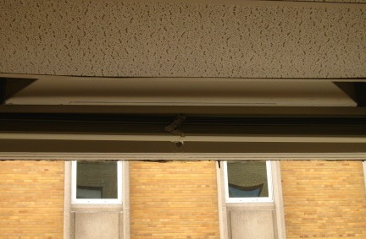
Fresh Air Intake above Window

Picture 2

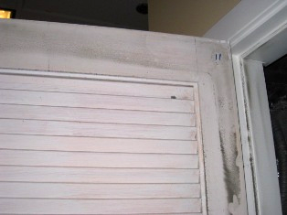

AHU Closet with Fixed Louvered Doors
Note Particulate Residue on Perimeter of Door and Casing

Picture 3

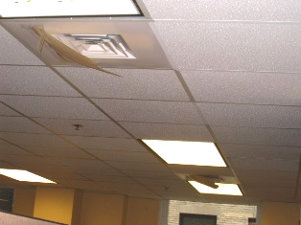

Obstructions Taped to Fresh Air Supply Diffusers (Arrows)

Picture 4

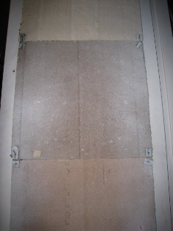

Insulating Material on Interior of AHU Closet Door
Picture 5

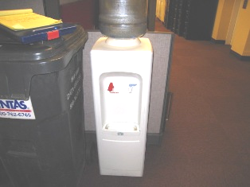

Water Cooler Located on Carpeting

Picture 6

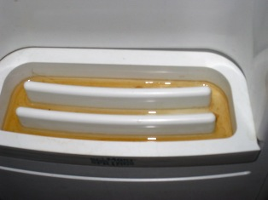

Water Cooler Reservoir with Accumulated Water

Picture 7

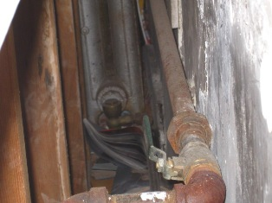

Paper, Magazines in Wall Cavity Adjacent to Radiator

Picture 8

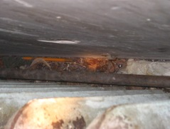

Plant Material, Paper Towel Adjacent to Radiator

Picture 9

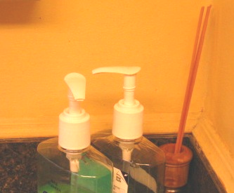

Reed Diffuser/Fragrance Sticks (Arrow)

Picture 10

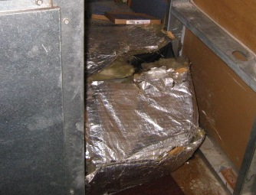

Ripped, Exposed Fiberglass Insulation

Picture 11

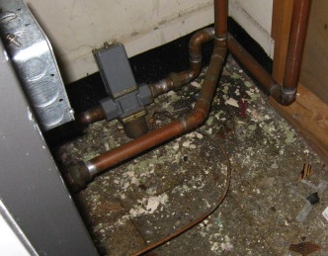

Paint Chips and Debris on Floor of AHU Closet

Picture 12

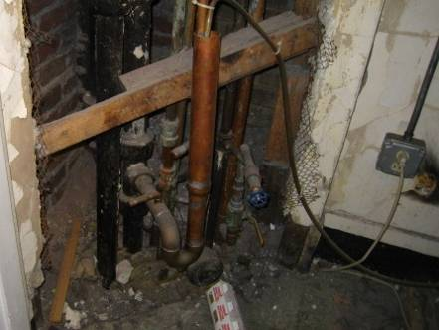

Open Wall Cavity

Picture 13

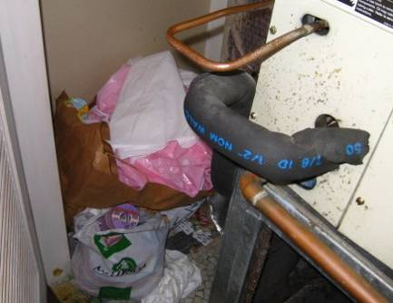

Debris Stored in AHU Closet

Picture 14

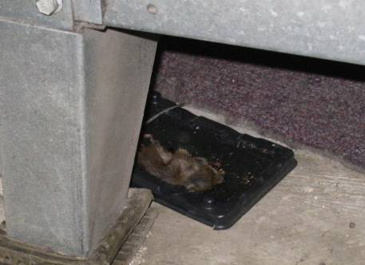

Dead Mouse beneath AHU

Picture 15

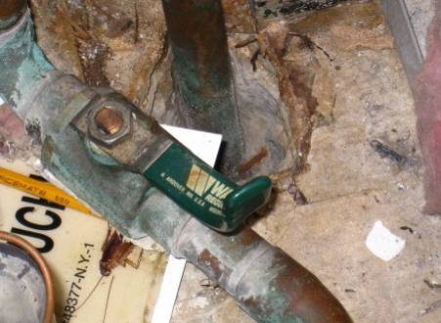

Dead Insect in AHU Closet (Arrow)
Note Fiberglass Insulation and Large Utility Hole in Floor

Picture 16

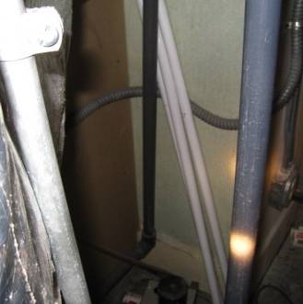

Fluorescent Light Bulbs Leaning Against Wall
Location/ Room | Occupants  in Room | Temp  (°F) | Relative  Humidity  (%) | Carbon  Dioxide  (ppm) | Carbon Monoxide  (ppm) | PM2.5  (µg/m³) | TVOCs  (ppm) | Windows  Openable | Ventilation |  | Remarks
 |  |  |  |  |  |  |  |  | Supply | Exhaust | Remarks
Background: |  | 58 | 59 | 446 | ND | 1-2 | ND |  |  |  | Overcast, light rain, wind speed 12 mph (north) (Weather Underground)
Front Desk | 5 | 73 | 46 | 1248 | ND | 14 | ND | N | Y | N | DO
Cash Area |  |  |  |  |  |  |  |  |  |  | WD CTs, AHU closets large penetrations into framing and open utility holes
210 | 0 | 74 | 41 | 1010 | ND | 15 | ND | Y | Y | Y
25 | 0 | 73 | 39 | 918 | ND | 11 | ND | Y | Y | Y
8 | 0 | 72 | 39 | 994 | ND | 14 | ND | Y | Y | Y
5 | 1 | 72 | 41 | 1015 | ND | 13 | ND | Y | Y | Y
1 | 0 | 72 | 40 | 904 | ND | 13 | ND | Y | Y | Y
36 | 1 | 71 | 40 | 979 | ND | 12 | ND | Y | Y | Y
Copy Area | 0 | 70 | 40 | 908 | ND | 12 | ND | Y | Y | Y | PC
Food Stamp Area |  |  |  |  |  |  |  |  |  |  | Chronic leaking urinal (recently repaired), filter bypass in AHUs, blocked air diffusers, WD GW, MT
44 | 3 | 71 | 41 | 782 | ND | 13 | ND | Y | Y | Y
62 | 2 | 72 | 41 | 774 | ND | 12 | ND | Y | Y | Y
67 | 4 | 73 | 40 | 790 | ND | 10 | ND | Y | Y | Y
340 Main Street Section |  |  |  |  |  |  |  |  |  |  | WD CTs, reported AHU leaked onto carpet
Entrance | 0 | 73 | 30 | 730 | ND | 14 | ND | Y | Y | Y
117 | 2 | 73 | 38 | 682 | ND | 14 | ND | Y | Y | Y
119 | 2 | 73 | 38 | 673 | ND | 13 | ND | Y | Y | Y
124 | 1 | 72 | 40 | 723 | ND | 15 | ND | Y | Y | Y
127 | 2 | 72 | 38 | 659 | ND | 13 | ND | Y | Y | Y
138 | 0 | 72 | 39 | 632 | ND | 14 | ND | Y | Y | Y
Computer Room | 0 | 72 | 39 | 610 | ND | 12 | ND | Y | Y | Y
Conference Room | 6 | 72 | 41 | 905 | ND | 13 | ND | Y | Y | N | Debris in AHU closet
132 | 0 | 71 | 39 | 627 | ND | 11 | ND | Y | Y | Y
Kitchen | 2 | 72 | 39 | 736 | ND | 10 | ND | Y | Y | Y
Waiting Room | 18 | 73 | 46 | 1383 | ND | 16 | ND | N | Y | Y

Actions on Previous MDPH Recommendations
The following is a status report of actions taken on previous MDPH recommendations (in bold). The summary is based on observations made by BEH staff:

Seal all holes in the AHU closets (i.e., floors, ceilings and walls) to eliminate both draw of air from building cavities and migration pathways for pests.
- Action Taken: Holes in walls, ceilings and floors of AHU closets remain.
Ensure leaks are repaired. Examine the area above and around these areas for mold growth.
- Action Taken: Leaks remain within the office space.
Replace water-damaged ceiling tiles in a manner consistent with recommendations found in “Mold Remediation in Schools and Commercial Buildings” published by US EPA.
- Action Taken: Water-damaged and missing ceiling tiles were observed.
Consult a ventilation engineer to maximize the operation of the building’s HVAC system, including an increase in filter efficiency. Have HVAC firm fully evaluate existing ductwork system for function to ensure proper distribution of fresh outside air to occupied areas.
- Action Taken: Carbon dioxide readings in the cash room and front desk area indicate a need for an evaluation of the HVAC system.
For buildings in New England, periods of low relative humidity during the winter are often unavoidable. Therefore, scrupulous cleaning practices should be adopted to minimize common indoor air contaminants whose irritant effects can be enhanced when the relative humidity is low. To control for dusts, a high efficiency particulate arrestance (HEPA) filter equipped vacuum cleaner in conjunction with wet wiping of all surfaces is recommended.
- Action Taken: Dust control measures were not in place on the day of the assessment. Dust was observed on many flat surfaces, on the AHU closet doors, walls and floors, and on the AHUs.
Use the principles of integrated pest management (IPM) to rid this building of pests. The IPM recommendations are available at the Massachusetts Department of Food and Agriculture (MDFA) website: http://www.state.ma.us/dfa/pesticides/publications/IPM_kit_for_bldg_mgrs.pdf
- Action Taken: Although there was evidence of an attempt to monitor pest activity (e.g., presence of sticky traps), current insect and rodent infestations were evident during the assessment.
Place rubber/plastic matting beneath water coolers to prevent water damage to carpeting. Clean and disinfect reservoir beneath water coolers periodically for mold growth and disinfect with an appropriate antimicrobial where necessary.
- Action Taken: Water coolers rested directly on carpeted areas and some reservoirs contained stagnant, discolored water.

