

**Commonwealth of Massachusetts**

**Executive Office of Health and Human Services**

**Chapter 257 of the Acts of 2008**

**Stakeholder and Provider Engagement Session:**

**Community Based Flexible Supports**

**November 18, 2013**

[www.mass.gov/hhs/chapter257](http://www.mass.gov/hhs/chapter257)

[eohhspospolicyoffice@state.ma.us](mailto:eohhspospolicyoffice@state.ma.us)

**Agenda**

* Chapter 257 of the Acts of 2008 – Timeline and Key Milestones
* Stakeholder Discussion
  + Review Steps to Date
  + Proposed CBFS Rate Framework
  + Operational Considerations
  + Open Questions
* Next Meeting – December 13, 2013

**Chapter 257 of the Acts of 2008 Regulates Pricing for the POS System**

**Pricing for the POS System**

* Chapter 257 places authority for determination of Purchase of Service reimbursement rates with the Secretary of Health and Human Services under MGL 118E. The Center for Health Information and Analysis (CHIA) provides staffing and support for the development of Chapter 257 pricing.
* Chapter 257 requires that the following criteria be considered when setting and reviewing human service reimbursement rates:
  + Reasonable costs incurred by efficiently and economically operated providers
  + Reasonable costs to providers of any existing or new governmental mandate
  + Changes in costs associated with the delivery of services (e.g. inflation)
* Substantial geographical differences in the costs of service delivery

**Community Based Flexible Supports:  
Timeline**

**CBFS Pricing Analysis, Rate Development, Approval, and Hearing Process**

**Proposed Timeline**

**May 2013**

Survey Results; Contract Data

**Summer 2013**

Model Development

Rate considerations

Input and Questions

**Fall 2013**

Regional Dialogues

Incorporating Stakeholder Input

**Winter 2013-14**

Rates shared with public

**Winter 2014**

**Winter/Spring 2014**

**Possible Revision / Promulgation**

**Public Comment and Hearing**

**Cost Analysis & Rate Methods Development**

**Cost Analysis & Rate Methods Development**

**Provider & Interested Stakeholder Consultations**

**Data Sources Identified or Developed**

**Community Based Flexible Supports:  
Steps to Date**

|  |  |
| --- | --- |
| **Timeframe** | **Activity** |
| Early 2013 | Project kick-off |
| May 8 | Issued Encounter and Housing surveys |
| July 22nd | Initial survey results shared |
| August 5th | Additional results, ABH model budget |
| September | Regional Dialogues |
| September 30th | More granular survey results |
| Today | Initial framework review |
| December 13 | Follow-up meeting to report changes based on provider feedback |

**Community Based Flexible Supports:  
Encounter Survey Results**

The Encounter Survey studied the number and types of encounters that CBFS clients received over a two-week period.

An encounter is a documented activity or contact with an identified client.

* Category Types: Rehabilitation, Support, Supervision, Health Promotion, Care Coordination.
* 100% of CBFS providers responded to the survey and reported data on 11,507 clients (over 95% of clients served during the time period).
* There were a total of 412,649 encounters reported during the time period.
* 92%of clients had one or more encounters during the two week time period.
* 17% of people had at least one “failed” encounter. Most of these people (94%) had at least one other documented encounter.
* 8% of clients had no encounters; 1% were a result of a “failed” encounter with no other documented encounter and 7% had no attempts.

**Community Based Flexible Supports:  
Encounter Survey: Total Client Encounters**



* The majority (57%) of CBFS clients received 10 or fewer encounters (5 or less per week).

**Community Based Flexible Supports:  
Encounter Survey: Totals by Living Arrangement**

|  |  |  |  |  |  |  |  |
| --- | --- | --- | --- | --- | --- | --- | --- |
| **Encounters Per Client by Living Arrangement** | | | | | | |  |
|  | **Staffed Setting** | **%** | **Non-Staffed Setting** | % | **Total** | **%** |  |
| 0 Encounters | 36 | 1% | 766 | 9% | 802 | 7% |  |
| 1-15 Encounters | 358 | 14% | 6,245 | 72% | 6,603 | 59% |  |
| 16-30 Encounters | 261 | 10% | 934 | 11% | 1,195 | 11% |  |
| 31+ Encounters | 1,984 | 75% | 676 | 8% | 2,660 | 24% |  |
| **Total** | 2,639 | 100% | 8,621 | 100% | 11,260 | 100% |  |

* Staffed settings (GLEs) had the highest number of encounters.

**Community Based Flexible Supports:  
Rehab Encounters**

* 36% of clients received one or less rehab encounter in the 2-week period of the encounter survey. The majority of these clients were in non-residential settings.

**Community Based Flexible Supports:  
R-Day Billing**

**Community Based Flexible Supports:  
Housing Survey**

* The majority of the total unit cost falls within a range from $10 to $30 per day.

* Median: $19.91, Average: $21.76

**Community Based Flexible Supports:  
Regional Dialogues – Feedback**

Regional Dialogues were held throughout the state and at varying times during the month of September. The intent was to encourage input on CBFS core services and programs from CBFS clients and interested parties.

Some recurring themes heard at the meetings include:

* Housing – need for affordable housing; maintain and expand service
* Family Involvement – desired expressed for families to understand the services being provided, and the CBFS services available to them
* Lack of consistent job titles used between providers
* Lack of consistent program design across providers – equity concerns
* Need for peer support
* Value of “hands on” help – grocery shopping, etc.
* Employment Assistance – some overlap with other programs (e.g., Clubhouse)
* Monitoring – some concerns expressed, but no alternative recommendations were offered
* Reporting – documentation requirements have impact on service delivery and client interaction

**Community Based Flexible Supports:  
Regional Dialogues - Summary of Findings**

**Findings –**

* Clients like services, want consistency
* Lower encounters than anticipated
* Encounters clustered in residential settings
* Low number of Rehab encounters for some clients
* Tight range of occupancy costs in residential settings\\

**Response –**

* Move away from a single rate for overall service
* Develop meaningful layers of care, with a rate established for each layer.

**Community Based Flexible Supports:  
Proposed Layers of Care**

**Core CBFS Services**

**Community Based Flexible Supports:  
Proposed Layers of Care**

**Non-Rehab CBFS Services**

**Core CBFS Services**

**Community Based Flexible Supports:  
Proposed Layers of Care**

Other Community-Based Services

**Non-Rehab CBFS Services**

**Core CBFS Services**

**Community Based Flexible Supports:  
Proposed Layers of Care**

**Group Living Environments (GLEs)**

Other Community-Based Services

**Non-Rehab CBFS Services**

**Core CBFS Services**

**Community Based Flexible Supports:  
Proposed Layers of Care**

**Group Living Environments (GLEs)**

Other Community-Based Services

**Non-Rehab CBFS Services**

**Community Based Flexible Supports:  
CBFS Layers – Core Services**

**Core CBFS Services**

**Core Services include:**

* The core CBFS continuum services
* Reporting requirements
* Rehab option
* Documentation – Assessments, Individualized Action Plans (IAPs), Service Notes, etc.

|  |  |  |  |  |  |  |
| --- | --- | --- | --- | --- | --- | --- |
| **CBFS Core Services Model Budget** | | | | | | |
| Clients: | 100 | Enrollment Days: | 36,500 | | | |
|  | | |  |  |  |  |
| **Staffing Roles** | | |  |  | **FTE** | **Expense** |
| Program Director | | |  |  | 1.00 | 3% |
| Assistant Director (LICSW level) | | | | | 1.00 | 3% |
|  | | |  |  |  |  |
| Psychiatrist | | |  |  | 0.05 | 1% |
| LPHA | | |  |  | 4.00 | 11% |
| RN | | |  |  | 2.00 | 8% |
| Substance Abuse Counselor | | | |  | 2.00 | 5% |
|  | | |  |  |  |  |
| General Staffing (DC I + II + III) | | | | | 10.00 | 17% |
| Housing Coordinator | | |  |  | 0.50 | 1% |
| Vocational Coordinator (Employment Spec.) | | | | | 1.00 | 2% |
| Peer & Family Specialist | | |  |  | 2.50 | 4% |
| *Relief* | | |  |  | 0.75 | 1% |
|  | | |  |  |  |  |
| Secretarial / Clerical | | |  |  | 1.00 | 2% |
| **Total Program Staff** | | |  |  | **25.80** | **59%** |

**Community Based Flexible Supports:  
CBFS Layers – Non-Rehab Services**

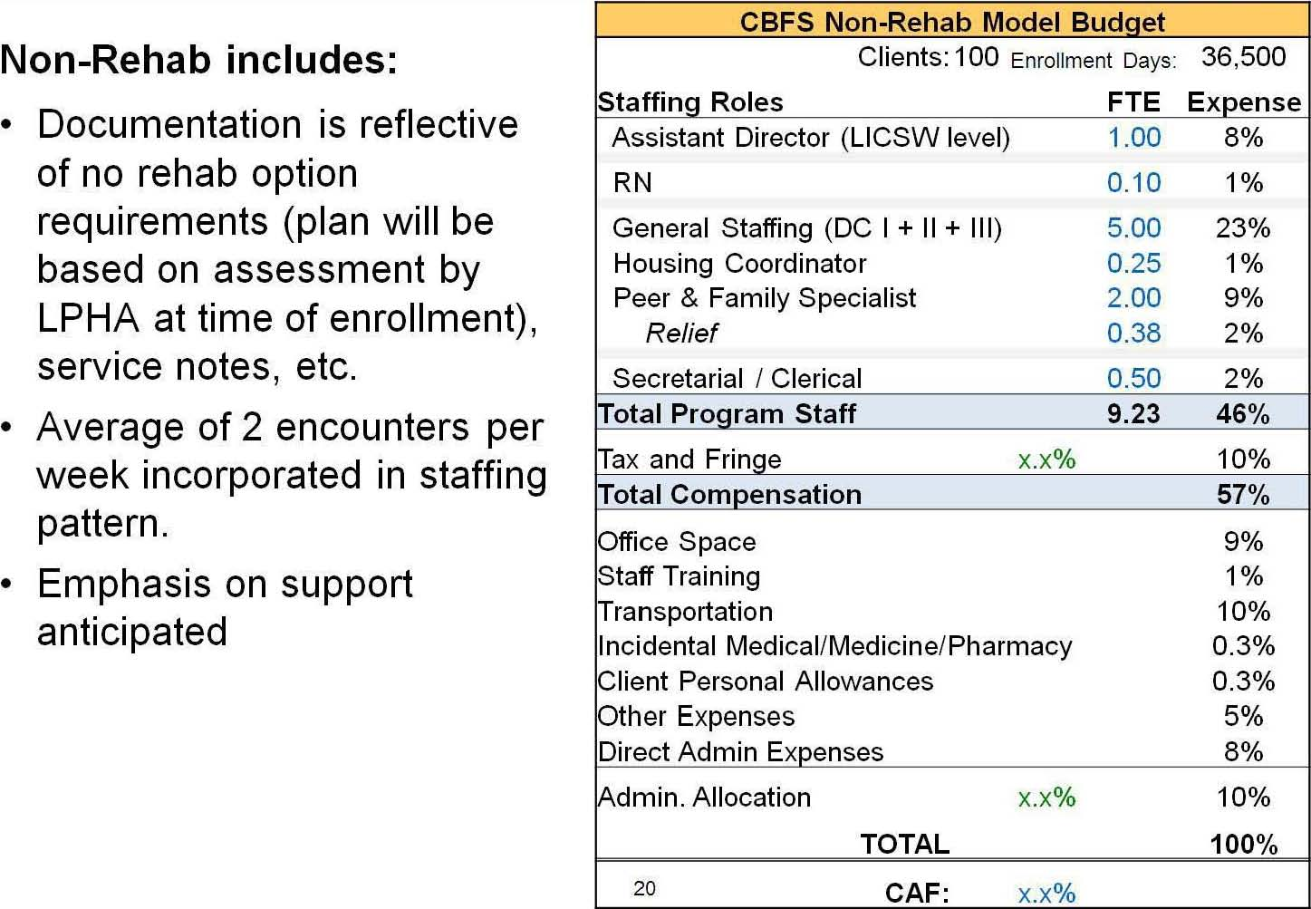

**Community Based Flexible Supports:  
CBFS Layers – GLEs**

|  |  |  |  |  |
| --- | --- | --- | --- | --- |
| **CBFS Standard GLE Model Budget** | | | | |
| Clients: | 5 | Bed Days: | | 1,825 |
|  |  |  |  |  |
| **Staffing Roles** |  |  | **FTE** | **Expense** |
| Program Director (Site Manager) | |  | 0.33 | 5% |
| General Staffing (DC I + II) |  |  | 4.20 | 46% |
| *Relief* |  |  | 0.65 | 6% |
| **Total Program Staff** |  |  | **5.18** | **57%** |
|  |  |  |  |  |
| **Expenses** |  |  |  |  |
| Tax and Fringe |  | x.x% |  | 13% |
| **Total Compensation** |  |  |  | **70%** |
|  |  |  |  |  |
| Occupancy |  |  |  | 14% |
| Food |  |  |  | 5% |
| Other Expenses |  |  |  | 1% |
|  |  |  |  |  |
| Admin. Allocation |  | x.x% |  | 10% |
|  |  |  |  |  |
| **TOTAL** |  |  |  | **100%** |
| **CAF:** |  | x.x% |  |  |

**Group Living Environments (GLEs) include:**

* Rate provides for staffing supervision costs alone – would also charge for Core Services for additional rehab, support and programming.
* Rates will be developed for GLEs at three capacity levels
* 4-6 beds,
* 7-9 beds and
* 10-12 beds.

**Community Based Flexible Supports:  
CBFS Layers – Contract Rent**

Recognizing that many consumers receive contract rental support via CBFS, the new rate model will capture those payments outside of the base CBFS rates.

* Providers will be reimbursed for actual costs, with a per-transaction fee provided in recognition of overhead and processing costs.
* In addition to current contract rent, non-staffed GLEs will be evaluated for inclusion in this category of funding.
* This approach mirrors that used in other programs both at DMH and other state agencies.

**Community Based Flexible Supports:  
CBFS Layers – Operational Considerations**

* Current CBFS Framework has a key feature – simplicity. DMH wants to maintain that as much as possible.
* The team kept that foremost in considering new structure. While layers will involve more than one rate, billing will be straightforward.
* Consumer will be “enrolled” at correct layer, pursuant to conversations between DMH and provider. The enrollment layer will transmit to EIM.
* Provider will access EIM and run a script to bill for each person enrolled at a particular layer. Correct rate will be applied.
* “R” days will continue to be recorded in EIM for those in Core CBFS Services.
* DMH will incorporate EIM data in contract monitoring.

**Community Based Flexible Supports:  
CBFS Layers – Open Discussion**

* How do the proposed CBFS Layers compare to your experience with CBFS consumers?
* With regard to the layered model, what are the operational considerations for DMH to consider?
* Are there other factors that we haven’t considered?
* Other questions?

**Community Based Flexible Supports:  
CBFS: Next Steps**

Next Provider and Stakeholder Input Session to be held:

Friday, December 13, 2013

Worcester Recovery Center and Hospital

10am-12pm

Today’s meeting materials will be posted on Chapter 257 website: www.mass.gov/hhs/chapter257

Comments and questions regarding Chapter 257 process can be sent to: EOHHSPOSPolicyOffice@state.ma.us