Do You Know What’s In Your Beverage?
Have you ever wondered if some drinks are as healthy as they claim to be?
If so, you’re not alone! Labels on these items can make them seem like good choices, but they can contain large amounts of sugar, caffeine, artificial sweeteners, colors, and flavorings.

Juice Drinks Flavored Water Energy Drinks

Sports Drinks Sugar-Free Drinks Flavored Coffees, Soda
Ads for sports drinks can make it seem like you need these
to stay hydrated, but most people don’t need them at all. Sports drinks and “juice drinks” are often just full of sugar and artificial ingredients.

Tips:
- Skip sports drinks and juice drinks.
- Limit kids to 4-6 oz. of 100% fruit juice a day.
- Plain water is the better choice!

The words “lite,” “flavored,” “diet,” and “sugar-free” on the label of a flavored beverage often means it contains artificial sweeteners and other ingredients you don’t need. Artificial sweeteners can cause cravings for even sweeter, higher-calorie foods.

Tips:
Flavor your water with:
- Oranges
- Lemons and limes
- Berries
- Cucumber slices
- Crushed mint
Energy drinks and flavored coffees claim to give you energy during the day. That’s because they (along with soda) can be loaded with caffeine, extra calories, sugar, and other unnecessary ingredients.
While these may give you a short burst of energy, they will often end up making you feel more tired.

Tips:
- Make your own protein-packed smoothies with yogurt and fresh, frozen, or canned fruit in 100% juice or water.
- Try adding peanut butter or vegetables like spinach to give you more energy throughout the day.

Water is the best and most natural way to quench thirst.
Water doesn’t have any calories, artificial ingredients, or sugar!

Confused about what to buy?
Use these tips for reading labels to help you choose beverages
for you and your family.

Serving Size is the amount of the beverage that the nutrition facts are based on. Be aware of the number of servings per container. You may be consuming more than you think!

Sugar New food nutrition labels make it easier to see the sugar content. In this beverage, only 4 grams of sugar come from actual fruit. Most of the sugar (28 grams) is added!

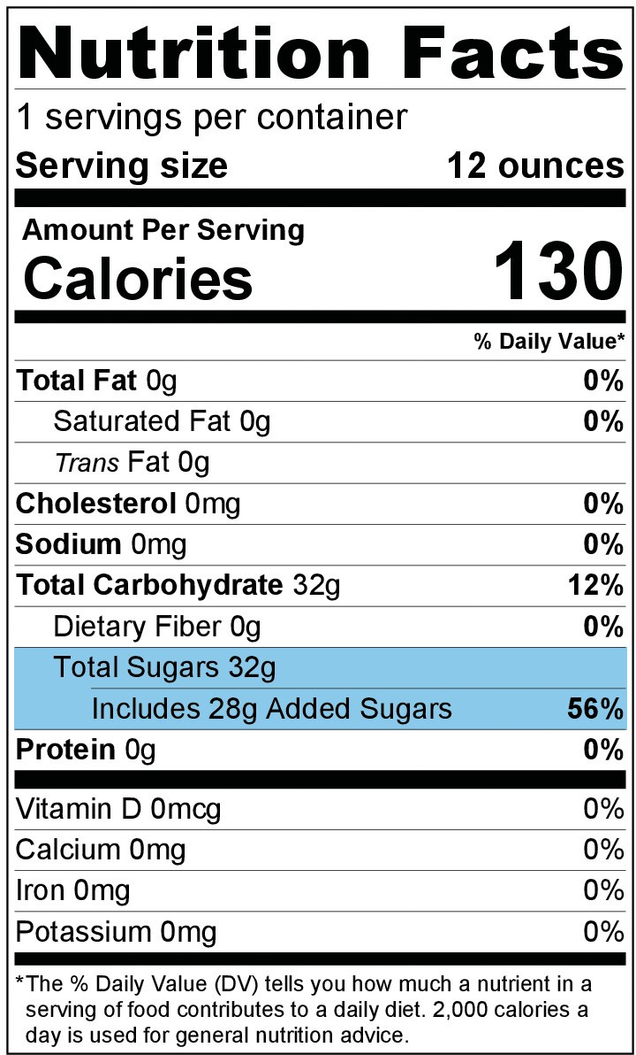
Ingredients are listed in decreasing order of quantity. This means that there is the largest amount of the first ingredient and the least amount of the last ingredient.

High Fructose Corn Syrup is considered a form of sugar. It is a processed and refined sweetener made from corn starch. Products with high fructose corn syrup should be avoided.

Yellow 5 and Yellow 6 are examples of artificial colors. These, along with artificial flavors, are unnecessary ingredients, especially for growing children.
Artificial Sweeteners come in several different types. Be aware of beverages that have these. The following are all names for artificial sweeteners: Sucralose, Aspartame, Acesulfame Potassium, and Saccharin.
Ingredients:
Water, High Fructose Corn Syrup and less than 2% of: Concentrated Juices (Apple, Orange), Ascorbic Acid (Vitamin C), Citric Acid, Natural Flavors, Pectin, Canola Oil, Modified Corn Starch, Yellow 5, Yellow 6,
Sucralose, Sucrose Acetate Isobutyrate, Sodium Citrate, Potassium Sorbate and Sodium Hexametaphosphate (Preservatives), Calcium Disodium EDTA (To protect color)
Form #387

This institution is an equal opportunity provider.
mass.gov/wic

