LEAD POISONING
Call for free: 1-800-532-9571
Assistance available in other languages.

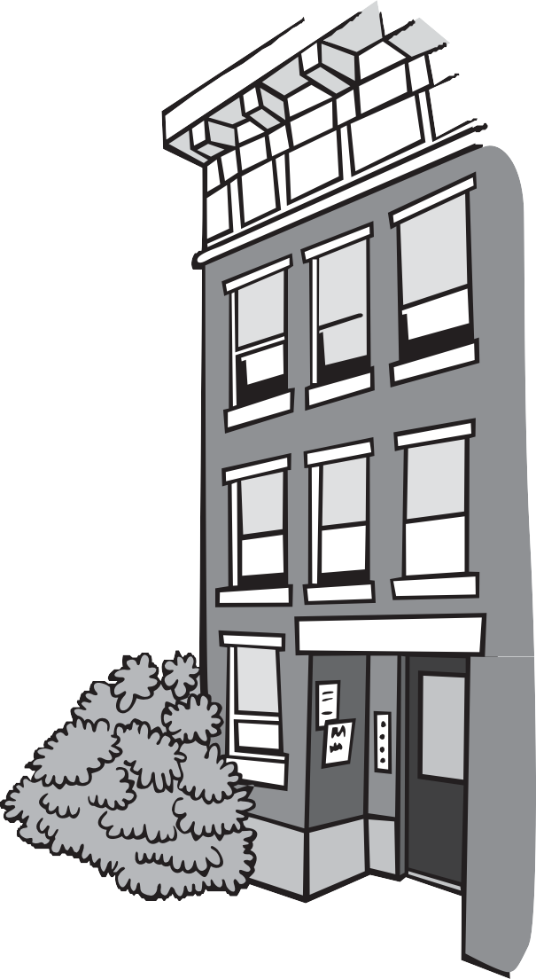Do You Rent Your Home?
Look Out for Lead!

Lead dust and lead paint in old homes can poison children. When old paint peels and cracks, it makes lead dust. Lead dust can also come from opening and closing old windows.

Find out if you have lead in your home.
If you rent your home and you have a child under 6, talk to your landlord about lead paint. Ask to see a Letter of Full Deleading Compliance (often called an L.O.C.). An L.O.C. means the home
was inspected for lead and that it was safe when the letter was given.
- If your home has an older L.O.C. and peeling paint, it may no longer be safe. You should call CLPPP to find out what you can do.
- If your landlord does not have an L.O.C., ask him to hire a licensed lead inspector to test your home for lead paint. If your landlord refuses, call CLPPP.

Families with children are protected by law.
The Lead Law protects children under 6 years old who live in a home built before 1978. If there is lead paint in the home, the landlord must fix it.

What if my home has lead paint?
The landlord must fix it. Fixing lead paint hazards is called deleading.
There may still be lead paint in homes that have been deleaded.
Deleading must be done by someone who is trained to do the work safely. Ask to see an authorization number from anyone working with lead paint. Your landlord cannot evict you because there is lead in your home.

- You may have to leave your home during deleading.
- Your landlord must find you a place to stay until the work is done.
- You must pay rent, unless you are staying with family or friends.

Looking for housing?

A landlord cannot refuse to rent to you because of lead paint.
This is discrimination. Call CLPPP to learn more about your rights.

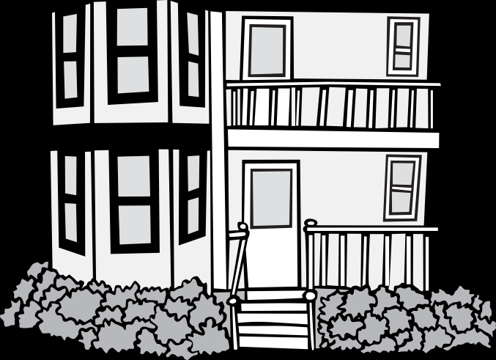Childhood Lead Poisoning
Prevention Program (CLPPP)
Call: 1-800-532-9571 or 1-617-624-5757
TTY: 1-617-624-5286
Email: clppp@state.ma.us
On the web: www.mass.gov/dph/clppp

Massachusetts Department of Public Health
Bureau of Environmental Health

2015

www.mass.gov/dph/clppp

