What’s the Problem with Dog Waste?
Dog waste left in our yards, forest areas and parks can have many adverse effects on the environment.
It’s full of harmful bacteria and excess nutrients.
Besides being a neighborhood nuisance, dog waste can make people sick, especially children who are more likely to come into contact with it while playing.
Dog waste left on lawns can also kill or damage grass and other plants.
When dog waste is washed into lakes or streams, the waste decays, uses up oxygen in the water, and sometimes releases ammonia. This can kill fish!
Dog waste also contains nutrients that encourage weed and algae growth.
Too much of these nutrients turn water cloudy and green . . . imagine this in your backyard pond or stream!

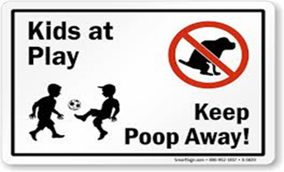

Managing dog waste properly is something easy that everyone can do to make a difference in the quality of our surface waters.

Brought to you by the Town of ___________




DOG WASTE
AND
SURFACE
WATER
QUALITY
Did You Know?
There are over __ licensed dogs in our town.
Each of these dogs produces about ¾ pound of solid waste and over 7 billion bacteria daily!

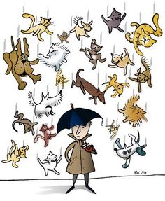
Rainfall and snowmelt in the Town of ______ goes untreated into our stormwater system, then directly into local streams, ponds, rivers and lakes.
As it flows, stormwater picks up contaminants and pollutants in its path.
That’s why it’s important to make sure that dog waste and its pollutants do not end up in the storm drains.
What’s So Bad About
Dog Waste?

Bacteria and other parasites found in pet waste, such as
Giardia and Cryptosporidium,
can survive for long periods when
left on the ground.

During a rain storm, these pollutants can be washed into local rivers and ponds and into local drinking water supplies.

Individual actions can result in significant water quality improvements when carried out by many people.
Unlike some forms of stormwater pollutants, individual people can easily and economically manage dog waste and help keep our waters safe and aesthetically pleasing.

How You Can Help
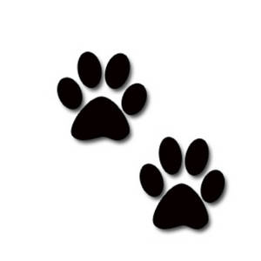
BRING IT – Always bring a plastic bag when you walk your dog.

BAG IT – Use the bag as a glove to pick up the dog waste. Scoop it up and turn the bag inside out around the waste.

DISPOSE IT – Properly dispose of dog waste by putting it in a trash can. Never throw dog waste down a storm drain.

AND REMEMBER
- Pick up after your pet in your yard
- Only bring your dog where dogs are allowed.

