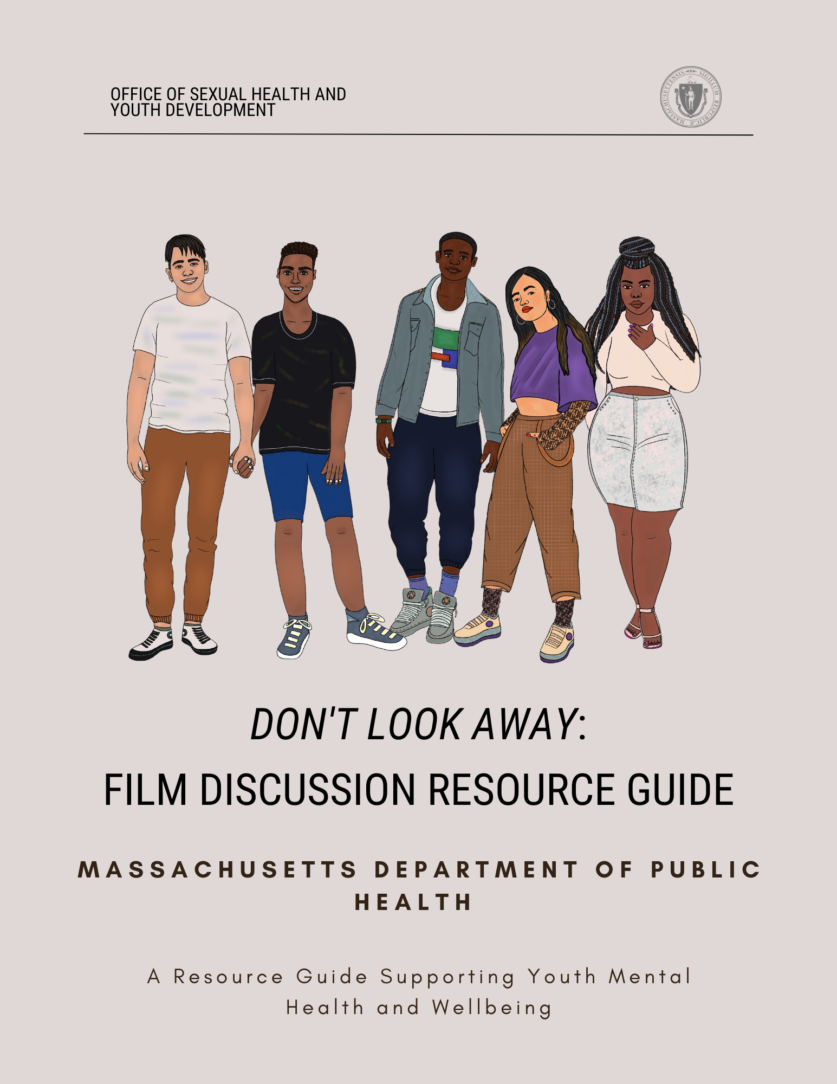

# Table of Contents

This Resource Guide 3

Thank You 5

Definitions 6

Mental Health Resources for Youth 7

988 Suicide and Crisis Lifeline 7

Health Steps 7

MCSP: Greater Boston Regional Suicide 7

Mass Suicide Prevention Program 7

Parent/Professional Advocacy League (PPAL) 7

Youth On Fire 8

GLASS 8

Speaking of Hope 8

Young Adult Access Centers 8

Video Summary 9

Guiding Discussion Questions 9

Facilitator Tips 11

Mandated Reporting & Managing Disclosure 11

Creating Brave Spaces 11

References 13

# 

# This Resource Guide

As a branch of the Massachusetts Department of Public Health, the Office of Sexual Health and Youth Development (OSHYD) is proud to offer this Mental Health Film Discussion Resource Guide to trusted caretakers and educators.

OSHYD is comprised of several programs that work synergistically to increase access to comprehensive sexuality education, decrease teen and unintended pregnancy, decrease the incidence of sexually transmitted infections (STIs), increase the sustainability of delivery networks serving youth and other vulnerable populations, and increase protective factors for young people using a positive youth development lens1.

Youth experience barriers that influence health and wellness, and some youth experience stressors like feeling unsafe, housing instability, or social isolation. Youth who identify as Black, Indigenous, and other People of Color (BIPOC) and BIPOC youth with different intersecting marginalized identities have inequitable access to mental healthcare2. These young people have compounding situations, such as accessibility, language needs, or stigma, that may prevent them from being able to seek appropriate mental healthcare resources. Historical and systemic factors such as institutional and structural racism uphold barriers and maintain inequities in mental health access and utilization. Often, blame is placed on individuals for struggling with their mental health—but many systemic factors impact overall health2. The COVID-19 pandemic only exacerbated numerous hardships for youth in the United States3. In 2022, the CDC’s Adolescent Behaviors and Experiences Survey (ABES) found that 67% of U.S. high school students reported that schoolwork was more difficult, 55% experienced some emotional abuse in the home, 11% experienced physical abuse, and 24% reported they did not have enough food to eat during the COVID-19 pandemic, all of which can have a detrimental effect on mental health. On top of this, 16.39% of youth (aged 12-17) reported experiencing at least one major depressive episode (MDE) in the past year4.

Trusted adults in young people’s communities play a significant and important role5. Youth mental health outcomes can be improved by having an accepting community, adult, or caregiver who can direct a young person to helpful resources or services. Trusted adults can create and maintain a brave space for youth to explore their mental health and well-being.

This discussion guide can be used in conjunction with the film, *Don’t Look Away*, on how to ask questions or have potentially challenging conversations with youth. This guide is a starter kit for facilitators, schools, community organizations, parents, and trustworthy adults on what support systems are available and how to navigate what may feel like uncharted territory.

Included are resources that provide accurate and trauma-informed information that addresses social determinants of health for youth’s mental well-being. Organizations that directly and indirectly focus on mental health needs of youth in Massachusetts are highlighted. As a result, the organizations in this resource guide are committed to providing inclusive care and to respecting and acknowledging the mental health gap that youth experience.

# Thank You

The Massachusetts Department of Public Health, the Office of Sexual Health and Youth Development (OSHYD) would like to thank the following organizations and individuals for their input and contribution to this resource guide:

Cecelia Werner, 2023 Fellow at the Boston University Maternal and Child Health Center for Excellence, Master of Public Health candidate

A special thanks go to the cast and crew of *Don’t Look Away*

[Lowell Community Health Center](https://www.lchealth.org/health-wellness/healthy-community/teen-block-youth-programs/)6

Tim Sokhoeun, Program Coordinator at Lowell Community Health Center

Jennifer Khat, Health Educator, at Lowell Community Health Center

[Thato Mwosa](https://thatomwosa.com/)7, Film Producer, Writer, and Director for Tuli Media

Dara Oloyede (DPH), Adolescent Health Coordinator at the Office of Sexual Health and Youth Development

Lissette Gil-Sanchez (DPH), Director of the Office of Sexual Health and Youth Development

# Definitions

These definitions are based on what is currently appropriate as of November 2023. These definitions are not exhaustive.

|  |  |
| --- | --- |
| Brave Space8 | An environment that acknowledges the challenges that both students and faculty have when discussing difficult and/or sensitive topics such as race, power, privilege, and the various forms of oppression for the purpose of learning. |
| Cultural Expectations/  Norms9 | Social and cultural norms are rules or expectations of behavior and thoughts based on shared beliefs within a specific cultural or social group. |
| Healthy Coping Skills10 | Coping refers to the conscious and voluntary thoughts and behaviors employed to navigate both internal and external stressors. These skills are behaviors that we develop to make sense of negative experiences in a productive way. They help us manage our emotions related to difficult times to improve our emotional health. It is distinct from 'defense mechanisms,' which are subconscious or unconscious adaptive responses.  Examples include but are not limited to movement or physical activity, meditation, creative outlets, journaling, etc. |
|  |  |
| Respect11 | Admiration shown or felt for someone or something that you believe has good ideas or qualities. |
| Trusted Adult12 | A trusted adult is chosen by the young person as a safe figure who listens without judgment, agenda, or expectation but with the sole purpose of supporting and encouraging positivity within a young person’s life. |
| Values13 | The beliefs people have, especially about what is right and wrong and what is most important in life, that control their behavior. |

# Mental Health Resources for Youth

## 

## [988 Suicide and Crisis Lifeline](https://www.mass.gov/info-details/about-the-988-suicide-and-crisis-lifeline)

988 is a direct three-digit number to trained Suicide and Crisis Lifeline specialists. 988 is free and available 24/7, 365 days a year via phone call, text or chat14.

## 

## [Health Steps](https://www.211.org/about-us/your-local-211)

211HELPSteps is the online platform of Mass211. From any desktop or mobile device, individuals can search and then connect to local health and human service resources across the Commonwealth. Programs that are included support basic needs such as food security, housing, childcare, transportation, and mental and emotional health resources15.

## [MCSP: Greater Boston Regional Suicide](https://www.greaterbostonpreventssuicide.org/resources)

The Greater Boston Regional Suicide Prevention Coalition (GBRSPC) is one of ten regional coalitions that operate under the umbrella of the Massachusetts Coalition for Suicide Prevention (MCSP). Massachusetts Coalition for Suicide Prevention (MCSP) is an inclusive alliance of suicide prevention advocates, including public and private agency representatives, policymakers, suicide loss, and attempt survivors, impacted family and friends, mental health and public health consumers and providers, and concerned citizens who are dedicated to working together to reduce the incidence of suicide and self-harm across the Commonwealth. Services include [mental health crisis hotlines](https://www.greaterbostonpreventssuicide.org/mh-crisis-hotlines), [emergency mental health services](https://www.greaterbostonpreventssuicide.org/mh-crisis-support), [statewide resources](https://www.greaterbostonpreventssuicide.org/ma-statewide-resources), [RIAC community services](https://www.greaterbostonpreventssuicide.org/communities-of-color), and [youth mental health resources](https://www.greaterbostonpreventssuicide.org/youth-mental-health)16.

## [Mass Suicide Prevention Program](https://www.mass.gov/suicide-prevention-program)

This program aims to reduce the number of suicides and suicide attempts and promote mental health and well-being among Massachusetts residents. We seek to raise awareness of suicide as a public health problem. The Program provides support to community agencies, education and training for professionals and caregivers, and funds programs working with youth, veterans, and older adults. We use data to identify populations and geographic areas of the state that need assistance. We also support and encourage communities to collaborate across disciplines to prevent suicide and suicide attempts across the lifespan. Services include crisis hotlines and [MassMen: Life tools for men](https://www.mass.gov/massmen)17.

## [Parent/Professional Advocacy League (PPAL)](https://ppal.net/)

Parent/Professional Advocacy League is a statewide, grassroots family organization that advocates for improved access to mental health services for children, youth, and their families. PPAL’s goals are to support families, nurture parent leaders, and work for systems change. PPAL is the only Massachusetts organization whose work focuses solely on the interests of families whose children have mental health needs. Founded in 1991, PPAL continues to work on behalf of children, youth, and families as a critical voice shaping policy and practice. Services include [family support services](https://ppal.net/family-support-services/) and [juvenile justice help](https://ppal.net/juvenile-justice/)18.

## [Youth On Fire](https://www.harvardsquare.com/venue/youth-on-fire/)

The Youth On Fire drop-in center was established in the fall of 2000 to provide a welcoming and non-judgmental environment for homeless and street-involved youth. YOF is open five days a week and serves young people between the ages of 14 and 24. The behaviors necessary to survive on the streets often put these youth at a higher risk of contracting HIV. YOF serves the physical and mental needs of these youth. The center offers basic necessities and prevention information on HIV, STDs, Hepatitis C, and other diseases associated with high-risk behavior. YOF has onsite hot meals, clothing, showers, laundry facilities, weekly medical care, mental health counseling, and referrals to community resources. The ultimate goal of YOF is to help as many youths as possible to have a healthy lifestyle, remain HIV-negative, and seek greater stability through permanent housing, employment, or school19.

## [GLASS](https://jri.org/services/health-and-housing/health/boston-glass)

GLASS provides [behavioral health services](https://jri.org/services/behavioral-health-and-trauma), [educational services](https://jri.org/services/educational-and-residential), and other [youth opportunities](https://jri.org/services) to LGBTQ+ youth of color and their allies in the Greater Boston and Greater Framingham areas20.

## [Speaking of Hope](https://www.speakingofhope.org/)

Speaking of Hope is a web and social media platform that supports mental wellness for young adults in Massachusetts and offers key resources such as employment and training services, mental health support, and substance use recovery support for young adults21.

## [Young Adult Access Centers](https://www.speakingofhope.org/access-centers/)

Young Adult Access Centers provide timely and effective services for young adults facing mental health concerns. These centers focus on outreach to those dealing with challenges such as mental illness, substance misuse, economic insecurity, and homelessness. Services are free and available in Massachusetts. Find a center at <https://www.speakingofhope.org/access-centers/> or contact Heidi Holland, Director of Young Adult Transitional Services at [Heidi.holland@mass.gov](mailto:Heidi.holland@mass.gov). Centers are affirming and inclusive spaces that promote an environment that specifically and effectively engages Black, Indigenous, People of Color (BIPOC) and Lesbian, Gay, Bisexual Queer/Questioning (LGBTQIA+) young people22.

# Video Summary: Don’t Look Away

This short film follows Sheba, a high school student who is an aspiring artist. Sheba’s mother and father are parents who value education and academic success. Sheba grapples with the delicate balance between honoring her parents’ values and nurturing her own artistic aspirations.

**Content Warning**:

This film delves into sensitive topics related to mental health. It is important to note that this film and the subsequent discussion may bring up strong emotions or reactions. Facilitators leading the discussions should be mindful of the potential emotional impact on youth.

We encourage facilitators to review the available resources in the designated section. Additionally, please be aware of the mental health resources and referral partners within your organization. If youth express a need for additional services or resources, it is crucial to have these options readily available.

# 

# Guiding Discussion Questions

Below are key talking points and takeaways for facilitators to address in the discussion and to leave with the group.

* **Key Themes:**

1. Healthy Coping Skills
2. Mental Health
3. Trusted Adults
4. Cultural Expectations and Awareness

* **Reflection Questions for Facilitators**

1. As a facilitator, how will you model a brave space, respect towards others, and call in any harm that has been done?
2. How do you integrate the arts and other modalities, like music, movement, writing, painting, or drawing, into your youth programming (e.g., [Raw Art Works](https://www.rawartworks.org/))?
3. What mental health resources or referral partners can your program provide for youth? Is there any protocol around follow-up?
4. What is your agency’s policy around disclosure and mandatory reporting (see section: Facilitator Tips)?
5. How would you approach a youth whom you notice has been more withdrawn from programming?
6. How can cultural expectations or norms be a protective factor for youth?
7. Has this conversation challenged your values in any way?
   1. If not, how does it align with your values?
8. How might this topic impact your ability to connect with youth?

* **Discussion Questions for Youth**

1. What does your culture or community think about mental health?
   1. Do you agree or disagree?
2. How can culture support healthy mental well-being? How can community support healthy mental well-being?
3. Do you feel like you have at least one trusted adult you can go to if you are struggling?
   1. What makes them a supportive adult?
   2. What examples of a supportive adult did you see in the film?
4. How can others’ expectations of you impact you and your mental health?
5. What are healthy strategies that can help you or other young people cope with these pressures?
6. What are some student support resources at your school or in your community?

# Facilitator Tips

Below are recommendations and factors to consider while leading a conversation about youth mental health in a group or in one-on-one setting.

## Mandated Reporting & Managing Disclosure

Under Massachusetts law, the Department of Children and Families (DCF) is the state agency that receives all reports of suspected abuse and/or neglect of children under the age of 18. Professionals who have regular contact with children are mandated by state law to inform the Department of Children and Families (DCF) if they have suspicions of child abuse or neglect23. If you work in childcare, you may find it necessary to submit a report to DCF regarding suspected child abuse or neglect24. To learn more about the process of reporting alleged child abuse or neglect under section 51A, please click [here](https://www.mass.gov/how-to/report-child-abuse-or-neglect) for additional information.

Below is a list of positions that are mandated reporters23:

1. Physicians, dentists, nurses, medical interns, hospital personnel, and all medical staff.
2. Public or private school teachers, educational administrators, guidance, or family counselors.
3. Early education, preschool, childcare, or after-school program staff, including any person paid to care for or work with a child in any public or private facility funded or licensed by the Commonwealth.
4. Voucher management agencies, family childcare, and childcare food programs.
5. Childcare licensors, such as staff from the Department of Early Education and Care.

Please note that the list above is not exhaustive. If you are unsure if you are a mandated reporter, you should refer to your supervisor.

Being well-informed about your agency's policies regarding mandated reporting and managing disclosures is crucial. Setting up a pre-planned strategy with your agency for managing disclosures and locating post-disclosure support is essential for effectively managing such challenging situations. It is vital to maintain transparency and honesty when interacting with children or youth under the age of 18 and disclose that you are a mandated reporter. This disclosure is essential, as it can provide children or students with support or guide them to other resources to feel comfortable and safe.

## Creating Brave Spaces

Establishing a brave space for youth is difficult but doable. As a facilitator, it is important to set and communicate discussion boundaries immediately to help maintain a healthy and safe environment. One effective approach is to involve the youth in collectively setting ground rules for your time together. Some examples of such rules could include: (1) focusing on challenging ideas, not individuals; (2) respecting confidentiality (“What's discussed here stays here,”); and (3) listening with the intent to learn rather than simply responding.

Another approach is using the “Comfort Circle” or similar concept. To follow this suggestion, see page 32 of the Valuing Our Insights for Civic Engagement (VOICES) curriculum25. This curriculum was developed by the Office of Sexual Health and Youth Development in collaboration with The Posse Foundation. Write down these rules somewhere where everyone can see them and seek consensus that everyone in the space will commit to following the ground rules. At the start of each day of programming, refer youth back to the ground rules.

It is important to understand that some of these suggestions and conversations can be challenging and uncomfortable. Many young individuals may be actively seeking and in need of resources. It is important to remember that your role as a facilitator is not to offer counseling but to serve as a trustworthy adult and direct the young person to the appropriate resources. Always seek permission before sharing resources, such as connecting them with a therapist or school staff member. Follow up with the students to see how they are doing and ensure they are mentally and physically safe.

Additionally, safeguarding your own mental health is critical. Engaging empathetically with youth who have experienced trauma can lead to vicarious trauma. Be watchful for signs of emotional exhaustion, reduced personal accomplishment, and dissociation. Establish a plan with your leadership team and seek mental health support for yourself26.

# References

1. Office of Sexual Health and Youth Development. Mass.gov. Accessed February 10,

2023. <https://www.mass.gov/orgs/office-of-sexual-health-and-youth-development>.

1. Metzger, I., Turner, E., Jernigan-Noesi, M., Fisher, S., Nguyen, J., Shodiya-Zeumault,

S., & Griffith, B., Conceptualizing Community Mental Health Service Utilization for BIPOC Youth, Journal of Clinical Child & Adolescent Psychology, 52:3, 328-342. 2023. Accessed October 9, 2023. <https://www.tandfonline.com/doi/full/10.1080/15374416.2023.2202236>.

1. CDC Data Illuminate Youth Mental Health Threats during the COVID-19 Pandemic,

Accessed March 31, 2023. <https://www.cdc.gov/media/releases/2022/p0331-youth-mental-health-covid-19.html>.

1. Youth Data 2023. Mental Health America. Accessed April 20, 2023.

<https://mhanational.org/issues/2023/mental-health-america-youth-data>.

1. Youth Online: High school YRBS - Massachusetts 2021 results | DASH | CDC. Accessed

May 10, 2023. <https://nccd.cdc.gov/youthonline/App/Results.aspx?LID=MA>.

1. Lowell Community Health Center, May 22, 2023. [www.lchealth.org/](http://www.lchealth.org/).
2. Thato R. Mwosa, October 6, 2023. <https://thatomwosa.com/>.
3. The 6 Pillars of a Brave Space. University of Maryland. Accessed November 10, 2023.

<https://www.ssw.umaryland.edu/media/ssw/field-education/2---The-6-Pillars-of-Brave-Space.pdf>.

1. National Academies. Addressing the Social and Cultural Norms that Underlie the

Acceptance of Violence: A Workshop. (2015) Accessed November 10, 2023. <https://www.nationalacademies.org/our-work/addressing-the-social-and-cultural-norms-that-underlie-the-acceptance-of-violence-a-workshop#:~:text=Social%20and%20cultural%20norms%20are,acceptable%20in%20interactions%20among%20people>.

1. Folkman, S., & Moskowitz, J. T. (2004). Coping: Pitfalls and Promise. *Annual Review of*

*Psychology*, *55*(1), 745–774. <https://doi.org/10.1146/annurev.psych.55.090902.141456>.

1. Cambridge Dictionary. Definition of “Respect.” Accessed November 10, 2023.

<https://dictionary.cambridge.org/us/dictionary/english/respect>.

1. YoungMinds. Definitions. Accessed. November 15, 2023.

<https://www.youngminds.org.uk/professional/community-support/someone-to-turn-to/defining-a-trusted-adult/#:~:text=What%20is%20a%20trusted%20adult,within%20a%20young%20person's%20life>.

1. Cambridge Dictionary. Definition of “Values.” Accessed November 10, 2023.

<https://dictionary.cambridge.org/us/dictionary/english/values>.

1. 988 Suicide and Crisis Lifeline. Mass.gov. Accessed October 6, 2023.

<https://www.mass.gov/info-details/about-the-988-suicide-and-crisis-lifeline>.

1. 211HELPSteps. Accessed May 10, 2023. <https://www.helpsteps.com/#/>.
2. “Home: Greater Boston Regional Suicide Prevention.” Mysite. Accessed June 14, 2023.

<https://www.greaterbostonpreventssuicide.org/resources>.

1. Suicide prevention program. Mass.gov. Accessed May 10, 2023.

<https://www.mass.gov/suicide-prevention-program>.

1. “PPAL: Children’s Mental Health.” Parent Professional Advocacy League |

Massachusetts Family Voice for Children’s Mental Health. Accessed June 12, 2023. <https://ppal.net/>.

1. “Youth on Fire.” Harvard Square. Accessed May 12, 2023.

<https://www.harvardsquare.com/venue/youth-on-fire/>.

1. “GLASS (GLBTQ+ Adolescent Social Services).” Leader in Social Justice (LRI).

Accessed August 7, 2023. <https://jri.org/services/health-and-housing/health/boston-glass>.

1. Speaking of Hope. Accessed October 6, 2023. <https://www.speakingofhope.org/>
2. Access Centers. Speaking of Hope. Accessed October 6, 2023.

<https://www.speakingofhope.org/access-centers/>

1. Massachusetts Department of Children & Families. Mass.gov. Accessed May 10, 2023.

<https://www.mass.gov/orgs/massachusetts-department-of-children-families>.

1. Reporting alleged child abuse or neglect (filing a 51A report). Mass.gov. Accessed

October 6, 2023. <https://www.mass.gov/info-details/reporting-alleged-child-abuse-or-neglect-filing-a-51a-report>.

1. Office of Sexual Health & Youth Development & The Posse Foundation. (2016). *Valuing*

*Our Insights for Civic Engagement (VOICES)* (2nd Ed.). Boston, MA.

1. Bell, H., Kulkarni, S., Dalton, L. Organizational Prevention of Vicarious Trauma.

*Families in Society*, *84*(4), 463-470. 2003. <https://doi.org/10.1606/1044-3894.131>