Doula Certification Program—Frequently Asked Questions

General certification questions

What is certification?
Certification is an optional, formal credentialing process through the Department of Public Health (DPH) and Bureau of Family Health and Nutrition (BFHN). The process establishes minimum standards for training, knowledge, and professional conduct. Certified doulas are expected to have knowledge of:
- Maternal anatomy and physiology during the perinatal period, including basic fetal growth and development in each trimester of pregnancy
- Common medical interventions during pregnancy, childbirth, and the postpartum period
- Common potential complications associated with pregnancy, childbirth, and the Postpartum period, including but not limited to:
  - Pregnancy termination, and infant loss;
  - Newborn feeding;
  - Mental health conditions, including perinatal mood and anxiety disorders (PMADs);
  - Substance use disorder (SUD); and
  - High blood pressure
- Labor and delivery comfort measures
- Best practices for supporting clients in advocating for their needs and making informed decisions using a trauma-informed approach
- Basic newborn care, including the fundamentals of breastfeeding/chestfeeding

Is certification free?
Yes! We’ve heard from doulas that cost is a leading barrier to doula training and certification, so we’ve made the DPH doula certification and recertification process entirely free.

What happens if a doula isn’t certified by DPH?
There are no consequences for practicing without being certified since certification is not mandatory to practice. Doulas may practice without certification. However, we highly encourage all doulas, regardless of whether you’ve already been certified by an independent organization, to apply for the DPH Doula Certificate. DPH-certified doulas will have access to several benefits outlined in the FAQ below.

What are the benefits of doula certification?
Doulas who receive DPH Doula Certification will gain access to free, virtual continuing education and a statewide community of practice. Based on what we’ve heard from doulas across the state, we’ll prioritize continuing education on topics such as billing support, substance use recovery support, trauma-informed care, and remote blood pressure monitoring. This certification helps remove barriers that often come with private certifying organizations—such as fees, extensive paperwork, or proof of a certain number of births—while honoring the training and experience doulas already have in Massachusetts. Certification may also help hospitals, healthcare settings, and payers collaborate with doulas more effectively through a centralized verification of competencies.

Is certification different from training?
Yes, doula certification is different from doula education and training. DPH Doula Certification validates your training and education free of charge. Certification also helps healthcare providers, organizations, and other partners in the maternal and infant health ecosystem recognize your training and experience. You may receive a certificate of completion at the end of your training, but this does not confer DPH-certified Doula status. Opportunities for doula education are available across the nation and through different organizations. Beginning in 2026, the DPH Doula Training Scholarship is available for eligible Massachusetts residents from communities experiencing disproportionately poor perinatal outcomes to complete doula education. Learn more information on the DPH Doula Initiative website.

Who is eligible for DPH doula certification?
You must be at least 18 years old, demonstrate knowledge in all six required competencies as defined in the program guidelines, and be of good moral character.

How long is certification valid?
Certification lasts at least 2 years and varies depending on the year of issue. All doulas who received their certificate in the same year will have the same expiration date and renewal period. To recertify, you must complete 5 hours of continued education within the past 24 months. If you do not recertify within two years after your expiration date, you will need to resubmit another application. View the expiration date and renewal periods based on the year of issue below.
Year of issue | Expiration date | 1st renewal period  (before expiration) | 2nd renewal period  (before reapplication)
2026 | Dec 31, 2029 | Nov 1, 2029—Jan 15, 2030 | Nov 1, 2031—Jan 15, 2032
2027 | Dec 31, 2029 | Nov 1, 2029—Jan 15, 2030 | Nov 1, 2031—Jan 15, 2032
2028 | Dec 31, 2031 | Nov 1, 2031—Jan 15, 2032 | Nov 1, 2033—Jan 15, 2034
2029 | Dec 31, 2031 | Nov 1, 2031—Jan 15, 2032 | Nov 1, 2033—Jan 15, 2034
2030 | Dec 31, 2033 | Nov 1, 2033—Jan 15, 2034 | Nov 1, 2035—Jan 15, 2036
2031 | Dec 31, 2033 | Nov 1, 2033—Jan 15, 2034 | Nov 1, 2035—Jan 15, 2036
2032 | Dec 31, 2035 | Nov 1, 2035—Jan 15, 2036 | Nov 1, 2037—Jan 15, 2038
2033 | Dec 31, 2035 | Nov 1, 2035—Jan 15, 2036 | Nov 1, 2037—Jan 15, 2038
2034 | Dec 31, 2037 | Nov 1, 2037—Jan 15, 2038 | Nov 1, 2039—Jan 15, 2040
2035 | Dec 31, 2037 | Nov 1, 2037—Jan 15, 2038 | Nov 1, 2039—Jan 15, 2040

Application process

What do I need to begin the certification process?
You can begin the certification process through the Experience Pathway, Training Pathway, proof of MassHealth provider status, or State Reciprocity Pathway (proof of Certification in New York or Rhode Island).
You’ll need to upload your documents to the online e-licensing system that will process your application. The system will also ask for your consent to run a criminal offender record information (CORI) report. Having a criminal record does not necessarily exclude you from certifying as a doula. We encourage individuals from all backgrounds to consider serving their community as a doula. Please note that we will only accept applications through the MassHealth Provider Pathway or State Reciprocity Pathway until March 31, 2028. You can learn more information in our Doula Certification Program Application Checklist.

If certification isn’t approved on my first attempt, can I reapply?
Yes. If your application is incomplete or doesn’t meet program requirements, DPH will notify you and you will have 90 calendar days to submit corrections or additional documentation. During this period, you may also choose to withdraw your application. If you do not submit the required information or withdraw your application, your application will be denied. After a denial, you may submit a new application. You may reapply for certification no more than two times per calendar year.

Which certification pathway should I choose?
Recognizing that birth work and being a doula is an ancestral art form with various pathways of entry, we have four application pathways to make the application as smooth and easy as possible:
- Experience Pathway
- Training Pathway
- Proof of MassHealth provider status
- State Reciprocity (Proof of certification in New York or Rhode Island).
The following diagram provides guidance on how to select an application pathway. For more information on the required documents for each pathway, visit Doula Certification Program Application Checklist.
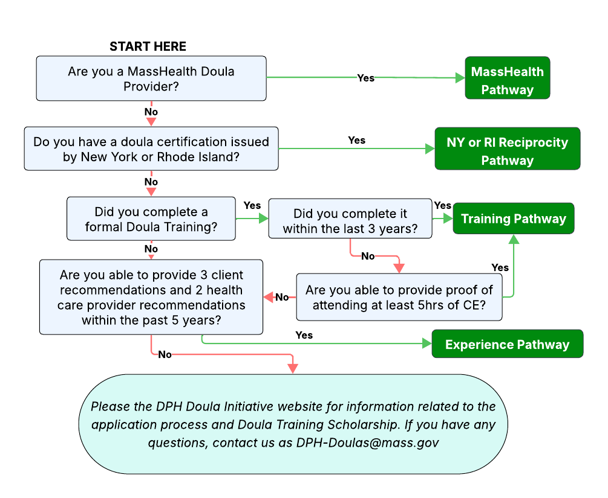

CORI check questions

Why do I need to submit to a CORI check?
As doulas work closely with individuals and families during medically and emotionally vulnerable times, the Doula Certification Program must ensure that Certified Doulas can provide safe, trustworthy care. The CORI check is a state-authorized background review that helps confirm eligibility for certification while still honoring fairness and second chances. It’s the final step of the certification process and only happens once you’ve met all other requirements. You can learn more about this step in our Doula Certification CORI Check Guidance.

What will the CORI check be looking at?
The CORI check shows criminal convictions and open or pending cases in Massachusetts. It does not include arrests without conviction, juvenile or sealed records, or cases that ended in dismissal or a not-guilty finding. The review focuses on whether any record relates to your ability to work safely as a doula. Every case is looked at individually, considering the nature of the offense, time since it occurred, and evidence of rehabilitation.

What CORI records will prevent me from becoming certified?
Certification may be denied if a record shows a serious offense that involves direct harm, exploitation, or violence—such as sexual assault, human trafficking, or abuse of a vulnerable person—and the offense is found to pose a continuing risk to client safety or public trust. Other offenses, like older misdemeanors or minor, unrelated matters, typically do not affect eligibility.

Additional Questions

Do DPH-certified doulas have to be enrolled in MassHealth?
MassHealth doula provider enrollment is not required to apply for DPH certification. MassHealth doula provider enrollment is necessary for reimbursement for services provided to MassHealth members. For more information, visit the MassHealth Doula Services Program Information website. As part of the certification process, DPH mandates that newly certified doulas who haven’t enrolled as a MassHealth doula provider take an on-demand webinar on benefits, support, and opportunities inherent in being a MassHealth doula provider.

Are doula care services covered by insurance?
It depends. Private insurance is not required to cover the cost of doula care services. Doula services are covered by MassHealth in accordance with MassHealth regulations at 130 CMR 463.000: Doula Services. View this website for a list of MassHealth-enrolled doulas.

If I’m a DPH-certified doula, can I accompany my client into any hospital?
No, each hospital and health center have policies and guidelines for doulas on accompanying their clients during labor and delivery. Doula certification will not automatically enable access to clinical settings.

How do I file a complaint related to doula care?
- If you are filing a complaint against a DPH-certified doula: You may submit a written complaint to the Doula Certification Program via DPH-Doulas@mass.gov. The program will review the complaint to determine if it involves a violation of certification standards or doula code of conduct. Complaints that do not involve potential violations may be closed without further action. Please do not submit any sensitive personal information, such as medical records, SSN, or other confidential data. Please note that information submitted may be subject to disclosure under Massachusetts public records law, and confidentiality cannot be guaranteed. Please see Doula Certification Program Complaints Review for more information.

- If you are filing a complaint against a health care professional who is not a doula: You have the right to file a complaint with the Massachusetts Bureau of Health Professions Licensure (BHPL) if you believe a health care professional has violated standards of professional conduct. A licensing board within BHPL will review the complaint. To file a complaint, please use BHPL’s Online Complaint Portal.
  - For more information, visit File a complaint against a health care professional or facility.
  - For more information on submitting a complaint against a physician, please visit Submit a Complaint Against a Physician.
  - All complaints against certified doulas are reviewed according to established disciplinary procedures outlined in Doula Certification Program Guidelines.

I am a doula trainer, how can my training program be added to the DPH list of pre-approved trainings for the DPH Doula Certification Program?
To be eligible for the DPH list of pre-approved trainings, a doula training program’s curriculum must cover all six core competency areas required for certification:
- Maternal anatomy and physiology during the perinatal period, including fetal growth and development
- Common medical interventions during pregnancy, childbirth, and postpartum
- Common complications during pregnancy, childbirth, and postpartum (including but not limited to pregnancy termination, infant loss, perinatal mood and anxiety disorders, substance use disorder, and high blood pressure)
- Labor and delivery comfort measures
- Client advocacy and trauma-informed decision-making
- Basic newborn care, including breastfeeding/chestfeeding

If you’re interested in adding your training program to the DPH pre-approved list, please email the following to DPH-Doulas@mass.gov:
- Name of your training agency/organization
- Name of the training course
- Information for one of the following:
  - A detailed syllabus or documentation that demonstrates all 6 of the competencies and/or topics taught throughout training
  - A breakdown indicating whether each of the 6 competencies above is covered, the approximate time spent on each competency, and the assessment methods used.

Once competency is confirmed, the training program will be added to the DPH list of pre-approved doula trainings for the Doula Certification Program. It may take up to 90 business days for the training program to be added to the DPH electronic licensing platform.

