# BACKGROUND

**INDOOR AIR QUALITY**

**ASSESSMENT**

**Dover Police Department**

**3 Walpole Street**

**Dover, MA**

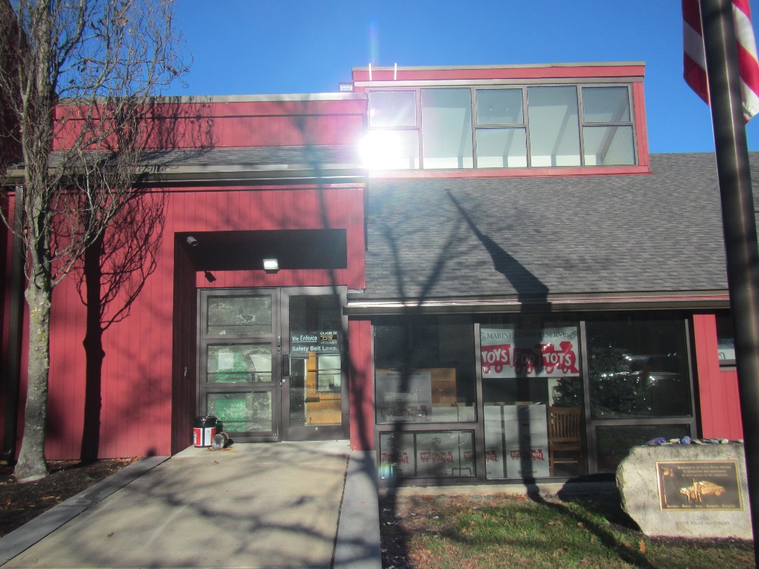

Prepared by:

Massachusetts Department of Public Health

Bureau of Climate and Environmental Health

Indoor Air Quality Program

January 2024

|  |  |
| --- | --- |
| Building: | Dover Police Department (DPD) |
| Address: | 3 Walpole Street, Dover, MA |
| Assessment Requested by: | Michael Blanchard, Town Administrator, Town of Dover |
| Reason for Request: | Respiratory symptoms and general indoor air quality (IAQ) |
| Date of Assessment: | December 20, 2023 |
| Massachusetts Department of Public Health/Bureau of Climate and Environmental Health (MDPH/BCEH) Staff Conducting Assessment: | Ruth Alfasso, Environmental Engineer/Inspector, Indoor Air Quality (IAQ) Program |
| Building Description: | The DPD is a wood-sided building with a sawtooth-style roof that is connected to the building for the Dover Fire Department with which it shares some facilities. It was built in 1976 with renovations in 1999. |
| Windows: | Openable in most areas |

# METHODS

Please refer to the IAQ Manual for methods, sampling procedures, and interpretation of results (MDPH, 2015).

# RESULTS AND DISCUSSION

The following is a summary of indoor air testing results (Table 1).

* ***Carbon dioxide*** levels were below the MDPH guideline of 800 parts per million (ppm), in all areas tested at the time of assessment.
* ***Temperature*** was within or close to the MDPH recommended range of 70°F to 78°F in areas tested.
* ***Relative humidity*** was below the MDPH recommended range of 40 to 60% in all areas tested. Note, low relative humidity can lead to common symptoms such as: dry skin, lips, and scalp; dry/scratchy throats and noses (nose bleeds); exacerbation of asthma, eczema, or allergies; dry/irritated eyes; and irritation of respiratory tract. Low relative humidity conditions are typical in New England during the heating season.
* ***Carbon monoxide*** levels were non-detectable (ND) in all areas tested.
* ***Fine particulate matter (PM2.5)*** concentrations measured indoors were below the National Ambient Air Quality Standard (NAAQS) limit of 35 μg/m3 in all areas tested.

## Ventilation

A heating, ventilating, and air conditioning (HVAC) system has several functions. First it provides heating and, if equipped, cooling. Second, it is a source of fresh air. Finally, an HVAC system will dilute and remove normally occurring indoor environmental pollutants by not only introducing fresh air, but by filtering the airstream and ejecting stale air to the outdoors via exhaust ventilation.

The DPD is served by several different HVAC units. Some are located in the attic, and some are located in a mechanical room on the first floor. Air from these is distributed to rooms in the building through ceiling-mounted air diffusers (Picture 1). No fresh air intake vent was identified for the first-floor mechanical room. If no fresh air vent exists for this system, it would recirculate air only. Return vents return the air back to the AHUs. Heating in some areas is provided by radiators. Additional cooling and filtration/recirculation is provided by mini-splits in the communications room (Picture 1) and in several utility rooms (Picture 2; Table 1). Note that mini-splits provide heat and/or cooling, recirculate air, and may filter it, but do not introduce fresh air.

The carbon dioxide measurements indicate that sufficient fresh air is being supplied for the occupancy on the day of the assessment, however, with higher occupancy, carbon dioxide levels may rise, particularly if parts of the HVAC system do not supply fresh air.

Thermostats control the activation of the HVAC system however some of them did not appear to be properly set, one read “system off” and another appeared to have the temperature set to 101°F. These indicate that the system is not set up in an optimal manner. Systems should work together in a coordinated manner to control temperature and airflow. Fresh air ventilation should be on at all times the building is occupied; in a police station the areas that are occupied 24/7 should have fresh air ventilation at all times.

In order to have proper ventilation with a mechanical ventilation system, the systems must be balanced after installation to provide an adequate amount of fresh air to the interior of a room while removing stale air from the room. It is recommended that HVAC systems be re-balanced every five years to ensure adequate air systems function (SMACNA, 2013). If balancing has not been done recently, balancing of the systems can be done along with “recommissioning” to bring all the systems back into proper function.

Concerns were expressed about the conditions in the men’s locker room on the main level. Locker rooms, especially with showers and toilets, can be a source of moisture and odors to the indoor environment. Adequate exhaust ventilation is necessary to remove these constituents. If exhaust ventilation in the locker room is inadequate, adjustments or an additional exhaust vent with fan to the exterior should be added.

AHUs have filters, which should be changed 2-4 times a year or per the manufacturer’s recommendations. Filters should be at least a Minimum Efficiency Rating Value (MERV) of 8 *or higher*, if they fit and the equipment can handle the pressure reductions caused by more restrictive filters. Boxes of filters for the HVAC system were noted in the attic, and the boxes indicate that these are MERV 8 filters (Picture 3).

Based on the date of the most recent renovations in 1999, components of the ventilation system are around 24 years old. According to the American Society of Heating, Refrigeration, and Air-Conditioning Engineers (ASHRAE), the service life[1] of this type of unit is 15-20 years, assuming routine maintenance of the equipment (ASHRAE, 1991). Some of the units, e.g., the mini-splits, may be newer.

Note that most of the windows in the DPD appear to be openable. Open windows can be used for fresh air during temperate weather. Windows should be tightly closed when it is raining heavily, or when air conditioning is operating to prevent water damage due to condensation/elevated humidity indoors. Occupants should ensure they close windows in rooms that are not occupied to prevent water intrusion, as well as address security concerns.

## Moisture Concerns

Water-damaged ceiling tiles were observed in the lower-level gym, locker room areas, and the shared meeting space (Table 1, Pictures 4 and 5). Water-damaged ceiling plaster or paint was also noted (Picture 6). These reportedly were from leaks from the roof that have since been fixed. Once water leaks have been stopped, any water-damaged materials including ceiling tiles should be replaced. This makes it easier to detect new leaks. When water-damaged ceiling tiles are replaced, the area above the ceiling tile system should be inspected for additional water-damaged material and repaired as needed. Water-damaged ceiling plaster or paint can be scraped and refinished.

As noted above under **Ventilation**, the locker rooms were a source of occupant’s concern. Locker rooms have sources of odors and moisture that need to be removed through active exhaust ventilation. If ventilation is insufficient, or if exhaust ventilation is connected to the general HVAC return rather than directly ejected from the building, odors and moisture can build up and be distributed to other parts of the building. In order to vent water vapor and odors from locker rooms, dedicated exhaust vents should be installed to vent these pollutants *directly outdoors* therefore preventing capture and distribution to occupied areas in the building.

Another frequent issue in locker/shower rooms is dry drain traps. If the traps on drains are not periodically wetted, such as in an infrequently used locker room or shower, the drain traps can dry out and allow sewer gases into the room. All drains, including shower and floor drains, should be wetted periodically if they do not otherwise receive water during typical use. No moldy odors or sewer gas odors were noted during the site visit.

Note that mini-split air conditioners produce condensation during operation, particularly when the outside air is hot and humid. These units are typically equipped with condensation drain tubing (Pictures 2 and 6), and sometimes a small pump. The tubing and pumps should be examined periodically to ensure they do not become clogged or malfunction. Porous items should not be stored directly beneath the units in case of leaks.

The exterior of the building was examined for conditions that may lead to water infiltration or other IAQ concerns. Plants and trees were noted next to and against the building (Picture 7). Plants can shade the building exterior, preventing drying, can shed leaves and debris to clog gutters and roof drains, and can lead to building envelope damage due to root systems. Trees can also fall on the building during extreme weather. Plants can also be a source of odors and pollen to the indoors, particularly if they are near openable windows, and can provide harborage and food for pests. Plants should be trimmed away from the building at least five feet, and tree limbs that overhang the building should be removed.

## Other Concerns

The DPD has a garage with a Sally Port for bringing people into the lockup area. A carbon monoxide detector has been installed in this area to warn occupants of dangerous levels of carbon monoxide from the garage. In addition, vehicles should not be operated with the garage doors closed. The Sally Port door should be kept closed at all times to prevent/reduce exhaust infiltration.

The DPD has a kitchen that is equipped with full-size appliances including a stove (Picture 8). The stove hood appears to be the type that only recirculates air rather than exhausts it from the room. This can allow smoke and food odors to build up. To prevent IAQ issues, the kitchen equipment should be kept clean, and care should be taken to avoid overcooking. The kitchen does have a window that can be opened to help remove kitchen odors. Food should be stored in closed, pest-resistant containers to prevent attracting insects or rodents.

Air purifiers were noted in several areas of the DPD (Picture 9). According to product information found on the internet regarding this unit, they use High-Efficiency Particulate Arrestance (HEPA) filtration to remove small particles, a carbon filter for odor removal, and photocatalytic oxidation. This last technology uses UV light and a catalyst like titanium dioxide to transform organic molecules into smaller components. While this unit has been tested by the California Air Resources Board (CARB) and determined to emit below their threshold for ozone (CARB, 2023), other by-products may be produced by this technology that have not been fully studied. In addition, air purifiers need to be cleaned and have filters changed in accordance with the manufacturers’ recommendations.

Note that mini-split units also have filters. These should also be cleaned periodically to remove dust and debris that can become moistened with condensation during the cooling season.

A number of areas are covered with carpeting. In general, it is not recommended for public safety/emergency response agencies to have carpeted floors due to the possible cross-contamination that may occur from footwear contact with automotive products, chemicals, or biological contamination. In addition, the Institute of Inspection, Cleaning and Restoration Certification (IICRC) discusses floor covering in its guideline, “Standard for Professional Cleaning of Textile Floor Coverings” (IICRC, 2015). Based on this standard, the IICRC recommends twice-daily vacuuming and/or pile-lifting cleaning for commercial carpeting in heavy traffic areas. This frequency of cleaning of the building as well as the use of vacuum cleaners equipped with HEPA filters would remove respirable dust from the indoor air. Carpets in office areas should be cleaned annually (or semi-annually in soiled/high traffic areas) in accordance with Institute of Inspection, Cleaning and Restoration Certification (IICRC) recommendations (IICRC, 2012).

# CONCLUSIONS AND RECOMMENDATIONS

In view of the findings at the time of assessment, the following recommendations are made:

## Ventilation recommendations

1. Operate all supply and exhaust ventilation equipment *continuously* during occupied hours, particularly in areas that serve 24/7.
2. Ensure thermostats are properly set including any setback times/temperatures. If comfortable conditions cannot be met without turning off or setting to extremes, an HVAC engineer can be consulted regarding recommissioning the systems, so they all work together properly.
3. Have HVAC engineer determine if mechanical room units are able to introduce fresh outside air, or if they can be retrofitted.
4. Ensure locker rooms have functioning exhaust vents that are on at all times.
5. Periodically check other exhaust vents in restrooms for draw and make adjustments/repairs as needed.
6. Clean the interior of AHUs during regular filter changes using a HEPA-filtered vacuum cleaner with brush attachment or compressed air.
7. Continue to use MERV 8 or better filters in HVAC units and change them at least twice a year.
8. Have the HVAC system balanced every 5 years in accordance with SMACNA recommendations (SMACNA, 2013).
9. Use openable windows for fresh air during temperate weather. Ensure windows are tightly closed during wet weather, when the air conditioning is operating to prevent condensation, or extreme cold to prevent pipe freezing.

## Water damage recommendations

1. Replace water-damaged ceiling tiles and monitor for additional leaks. If water damage to ceiling tiles reoccurs, have the roof inspected and repaired.
2. Ensure all drains in locker rooms are wetted periodically. Drains that may not be used under typical occupancy should have water manually poured into them once a week, or as needed to maintain the drain trap seal.
3. Monitor the tubing and any associated pumps from mini-split air conditioners to ensure they do not clog, leak, or malfunction. Avoid storing porous materials underneath mini-splits to prevent water damage in case of leaks or condensation.
4. Trim plants and trees away from the building.

## Other recommendations

1. Calibrate or replace the carbon monoxide sensor in the Sally Port entrance area when recommended by the unit manufacturer. Keep the door between the garage and the interior closed at all times.
2. Avoid idling vehicles in the garage and do not operate vehicles inside with the doors closed.
3. Keep the kitchen equipment clean and take care to avoid burning food. Use the kitchen window if needed to remove cooking odors.
4. Maintain air purifiers in accordance with manufacturer’s instructions including filter changes and cleaning. If purchasing new units, avoid those that may produce ozone or other byproducts.
5. Clean mini-splits/filters to remove dust and debris at least twice a year.
6. Consideration should be given to replacing carpeting with a different type of floor covering that can be readily cleaned. Until that time, clean carpeting in accordance with IICRC recommendations (IICRC, 2012); annually (or semi-annually in soiled/high traffic areas). Worn carpeting past its lifespan (>11 years) should be replaced.
7. For buildings in New England, periods of low relative humidity during the winter are often unavoidable. Therefore, scrupulous cleaning practices should be adopted to minimize common indoor air contaminants whose irritant effects can be enhanced when the relative humidity is low. To control for dusts, a high efficiency particulate arrestance (HEPA) filter equipped vacuum cleaner in conjunction with wet wiping of all surfaces is recommended. Avoid the use of feather dusters. Drinking water during the day can help ease some symptoms associated with a dry environment (throat and sinus irritations).
8. Refer to resource manual and other related IAQ documents located on the MDPH’s website for further building-wide evaluations and advice on maintaining public buildings. These documents are available at: <http://mass.gov/dph/iaq>.

# REFERENCES

ASHRAE. 1991. ASHRAE Applications Handbook, Chapter 33 “Owning and Operating Costs”. American Society of Heating, Refrigeration and Air Conditioning Engineers, Atlanta, GA.

CARB. 2023. California Air Resources Board. List of CARB-Certified Air Cleaning Devices. State of California. <https://ww2.arb.ca.gov/list-carb-certified-air-cleaning-devices>

IICRC. 2012. Institute of Inspection, Cleaning and Restoration Certification. Carpet Cleaning: FAQ.

IICRC. 2015. Institute of Inspection, Cleaning and Restoration Certification. Commercial Carpet Cleaning: FAQ.

MDPH. 2015. Massachusetts Department of Public Health. “Indoor Air Quality Manual: Chapters I-III”. Available at: [Indoor air quality - manual and appendices | Mass.gov](https://www.mass.gov/lists/indoor-air-quality-manual-and-appendices)

SMACNA. 2013. HVAC Systems Commissioning Manual. 2nd ed. Sheet Metal and Air Conditioning Contractors’ National Association, Inc., Chantilly, VA

**Picture 1**

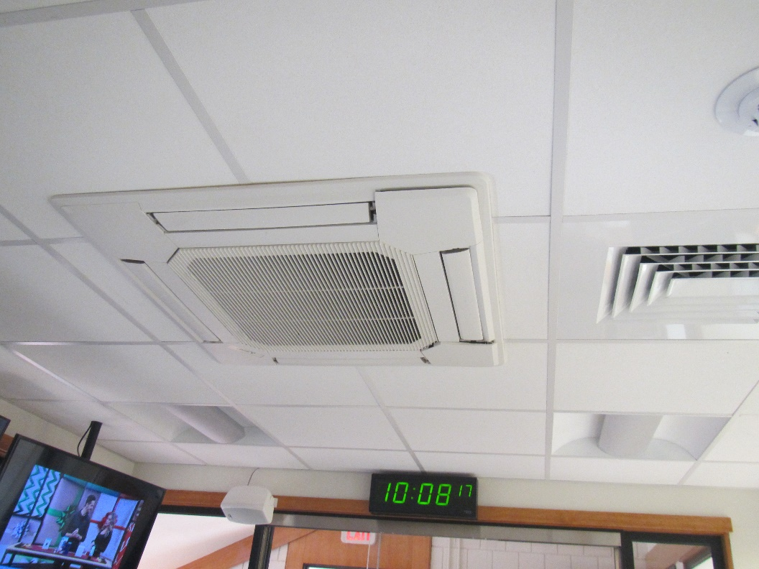

**Supply vent and overhead mini-split in the Communications Center**

**Picture 2**

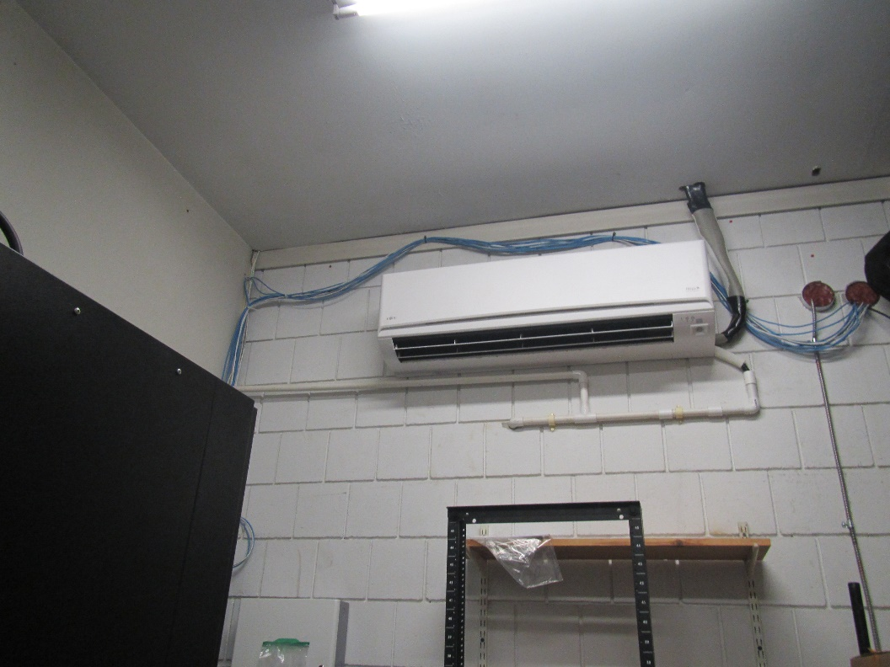

**Wall-mounted mini-split, note drainage tubing entering wall**

**Picture 3**

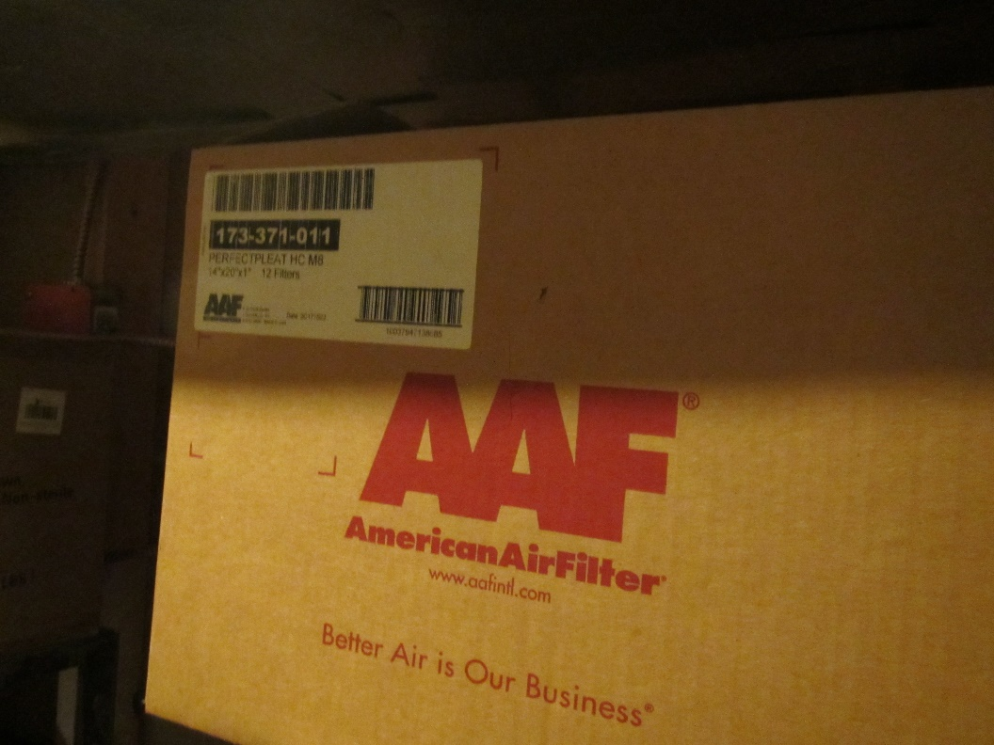

**Box of replacement AHU filters, showing they are MERV 8**

**Picture 4**

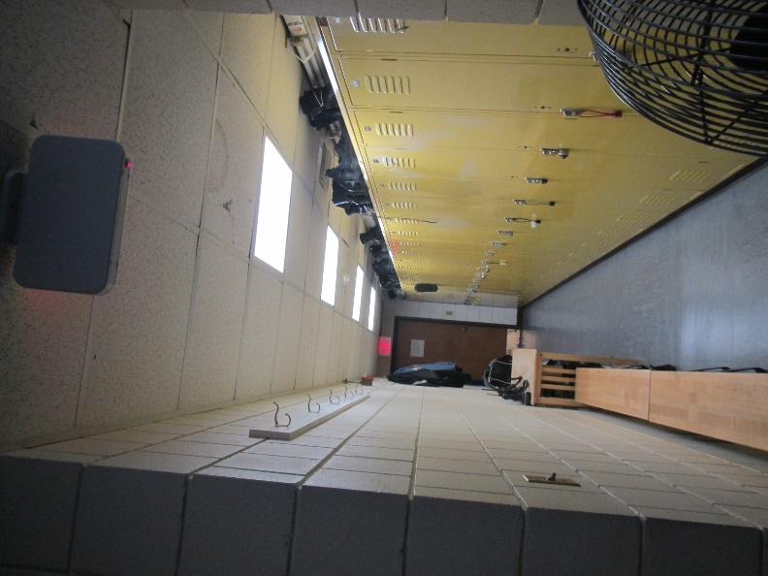

**Water-damaged ceiling tiles in the men’s locker room**

**Picture 5**

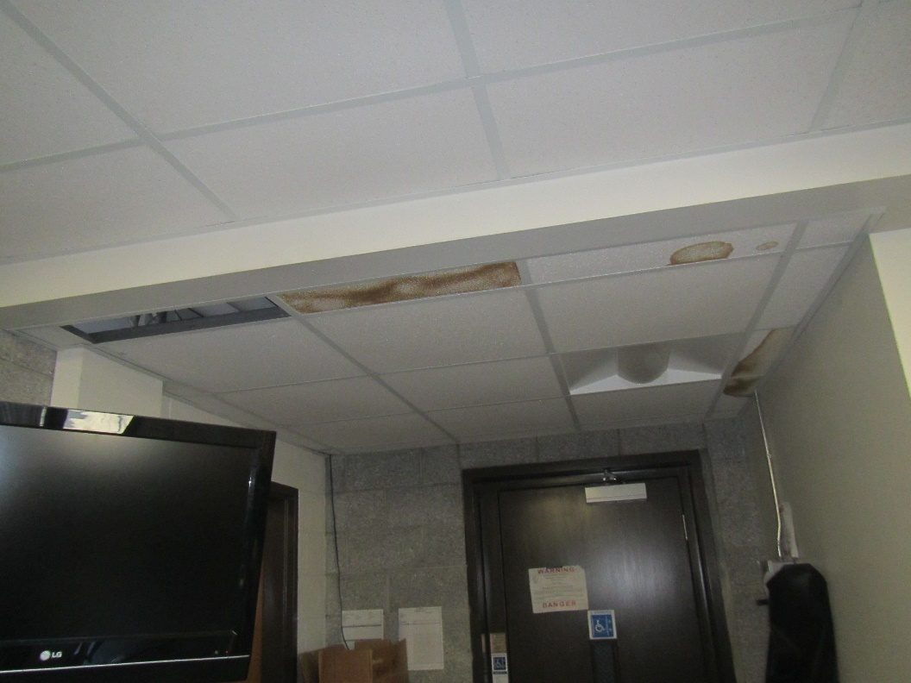

**Water-damaged ceiling tiles in the shared meeting room on the lower level**

**Picture 6**

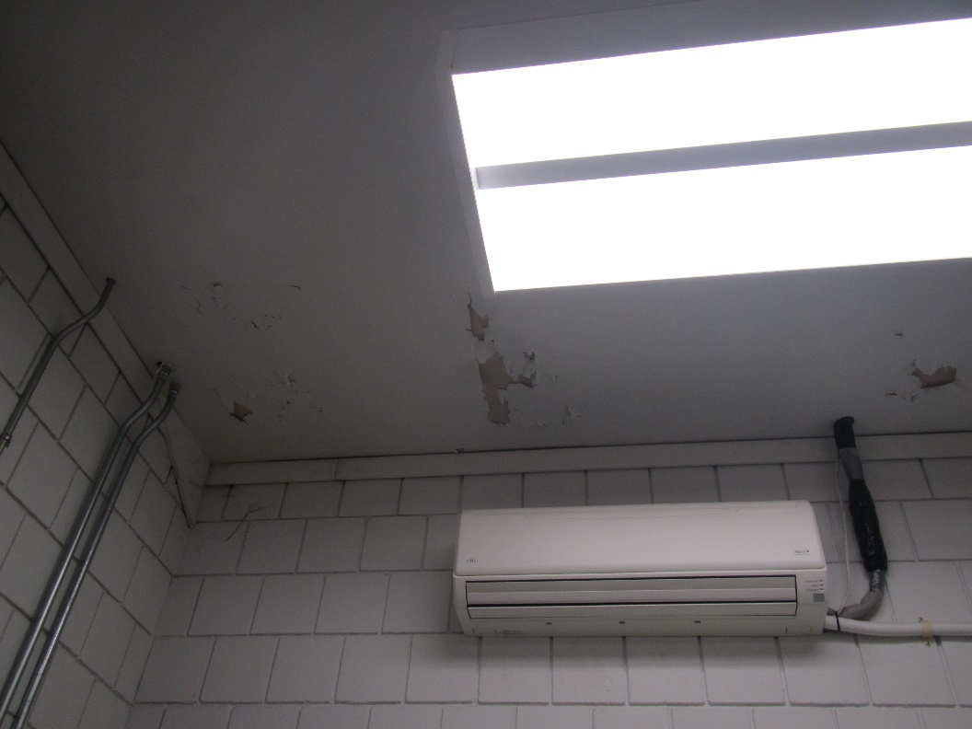

**Water-damaged ceiling paint**

**Picture 7**

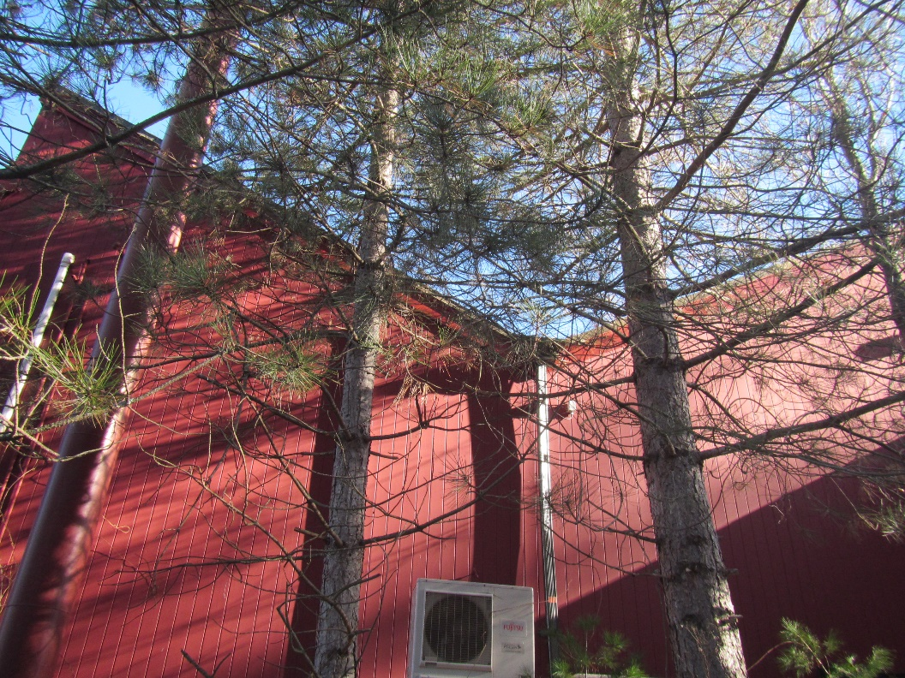

**Trees next to the building**

**Picture 8**

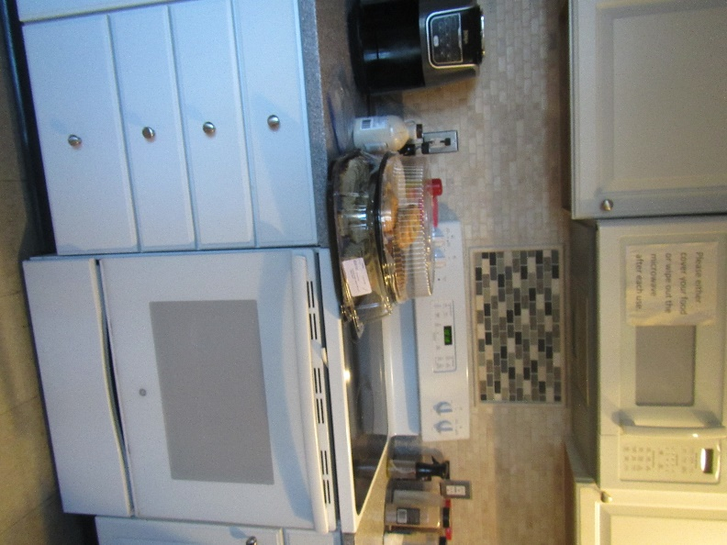

**Appliances in the kitchen**

**Picture 9**

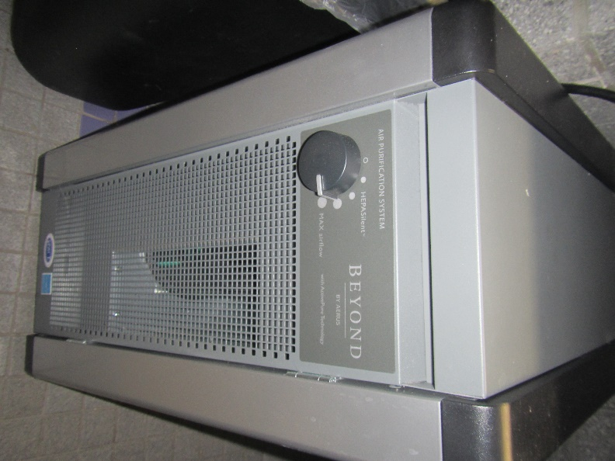

**Air purifier**

| **Location** | **Carbon**  **Dioxide**  **(ppm)** | **Carbon Monoxide**  **(ppm)** | **Temp**  **(°F)** | **Relative**  **Humidity**  **(%)** | **PM2.5**  **(µg/m3)** | **Occupants**  **in Room** | **Windows**  **Openable** | **Ventilation** | | **Remarks** |
| --- | --- | --- | --- | --- | --- | --- | --- | --- | --- | --- |
| **Supply** | **Exhaust** |
| Background | 398 | ND | 44 | 30 |  |  |  |  |  |  |
| Shift Commander | 545 | ND | 68 | 29 | ND | 0 | Y | Y | Y | Carpeted, clothing |
| Chief | 540 | ND | 68 | 29 | ND | 0 | Y | Y | Y | Carpeted |
| Detective | 537 | ND | 67 | 30 | ND | 0 | Y | Y | Y | Carpeted, heater, plant |
| Shift Commander | 567 | ND | 66 | 30 | ND | 0 | Y | Y | Y | Carpeted, fridge, clothing |
| Conference | 541 | ND | 66 | 30 | ND | 0 | Y | Y | Y | Carpeted, DEM |
| Main area | 574 | ND | 68 | 30 | ND | 0 | N | Y | Y | Skylight |
| Communication Center | 582 | ND | 69 | 28 | ND | 2 | N | Y | Y | Mini-split in ceiling (provides cooling only, off) |
| Gun Repair | 558 | ND | 70 | 27 | ND | 0 | N | N | N | Former darkroom |
| Office | 584 | ND | 71 | 26 | ND | 00 | Y | Y | N | Plant, carpeted |
| Closet in office |  |  |  |  |  |  | N | N | N | Boxes on floor, NC |
| Computer room | 522 | ND | 71 | 27 | ND | 0 | N |  |  | Mini-split, shredder, NC, WD ceiling plaster |
| Office by cells | 568 | ND | 72 | 26 | ND | 0 | N |  |  | DEM, NC |
| Server room | 511 | ND | 65 | 32 | ND | 0 | N |  |  | Mini-split, NC, computer equipment |
| Men’s locker | 515 | ND | 70 | 26 | ND | 0 | N |  |  | WD CT and ajar tile, fan |
| Sally port/garage |  |  |  |  |  |  |  |  |  | Carbon monoxide detector |
| Meeting room, shared with Fire Department | 595 | ND | 72 | 24 | ND | 0 | N, door outside |  |  | DEM, NC, AC |
| Gym, shared with fire department | 595 | ND | 70 | 27 | ND | 0 | Door outside |  |  | NC, WD CT |
| Women’s locker room |  |  |  |  |  |  | N | Y | Y |  |
| Women’s locker room, fire department |  |  |  |  |  |  | N | Y | Y |  |
| Police kitchen area | 566 | ND | 71 | 25 | ND | 1 | Y | Y | Y | Food, appliances (Stove, fridge), NC |

1. The service life is the median time during which a particular system or component of … [an HVAC] … system remains in its original service application and then is replaced. Replacement may occur for any reason, including, but not limited to, failure, general obsolescence, reduced reliability, excessive maintenance cost, and changed system requirements due to such influences as building characteristics or energy prices (ASHRAE, 1991).