Table of Contents
- Introduction
- Module 1: Why PLCs?
- Module 2: Structures of PLCs
- Essential Questions, Objectives, & Vocabulary – 2
- Introduction – 3
- Organizing for Success – 3
- Putting it all Together – 4
- Suggested Timeline/Next Steps – 4
- Sample Continuum of School Cultures – 8
- Supporting and Sustaining the Work – 11
- Case Study – 12

- Module 3: Building Effective PLC Teams
- Module 4: The Practice of PLCs
- Module 5: District-Level PLCs
- Tools and Resources
- Facilitators Guide

Module 2: Structures of PLCs

Essential Questions
- What does a highly functioning school or district professional learning community look like?

- How do we put structures in place that will support the establishment of a professional learning community in our school or district?

- How are effective teams developed?

Expected Outcomes
Participants will:

- Be able to assess current school and district culture

- Understand the structures that need to be in place to support effective PLCs

- Use professional resources and tools that support collaborative creation of team time and function

Vocabulary
- Facilitator – Someone whose role it is to work with group processes to ensure that meetings and protocols run well and achieve designated goals

- Norms – Ground Rules established for a group that intends to work together

- Protocol – Consists of agreed upon guidelines for conducting a focused and effective conversation. Protocols vary depending upon the purpose and desired outcome of the conversation

- School Culture – The values and beliefs that are reflected in the way a school looks, and faculty and students behave and work

- Vision – A vision statement details an ideal end result, a state of being that the school would like to achieve and which clearly reflects its educational mission.

Introduction
“Once you get to the point of being, as soon as someone walks in the front door of your school they will know that something is different. What they will notice are the cultural shifts.” Brian Butler

It’s not a meeting and it’s not an add-on—it’s a culture. It’s a way of being. A PLC uses norms and structures that allow it to deal with hard questions and to work on what really matters.

Collaboration as a PLC focuses on teachers as learners which means being open to looking closely together at what we teach, why we teach it, how we teach it and whether our students are learning. The work of a PLC is to create a culture that allows hard questions to be asked and productive responses to be created.

A Professional Learning Community (PLC) is widely recognized as an effective form of pulling educators together and providing a forum for true professional development in schools. While many schools flock to the concept of creating a PLC, it takes more than an expression of will to create one.

Organizing for Success

The McKay Arts Academy Innovation School, Springfield, Massachusetts
McKay Arts Academy faced a serious challenge. New principal Daniel Hanneken knew he had two schools with two very different ways of being (one a 5-8 project-based former Pilot school and the other a traditional Pre K—4). He knew they had to cross the divide that occupying the same building on two different floors created when FAA moved onto McKay’s campus with the district expectation that they would be a unified Innovation school. Using PLC frameworks as the lens to making change, a representative teacher and administrative Innovation Leadership Planning Team (IPT) from both schools began in September, working with facilitated protocols, focused agendas and norms to drive the conversation.
The IPT saw it as critical to build a shared culture and vision in order to move forward. Recognizing that they needed to bridge the gap between yeah and naysayers, they used protocols to engagingly structure dedicated faculty half days and focused Team Common Planning Time which had been built in as grade level teams in the year’s schedule. Posting all agendas, minutes and feedback forums, they used virtual dialogue as well, allowing all faculty members to have an opportunity to look more deeply at their own beliefs about teaching and learning as well as faculty identification of key professional development needs. This process brought the whole faculty together and resulted in a sense of new unity and purpose. Every member of the adult school community, with the support of the school’s Governing Board “owns” what the school is about and feels a sense of excitement in working to realize that vision. Using their regularly schedule Common Planning Time, they use their time well on focused goals and share their work with the rest of the school digitally so that there are no longer pockets of “those in the know”. Accordingly, the McKay AA moved from a Level 3 to a Level 2 school in the space of one short year.
We asked the faculty: Was it hard work? Yes! Is it worth it? Yes!
Putting it all Together

Each school and district will take its own unique path to developing a Professional Learning Community, but there are some common elements that all schools and districts should consider.

- Maintain a Focus on Learning, Teaching, and Assessment. The focus on all school change is improving the educational experience for all students learning, teaching, and assessment. PLC is the lens through which change happens.

- Ensure Regular Communication and Opportunities for Input of the Entire School Community. Schools will be successful when they build support for professional collaboration among all the constituencies of the school community- faculty, administration, families, students, and the larger community. Everyone involved needs to know what’s happening and have opportunities to provide input to shaping the evolving models of professional collaboration.

- Ensure Representation of Key Constituencies on Leadership Teams. Including representation of all key constituencies on Leadership Teams ensures that there are diverse voices involved in creating school change. Professional collaborative culture means that all voices are heard, all voices are respected.

Next Steps

Step 1: Establish an Instructional Leadership Team for the school.
The Instructional Leadership Team (the name may change according to the school’s wish) is the active group which oversees the school’s action plan. It does not function as a lone decision-making body but is representative of the diverse school constituency.

- Identify members for a Leadership Team who represent the diverse school constituency.

- Leadership Teams use the same structures as Teacher Teams to focus discussion and share their notes. Administrators function as members of the team and not as the “driver” of the engine. Norms of conduct and a shared commitment to regular meetings, ideally 2-4 times a month, are essential.

- Roles, facilitation, note-taking, time-keeping and follow-up are shared among members.

- Agendas, notes and opportunities for feedback are shared with the school community.

- Often the Leadership team is responsible for identifying and organizing professional development that is relevant to PLC- identified instructional needs.

Tools and resources to support Step 1:
*Note: All tools & resources listed here can be downloaded as PDFs from our PLC website: http://plcexpansionproject.weebly.com

Protocols:
Note: Norms should be brief, positive and can be general enough to encompass a number of possibilities. Many PLCs include the norms on every agenda and assess how they worked at the end of every session.
- Creating Ground Rules: Ground Rules, or Norms, are important for a group that intends to work together on difficult issues, or who will be working together over time. They may be added to, or condensed, as the group progresses. Starting with basic Ground Rules builds trust, clarifies group expectations of one another, and establishes points of “reflection” to see how the group is doing regarding process. Materials: Stickies. Chart Paper. Using a T Chart to delineate norms of structure on one side and norms of conduct on the other helps to clarify who, what, when and how. Norms are the bedrock of successful PLCs. Attention to these, and continual re-visiting before and after EVERY meeting is essential.
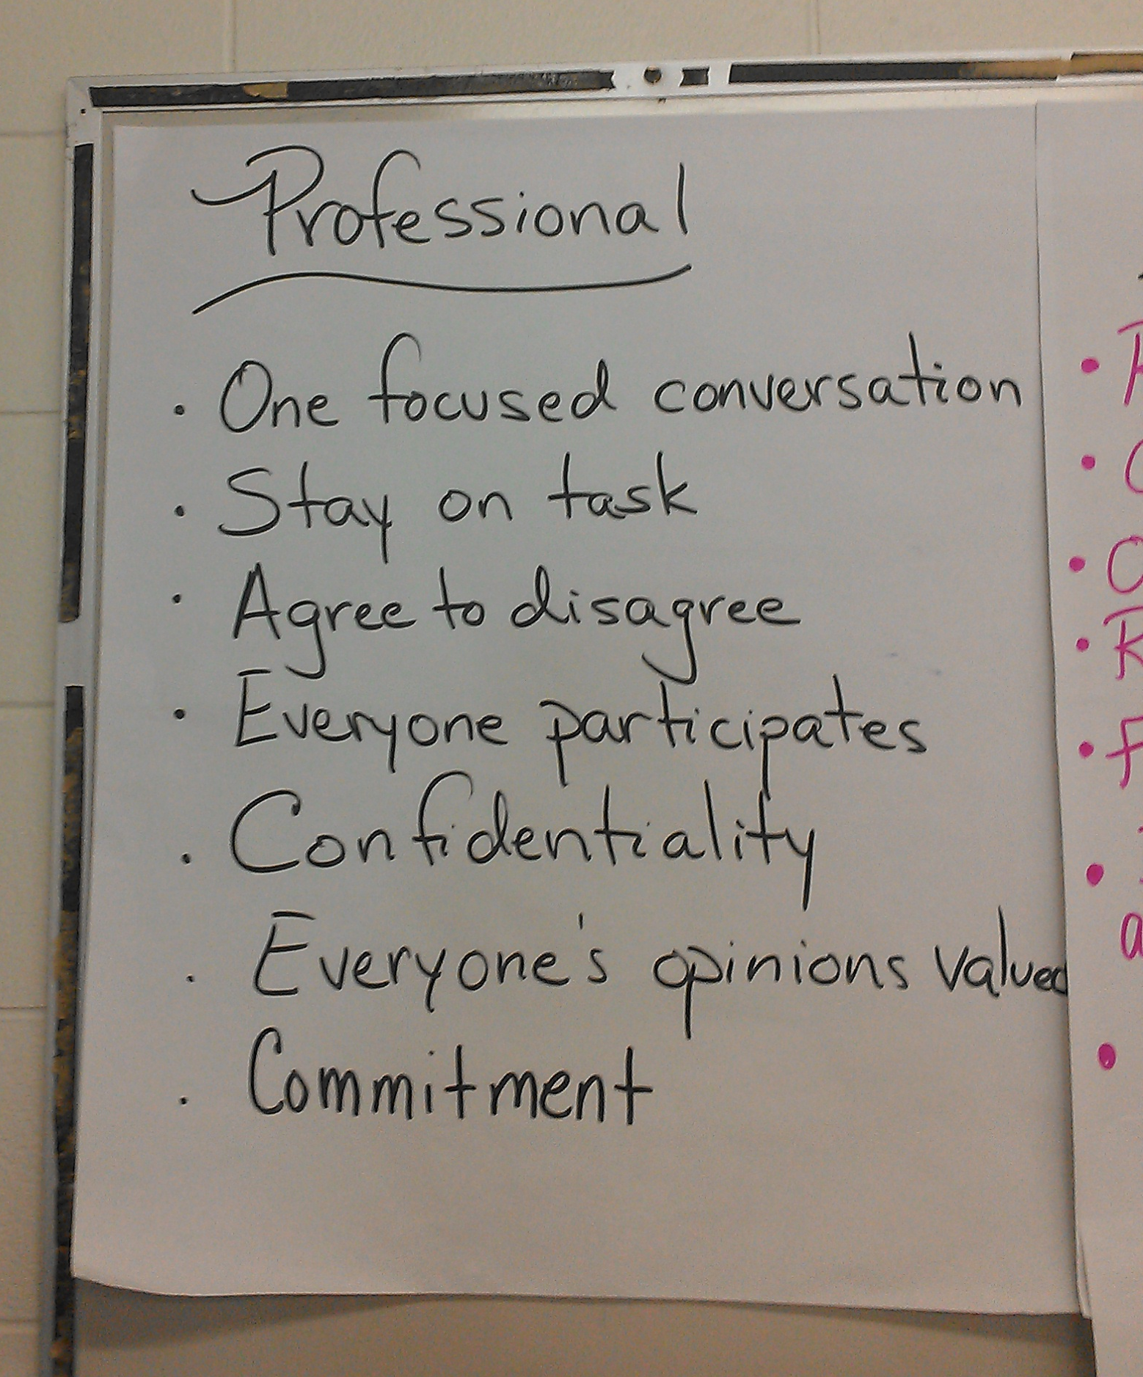
McKay Innovation Arts Academy, Fitchburg

Step 2: Create a Unified and Dynamic Vision
Every school and district has a vision. Many of these while well-meant appear as a nominal function on the District webpage. PLC schools have a culture of action that is driven by having created that vision through shared process. Engaging the whole school in creating a shared picture of what the school or district could ideally look like is one of the most powerful activities a PLC can engage in.

- Leadership Teams identify at least a 90 minute (preferably 2 hour) block of time in which either the whole faculty or smaller groups who come back together to share and find commonalities in their work, can meet.

- Using a protocol like “Back to the Future” allows all participants to define what the ideal school would be:
- “What do powerful learning experiences look like?”
- “What would we look like as highly functioning Professional Learning Community?”
- “What would our school look like, feel like, what would we see as we walked through the building and classrooms?”
- If this is our vision—how do we get there?

- The Instructional Leadership Team with significant input and final decision-making by the whole faculty, use this collaborative picture to create a dynamic vision and mission statement which is “owned” by all members of the community.

- The vision and mission serve as the cornerstone to which all decisions are made (“How does this align with what we say we want to be?”) and is key to goals-based action planning.

Tools and Resources to Support Step 2:

Protocols:

- Powerful Learning Experiences Protocol: Allows participants to look at the relationships between “life” learning experiences that have profound impacts on learners and the role of teaching and learning

- Back to the Future Protocol: An engaging tool for “visioning”: what a school can be. This protocol is adaptable to any good driving question (“What our school or district look like as a PLC?”) and creates the groundwork for creatively approaching Vision (what we want to be) and Mission (how to get there). A modified version for school teams is also available in Step 2 Resources.

- Protocol for Writing Vision and Mission: The vision statement, created before the mission statement through the Futures Protocol, communicates an ideal end result, a vision. It reflects values and beliefs, and should inspire and challenge. A vision statement does not describe what a company does, nor does it describe how a company operates. Rather, a vision statement details an ideal end result, a state of being that the company would like to achieve. A vision for the school is an ideal. It is a picture of an ideal state in the future. The vision is the foundation for the mission, goals, plans, and activity of an organization.

- Vision Statement Checklist: Answering the questions on this checklist will help you make sure your school’s vision statement is in line with principles of effective learning and teaching.
Step 3: Assess Current School Culture
Once the school has a unified vision and mission, one big question that will come up very early in the creation of PLC is in identifying what is in place to support that—and what needs to be. Many schools have had some pockets of work around PLC which need to be identified in terms of what worked—and what didn’t.

- Specific tools to support these conversations about where a PLC is on a spectrum of highly functioning are best used in structured discussions that involve all members of the community. These Surveys ask hard questions which are often perceptions and lead to looking at how decisions get made—and by whom.

- The School Culture Survey and School Culture Questionnaire can serve both as data which gives feedback from all members of the school community as well as triggers for deeper conversations about where structural and cultural change needs to happen.

- Structures agendas with norms allowing for all voices to be heard are of importance in beginning this work.

- Ensure that feedback and data are shared with all those who participated without assumptions. One way to do this is to simply create a document from the feedback and bullet responses and numbers, and using a protocol with the Leadership or Teacher Teams which allows members to look at what the data tells them to identify strengths and weaknesses.

- Identify an Action Plan that leads towards desired School Culture goals.

Tools and Resources to Support Step 3:
*Download all tools from the PLC website (http://plcexpansionproject.weebly.com).

- School Culture Survey: (see link above)
- School Culture Questionnaire: (see link above)
- Planning for PLC Success: Agreeing on common templates to plan and benchmark are foundational activities for successful teams
- Goal-setting Protocol: Template—what, why, when, where and how!
- Processes for Developing PLC (Senghe)—Peter Senghe writes about the need for PLC-like structures in business, this short article (from SEDL) is a good read for a new PLC.

Sample Continuum of School Cultures

This chart provides a general overview of types of school governance and decision making; and instruction, curriculum, and assessment.

Type of Culture | School Governance and Decision Making | Instruction, Curriculum, and Assessment
Hierarchical and Bureaucratic | Centralized decision making by a small group of administrators with little or no teacher input  Teacher autonomy within the classroom with restricted participation in school-wide organizational and curricular decisions | Defined by state and district specialists  Testing used to sort students homogeneously (by grade levels, for programs, in classroom groups)  Teacher’s job is to present a prescribed set of content and skills  Individual teachers are held accountable for student failure
Non-collaborative:  Balkanization | Separate and competing groups seek power for own ends | Poor integration of curriculum and instructional goals  Atmosphere of competition among teachers
Non-collaborative:  Comfortable collaboration | Comfortable, easy going atmosphere is pleasant but does not solve troublesome issues facing the school community | Teachers share some ideas, techniques, and materials to improve teaching and learning but avoid deeper issues that impact curriculum and long range planning
Non-collaborative:  Contrived Collegiality | Formal, but not necessarily collaborative, structures (such as site-based management councils, school improvement teams, peer coaching) are in place and enable teachers to work together | Work appears collaborative on the surface but doesn’t translate into the deeper, more significant and productive practices found in collaborative settings
Professional collaborative culture | Principal as facilitative leader; significant teacher involvement in decision making  Teacher and student collaboration on issues that affect the whole school | Significant teacher involvement in decision making about school goals, curriculum, and instructional practices  Collective responsibility for student achievement

Step 4: Create and Configure Teacher Teams
Professional learning communities can only be successful in schools in which there are established Teacher Teams. There are two types of conditions necessary to support a Professional Learning Community: structures and collegial relationships. We can identify structures as things like the size and schedule of the school, the proximity of staff to one another, communication systems, facilitation training and support, and adequate time and space for staff to meet.

Teacher teams can be configured in many ways - allowing schools creativity and flexibility in terms of size, scale, and method of grouping teachers within a school. In using this orientation, administrators have more options in terms of creating common planning time within a schedule.

- Productive Teacher Teams are often well-sized at 5-6. Large teams are often unwieldy and less productive.

- Teacher teams can be configured in many ways - allowing schools creativity and flexibility in terms of size, scale, and method of grouping teachers within a school.

- Teams are created around a common group of students. Grade-level teams can include solely the classroom (elementary) or core academic (secondary) teachers, or also include special education, English language learner, and electives teachers.

- Teams grouped by subject; Teachers are teamed by academic area. All teachers from an academic area (e.g., Social Studies) are given the same planning period.

- Pairs - teachers are teamed with a partner or partners. Partners would have the same planning period each day. Teachers can share the same students but this is not a necessity. Teachers within the same subject area or teachers from different subject areas can be partners.

Step 5: Finding Time for Teacher Teams to Meet
In most schools, the basic structural component of identifying the time for staff to meet is the first hurdle administrators and teachers face in building a PLC. A fundamental lesson learned in the past decade of school reform efforts is that far more time is required for professional development and cooperative work than is now available. In fact, time has emerged as the key issue in every analysis of school change appearing in the last two decades (Fullan & Miles, 1992).

Creating common planning time in a school schedule, in an age of increased accountability and pressure to maximize instructional time, is still often perceived by some as a privilege or a luxury, and not as a mandatory component of a school day despite well-documented research which attributes common planning time to a positive impact on teaching, learning, and student achievement. Generally speaking, common planning time can provide opportunities for teachers to collaboratively discuss and resolve curricular issues, coordinate lesson plans, and to identify common issues or challenges faced by the school. Clearly, teachers "need more time to work with colleagues, to critically examine the new standards being proposed, and to revise curriculum. They need opportunities to develop, master, and reflect on new approaches to working with children" (Corcoran, 1995).
Example:

At the Healey Elementary School in Somerville, MA teachers and administrators devised a schedule that creates a weekly common planning time period for every grade level team.

Teams meet on one of three days of the week – Tuesday, Thursday, or Friday – for 40 minutes.

On the day of the CPT for a grade level team, teachers in the grade level teams decided to give up their individual prep to all meet at the same time, which is when students from that grade level are off with specials teachers (e.g., art, music, PE, etc.).

That same day, an instructional aide (with a bachelor’s degree) rotates through the day to free teachers up to take their individual prep at a different time.
- PLCs are impossible to create and sustain without dedicated common planning time for teacher teams. Two to three common planning periods per week are recommended, while one meeting per week is the minimum needed for effective PLCs.

- As teams work to create plans for staff members to meet regularly, finding time to meet often presents a most significant challenge. Many schools have had to be very creative to make this work. The long term success of high quality PLC means investing in embedded time where teams meet 3-5 times a week. Some of them:
- Release students early one day a week
- Use teacher assistants to release teachers for one-hour study group meetings
- Use teams of parents and/or business partners to release teachers for collaborative work
- One day a week, begin school 30 minutes later and ask teachers to come in 30 minutes earlier Assign teachers to the same study groups while their students attend classes of art, music, physical education, and other "specialty" areas
- Hire a team of substitute teachers to spend a day every other week at the school in order to release groups of teachers for collaborative work
- Schedule "special enrichment assemblies" for students to provide time for teachers to meet
- Dedicate after-school full faculty meeting and departmental time to common planning time for teacher teams
- Compensate teachers for collaborative work done after school
- Start school 10 minutes early and end 5 minutes later Tuesdays through Fridays; On Mondays, have students leave one hour early and teachers have a one-hour common planning period of time
- Shorten required after-school time for teachers four days a week to allow for an hour of collaborative work after school one day a week
- Use a team of college or university students to free teachers for collaborative work
- Create regular common planning time for academic teams by sending all students in a cluster or grade level to specialists during designated periods.
Challenges for finding time within traditional schedules are most acute for elementary teachers and for including related arts teachers on content teams. Some sample elementary schedules in schools which have created regular CPT can serve as tools for creatively thinking about change.

In addition to these important factors to consider in building professional collaborative cultures, here are some suggested steps which can support the creation of PLC at the school level.

Tools and resources to support step 5:

Articles:

“Finding Time for Collaboration” by Mary Anne Raywid: PLCs are transparent about their challenges. Using an article that frames the question in front of the group as a text-based discussion is often a very effective means of kick-starting a hard conversation.

Sample school schedules:
See tools section of our website http://plcexpansionproject.weebly.com for sample schedules from schools who are implementing PLCs

What Can Schools Do To Support and Sustain PLCs?

- Provide facilitation training to all team leaders

- Establish clear expectations for the focus of discussions and work products developed during planning time.

- Prepare agendas for team planning time so that time is used efficiently.

- Organize the instructional schedule to include sustained time for team collaboration. All teachers at each grade level should have at least one common planning time a week.

- Utilize other teachers, the principal, aides, or parent volunteers to free teachers to participate in team meetings.

- Create a weekly schedule for planning time that specifies the purpose for each period, that is, to plan individually, with their grade level colleagues, and in subject or interdisciplinary teams.

- Offer relevant professional development for grade level, subject, or interdisciplinary teams identified by the school’s goals and by team action plans.

- Empower Leadership Team to organize planning time, expectations, and professional development

Case Study

A Window Into How One School Worked to Build PLC

Principal Rosario was about to meet with staff members she knew were going to be the key players in launching professional learning communities. There was a district-wide push for collaborative planning time to be built into every school’s schedule this fall, and her school had to get on board. She was excited about the opportunity this new push created. She had long been reading the research on and looked forward to working with her teachers on establishing time for teachers to meet and work collaboratively. Every day the momentum of planning lessons, testing, state accountability, and the “regular” business of running a school left too many teachers in isolation, she thought.

The teachers’ union representative, Mr. Mendes, along with the ELA department head Ms. Lewis and the Math department head Mr. Khan met with Principal Rosario in her office. While everyone was in support of teachers getting common planning time, the nuts and bolts of who and when were the sticking points of the conversation. Mr. Mendes was concerned about additional uncompensated time being forcibly added to the teachers’ already busy day. Ms. Lewis and Mr. Khan, while sharing Mr. Mendes’ concern, were also worried about their students. No one wanted to be pulled out of classes for meetings in a way that mean losing instructional time with them. Rosario shared all of those concerns and also worried about how much actual cost would be incurred in trying to pull this together. After much brainstorming, they all agreed to four possible methods of creating time to meet. Each method had a cost and a trade-off, but all were worth exploring as potential answers to the problem.

Creating time for professional learning communities to meet:

- Hire substitutes to allow teachers to have occasional collaborative planning time.
- Explore the use of paraprofessionals and administrators as substitutes for 1 period per week per team so that a group of teachers can get together.
- Offer stipends to teachers who are willing to meet during non-school hours.
- Explore community involvement options. If schools were to make one day or half day a week community involvement day and have every student involved in volunteering at a community agency or business in town, this would free up time for collaboration.

After much discussion, they decided on a combination of options 1 and 2 – using paraprofessionals, and administrators and substitutes when needed, to free up one common planning period per week for each grade-level team. In creating the schedule, they would select periods in which the majority of team members already had duty time in order to avoid pulling them out of class and losing instructional time.

_________________________________________________________________________
This module is interdependent with tools introduced in Modules 1 as well as those you will use from Modules 3, 4, 5 and 6. Many of the protocols are useful in a variety of situations. Read ahead!

Fullan and Graves (1991) offer descriptions of three non-collaborative cultures: Balkanization, Comfortable Collaboration, and Contrived Collegiality

