CONTENT
- Event posters & flyers
- Suggested school website content
- Suggested newsletter announcement
- Suggested social media content & graphics
Car-Free Campus Day Promotional Kit
Event Flyers & Posters
Click the links below to download the event flyer and poster files.
All are formatted as Word documents to customize with your school’s event date.
Walk  8.5” by 11”  11” by 17” | 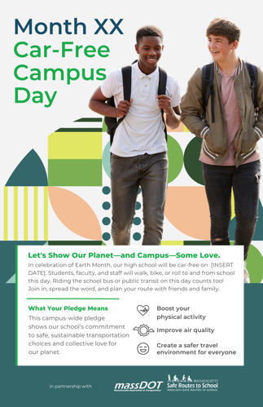
Bike  8.5” by 11”  11” by 17” | 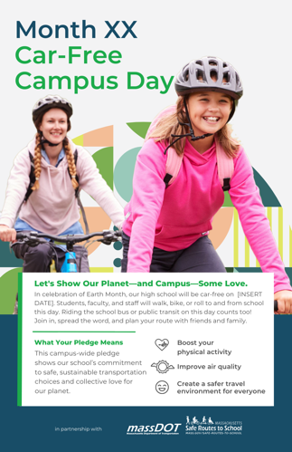
Roll  8.5” by 11”  11” by 17” | 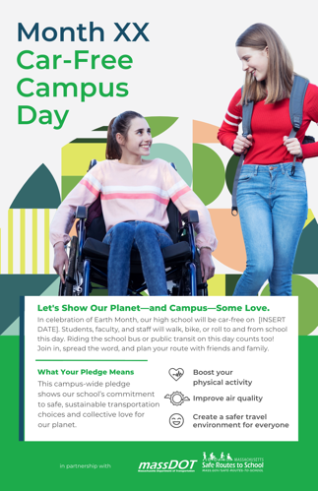
Bus/Transit  8.5” by 11”  11” by 17” | 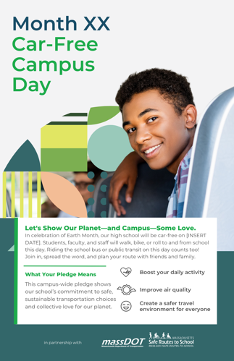

Suggested Content for School’s Website/Event Calendar
Download the website and newsletter graphic files
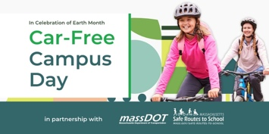 | 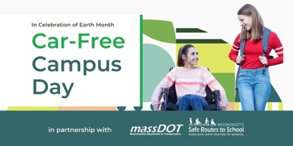
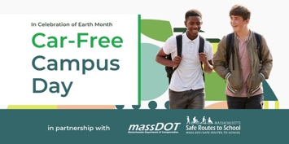 | 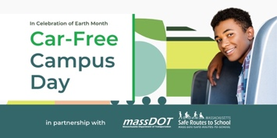

[Insert Month and Date]: [High School Name] Celebrates Car-Free Campus Day
In celebration of Earth Month, our high school will be car-free on [INSERT DATE]. Students, faculty, and staff are encouraged to walk, bike, or roll to and from school this day. Riding the school bus or public transit on this day counts too! Join in, spread the word, and plan your route with friends and family.

This campus-wide pledge demonstrates our school’s commitment to safe, sustainable transportation choices and collective love for our planet.

Park, Walk, & Roll Locations
Use any of the following parking locations or drop-off/pick-up locations to meet and walk, bike, or roll in with your friends and family.
- [Insert Location Details]

Resources to Help You Plan Your Route
- View our school’s Arrival/Dismissal Plan
- [Insert additional school resources if available]
- SRTS Arrival/Dismissal Flyer

School E-Newsletter Blurb

[Insert Month & Date] Is Car-Free Campus Day

In celebration of Earth Month, our high school will be car-free on [INSERT DATE]. Students, faculty, and staff are encouraged to walk, bike, or roll to and from school this day. Riding the school bus or public transit on this day counts too! Join in, spread the word, and plan your route with friends and family.

This campus-wide pledge shows our school’s commitment to safe, sustainable transportation choices and collective love for our planet.

Learn more + access resources to plan your route for the day. Interested in lending a hand? Contact [Insert School Contact & Contact Details].

[Button: LEARN MORE – hyperlink to school’s event listing]

Social Media Content & Graphics
Download all social media graphics

Please use #SRTSCarFreeCampus and tag Massachusetts DOT and the Massachusetts Safe Routes to School (SRTS) program in your posts.
- Massachusetts DOT
  - Facebook: @MassDOT
  - X (formerly Twitter): @massDOT
  - Instagram: @massdot
  - LinkedIn: MassDOT
- Massachusetts SRTS
  - Facebook: @SafeRoutes.MA
  - X (formerly Twitter): @SafeRoutes_MA
  - Instagram: @srts_ma
  - LinkedIn: Massachusetts Safe Routes to School

Post #1  🌎 Let’s celebrate Earth Month as an #SRTSCarFreeCampus! [HIGH SCHOOL NAME] has partnered with MassDOT and the Massachusetts SRTS program for Car-Free Campus Day!  Students, faculty, and staff are encouraged to walk, bike, or roll to and from school on [INSERT DATE]. Riding the school bus or public transit on this day counts too!  👟Boost your physical activity  🌤️Improve air quality  🫶Create a safer travel environment for everyone  Learn more: [ADD IN SCHOOL’S EVENT PAGE LINK] |  | 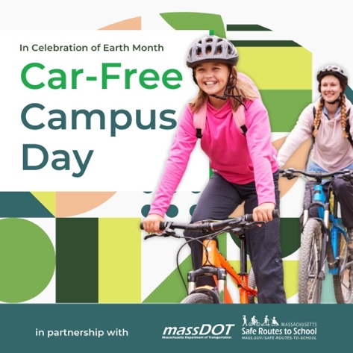
Post #2  Let’s show our planet—and campus—some love 🫶  [INSERT DATE] is Car-Free Campus Day at [HIGH SCHOOL NAME]. In partnership with MassDOT and the Massachusetts SRTS program, our school will commit to be an #SRTSCarFreeCampus to demonstrate collective love for our planet.  How do you participate? Simply arrive to school without a car—walking, biking, rolling, riding the school bus, or taking public transit all count!  Mark your calendars + start planning your route >> [ADD IN SCHOOL’S EVENT PAGE LINK] |  | 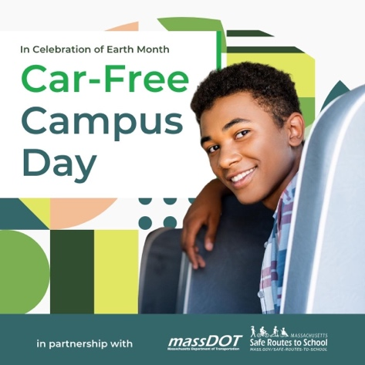
Post #3  Think you need a car to arrive at school? Think again!  On [INSERT DATE], [HIGH SCHOOL NAME], in partnership with MassDOT and the Massachusetts SRTS program, will be an #SRTSCarFreeCampus.  Participation is simple—arrive to school on this day using any of the car-free, sustainable travel options:  👟Walking  🚲Biking  🛴🦽Rolling  🚌Riding the school bus or public transit  Plan your route with friends, family, and neighbors >> [ADD IN SCHOOL’S EVENT PAGE LINK] |  | 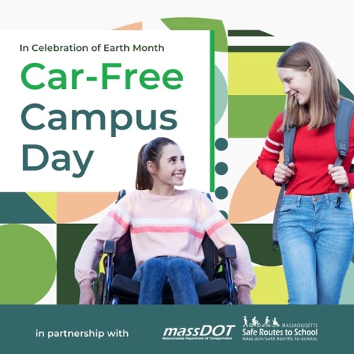
Post #4  Today’s the day! Students, faculty, and staff alike are arriving today without their cars to make our school an #SRTSCarFreeCampus.  Thank you to all participants and safety personnel for making this day a success! Your participation helped us reduce our carbon footprint and create a safer travel environment for everyone! 🫶 | Tip: For this post’s image, show pictures from your Car-Free Campus Day events.

