INDOOR AIR QUALITY ASSESSMENT

Doyle Early Education Center
11 Paul Avenue
Wakefield, Massachusetts

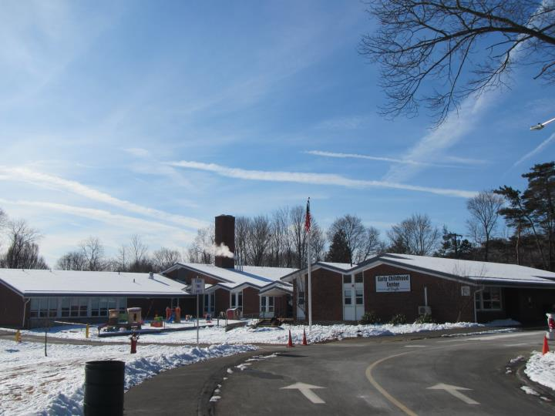

Prepared by:
Massachusetts Department of Public Health
Bureau of Environmental Health
Indoor Air Quality Program
March 2020

BACKGROUND
Building: | Doyle Early Education Center (DEEC)
Address: | 11 Paul Ave., Wakefield, MA
Assessment Requested by: | Bob Schiaroli, Facilities Director, Wakefield Public Schools (WPS)
Reason for Request: | Collaborative effort to perform general indoor air quality (IAQ) assessments throughout the WPS
Date of Assessment: | January 23, 2020
Massachusetts Department of Public Health/Bureau of Environmental Health (MDPH/BEH) Staff Conducting Assessment: | Jason Dustin, Environmental Inspector, IAQ Program
Date of Building Construction: | Originally constructed in 1961
Building Description: | This is a single-story brick/concrete building. The building contains general classrooms, kitchen, cafeteria, gymnasium, faculty workrooms and office space. Most areas have a pitched roof.
Windows: | Openable

METHODS
Please refer to the IAQ Manual and appendices for methods, sampling procedures, and interpretation of results (MDPH, 2015).

RESULTS and DISCUSSION
The following is a summary of indoor air testing results (Table 1).
- Carbon dioxide levels were above the MDPH recommended level of 800 parts per million (ppm) in 12 out of 18 areas surveyed, which indicates a lack of air exchange in these areas at the time of assessment. This is most likely due to deactivated and/or malfunctioning mechanical ventilation components and is explained further in the Ventilation section of this report.
- Temperature was within the MDPH recommended range of 70°F to 78°F in all occupied areas. Temperature control issues were reported in several areas.
- Relative humidity was below the MDPH recommended range of 40 to 60% in all areas tested on the day of the assessment, which is typical of conditions during the heating season.
- Carbon monoxide levels were non-detectable (ND) in all areas tested.
- Particulate matter (PM2.5) concentrations measured were below the National Ambient Air Quality (NAAQS) level of 35 μg/m³ in all areas tested.

Ventilation
A heating, ventilating and air conditioning (HVAC) system has several functions. First it provides heating and, if equipped, cooling. Second, it is a source of fresh air. Finally, an HVAC system will dilute and remove normally-occurring indoor environmental pollutants by not only introducing fresh air, but by filtering the airstream and ejecting stale air to the outdoors via exhaust ventilation. Even if an HVAC system is operating as designed, point sources of respiratory irritation may exist and cause symptoms in sensitive individuals.
Fresh air in classrooms is supplied by unit ventilators (univents, Picture 1). Univents draw air from the outdoors through a fresh air intake located on the exterior wall of the building and return air through an air intake located at the base of the unit. Fresh and return air are mixed, filtered, heated or cooled and provided to rooms through an air diffuser located in the top of the unit (Figure 1). In several rooms, univents were intentionally deactivated due to overheating/control issues; therefore no fresh air was being introduced at the time of testing. In addition, in some rooms the top and/or front of some univents were blocked by classroom items. In order for univents to provide fresh air as designed, intakes/returns must remain free of obstructions. Importantly, these units must remain on and be allowed to operate while rooms are occupied.
Older thermostats and pneumatic activated controls serve to activate the univents heat loop control valves and fresh air louvers. The fresh air louvers are used to adjust the amount of fresh air into classrooms. Due to the pervasive complaints regarding extremely hot temperatures, these systems appear to be in disrepair.
It was reported by DEEC staff that room #105 had a frozen pipe due to the fresh air louvers being stuck in the wide open position. Since making repairs to the pipe, it was further reported that the exterior fresh air vent was blocked to keep it from freezing again. This situation will not allow for any fresh air to enter the classroom other than openable windows.
Classroom exhaust vents (Picture 2) are connected with ducts to exhaust fans on the roof. A number of these exhaust vents were not drawing air during the assessment. WPS staff reported that fan belts are needed on some of the motors. Other rooms were lacking exhaust vents except for those located in adjacent bathrooms. This situation may be effective so long as the door to the bathroom is adequately undercut or a passive exhaust vent/grill is installed in the door. Without adequate supply and exhaust ventilation, excess heat and environmental pollutants can build up and lead to indoor air/comfort complaints.
To maximize air exchange, the IAQ program recommends that both supply and exhaust ventilation operate continuously during periods of occupancy. In order to have proper ventilation with a mechanical ventilation system, the systems must be balanced after installation to provide an adequate amount of fresh air to the interior of a room while removing stale air from the room. It is recommended that HVAC systems be re-balanced every five years to ensure adequate air systems function (SMACNA, 1994).
It is also important to note that most of the HVAC equipment appears to be original equipment (1960s) over 50 years old. Efficient function of equipment of this age is difficult to maintain, since compatible replacement parts are often unavailable. According to the American Society of Heating, Refrigeration, and Air-Conditioning Engineering (ASHRAE), the service life of this type of unit is 15-20 years, assuming routine maintenance of the equipment (ASHRAE, 1991). It appears the optimal operational lifespan of this equipment has been exceeded.

Microbial/Moisture Concerns
In order for building materials to support mold growth, a source of water exposure is necessary. Identification and elimination of the source of water moistening building materials is necessary to control mold growth. Very few water-damaged ceilings/tiles were observed at the DEEC perhaps due to the pitched roof. Typically, ceiling stains can indicate current/historic roof/plumbing leaks or other water infiltration. Water-damaged ceiling tiles can provide a source of mold and should be replaced after a water leak is discovered and repaired.
The United States Environmental Protection Agency (US EPA) and the American Conference of Governmental Industrial Hygienists (ACGIH) recommend that porous materials be dried with fans and heating within 24 to 48 hours of becoming wet (US EPA, 2008; ACGIH, 1989). If porous materials are not dried within this time frame, they should be removed and discarded.

Other Conditions
Other conditions that can affect IAQ were observed during the assessment. The MDPH recommends pleated filters with a Minimum Efficiency Reporting Value (MERV) of 8, which are adequate in filtering out pollen and mold spores (ASHRAE, 2012). Filters should also be changed two to four times a year, or per the manufacturer’s recommendations. In some areas, exhaust vents, supply diffusers and the interior of univents had accumulated dust/debris. This dust can be re-aerosolized under certain conditions, and can also be a medium for mold growth. Univent cabinets can also accumulate dust and debris, which should be cleaned when filters are changed (2-4 times/year).
Some areas in the school contain older carpeting. Carpeting should be vacuumed regularly with a high efficiency particulate arrestance (HEPA) filter equipped vacuum cleaner to avoid particulates from causing further irritation or serving as a reservoir for microbial colonization. Also, carpeting and rugs should be cleaned at least once per year according to IICRC recommendations (IICRC 2012). It should be noted that the usable life of carpeting in schools is approximately 10-11 years (IICRC, 2002). Aging carpet can produce fibers that can be irritating to the respiratory system. Area carpets too worn to be effectively cleaned should be replaced. Area rugs should be rolled up and stored in a clean, dry place when rooms are not occupied during the summer months to prevent moistening due to condensation. Vinyl flooring solutions should be considered instead of carpeting for areas subjected to condensation (e.g., on slab, below grade).
In many classrooms, large numbers of items were on floors, windowsills, tabletops, counters, bookcases and desks, which provide a source for dusts to accumulate. These items (e.g., papers, folders, boxes) make it difficult for custodial staff to clean. Items should be relocated and/or be cleaned periodically to avoid excessive dust build up. In addition, dust and debris can accumulate on flat surfaces (e.g., desktops, shelving and carpets) in occupied areas and subsequently be re-aerosolized causing further irritation.
Exposure to low levels of total volatile organic compounds (TVOCs) may produce eye, nose, throat, and/or respiratory irritation in some sensitive individuals. BEH/IAQ staff examined rooms for products containing VOCs. BEH/IAQ staff noted hand sanitizers, scented products, plug in air fresheners/diffusers (Picture 3), home cleaning products, and dry erase materials in use within the building. All of these products have the potential to be irritants to the eyes, nose, throat, and respiratory system of sensitive individuals. In addition, spray bottles/cleaning products should be kept out of reach of children.
Note that the Environmental Protection Agency (EPA) conducted a National School Radon Survey in which it discovered nearly one in five schools had “…at least one frequently occupied ground contact room with short-term radon levels above 4 [picocuries per liter] pCi/L” (US EPA 1993). The BEH/IAQ Program therefore recommends that every school be tested for radon, and that this testing be conducted during the heating season while school is in session in a manner consistent with USEPA radon testing guidelines. Radon measurement specialists and other information can be found at www.nrsb.org and http://aarst-nrpp.com/wp, with additional information at: http://www.mass.gov/eohhs/gov/departments/dph/programs/environmental-health/exposure-topics/iaq/radon.

RECOMMENDATIONS
In view of the findings at the time of the visit, the following recommendations are made:
- Operate the HVAC system to provide for continuous fresh air ventilation during occupied hours.
- Make repairs to the univent fresh air louver/actuator serving classroom #105 so that the barrier blocking the vent can be removed and allow fresh air into the classroom as designed.
- Remove furniture and items blocking the front and top of univents.
- Consider replacing older/problematic pneumatic controls for univents with a compatible and reliable control system to avoid system wide issues.
- Work to troubleshoot temperature control problems (e.g., thermostats, heat coil control valves, etc.).
- Educate occupants/facilities staff that when univents are shut off, the room does not receive fresh air. Distribute the guideline “IAQ primer for Teachers” in this effort. This guideline can be found at: https://www.mass.gov/service-details/indoor-air-quality-in-schools-a-primer-for-teachers and contains many more common ways to further improve air quality in the classroom.
- Use openable windows to supplement fresh air during temperate weather. Ensure all windows are closed tightly at the end of each day. Do not use windows while AC system is operating to prevent condensation/mold growth.
- Periodically assess whether exhaust vents (classrooms and restrooms) are drawing air and repair as needed.
- Undercut restroom doors (in classrooms) or install passive door vents to facilitate classroom exhaust/air exchange especially in rooms where this is the only means of exhaust.
- Consider assigning building specific IAQ committees/liaisons with regular walk-throughs of the building to identify on-going and/or potential issues.
- Utilize a system to report and track maintenance issues (e.g., school dude) so that concerns can be reported by staff and maintenance staff can report when issues have been resolved.
- Consider adopting a balancing schedule of every 5 years for all mechanical ventilation systems, as recommended by ventilation industrial standards (SMACNA, 1994).
- Once repairs are made to any active leaks, refinish water-damaged materials and replace ceiling tiles. Inspect the area above the stained tiles for water damage or odors and remediate or clean as necessary.
- Reduce or eliminate the use of air fresheners, scented cleaners, hand sanitizers and dry erase materials to reduce irritation.
- Continue to change filters in HVAC units at least twice a year with MERV 8 or higher pleated disposable filters. Clean HVAC and univent cabinets of debris and dust when filters are changed.
- Clean supply/exhaust vents and personal fans regularly to remove accumulated dust/debris.
- Ensure that condensation from AC equipment is draining properly. Check collector pans, piping and any associated pumps for clogs and leaks and clean periodically to prevent stagnant water build-up and remove debris that may provide a medium for microbial growth.
- For buildings in New England, periods of low relative humidity during the winter are often unavoidable. Therefore, scrupulous cleaning practices should be adopted to minimize common indoor air contaminants whose irritant effects can be enhanced when the relative humidity is low. To control for dusts, a high efficiency particulate arrestance (HEPA) filter equipped vacuum cleaner in conjunction with wet wiping of all surfaces is recommended. Avoid the use of feather dusters. Drinking water during the day can help ease some symptoms associated with a dry environment (throat and sinus irritations).
- Clean carpeting and area rugs at least once per year according to IICRC recommendations (IICRC 2012). Area carpets too worn to be effectively cleaned should be replaced. Roll up and store are rugs in a clean, dry place during the summer.
- Consider replacing carpeting with a non-porous surface such as vinyl tile particularly in below-grade areas.
- Relocate or consider reducing the amount of materials stored in classrooms to allow for more thorough cleaning of classrooms. Clean items regularly with a wet cloth or sponge to prevent excessive dust build-up.
- Continue to utilize the US EPA’s (2000), “Tools for Schools”, as an instrument for maintaining a good IAQ environment in the building available at: http://www.epa.gov/iaq/schools/index.html.
- Continue to maintain compliance with the Department of Labor Standard’s AHERA plan.
- The school should be tested for radon by a certified radon measurement specialist during the heating season when school is in session. Radon measurement specialists and other information can be found at: www.nrsb.org, and http://aarst-nrpp.com/wp.
- Refer to resource manuals and other related IAQ documents for further building-wide evaluations and advice on maintaining public buildings. Copies of these materials are located on the MDPH’s website: http://mass.gov/dph/iaq.

REFERENCES
ACGIH. 1989. Guidelines for the Assessment of Bioaerosols in the Indoor Environment. American.
ASHRAE. 1991. ASHRAE Applications Handbook, Chapter 33 “Owning and Operating Costs”. American Society of Heating, Refrigeration and Air Conditioning Engineers, Atlanta, GA.
ASHRAE. 2012. American Society of Heating, Refrigeration and Air Conditioning Engineers (ASHRAE) Standard 52.2-2012 -- Method of Testing General Ventilation Air-Cleaning Devices for Removal Efficiency by Particle Size (ANSI Approved).
IICRC. 2002. Institute of Inspection, Cleaning and Restoration Certification. A Life-Cycle Cost Analysis for Floor Coverings in School Facilities.
IICRC. 2012. Institute of Inspection Cleaning and Restoration Certification. Institute of Inspection, Cleaning and Restoration Certification. Carpet Cleaning: FAQ.
MDPH. 2015. Massachusetts Department of Public Health. Indoor Air Quality Manual: Chapters I-III. Available at: http://www.mass.gov/eohhs/gov/departments/dph/programs/environmental-health/exposure-topics/iaq/iaq-manual/.
SMACNA. 1994. HVAC Systems Commissioning Manual. 1st ed. Sheet Metal and Air Conditioning Contractors’ National Association, Inc., Chantilly, VA.
US EPA. 1993. Radon Measurement in Schools, Revised Edition. Office of Air and Radiation, Office of Radiation and Indoor Air, Indoor Environments Division (6609J). EPA 402-R-92-014.
US EPA. 2000. Tools for Schools. Office of Air and Radiation, Office of Radiation and Indoor Air, Indoor Environments Division (6609J). EPA 402-K-95-001, Second Edition. http://www.epa.gov/iaq/schools/index.html.
US EPA. 2008. Mold Remediation in Schools and Commercial Buildings. US Environmental Protection Agency, Office of Air and Radiation, Indoor Environments Division, Washington, D.C. EPA 402-K-01-001. http://www.epa.gov/mold/mold-remediation-schools-and-commercial-buildings-guide.
Picture 1
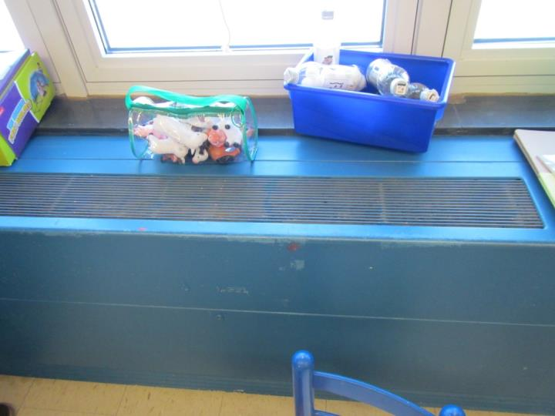
Univent in classroom
Picture 2
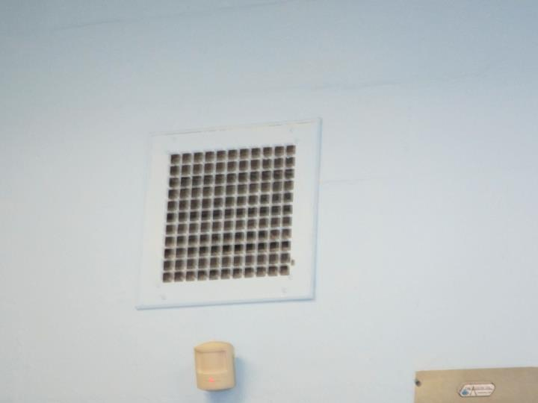
Wall-mounted exhaust vent
Picture 3
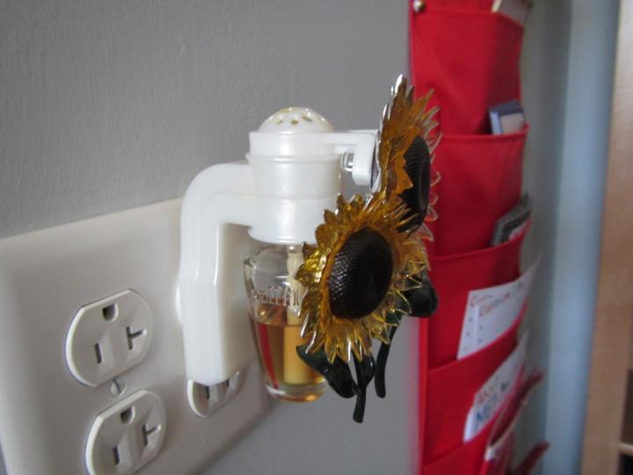
Plug-in air freshener

Location | Carbon  Dioxide  (ppm) | Carbon Monoxide  (ppm) | Temp  (°F) | Relative  Humidity  (%) | PM2.5  (µg/m³) | TVOCs  (ppm) | Occupants  in Room | Windows  Openable | Ventilation |  | Remarks
 |  |  |  |  |  |  |  |  | Supply | Exhaust
Background (outside) | 432 | ND | 45 | 21 | 20 | ND | - | - | - | - | Sunny
Teacher’s Lounge | 797 | ND | 70 | 18 | 15 | ND | 3 | Y | Y | Y | 9x9 probable ACM tiles intact
101 OT | 974 | ND | 72 | 19 | 14 | ND | 2 | Y | N | Y off | Carpet, radiators
Gym | 1380 | ND | 71 | 23 | 10 | ND | 20+ | Y | N | Y | radiators
Academy room | 1056 | ND | 70 | 20 | 10 | ND | 3 | N | N | Y (in bath) | Split AC/heat pump unit
ASD | 1296 | ND | 71 | 23 | 12 | ND | 7 | Y | N | Y (in bath) | Split AC/heat pump unit, DEM
Kitchen | 1088 | ND | 71 | 18 | 10 | ND | 1 | Y | N | Y | Food is not prepared on site (meals are delivered and stored in refrigerator)
102 | 992 | ND | 72 | 18 | 12 | ND | 2 | Y | N | N | Carpet, interlocking CTs (ACM?)
Principal | 812 | ND | 73 | 16 | 15 | ND | 1 | Y | N | N | Radiators, 9x9 tile
Main Office | 775 | ND | 73 | 15 | 10 | ND | 3 | Y | N | N
Conference | 779 | ND | 74 | 15 | 10 | ND | 3 | Y | N | Y | Area rug
103 | 1081 | ND | 73 | 19 | 9 | ND | 15 | Y | N | N
105 | 773 | ND | 74 | 16 | 8 | ND | 15 | Y | Y blocked | N | *Univent exterior fresh air intake vent was blocked due to a previous frozen pipe issue. Reported cause was louvers were stuck in wide open position.
107 | 963 | ND | 75 | 17 | 7 | ND | 12 | Y | Y off | Y off | HS, UV off
106 | 847 | ND | 74 | 15 | 7 | ND | 9 | Y | Y off | Y off | UV
104 | 968 | ND | 74 | 17 | 6 | ND | 7 | Y | Y off | N | HS, UV blocked, area rug, AC
109 | 1007 | ND | 72 | 18 | 9 | ND | 2 | Y | Y off | N | CPs, HS, area rug
108 | 667 | ND | 73 | 14 | 9 | ND | 14 | Y | Y on | N | UV on
110 | 759 | ND | 73 | 15 | 10 | ND | 12 | Y | Y off | N

The service life is the median time during which a particular system or component of …[an HVAC]… system remains in its original service application and then is replaced. Replacement may occur for any reason, including, but not limited to, failure, general obsolescence, reduced reliability, excessive maintenance cost, and changed system requirements due to such influences as building characteristics or energy prices (ASHRAE, 1991).

