Fee $42.00

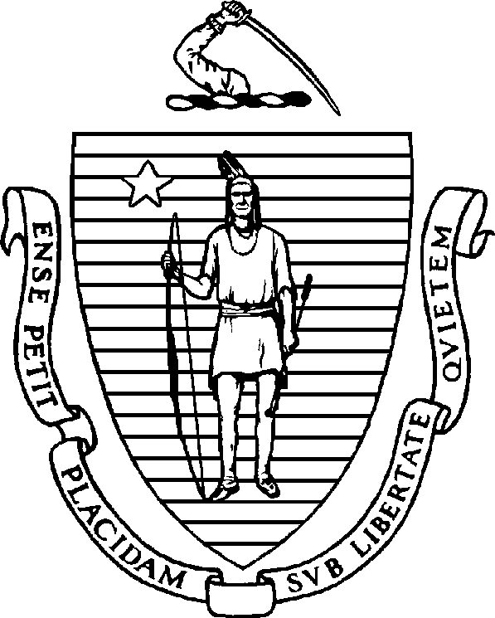
The Commonwealth of Massachusetts
Department of Public Health

Board of Registration in Optometry
250 Washington Street, Boston MA 02108

DPA Certification Application

Last Name: First Name: M.I.

Address:

MA License number

Year of original license by examination

State where originally licensed by examination

If original state of licensure by examination is not MA, request official verification of date of original licensure by examination from state of original licensure to be sent directly to the MA Optometry Board.

If original date of licensure by examination is prior to 1984, either in MA or another state, provide:
- official documentation (sent directly from the school, or in a sealed envelope from the school, and attached to application) from the school of optometry or school of medicine where the 97 hour post graduate DPA study was taken; and
- Official documentation (transcript, affidavit, certificate of completion) of 30 hours post graduate supervised clinical practice, including 6 hours in pediatric practice.

For office use only
Fee Received/Initials
Application Review Date(s)
DPA Certification Approved by Certificate issued □

