Opioid Treatment Programs:
DPH BSAS Guidelines for Exception Requests, Take-Home Criteria, and Closures
Revision: 5/1/2023

Contents

- Introduction
- Authorization to Submit Exception Requests
- Assessing and Documenting Justification for Exception Request
  - Exceptions to Limits on Unsupervised Take-Home Doses Documentation
  - Exception Requests related to Detoxification Requirements
- Exception Request Submission Process
  - Timing of Submission
  - Method of Submission
  - Procedures for Completing the Form SMA 168
- BSAS and SAMHSA Response
- Take-Home Criteria and Schedule (Federal and State) Post-COVID Public Health Emergency (PHE)
- OTP Closure Blanket Exception Request Submission
  - Permanent One-Day Weekend Closure

- Resources

Introduction

Exception Requests are required when an OTP treatment team proposes a deviation from limitations or protocols established by regulation (42 CFR Part 8 and 105 CMR 164.300 et seq.). The most common reasons for these requests are to permit exceptions to the number of allowed take-home doses, and exceptions to detoxification limits. Additionally, OTPs are required to submit exception requests when the medication is handled by someone other than the patient (e.g., patient enrolled in a residential program, patient residing in a skilled nursing facility (SNF), etc.). Any deviation from the opioid treatment standards in 42 CFR 8 and DPH BSAS OTP regulations 105 CMR
164.300 requires the submission and federal and state approval of the Form SMA-168 exception request.
Failure to submit the Form SMA-168 exception request and obtain approval from the State Opioid Treatment Authority and SAMHSA CSAT prior to providing care that deviates from the federal opioid treatment standards constitutes a serious regulatory violation.

Authorization to Submit Exception Requests
Exception requests may be submitted only by persons who are registered users of the SAMHSA/CSAT Opioid Treatment Program Extranet. Registered users cannot share their login information.
  - To register follow this link: OTP Extranet Access.

Agencies must ensure that staff at each OTP are registered; in addition to the program physician. A registered staff person may initiate and fill out an exception request, but only a registered physician or an approved exempted practitioner (https://otp-extranet.samhsa.gov/login.aspx) may approve and execute the submission. Note that current registration categories do not include nursing, although nurses may register under another category such as counselor. SAMHSA/CSAT guidelines, information, and links are available at: https://www.samhsa.gov/medication- assisted-treatment/otp-resources/submit-exception-request.

Assessing and Documenting Justification for Exception Request

Exceptions to Limits on Unsupervised Take-Home Doses:

Limits on unsupervised, take-home doses are established to prevent diversion, overdose, and unintentional injury from poisoning, and to promote engagement in treatment and ongoing assessment of recovery status. It is the expectation of DPH BSAS that OTPs continuously monitor patients’ progress for eligibility for take-homes and provide take-homes as appropriate according to regulations.

Take-home medication is a valuable therapeutic tool and an important means of individualizing treatment. Program policies that do not permit take-homes for any patients are unacceptable because these policies preclude individualized patient care. Take-home medication often is a critical issue for patients who are deciding whether to enter and remain in treatment. The OTP medical director, therefore, should ensure that policies for the approval of take-home medication do not create barriers to patients continuing in treatment (https://store.samhsa.gov/sites/default/files/d7/priv/pep15-fedguideotp.pdf).

The Federal Guidelines for Opioid Treatment Programs (https://store.samhsa.gov/product/Federal- Guidelines-for-Opioid-Treatment-Programs/PEP15-FEDGUIDEOTP: See Appendix C: FAQ) state that a patient who is on short-term medically supervised withdrawal (MSW) cannot have take-home medication. However, an OTP may submit a program-wide blanket exemption request for patients who fit into this treatment modality. The exemption permits only those patients deemed stable enough to safely take the medication unsupervised to be granted a take-home dose in this situation. With a program-wide exemption in place, the program may provide a take-home for such patients without requesting an individual exemption for each one on each occasion. Additionally, a patient who is on methadone maintenance treatment and on take-home status, who then requests a medically supervised withdrawal (MSW) may remain on take-homes during their MSW, as they were admitted on maintenance treatment.

Medical Directors shall consider the following take-home criteria as defined in 42 CFR 8 in determining whether a patient is responsible in handling any take-home Medications for Opioid Use Disorder medications for unsupervised use:
  - Absence of recent illicit drug use
  - Regular attendance (for dosing)
  - Absence of serious behavioral problems at the OTP
  - Absence of known recent criminal activity
  - Stability of the patient’s home environment
  - Meet the required length of time in treatment (outlined in the Table: Schedule of Maximal Take- Home Medications per 42 CFR 8.12 AND see most recent SAMHSA guidance
    - https://www.mass.gov/doc/covid-19-medication-dosing-in-opioid-treatment- programs/download
    - https://www.ecfr.gov/current/title-42/chapter-I/subchapter-A/part-2
    - https://www.samhsa.gov/coronavirus
  - Provide assurance that take-home medication will be safely stored
  - Show that the rehabilitative benefit outweighs the risk of diversion
  - Buprenorphine Take-homes: The Time in Treatment criteria is waived for Buprenorphine, all other criteria must be met (https://www.samhsa.gov/medication-assisted-treatment/become- accredited-opioid-treatment-program/buprenorphine-dispensing-by-program).

The Medical Director and treatment team must agree that an exception should be submitted. If the Medical Director and treatment team is uncertain whether the exception is justified, the request should not be submitted. In those cases, treatment staff should inform the patient of the team’s decision and reasons.

The following table provides examples of circumstances in which an OTP may submit an exception request along with factors to consider. These factors should be discussed with the patient and the treatment team prior to submitting the request. Be reminded that exception requests should only be submitted if the patient requires take-homes and does not meet the regulatory requirements. The factors to consider should be included in the comments section of the request to provide more information and detail.

Circumstances | Factors to Consider
Vacation and Travel | - Provision for safe storage while traveling  Patients intending to travel for any planned event should be advised not to book travel arrangements until an exception request has been approved.
Medical Reasons (hospital admission, homebound care, etc.) | - Treating physician’s confirmation of diagnosis and treatment plan  - Anticipated duration of exception period; if longer than four weeks, description of the plan to the patient receives all of the required OTP services  - For home health dosing service, describe face to face daily dose plan, OR describe:  - Rationale for home-bound care  - Assessment of safety of the home environment, including the presence of children and/or pets  - Plan for designating person(s) responsible for picking up take-home doses.  - Plan for ensuring chain of custody.
Emergency | - Nature of emergency  - Where the patient is traveling  - Rationale for supporting the request  - Provision for safe storage while traveling
Split Dosing | Please see the Updated SAMHSA Split Dosing Guidance:  SAMHSA Split-Dosing Guidance
OTP Patient Residing in any type of Residential Facility (Skilled Nursing, Long-term Care, BSAS Residential Treatment Facility, etc.)  Note: OTPs must submit an exception request when a patient is admitted into a Residential Program (e.g., Skilled Nursing Facility (LTF), Long-Term Care Facility (LTCF), Residential Treatment Facility) | - Name and Address of the residential program  - Description of how patients will receive their methadone/or buprenorphine at the residential program  - Detailed plan for transportation between the residential program and OTP  - Provision for safe storage during transport and at the facility  - Plan for ensuring and maintaining chain of custody, and plan for patient to sign off daily that they received their methadone  - Plan for patient to be oriented regarding what to do if they feel methadone has been tampered with  - Brief diversion plan including reconciliation of chain of custody form and empty bottle reconciliation process  - Plan for when/if the patient is discharged from the facility, including managing remaining doses after discharge  - Affirmation that a QSOA is in place or in process between the OTP and the facility

Sample Brief Explanation for a residential placement exception request:
Per agreement between this OTP and [name of program], the patient will pick up 6 TH's on [specify day each week] in the company of staff from [name of program]. On [specify day of pick up], the patient will be dosed at [name of OTP]. Six methadone doses will be placed in a locked box and will be transported back to the residential program by staff from [name of program] with the patient. The patient and a staff member from the residential program will sign a chain of custody for these take-homes. The patient will receive their daily methadone doses at the residential program. After each observed daily ingestion, the patient will sign that they received the dose. On [specify day each week] the patient will return to the OTP with the locked box with the empty methadone bottles and chain of custody form. The residential program and the patient have been made aware that if the patient leaves the program at any point in time that the OTP will be notified, and a decision will be made by the OTP in collaboration with the facility regarding whether the patient will be able to take their remaining take-home bottles with them or not. Any remaining doses will be disposed of in accordance with the residential program’s policy on the disposal of medication left behind.

Exception Requests related to Detoxification Requirements:

The most common exceptions related to detoxification are:
  - Transfer of a patient from detoxification to maintenance when there is no documentation or evidence of a history of at least one year of opioid dependence. In these cases, justification should include:
    - Physician’s rationale and clinical assessment;
    - Patient’s age
    - Drug testing results and dates
    - Reported length of opiate use
  - Admission for more than two detoxification treatment episodes within one year. In these cases, justification should include:
    - Results of referrals to and attempts at other forms of treatment;
    - Physician’s rationale and clinical assessment;
    - Documentation of time elapsed between detoxification attempts; and
    - Treatment team’s rationale for an additional detoxification attempt.
The above information should be recorded in the ‘Brief Explanation’ text box in the ‘Justification’ section of the request form.

Exception Request Submission Process
- Timing of Submission: Exception requests will not be approved retroactively. Except in emergencies, requests should be submitted at least two business days in advance. Storm and any unexpected closure blanket take-home requests must be submitted within 72 hours after the event.
- Method of Submission: Exception requests must be submitted through the online SMA-168 process. Online requests generate a notification to both SAMHSA/CSAT and BSAS that a request is

awaiting review. If a request does not require federal agency approval, SAMHSA/CSAT’s and BSAS’s State Opioid Treatment Authority response will so state.

Procedures for Completing Form SMA-168

OTP Information: Staff may log in to complete a Form SMA-168 ONLY if they have an authorized user ID and password. Staff may not log in using someone else’s user ID and password. After logging in, complete OTP Information by providing the name, title, and contact information of the staff person making the request – this is the person BSAS will contact if there are questions.
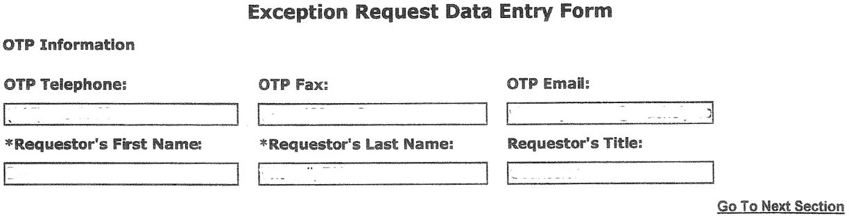

PATIENT INFORMATION

This section records identifying information and the CURRENT protocol and status of the patient. Describe the patient’s protocol as it is prior to the change requested (see example next page).

Patient Information Examples – Patient’s program attendance schedule per week:

Patient Program Attendance: Examples

  - Patient has one take-home per week on Friday:
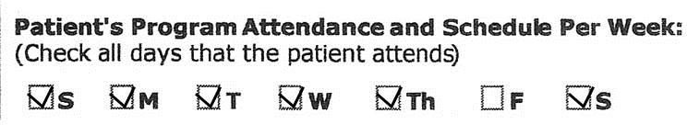

  - Patient has 6 take-homes per week, and comes in on Monday:

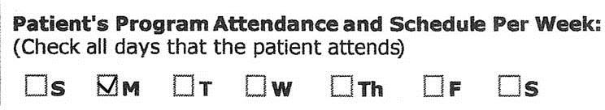

Patient Status: Check the item that best describes the patient; if ‘Other’, please describe the status briefly.
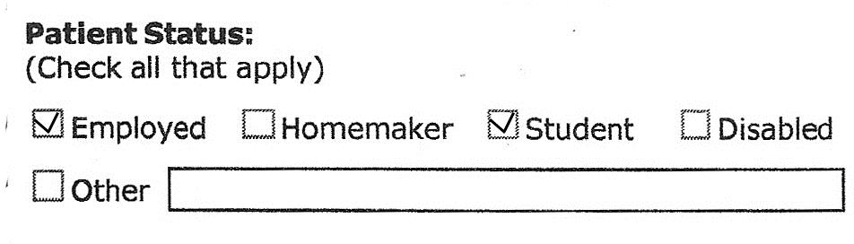

PART TWO: REQUEST FOR CHANGE

Nature of Request:

Click on the button next to the item that best describes the reason you are asking for an exception. Exceptions may be requested for:

Temporary take-home medication: is a one-time increase in the number of take-homes. For example, a person with no take-homes needs to travel to take a vacation or to attend a funeral and requires one take-home dose for the period of travel. Patients’ entry into a residential program at a distance from the clinic would also be included here.

Temporary change in protocol: is an exception to required dosage, for example, a higher initial dose.

Detoxification exception: is a request for a variation from detoxification standards which limit the number of detoxification attempts an individual may make within 12 months.

Other: If none of the above reasons apply, click on the button next to ‘Other’ and explain the reason for the request on the ‘Other’ text box. Be clear and specific. The form will expand to allow a full explanation. Use this section to request transfer from detoxification to maintenance for a patient without documentation of a one-year history of opioid dependence; or to request take-homes for split doses.

Decrease regular attendance to: Record the attendance, as it would be under the exception. The ‘Beginning date’ and the first ‘Dates of Exception’ are the same date and refer to the first date of the exception. The ‘to’ date is the last day of the exception (the first day patient does not come to the clinic). See the examples below.

Example:

  - Patient currently has one take-home per week on Friday. The requested change is to provide three take-homes, so the patient attends clinic on Sunday, Monday, Tuesday, and Saturday, and does not come in on Wednesday, Thursday, and Friday.

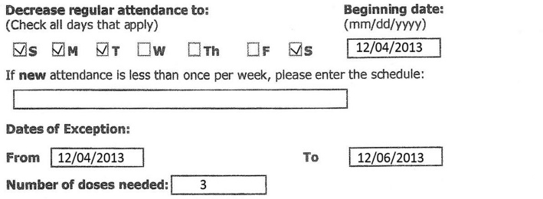
These dates are the same day – the first day the patient does NOT come into the clinic, i.e., the day AFTER the patient picks up the doses.
Number of doses should match the number of unchecked days in the ‘Decrease regular
This is the LAST day of the exception, and the day before the patient will come back to the clinic.

  - Patient currently has 13 take-homes and comes in every other Thursday. The requested change is to provide an additional 1 additional take-home for a day of travel at the beginning of a 14-day vacation.

`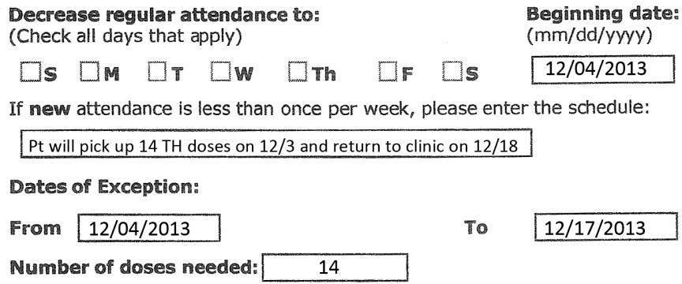
Justification: It is important to provide as much information as needed to fully explain the reason for the exception request. Check all items that apply. In the example below, both ‘Family Emergency’ and ‘Funeral’ is checked. Then provide detailed information in the ‘Brief Explanation’ box.

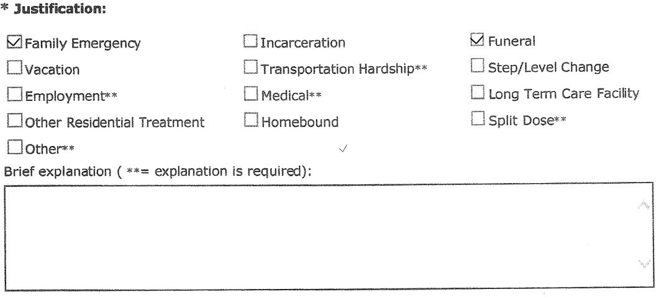

BSAS and SAMHSA Response – Approvals and Denials

Be sure to read all comments regardless of whether approved or denied. These comments often contain questions or requests for additional information to which you must respond. All exception requests must be approved by both DPH BSAS’ State Opioid Treatment Authority and SAMHSA/CSAT. In other words, if it denied by either, it is considered denied.

Take-Home Eligibility Criteria and Schedule Post-COVID Public Health Emergency (PHE)

DPH BSAS OTP Take-home regulations 164.307(C) fully align with the federal OTP Take-home criteria, schedule, and guidelines.

On April 19, 2023, SAMHSA released this NEW Take-home Criteria and Schedule which will be in effect once the federal Public Health Emergency (PHE) is rescinded. The table below outlines the changes to the take-home criteria and schedule.

s

Only submit Exception Requests if the request falls outside of these guidelines.

Additionally, please see SAMHSA and DPH BSAS Guidance:
  - https://www.samhsa.gov/medication-assisted-treatment/statutes-regulations-guidelines/methadone- guidance
  - https://www.mass.gov/doc/covid-19-medication-dosing-in-opioid-treatment-programs/download

DPH BSAS OTP regulations and federal OTP regulations state that the Medical Director may reduce the number of times patients must present themselves for observed ingestion of medication by providing take-home doses. In determining whether to provide take-home doses to a patient, the Medical Director shall ensure all decisions comply with federal and state take-home criteria and schedule.
The Licensed or Approved Provider shall adhere to federal and state limits for providing take-home doses of any opioid agonist or partial agonist, including that any patient in opioid maintenance treatment may receive a single take-home dose for a day the program is closed, such as on Sundays and state and federal holidays. OTPs must have plans in place to be able to provide in person dosing to any patient that is deemed ineligible by the OTP’s medical director when there is a planned or unforeseen closure.

8

Requirements | April 2023 Methadone Take-Home Flexibilities Extension Guidance
Factors to be Considered | Appropriately licensed OTP medical practitioner or medical director must consider six factors (and other pertinent factors) that indicate whether therapeutic benefits of unsupervised doses outweigh the risks:  - Absence of active substance use disorders, other physical or behavioral health conditions that increase the risk of patient harm as it relates to the potential for overdose, or the ability to function safely;  - Regularity of attendance for supervised medication administration;  - Absence of serious behavioral problems that endanger the patient, the public or others;  - Absence of known recent diversion activity; and  - Whether take-home medication can be safely transported and stored; and  - Any other criteria that the medical director or medical practitioner considers relevant to the patient's safety and the public's health.
Time Restrictions | During the first 14 days, take-home limited to 7 days.  From 15 days, take-home is limited to 14 days.  From 31 days, take-home is limited to 28 days.

Opioid Treatment Programs Closure Blanket Exception Request Submission

In line with SAMHSA’s federal standard which allows OTPs to close on state and federal holidays as well as one day per week, the MA Department of Public Health (DPH) Bureau of Substance Addiction Services (the Bureau) is permitting OTPs to close on State and Federal holidays provided patients are given take-home dosing and/or

alternative arrangements made such as chain of custody take-homes or guest dosing for all days closed. Also, consistent with SAMHSA’s federal standards, The Department is making allowances for OTPs to adjust hours of operation on either Saturday or Sunday. The program shall be open to provide treatment and to dispense medications at least six days per week, year-round; provided nothing shall limit the OTP’s ability to dispense medication for take-home use in accordance with federal and state requirements including on days the program is closed.

Please note that while the Bureau encourages programs to consider closing on holidays and supports decisions to close one day per week, this decision is within the sole discretion of the individual OTP. These considerations that follow shall be implemented as appropriate in any type of emergency closure for example severe weather or disaster related.

Permanent one-day weekend closures do not require a blanket exception request submission. However, OTPs must receive approval from DPH BSAS prior to instituting the closure. Additionally, a required notification and plan which describes how all patients will be medicated on the day of the closure must be submitted.

Please see regulations 164.315: Hours of Operation & 164.035 (D): Change of Program or Service Provision

Operational Hours

Operational schedule decisions shall consider any identified barriers to receiving and remaining in treatment, including but not limited to transportation, child/family care, employment, and educational needs of the patients. All OTP operations must schedule for and be reflective of patient and community needs, including the ability to provide intakes and medication services that ensure immediate access to treatment.

Services must be provided during hours that meet the needs of the overwhelming majority of patients, including hours outside of the traditional 9:00 A.M. to 5:00 P.M., Monday through Friday work schedule. Medication dispensing must be scheduled for a period reflective of the program census and to allow for adequate social distancing and/or take- home medication dispensing in accordance with the program’s emergency continued operation plan and subsequent policies.

Closure Policy

OTPs must have closure policies in place and must include all guidance provided in the guidelines listed below.

Holiday Closure

Programs may close on Federal and State Holidays. The program may only close on the Federal/State observed holiday.

Any Type of Closure

Patients identified by the Medical Director who do not qualify for take-homes are required to be medicated face-to- face, or arrangements must be made by the program to dose these patients on the day the program is closed. OTPs must have policies in place for patients who do not qualify for take-homes to receive their medication during a closure. For example, the OTP will remain open for minimal hours to face dose specific patients, and/or an identified household/family member deemed stable by the program will pick up the medication for the patient through chain of custody documentation.

Emergency Contact During Closures

Facility offices and waiting areas must display the names and telephone numbers of individuals, such as physicians,

hospitals, and emergency medical technicians, who should be contacted in case of emergency or utilize 911 or similar local emergency resources. A mechanism to address patient medical or psychiatric emergencies occurring outside of program hours of operation must be provided, including the establishment of an emergency contact system to obtain dosage levels and other pertinent patient information on a 24-hour, 7-days-a-week basis, as appropriate under confidentiality regulations, see 164.062

Notification to BSAS

OTPs may not close without the approval of DPH BSAS. A Required Notification Form must be submitted for any closures or changes in operational hours including closing one day per week.

Additionally, one blanket exception request shall be submitted in the SAMHSA Extranet which includes information on the one day/week closure.

Please contact Jen Babich, State Opioid Treatment Authority at Jennifer.Babich@Mass.Gov and Mike Gurney, Opioid Services Coordinator at Michael.Gurney@Mass.Gov should there be an urgent need to close aside from a planned event. See the Link to Required Notification Form: https://www.mass.gov/doc/health-and-safety-required- notification-form-0/download

Notification to Patients and Other Providers

Programs that choose to close are required to provide advance notification to patients. Additionally, the operational hours and schedule shall be included in the Patient Handbook and posted. Notification should be through multiple mechanisms and ensure the most advance notice applicable to the reason for the closure. The program shall coordinate all required care including guest dosing and must ensure take-home medication is available to all patients deemed stable by the program’s medical director.

Patients identified as unstable by the Medical Director are required to be medicated face-to-face, or arrangements must be made by the program to provide medication to these patients on the day the program is closed. OTPs must have policies in place for patients deemed unstable to receive their medication during a closure. For example, the OTP will remain open for minimal hours to face dose specific patients, and/or an identified household/family member deemed stable by the program will pick up the medication for the patient through chain of custody documentation, and/or the patient will guest dose at another geographically close OTP if feasible for the patient.

Additionally, OTPs must provide notification of any planned closures to other community-based OTPs and healthcare facilities such as local hospitals and other providers within the continuum of care.

Severe Weather / Emergency Protocols

Storm Closure
Though the Department tries to monitor the weather to ensure that there is an appropriate and coordinated State response when there is a severe weather situation that impacts the whole state, weather events can come on quickly, without much warning, and be very localized. Therefore, it is critical to have your OTPs Severe Weather Policy per DPH BSAS regulation 105 CMR 164.316 in place with every staff member trained in their role in implementing it when the Medical Director and leadership make the decision to do so. Patients should also be informed regarding each OTPs status and severe weather/emergency plan.

Each OTP’s Medical Director in conjunction with the leadership team can make the decision to activate the OTP’s Severe Weather Policy. Please be reminded that OTPs cannot decide to close without the State’s approval. All Storm Exception Requests should be submitted within one business day after the storm event.

Please notify State Opioid Treatment Authority Jen Babich (Jennifer.Babich@mass.gov) and Opioid Services Coordinator Mike Gurney (Michael.Gurney@mass.gov) however, if you are planning to implement your Severe

Weather Plan and/or Close, if applicable, at which of your programs. This is not to gain approval, but to inform BSAS.

Storm Exception Requests must be submitted electronically within 72 hours after the event, and you may use blanket exception requests. Please see the template(s) for submitting blanket exception requests in Section 4.

BSAS will continue to use the Weather Emergency Notification System (WENS) to post alerts. If there is a major statewide emergency, and interactive communication is required, BSAS staff will contact your designated emergency contact directly to set up a conference call as necessary.

The WENS information system includes two methods for OTPs to obtain information regarding the State’s updates on weather-related closures and other emergencies affecting OTPs: receive a pre-recorded informational voice mail message by calling 617-624-5346 or an automated email message by emailing bsas.weather@state.ma.us. Neither of these tools accepts messages, and they should not be widely shared beyond your identified emergency contacts.

The decision to grant take-home dosing under the above criteria must be made at the discretion of the OTPs Medical Director. OTPs must have policies in place which describe how take-home decisions are made including holiday and/or closure take-homes.

Patients must be informed in a timely manner about the closure.

- OTPs must have policies in place to ensure the continuation of medication for patients that may have missed the pick-up day prior to the closure, and ultimately miss two or three days of dosing due to the closure. This may include coordinating care with local OTPs / and or communicating directly with local emergency department heads.

- Patients are required to have a lockable container for single day take-homes and ensure that the medication is stored in a manner that is considered ‘secure’ (i.e., childproof/tamperproof container) by the program.

- All patients receiving take-home medication must be educated about and informed in writing of the dangers of accidental methadone ingestion by persons for whom it is not prescribed, especially children and animals. A patient signed acknowledgment of this information must be placed in the patient’s record.

- Staff must be available to patients who may have an emergency clinical need and the OTP must provide clear direction for patients regarding contacting the OTP for emergency purposes during the closure.

- For the closure, OTPs may grant a one-day supply of medication regardless of time in treatment for stable patients in treatment. Programs do not have to submit individual exception requests for these patients. However, at least 2 business days prior to any planned Holiday Closure OTPs must submit one blanket exception request in the SAMHSA Extranet. Individual patient numbers of patients receiving the take-home dose do not need to be listed. However, in the comment section please provide the patient record number for those who are identified as unstable and/or on a medically supervised withdrawal (MSW) or are being inducted and indicate the arrangements for those patients.

- Programs may not dispense take-home doses that exceed federal guidelines without prior written approval from SAMHSA CSAT and BSAS. Programs are responsible for submitting individual exception requests for any patient for whom the number of take-home doses allowed under these BSAS holiday guidelines would exceed the amount allowed by federal and state regulations.

Blanket Exception Request Templates

Holiday Closure Exception Request Template:

    - With prior approval from DPH BSAS, PROGAM NAME & LOCATION will be closed (DATE). The program will provide one (1) take-home dose of medication to all patients deemed stable by the treatment team on (DAY PRIOR TO CLOSURE), the day prior to the program closure. The bottle will be placed in a lockbox. (Enter the individual patient record numbers of patients who will NOT receive a take-home bottle) as they were deemed unstable by the OTP treatment team, also include the arrangements made by the OTP for them to receive their daily medication. All patients signed the take-home agreement, received education on accidental ingestion and safe storage, and were advised to return the empty bottle upon returning to the program.

Full Program Closure (Weather-Related) Exception Request:

    - The (Name) OTP closed on (Day, Date) for dosing during the storm. The clinic provided take-home doses to (Number) patients. Of those (Number) patients did not meet the 8-point criteria and/or the time in treatment criteria. All take-home doses were given with the prior approval of the SOTA. In the case of patients who did not meet the 8-point criteria and/or time in treatment criteria the Medical Director, in consultation with the clinical team, determined that the risk posed by travel or potentially missing a dose during the storm was greater than the risk of diversion or other harm. All of the clinic patients were dosed the day of the storm (or Number) patients did not receive a dose on (date of the storm) as they did not attend the clinic.

Severe Weather / Emergency Exception Request:

    - The (Name) OTP remained open on (Day, Date) for dosing during the storm. The clinic provided take-home doses to (Number) patients. Of those (Number) patients did not meet the 8-point criteria and/or the time in treatment criteria. All take-home doses were given with the prior approval of the SOTA. In the case of patients who did not meet the 8-point criteria and/or time in treatment criteria the Medical Director, in consultation with the clinical team, determined that the risk posed by travel or potentially missing a dose during the storm was greater than the risk of diversion or other harm. All of the clinic patients were dosed the day of the storm (or Number) patients did not receive a dose on (date of the storm) as they did not attend the clinic.

Resources:
    - 105 CMR 164: Licensure of Substance Use Treatment Programs: https://www.mass.gov/regulations/105-CMR- 16400-licensure-of-substance-abuse-treatment-programs

    - TIP 63: Medications for Opioid Use Disorder: https://store.samhsa.gov/product/TIP-63-Medications-for-Opioid- Use-Disorder-Full-Document/PEP21-02-01-002

    - SAMHSA Exception Request Submission Instructions: https://www.samhsa.gov/medication-assisted- treatment/otp-resources/submit-exception-request

    - SAMHSA FAQs: Provision of methadone and buprenorphine for the treatment of Opioid Use Disorder in the COVID-19 emergency: https://www.samhsa.gov/sites/default/files/faqs-for-oud-prescribing-and-dispensing.pdf

    - TAP 34: Disaster Planning Handbook for Behavioral Health Service Programs: https://store.samhsa.gov/product/tap-34-disaster-planning-handbook-for-behavioral-health-service- programs/pep21-02-01-001

