**Opioid Treatment Programs:**

**DPH BSAS Guidelines for Exception Requests, Take-Home Criteria, and Closures**

**Revised: November 2024**

**Contents:**

1. Introduction
2. Authorization to Submit Exception Requests
3. Exceptions to Limits on Unsupervised Take-Home Medication
   1. Updated Criteria for Consideration
   2. Updated Time in Treatment Criteria
4. Exception Request Submission Process
5. DPH BSAS and SAMHSA Response – Approvals, Denials, Decision Not Required
6. Opioid Treatment Programs Closure Blanket Exception Request Submission
   1. Permanent One-Day Weekend Closure
   2. Holiday Closure
   3. Any Type of Closure
   4. Severe Weather / Emergency Protocols
   5. Notification to Patients and Other Providers
   6. Blanket Exception Request Templates
7. Resources
8. **Introduction**

Exception Requests are required when an Opioid Treatment Program (OTP) treatment team proposes a deviation from the opioid treatment standards in 42 CFR 8 and the Department of Public Health Bureau of Substance Addiction Services (DPH BSAS) OTP regulations 105 CMR 164.300. Deviations for this purpose are centered around the criteria for take-home/unsupervised use or when the medication leaves the hands/custody of the patient or OTP staff. These deviations require submission of an exception request through the filing of a Form SMA-168 in the SAMHSA Extranet. Both federal and state approval of the Form SMA-168 exception request must be granted.

[42 CFR Part 8](https://www.samhsa.gov/medications-substance-use-disorders/statutes-regulations-guidelines/42-cfr-part-8) (The Final Rule) and [DPH BSAS Waiver from Certain Regulatory Requirements and Guidance](https://www.mass.gov/doc/dph-bsas-revised-waiver-from-certain-regulatory-requirements-and-guidance-42-cfr-part-8-and-105-cmr-164000/download) include revised take-home criteria in alignment with the updated federal regulations effective April 2, 2024. The Final Rule “promotes practitioner autonomy and individualized care. This includes removal from sole consideration the length of time an individual has been in treatment and requirements for rigid reliance on toxicology testing results that demonstrate complete and sustained abstinence from all substances prone to misuse. Based on the clinical judgment of the treating provider, patients may be eligible for unsupervised, take-home doses of methadone upon entry into treatment. This change recognizes the importance of the practitioner-patient relationship and is consistent with modern substance use disorder treatment standards”.0F[1] In other words, the updated regulation allows for individualized treatment decisions including take-home decisions. OTP Practitioners shall **consider** the updated criteria among other pertinent factors that indicate the therapeutic benefits of unsupervised doses may outweigh the risks. The practitioner’s determination and the basis of the determination shall be documented in the patient’s medical record.

The most common reason for exception requests is to permit exceptions to the number of allowed take-home doses. For example, if a patient doesn’t meet the time in treatment criteria, the OTP must submit an exception request. Additionally, OTPs are required to submit exception requests when the medication is handled by someone other than the patient. Examples of these situations include a trusted household member handling the methadone rather than the patient, a patient residing in a residential program, a long-term care (LTC)/skilled nursing facility (SNF), a carceral setting, etc.

Failure to submit the Form SMA-168 exception request and obtain approval from the [State Opioid Treatment Authority](https://dpt2.samhsa.gov/regulations/smalist.aspx) and SAMHSA CSAT prior to providing care that deviates from the federal opioid treatment standards constitutes a serious regulatory violation.

1. **Authorization to Submit Exception Requests**

Exception requests may be submitted only by persons who are registered users of the SAMHSA/CSAT Opioid Treatment Program Extranet. Registered users cannot share their login information. Follow this link to register: [OTP Extranet Access](https://otp-extranet.samhsa.gov/request/(S(oy3x5qsoflm5btg4ctqyvxc2))/default.aspx).

Agencies must ensure that staff at each OTP are registered. At a minimum, the medical director, physician, or practitioner must have access. A registered staff person may initiate and fill out an exception request, but only a registered physician or a practitioner may approve and execute the submission. Note that current registration categories do not include nursing, although nurses may register under another category such as counselor. SAMHSA/CSAT guidelines, information, and links are available at: <https://www.samhsa.gov/medication-assisted-treatment/otp-resources/submit-exception-request>.

1. **Exceptions to Limits on Unsupervised Take-Home Medication**
2. **Updated Criteria for Consideration**

Decisions on dispensing MOUD to patients for unsupervised use shall be determined by an appropriately licensed OTP Medical Practitioner. OTP Practitioners shall consider the updated criteria as defined in [42 CFR 8](https://www.ecfr.gov/current/title-42/chapter-I/subchapter-A/part-8/subpart-C/section-8.12) among other pertinent factors that indicate the therapeutic benefits of unsupervised doses may outweigh the risks. The ability for practitioners to consider these factors while making take-home decisions is a flexibility allowing for individualized treatment decisions versus a one size fits all approach:

(i) Absence of active substance use disorders, other physical or behavioral health conditions that increase the risk of patient harm as it relates to the potential for overdose, or the ability to function safely;

(ii) Regularity of attendance for supervised medication administration;

(iii) Absence of serious behavioral problems that endanger the patient, the public or others;

(iv) Absence of known recent diversion activity;

(v) Whether take-home medication can be safely transported and stored; and

(vi) Any other criteria that the medical director or medical practitioner considers relevant to the patient's safety and the public's health.

The practitioner’s determination and the basis of the determination shall be documented in the patient’s medical record.

1. **Updated Time in Treatment Requirement**

Additionally, patients must meet the time in treatment requirement per regulations:

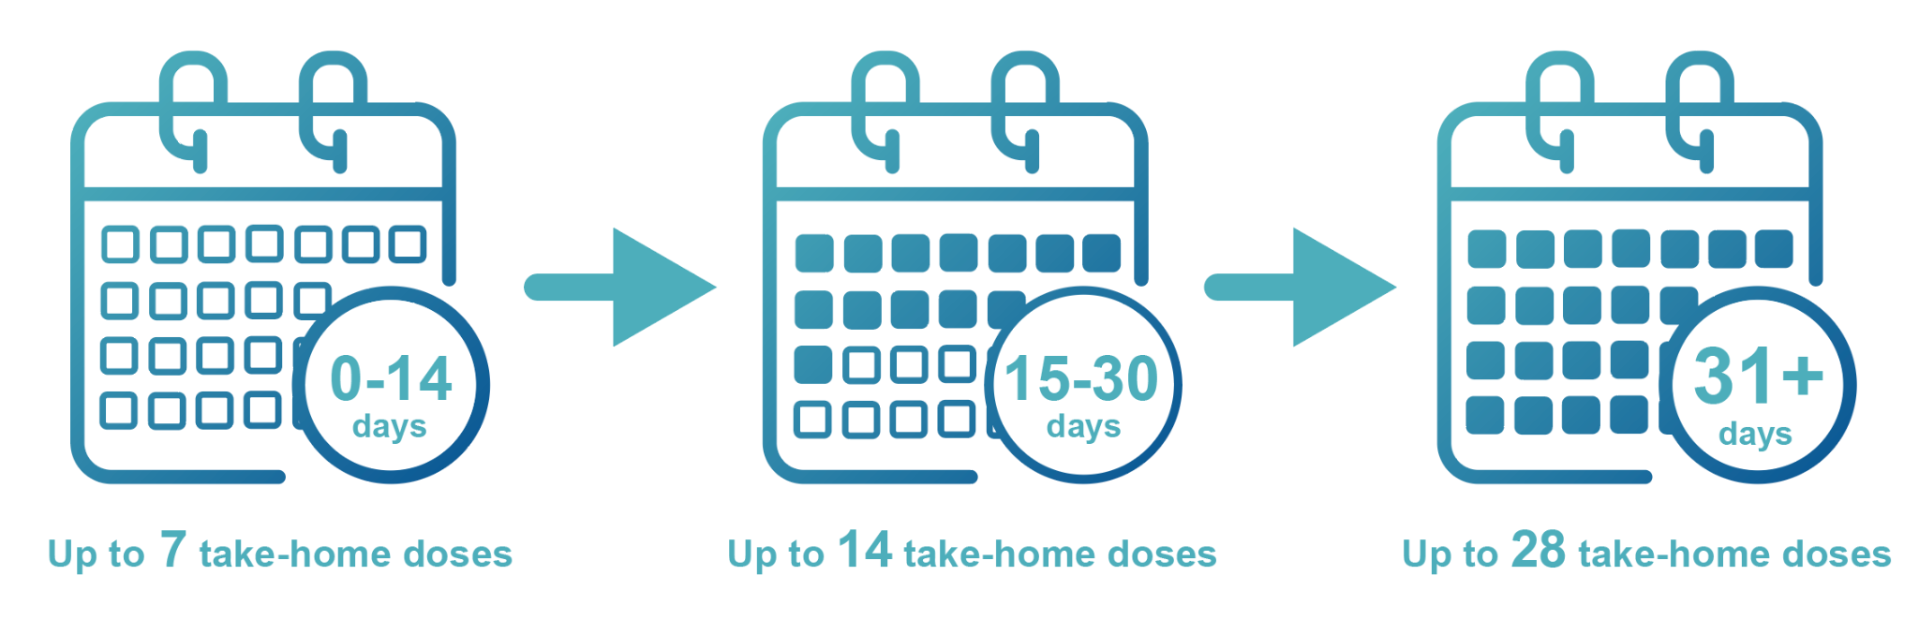

Split-Dosing: **DO NOT** need to be submitted as an Exception Request

Buprenorphine Take-homes: The Time in Treatment criteria does not apply; all other criteria must be met.

An exception request **does not need to be submitted** if the patient meets the regulatory requirement (time in treatment requirement and consideration of criteria).

An exception request **is required for any reason** when the medication leaves the hands of the patient (e.g., surrogate/trusted family member/visiting nurse/staff at congregate care setting).

If an exception request must be submitted, it must include the following information. This table provides examples of circumstances in which an OTP may submit an exception request along with factors to consider.

|  |  |
| --- | --- |
| **Exception Request**  **Examples** | **What to Include Within the Request** |
| Travel | * Dates of Travel * Provision for safe storage while traveling |
| Medical Reasons (homebound care, etc.) | * Treating physician’s confirmation of diagnosis and treatment plan * Anticipated duration of exception period; if longer than four weeks, provide a plan for the patient to receive OTP required services * For home health dosing service, describe face to face daily dose plan, OR describe: * Rationale for home-bound care * Assessment of safety of the home environment, including the presence of children and/or pets * Plan for designating person(s) responsible for picking up the take-home doses * Plan for ensuring chain of custody |
| Emergency | * Nature of emergency * Rationale for supporting the request * Provision for safe storage of medication |
| OTP Patient Residing in any type of Congregate Care  Note:  OTPs must submit an exception request when a patient is admitted into a Residential Program (e.g., Skilled Nursing Facility (LTF), Long-Term Care Facility (LTCF), Residential Treatment Facility, Carceral, etc.) | * Name and Address of the residential program * Description of how patients will receive their methadone/or buprenorphine at the residential program * Detailed plan for transportation between the residential program and OTP * Provision for safe storage during transport and at the facility * Plan for ensuring and maintaining chain of custody, and plan for the patient to sign off daily that they received their methadone * Plan for the patient to be oriented regarding what to do if they feel methadone has been tampered with * Brief diversion plan including reconciliation of chain of custody form and empty bottle reconciliation process * Plan for when/if the patient is discharged from the facility, including managing remaining doses after discharge * Affirmation that a QSOA is in place or in process between the OTP and the facility   OTPs may submit one exception request with multiple patients which includes specific patient numbers and their specific medication dosage (mg).  OTP congregate care requests may not exceed 90 days UNLESS the program identifies a need/rationale exceeding 90 days. |

## Exception Request Submission Process

* 1. **Timing of Submission:** OTPs must submit exception requests at least two business days in advance. Storm and any unexpected closure blanket take-home requests must be submitted within 72 hours after the event. Exception requests will not be approved on weekends or holidays.
  2. **Method of Submission:** Exception requests must be submitted through the online SMA-168 process. Online requests generate a notification to both SAMHSA/CSAT and DPH BSAS that a request is awaiting review. If a request does not require federal agency approval, SAMHSA/CSAT’s and DPH BSAS’s State Opioid Treatment Authority response will indicate “Decision Not Required”.
  3. **Procedures for Completing Form SMA-168:** Staff may log in to complete a Form SMA-168 ONLY if they have an authorized user ID and password. Staff may not log in using someone else’s user ID and password. After logging in, complete OTP Information by providing the name, title, and contact information of the staff person making the request – this is the person DPH BSAS will contact if there are questions.

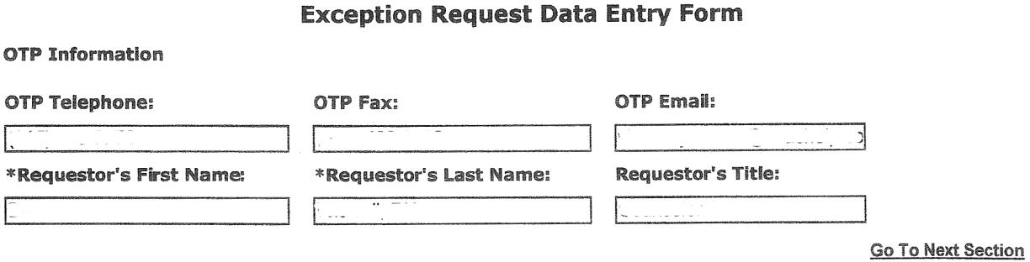

## Patient Information

This section records identifying information and the **CURRENT** protocol and status of the patient. Describe the patient’s protocol as it is prior to the change requested (see example next page).

*Patient Information Examples – Patient’s program attendance schedule per week:*

### Patient Program Attendance: Examples

Patient has one take-home per week on Friday:

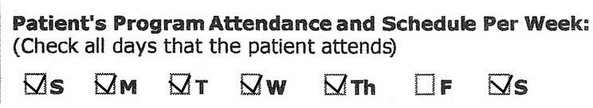

Patient has 6 take-homes per week, and comes in on Monday:

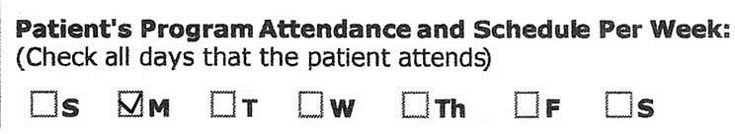

**Patient Status:** Check the item that best describes the patient; if ‘Other’, please describe the status briefly.

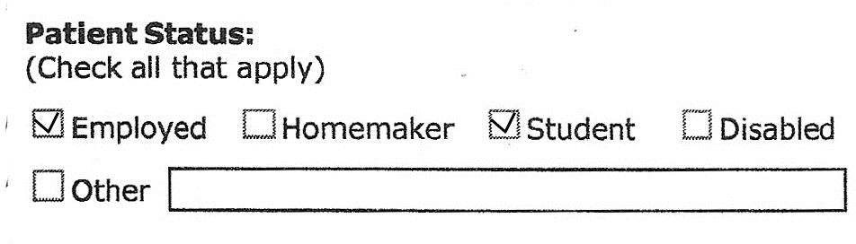

## PART TWO: REQUEST FOR CHANGE

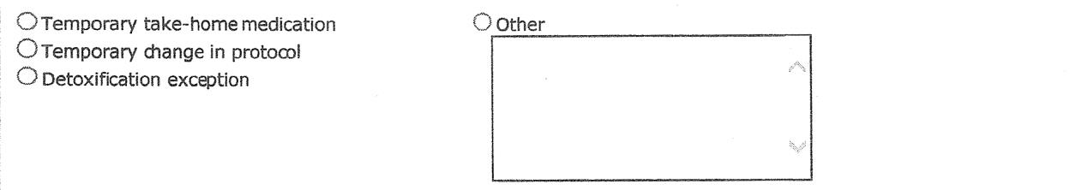

### Nature of Request:

Click on the button next to the item that best describes the reason you are asking for an exception. Exceptions may be requested for:

*Temporary take-home medication*: A one-time increase in the number of take-homes.

*Other*: If none of the above reasons apply, click on the button next to ‘Other’ and explain the reason for the request on the ‘Other’ text box. Be clear and specific. The form will expand to allow a full explanation.

**Decrease regular attendance to:** Record the attendance, as it would be under the exception. The

‘Beginning date’ and the first ‘Dates of Exception’ are the same date and refer to the first date of the exception. The ‘to’ date is the last day of the exception (the first day patient does not come to the clinic). See the examples below.

*Example:*

The patient currently has one take-home per week on Friday. The requested change is to provide three take-homes, so the patient attends clinic on Sunday, Monday, Tuesday, and Saturday, and does not come in on Wednesday, Thursday, and Friday.

The patient currently has 13 take-homes and comes in every other Thursday. The requested change is to provide an additional take-home for a day of travel at the beginning of a 14-day vacation.

**`**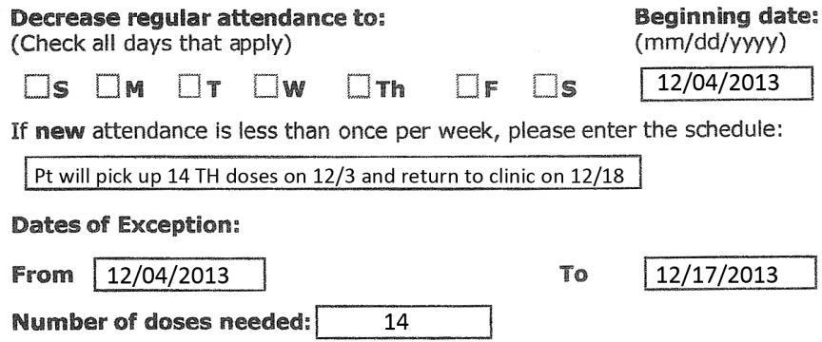

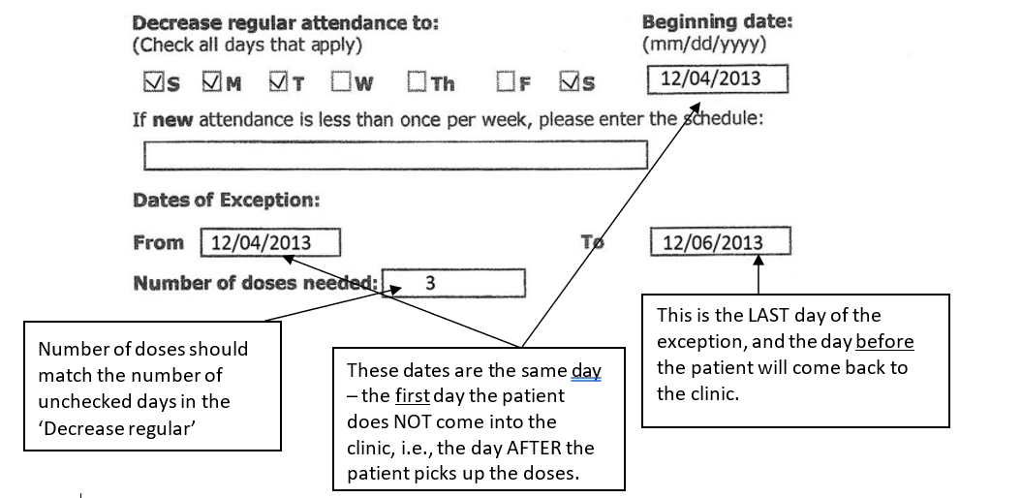

**Justification:** It is important to provide as much information as needed to fully explain the reason for the exception request. Check all items that apply. In the example below, both ‘Family Emergency’ and

‘Funeral’ is checked. Then provide detailed information in the ‘Brief Explanation’ box.

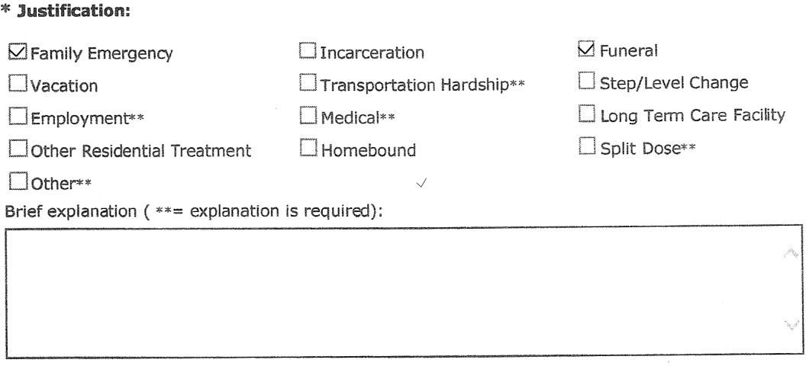

1. **DPH BSAS and SAMHSA Response – Approvals, Denials, Decision Not Required**

All exception requests must be approved by both DPH BSAS’ State Opioid Treatment Authority and SAMHSA/CSAT. In other words, if it is denied by either, it is considered denied.

A “Decision Not Required” response means that the reviewer determined that the exception request does not require an exception based on the regulations. If the response was Decision Not Required from both the State Opioid Treatment Authority and SAMHSA, this means that the submission of the request was unnecessary.

OTPs should note when submissions are not required and ensure their policies do not require the submission of unnecessary requests. OTPs must review all comments regardless of whether the request is approved or denied. These comments often contain questions or requests for additional information to which you must respond.

1. **Opioid Treatment Programs Closure Blanket Exception Request Submission**

In line with SAMHSA’s federal standard which allows OTPs to close on state and federal holidays as well as one day per week, the DPH BSAS permits OTPs to close on State and Federal holidays provided patients are given take-home dosing and/or alternative arrangements such as chain of custody take-homes or guest dosing for all days closed. Also, consistent with SAMHSA’s federal standards, the DPH BSAS is making allowances for OTPs to adjust hours of operation on either Saturday or Sunday. The program shall be open to provide treatment and to dispense medications at least six days per week, year-round, provided nothing shall limit the OTP’s ability to dispense medication for take-home use in accordance with federal and state requirements including on days the program is closed.

Please note that while the Bureau encourages programs to consider closing on holidays and supports decisions to close one day per week, this decision is within the sole discretion of the individual OTP. These considerations that follow shall be implemented as appropriate in any type of emergency closure for example severe weather or disaster-related.

1. **Permanent One-Day Weekend Closure**

Permanent one-day weekend closures do not require a blanket exception request submission. However, OTPs must receive approval from DPH BSAS before instituting the closure. Additionally, a required notification and plan that describes how all patients will be medicated on the day of the closure must be submitted.

* Please see regulations 164.315: Hours of Operation & 164.035 (D): Change of Program or Service Provision

1. **Holiday Closure**

Programs may close on Federal and State Holidays. An exception request must be submitted at least 2 business days prior to any planned holiday closure. See the blanket exception request template below.

1. **Any Type of Closure**

OTPs must have policies in place for patients who do not qualify for take-homes to receive their medication during a closure. For example, the OTP will remain open for minimal hours to medicate patients who do not receive take-homes, and/or an identified household/family member deemed stable by the program will pick up the medication for the patient through chain of custody documentation. Plans should not include sending OTP patients to the Emergency Department to receive their medication.

Please contact Jen Babich, State Opioid Treatment Authority at [Jennifer.Babich@Mass.Gov](mailto:Jennifer.Babich@Mass.Gov) and Mike Gurney, Opioid Services Coordinator at [Michael.Gurney@Mass.Gov](mailto:Michael.Gurney@Mass.Gov) should there be an urgent need to close aside from a planned event.

DPH BSAS Required Notification Form: <https://www.mass.gov/doc/health-and-safety-required-notification-form-0/download>

1. **Severe Weather / Disaster Emergency Closure**

DPH BSAS will **NO LONGER** use the Weather Emergency Notification System (WENS) to post alerts. In addition to email, if there is a major statewide emergency, and interactive communication is required, DPH BSAS staff will utilize the OTP Central Registry System to communicate directly with OTP leadership. All communication with patients should be completed within the OTP Central Registry System and alternative communication methods for patients who have not consented to participate in the OTP Central Registry System.

OTP Leadership should monitor their region’s forecast and make decisions based on the local forecast. OTPs should not wait for DPH BSAS to send an email/alert before determining if the program needs to implement its severe weather policy or program closure. Therefore, it is critical to have your OTPs Severe Weather Policy per DPH BSAS regulation 105 CMR 164.316 in place with every staff member trained in their role in implementing it when the Medical Director and leadership make the decision to do so.  Patients should also be informed regarding each OTPs status and severe weather/emergency plan.

Each OTP’s Medical Director in conjunction with the leadership team can make the decision to activate the OTP’s Severe Weather Policy.  Please be reminded that OTPs cannot decide to close without the State’s approval.  All Storm Exception Requests should be submitted within one business day after the storm event.

Please notify State Opioid Treatment Authority Jen Babich ([Jennifer.Babich@mass.gov](mailto:Jennifer.Babich@mass.gov)) and Opioid Services Coordinator Mike Gurney ([Michael.Gurney@mass.gov](mailto:Michael.Gurney@mass.gov)) however, if you are planning to implement your Severe Weather Plan or Close, and if applicable, at which of your programs.  This is not to gain approval but to inform DPH BSAS.

Storm Exception Requests must be submitted on the SAMHSA/CSAT Opioid Treatment Program Extranet within 72 hours after the event; blanket exception requests may be used. Please see the template(s) for submitting blanket exception requests in Section F.

* OTPs must have policies in place to ensure the continuation of medication for patients that may have missed the pick-up day prior to the closure, and ultimately miss two or three days of dosing due to the closure. This may include coordinating care with local OTPs and/or communicating directly with local emergency department heads.
* Patients **are required** to have a lockable container for single day take-homes and ensure that the medication is stored in a manner that is considered ‘secure’ (i.e., childproof/tamperproof container) by the program.
* All patients receiving take-home medication must be educated about and informed in writing of the dangers of accidental methadone ingestion by persons for whom it is not prescribed, especially children and animals. A patient signed acknowledgment of this information must be placed in the patient’s record.
* Staff must be available to patients who may have an emergency clinical need and the OTP must provide clear direction for patients regarding contacting the OTP for emergency purposes during the closure.
* For the closure, OTPs may grant a one-day supply of medication regardless of time in treatment for stable patients in treatment. **Programs do not have to submit individual exception requests for these patients.** Individual patient numbers of patients receiving the take-home dose do not need to be listed. However, in the comment section please provide the patient record number for those who are identified as unstable and/or on a medically supervised withdrawal (MSW) or are being inducted and indicate the arrangements for those patients.
* Programs may not dispense take-home doses that exceed federal guidelines without prior written approval from SAMHSA CSAT and DPH BSAS. Programs are responsible for submitting individual exception requests for any patient for whom the number of take-home doses allowed under these DPH BSAS holiday guidelines would exceed the amount allowed by federal and state regulations.
* Patients must be informed in a timely manner about the closure.

1. **Notification to Patients and Other Providers**

Programs that choose to close are required to provide advance notification to patients. Additionally, the operational hours and schedule shall be included in the Patient Handbook and posted. Notification should be through multiple mechanisms and ensure the most advance notice applicable to the reason for the closure. The program shall coordinate all required care including guest dosing and must ensure take-home medication is available to all patients deemed stable by the program’s medical director.

Patients identified as unstable by the Medical Director are required to be medicated face-to-face, or arrangements must be made by the program to provide medication to these patients on the day the program is closed. OTPs must have policies in place for patients deemed unstable to receive their medication during a closure. For example, the OTP will remain open for minimal hours to medicate specific patients, and/or an identified household/family member deemed stable by the program will pick up the medication for the patient through chain of custody documentation, and/or the patient will guest dose at another geographically close OTP if feasible for the patient.

Additionally, OTPs must provide notification of any planned closures to other community-based OTPs and healthcare facilities such as local hospitals and other providers within the continuum of care.

1. **Blanket Exception Request Templates**

Holiday Closure Exception Request Template:

* With prior approval from DPH BSAS, **PROGAM** **NAME & LOCATION** will be closed (DATE). The program will provide one (1) take-home dose of medication to all patients deemed stable by the treatment team on (DAY PRIOR TO CLOSURE), the day prior to the program closure. The bottle will be placed in a lockbox. (Enter the individual patient record numbers of patients who will NOT receive a take-home bottle) as they were deemed unstable by the OTP treatment team, also include the arrangements made by the OTP for them to receive their daily medication. All patients signed the take-home agreement, received education on accidental ingestion and safe storage, and were advised to return the empty bottle upon returning to the program.

Full Program Closure (Weather-Related) Exception Request:

* The **PROGAM** **NAME & LOCATION** closed on (Day, Date) for dosing during the storm. The clinic provided take-home doses to (Number) patients. All take-home doses were given with the prior approval of the SOTA. In the case of patients who did not meet the 6-point criteria and/or time in treatment criteria the Medical Director or OTP Practitioner, in consultation with the clinical team, determined that the risk posed by travel or potentially missing a dose during the storm was greater than the risk of diversion or other harm. All of the clinic patients were dosed the day of the storm (or Number) patients did not receive a dose on (date of the storm) as they did not attend the clinic.

Severe Weather / Emergency Exception Request:

* The **PROGAM** **NAME & LOCATION** remained open on (Day, Date) for dosing during the storm. The clinic provided take-home doses to (Number) patients. All take-home doses were given with the prior approval of the SOTA. In the case of patients who did not meet the 6-point criteria and/or time in treatment criteria the Medical Director or OTP Practitioner, in consultation with the clinical team, determined that the risk posed by travel or potentially missing a dose during the storm was greater than the risk of diversion or other harm. All of the clinic patients were dosed the day of the storm (or Number) patients did not receive a dose on (date of the storm) as they did not attend the clinic.

Sample Brief Explanation for a Residential Placement Exception Request:

* Per agreement between this OTP and [*name of program*], the patient will pick up 6 THs on [*specify day each week]* in the company of staff from [*name of program*]*.* On [*specify day of pick up*], the patient will be dosed at [*name of OTP*]. Six methadone doses will be placed in a locked box and will be transported back to the residential program by staff from [*name of program*] with the patient. The patient and a staff member from the residential program will sign a chain of custody for these take-homes. The patient will receive their daily methadone doses at the residential program. After each observed daily ingestion, the patient will sign that they received the dose. On [*specify day each week]* the patient will return to the OTP with the locked box with the empty methadone bottles and chain of custody form. The residential program and the patient have been made aware that if the patient leaves the program at any point in time the OTP will be notified, and a decision will be made by the OTP in collaboration with the facility regarding whether the patient will be able to take their remaining take-home bottles with them or not. Any remaining doses will be disposed of in accordance with the residential program’s policy on the disposal of medication left behind.

1. **Resources**

* [105 CMR 164: Licensure of Substance Use Treatment Programs](https://www.mass.gov/regulations/105-CMR-16400-licensure-of-substance-abuse-treatment-programs)
* [DPH BSAS Waiver from Certain Regulatory Requirements and Guidance – 42 CFR Part 8 and 105 CMR 164.000](https://www.mass.gov/doc/dph-bsas-revised-waiver-from-certain-regulatory-requirements-and-guidance-42-cfr-part-8-and-105-cmr-164000/download)
* [OTP Training and Technical Assistance (OTP TTA) – Regulatory Change Companion Guide](https://www.mass.gov/doc/otp-training-and-technical-assistance-otp-tta-regulatory-change-companion-guide/download)
* [42 CFR Part 8 Final Rule](https://www.ecfr.gov/current/title-42/chapter-I/subchapter-A/part-8?toc=1)
* T[IP 63: Medications for Opioid Use Disorder](https://store.samhsa.gov/product/TIP-63-Medications-for-Opioid-Use-Disorder-Full-Document/PEP21-02-01-002)
* [TAP 34: Disaster Planning Handbook for Behavioral Health Service Programs](https://store.samhsa.gov/product/tap-34-disaster-planning-handbook-for-behavioral-health-service-programs/pep21-02-01-001)
* [Best Practices for Take-Home Methadone in Residential Settings](https://lecturepanda.com/v2/register/ag1zfnJ4Y2V0cmFja2VychMLEgZDRVVzZXIYgIDQ4vaZlgkM/ag1zfnJ4Y2V0cmFja2VycicLEgZDRVVzZXIYgIDQ4vaZlgkMCxIHTGVjdHVyZRiAgIjbnNuFCww/new)

1. <https://www.federalregister.gov/documents/2024/02/02/2024-01693/medications-for-the-treatment-of-opioid-use-disorder>