
Data Brief:
Massachusetts Teen Pregnancy

Prevention Program, FY13

Massachusetts Department of Public Health POSTED: MAY 2016

Preventing Teen Pregnancy in Massachusetts

The Massachusetts Teen Pregnancy Prevention (TPP) program is a state-funded Massachusetts Department of Public Health (MDPH) program that funds 13 agencies in 15 communities^{i} with high teen birth rates to provide evidence-based teen pregnancy prevention curricula and youth development programming. TPP has three goals: 1) Increase youth access to evidence-based TPP programs; 2) Increase protective factors for high-risk youth in targeted communities; and 3) Reduce the incidence of teen pregnancies and births in select communities. Programming is offered in schools, community-based agencies, and foster care settings. This data brief summarizes TPP program outcomes in fiscal year 2013 (7/1/12 – 6/30/13).

Youth Served in FY13

In FY13, TPP served 1,613 youth aged 10-19 years with evidence-based TPP curricula; 805 youth in 3 or more session youth development programming; and 17,908 youth and community members in one- or two-time workshops. Programming is targeted to youth at highest risk for teen pregnancy based on recent research and teen birth rates. This includes youth in foster care, Hispanic youth, and youth in high-need geographic areas. In FY13, 11% of the youth served reported being involved with the Department of Children and Families (DCF), and 33% identified as Hispanic.

# of youth served

Figure 1: Youth Served by Evidence-Based TPP
Programs, FY09-FY13
2000
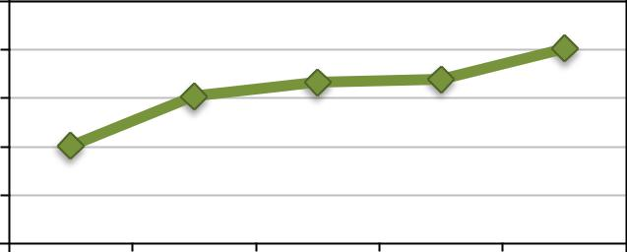

1600
1200 |  |  | 1613
800 | 1217 | 1331 | 1357

- 806

0

FY09 FY10 FY11 FY12 FY13

Protective Factors

% reporting yes

Figure 2: Since this program started, have you talked
 |  |  |  |  |  |  |  |  |  |  |  |  |  |  |  |  | Pre
about any of these topics with an adult you trust....?* |  |  |  |  |  |  |  |  |  |  |  |  |  |  |  |  | Post
60%
60% |  | 46% |  |  |  | 40% |  |  |  |  |  |  |  | 43%
40% |  | 25% |  |  |  | 25% |  |  |  |  | 23%
20%
0%
 |  | Birth control |  |  |  |  | Readiness for a |  |  |  |  | How to talk to a
 |  | methods available |  |  |  |  | sexual relationship |  |  |  |  | partner about sex

Protective factors, such as positive family dynamics, connection with a trusted adult, and connectedness to school and community, are associated with decreased sexual risk behaviors.^{ii} In FY13, there was an increase in the percentage of youth reporting having an adult to talk to about a problem over the course of TPP programming (p<0.01). There were also increases in the percentages of youth reporting talking to a trusted adult about sexual health-related topics (Figure 2).

*Data is from matched pre and post surveys (n=1,162). Pre to post changes were tested using McNemar’s paired chi-square test; p<.0001 for all data presented.

Sexual Health: Knowledge & Attitudes

High percentages of youth in the TPP program reported that the program helped them learn to set limits on their sexual behavior, talk to sexual partners about birth control, prevent sexually transmitted infections (STIs), and prevent pregnancy (Figure 3). Over the course of the program, there was a 7% absolute increase in the percentage of youth reporting that they would use a birth control method all or most of the time if they were sexually active (compared to some or none of the time; McNemar’s paired chi-square test, p=0.05).

Figure 3: This program helped me to....*

Learn about preventing STIs and
Learn about preventing STIs and |  |  |  |  |  |  |  |  |  |  | 93%
pregnancy
Learn how to talk to my sexual
partner(s) about birth control |  |  |  |  |  |  |  |  |  |  | 87%
choices
Better understand how to set limits
Better understand how to set limits |  |  |  |  |  |  |  |  |  |  | 93%
on my sexual behavior
0% |  | 20% |  |  | 40% |  |  | 60% |  |  | 80% |  |  |  | 100%

% reporting strongly agree or agree

*Data is from post surveys (n=1,714) | 1

Sexual Behavior

Twenty percent (20%) of TPP program participants were sexually active at program intake, defined here as having reported participating in sexual activity in the past three months.^{iii} Among sexually active youth, 79% reported having vaginal intercourse in the past 3 months. When asked about their last sexual encounter, 64% of sexually active youth reported using a condom. Eighty-one percent (81%) of youth who had engaged in vaginal intercourse in the past 3 months reported using a birth control method. There was a non-statistically significant increase in the use of a short-acting hormonal birth control method (McNemar’s paired chi-square test; p=0.09) among youth reporting vaginal intercourse over the course of the program (Figure 4). There were no changes in condom use over the course of the program.

Teen Births in Massachusetts
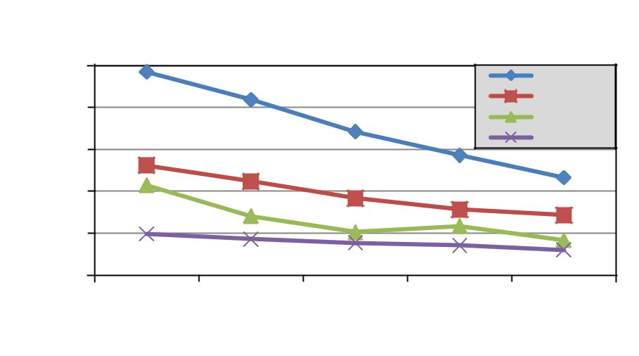

 | Figure 4: Percentage of Sexually Active Youth
 | Using a Short-Acting Hormonal Birth Control
50% |  |  | Method*, TPP Participants, FY13
 |  |  |  |  |  |  |  | 49%
40%
40% |  |  |  | 43%
30%
 |  |  |  | Pre |  |  |  | Post

*Data is from matched pre and post surveys of youth reporting sexual activity in the past 3 months (n=136). A short-acting hormonal method is defined here as birth control pills, the vaginal ring, or an injectable such as Depo-Provera.

Birth rate per 1,000 women

Figure 5: Birth Rates among Women aged 15-19 years,

MA and Select TPP Communities, 2009-2013
100 | 96.8 |  |  |  | Holyoke
80 |  |  |  |  | Lowell
80 |  |  |  |  | Taunton
60 |  |  |  |  | MA
60 | 52.3
 | 52.3 |  |  |  | 46.4
40 | 42.9 |  |  |  | 46.4
40 | 42.9 |  |  |  | 28.6
20 | 19.6 |  |  |  | 16.6
0 |  |  |  |  | 12
 | 2009 | 2010 | 2011 | 2012 | 2013

*Source: Registry of Vital Records and Statistics, MDPH

During the 5-year period 2009-2013, the Massachusetts teen birth rate decreased by an average of 11.1% per year, reaching an historic low of 12.0 births per 1,000 women aged 15-19 years in 2013. All TPP-funded communities saw a statistically significant declined in teen birth rates during this period. Holyoke, Taunton, and Lowell in particular saw pronounced decreases in their teen birth rates (Figure 5). The average annual decrease in teen birth rates in TPP-funded communities ranged from 3.7% in Southbridge to 18.8% in Taunton.

Despite the decline in teen birth rates in Massachusetts over the past decade, there continue to be disparities in teen birth rates by race/ethnicity, geography, foster care status, and sexual orientation. In 2013, the MA Hispanic teen birth rate was nearly 7 times the White non-Hispanic rate. These disparities by race/ethnicity also exist in TPP-funded communities (Figure 6). The average annual percent decrease in Hispanic teen birth rates in the TPP-funded communities of including Springfield, Holyoke, Lawrence, Lynn, and Lowell ranged from 14%-18% from 2009-2013. The statewide Hispanic teen birth rate decreased by an average of 9% per year during the same period.

Method Notes:

Birth Rate per 1,000 women

Figure 6: Birth Rates by Select Race/Ethnicity among Women aged 15-19 years, MA and Select TPP Communities, 2013

70
60 |  |  | 65.5 |  |  |  |  |  |  |  |  |  |  |  | Hispanic
60 |  |  | 65.5 |  |  |  |  |  |  |  |  |  |  |  | White non-Hispanic
50
50 |  |  |  |  |  |  |  | 50.9
40 |  |  |  |  |  |  |  | 50.9
40 |  |  |  |  |  |  |  | 50.9 |  |  |  |  | 45.8
40 |  |  |  |  |  |  |  |  |  |  |  |  |  |  |  |  |  |  |  | 40.8
30 |  |  |  |  |  |  |  |  |  |  |  |  |  |  |  |  |  |  |  | 40.8
20
10 |  |  |  |  |  |  |  |  |  |  |  |  |  |  |  | 18.6
10 |  |  |  | 13.1 |  |  |  |  | 12.5
0 |  |  |  | 13.1 |  |  |  |  | 12.5 |  |  |  |  |  |  |  |  |  |  |  | 6.1
 |  | Springfield |  |  |  |  | Worcester |  |  |  |  |  | Lawrence |  |  |  |  |  |  | MA

*Source: Registry of Vital Records and Statistics, MDPH

Program data presented is from pre and post-surveys completed by youth who participate in evidence-based and 3 or more session TPP programming. The average time elapsed between pre and post survey was 2-3 months, but can range from 1 week to 9 months. All pre to post changes were measured using McNemar’s paired chi-square test using only matched pre and post surveys; surveys are matched using a unique code. Data on teen birth rates is from the Registry of Vital Records and Statistics, MDPH. Average annual percent changes in teen birth rates were calculated using Joinpoint Regression Program, Version 4.1.1.1. October 2014; Statistical Research and Applications Branch, National Cancer Institute. All changes reported are statistically significant at p<0.05 unless otherwise noted; bias in p-values may occur with a larger sample size.

- Communities funded by MDPH for TPP include: Brockton, Chelsea, Chicopee, Everett, Fall River, Fitchburg, Holyoke, Lawrence, Lowell, Lynn, New Bedford, Southbridge, Springfield, Taunton, and Worcester

- Kirby, D. (2007). Emerging Answers 2007: Research Findings on Programs to Reduce Teen Pregnancy and Sexually Transmitted Diseases. Washington, DC: National Campaign to Prevent Teen and Unplanned Pregnancy
- Data is taken from matched pre/post surveys only (n=1,162) and excludes youth who completed a pre-survey but did not complete a post-survey.

2

