The Commonwealth of Massachusetts
Executive Office of Health and Human Services
Department of Public Health
Bureau of Health Care Safety and Quality
Division of Health Care Facility Licensure & Certification
67 Forest Street, Marlborough, MA 01752
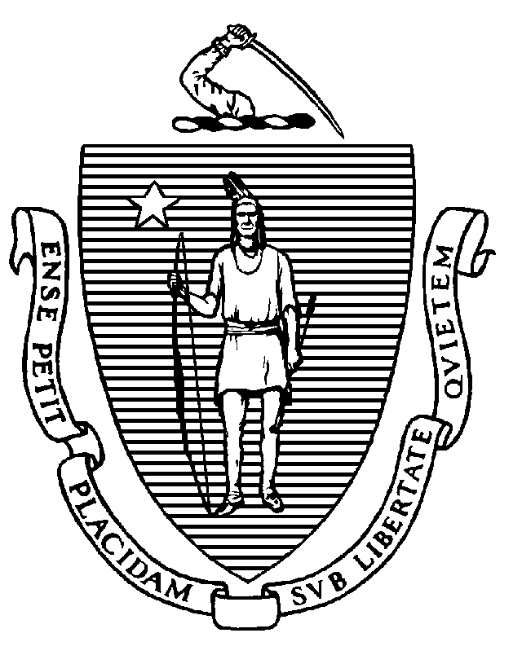

MARYLOU SUDDERS
Secretary
MONICA BHAREL, MD, MPH Commissioner

Tel: 617-624-6000
www.mass.gov/dph

CHARLES D. BAKER
Governor
KARYN E. POLITO
Lieutenant Governor

January 25, 2021

Andrew S. Levine, Esq.
Summit Health Law Partners
One Beacon Street, Suite 1320
Boston, MA 02108
ALevine@summithealthlawpartners.com

BY EMAIL ONLY

Re: Essential Services Finding
Facility: Newton-Wellesley Hospital
Ref. #: 2075-776

Dear Attorney Levine:

On November 9, 2020, the Department of Public Health (the “Department”) received a notice from you regarding Newton-Wellesley Hospital’s (the “Hospital”) intent to reduce the number of inpatient Pediatric beds by twelve (12) at Newton-Wellesley Hospital in Newton, MA. A public hearing was held via teleconference on January 13, 2021.

Following the hearing and review of information presented, the Department has determined, pursuant to 105 CMR 130.122(E), the twelve (12) inpatient Pediatric beds the Hospital intends to remove from its license are not necessary for preserving access and health status in the Hospital's service area. The Department has based this finding on information presented that, after the reduction, the Hospital will retain a twelve (12) bed inpatient Pediatric unit. The Department also bases this finding on information presented that, over the previous four years, the average daily census has remained under 7 out of 24 licensed beds.

The Hospital may proceed with its plans to reduce the number of inpatient Pediatric beds by twelve (12) on or before March 14, 2021. Please notify the Department of the actual reduction date when that occurs.

Thank you for your continued cooperation in this process. If you have any questions, please contact me at Sherman.Lohnes@Mass.Gov.

Sincerely,

Sherman Lohnes
Director

cc: R. Rodman, DPH
M. Callahan, DPH
W. Mackie, DPH

