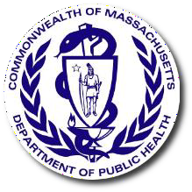

DPH BSAS Q1 Opiate Report Slides 5-14-2021

Preliminary data show 507 confirmed and estimated opioid- related overdose deaths in the first three months of 2021, an estimated 2% increase compared with the same period in 2020.
Figure 1. Opioid-Related Overdose Deaths, All Intents by Month
Massachusetts Residents: October 2019- March 2021
250

200
3
5
4
7
4
4
5
150
6
27
2
79
100
176
171
191
210
176
183
173
146
141
156 150
50
86
0
Oct
Nov
Dec
Jan
Feb
Mar
Apr
May
Jun
Jul
Aug
Sep October November December Jan
11
Feb
2
Mar
2019 2020 2021
1

153
1

155

168

177

183

185
Confirmed Estimated
Number of Deaths

Estimated 498 deaths Estimated 507 deaths

The rate of opioid-related overdose deaths has increased 5% in 2020 compared with 2019 and is 1% lower than the 2016 peak.

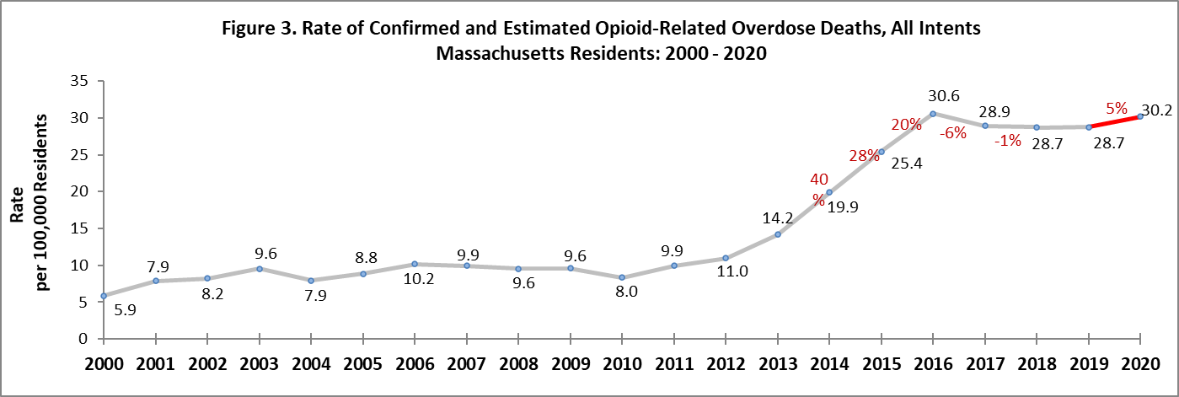

Fentanyl remains a key factor in opioid-related overdose deaths (92% present in toxicology screen in 2020).
Figure 4. Percent of Opioid-Related Overdose Deaths with Specific Drugs Present
Massachusetts Residents: 2014 - 2020
100
90
80
70
60
50
40
30
20
10
0
1 2 3 4 1 2 3 4 1 2 3 4 1 2 3 4 1 2 3 4 1 2 3 4 1 2 3 4
2014
2015
2016
2017
2018
2019
2020
Year and Quarter
Fentanyl¹ Likely Heroin
Prescription Opioid² Benzodiazepine Cocaine
Amphetamine3
Percent

Between 2019 & 2020, the confirmed opioid-related overdose death rates for Black non-Hispanic men increased significantly at 69%.

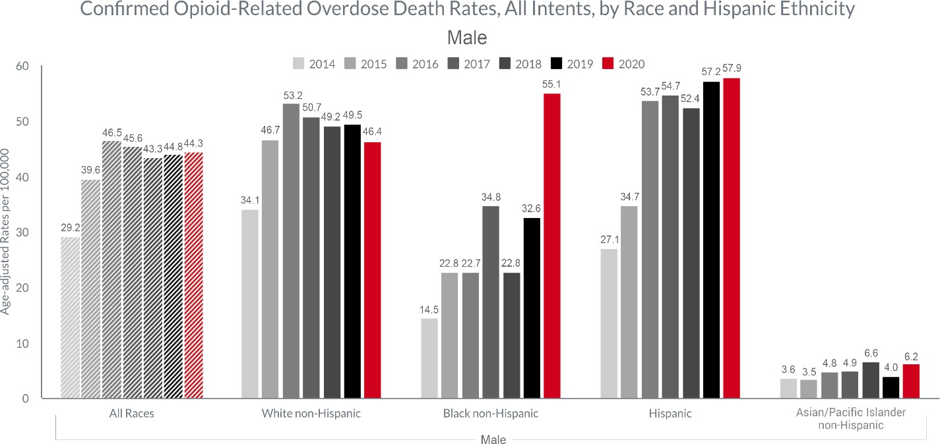

DPH/BSAS is implementing new investments to enhance treatment and recovery support, particularly in communities of color
- BSAS is dedicating a significant portion of supplemental funding from SAMHSA’s Substance Abuse Prevention & Treatment Block Grant towards addressing racial equity, including:
  - Increasing behavioral healthcare workforce diversity, recruitment, and retention through workforce development initiatives
  - Funding community-led programming in communities of color through grant making and support for increasing community-based organizations’ ability to contract with the Commonwealth
  - Increasing the number of culturally-specific programs across the continuum of prevention, outreach/engagement, treatment, and recovery support services
  - Increasing investments in pre-arrest diversion/co-response models, in order to divert people with SUD from the criminal justice system, in partnership with the Department of Mental Health
  - Increasing funding for low-threshold housing/housing first models in Suffolk County, with program expansions expected in Merrimack Valley, Springfield, and Worcester to address communities in need

DPH/BSAS addresses health and racial equity by continuing

and enhancing existing programs
- Current BSAS programs dedicated to addressing overdoses in the Black/Latinx community include:
  - Recovery-Based Re-Entry Services for Black and Latino Men, a pilot program for Black and Latino men leaving incarceration that will be provided by the following agencies:
ꟷ Fathers’ Uplift
ꟷ Casa Esperanza
ꟷ Legendary Legacies
ꟷ New North Citizens’ Council
ꟷ Greater Lawrence Family Health Center/Lynn Community Health Center
  - Increased investments in the Black Addiction Counselor Education (BACE) and Latinx Addiction Counselor Education (LACE) programs to support Black and Latinx people seeking to enter the SUD workforce

- BSAS is also partnering with other existing culturally-specific agencies/programs in the Commonwealth to expand their services and provide increased access for communities of color

DPH/BSAS has aggressively maximized access to SUD treatment during the COVID-19 pandemic, and is continuing the fight against the opiate crisis
- Increasing access to naloxone – from March 2020 to April 2021 over 110 thousand naloxone kits have been distributed to Opioid Treatment Providers (OTP), Syringe Service Programs, community health centers, hospital emergency departments, and county Houses of Correction.

- Implementing a new standing order for naloxone allowing providers/organizations such as first responders, co-response/jail diversion teams, criminal justice personnel, and health and human services workers (such as those in homeless shelters, drop-in centers, and soup kitchens) to give naloxone to individuals at risk and their friends/family.

- Obtaining a blanket exception from SAMHSA on behalf of Massachusetts Opioid Treatment Programs (OTP) for take home doses of MOUD. As of December 2020, 48.5% of OTP patients are receiving take home doses, compared to the pre-COVID average of 15.6% in December 2019.

- Implementing the broad adoption of a DEA waiver allowing prescriptions for buprenorphine and naltrexone to patients for whom providers have conducted telehealth sessions, as well as induct patients on buprenorphine and naltrexone.

- Reimbursing contracted Office Based Opioid Treatment (OBOT) providers for cell phones and data plans to maintain patients’ ability to keep in contact with their providers for telehealth.

- Establishing COVID+ ATS and CSS units to facilitate positive patient transfers and maintain capacity within the rest of the treatment system.

- Leveraging the second round of State Opioid Response (SOR) funding from SAMHSA to increase access in Massachusetts to all FDA-approved forms of MOUD, reduce unmet treatment needs, and reduce opioid/stimulant misuse and overdose.

- Working with programs to prevent and mitigate the spread of COVID-19, including distributing guidance on surveillance testing, screening and isolation of patients/staff, and increased flexibility in bed allocation between different service settings to accommodate changing patient needs at individual programs.

