The Commonwealth of Massachusetts

Executive Office of Health and Human Services

Department of Public Health

Bureau of Health Care Safety and Quality

99Chauncy Street, Boston, MA 02111



CHARLES D. BAKER

Governor

KARYN E. POLITO

Lieutenant Governor

MARYLOU SUDDERS

Secretary

MONICA BHAREL, MD, MPHCommissioner

**Tel: 617-624-6000**

**www.mass.gov/dph**

April 25, 2016

Steven T. James

House Clerk

State House Room 145

Boston, MA 02133

William F. Welch

Senate Clerk

State House Room 335

Boston, MA 02133

Dear Mr. Clerk,

Pursuant to Section 24A(k) of Chapter 94C of the Massachusetts General Laws and Section 37 of Chapter 28 of the Acts of 2014, please find enclosed a report on the Prescription Monitoring Program from the Department of Public Health.

Sincerely,

Monica Bharel, MD, MPH

Commissioner

Department of Public Health



**Prescription Monitoring Program**

**Annual Report**

**April 2016**

**Legislative Mandate**

The following report is hereby issued pursuant to Section 24A(k) of Chapter 94C of the Massachusetts General Laws, and Section 37 of Chapter 258 of the Acts of 2014.

Section 24A(k) of Chapter 94C of the Massachusetts General Laws reads as follows:

*The department shall submit an annual report on the effectiveness of the prescription monitoring program with the clerks of the house and senate, the chairs of the joint committee on public health, the chairs of the joint committee on health care financing and the chairs of the joint committee on public safety and homeland security.*

Section 37 of Chapter 258 of the acts of 2014reads, in relevant part, as follows:

*The department of public health shall submit a report, not later than January 4, 2016, to the clerks of the house and senate, who shall forward the report to the house and senate committees on ways and means, the joint committee on health care financing and the joint committee on mental health and substance abuse. The report shall include, but not be limited to, the following information: an analysis of whether practitioners are using the prescription monitoring program prior to prescribing drugs contained in schedule II; the number of violations of law or breaches of professional standards that were referred to law enforcement or a professional licensing, certification or regulatory agency or entity, under 105 CMR 700.012 (D) (5)(a), between November 2, 2014 and December 15, 2015; the type of violations of law or breaches of professional standards that were referred to an outside entity between November 2, 2014 and December 15, 2015; the outcome of the referrals; recommendations about how to improve the use of prescription monitoring program’s data to prevent prescription drug abuse and the diversion of prescription drugs; and an explanation of how the department has improved its use of the prescription monitoring program’s data over the past year.*

**Executive Summary**

The Massachusetts Prescription Monitoring Program (PMP) was established through joint regulations of the Department of Public Health’s (Department) Office of Prescription Monitoring and Drug Control (OPMDC) and the Board of Registration in Pharmacy (BORP) in 1992. The OPMDC launched an online version of the PMP (MA Online PMP) in 2012, using state appropriations and grants from the Bureau of Justice Assistance (BJA).

Nationwide, PMPs are important tools to support safe and appropriate prescribing. Information provided by PMPs help prescribers and pharmacists identify individuals who maybe misusing, abusing, or diverting prescription controlled substance and may need intervention, such as a treatment referral.

The PMP collects prescribing and dispensing information on Schedule II through V controlled substances dispensed by Massachusetts pharmacies and out-of-state pharmacies that deliver to Massachusetts residents. The PMP provides critical information to prevent and detect the misuse, abuse and diversion of prescription drug products, which affect public health and safety. Data in the PMP can be queried by authorized health care providers for use as a clinical tool and has improved prescriber and pharmacist access to necessary patient information for timely intervention of at-risk patients. Additionally, PMP data are also used by law enforcement and regulatory agencies as a tool in active cases against patients, prescribers, and dispensers.

During CY 2015, the Department concentrated its efforts on increasing enrollment in the MA Online PMP. The OPMDC continued automatic enrollment of practitioners and began automatic enrollment of mid-level prescribers (e.g., advanced practice nurses and physician assistants) in the MA Online PMP. In addition, the OPMDC implemented procedures to assist teaching facilities in enrolling medical residents. The Department also worked on initiatives to improve the timeliness of the data collected in the MA Online PMP, including mandating the 24 hour/next business day reporting of PMP data by pharmacies in the MA Online PMP.

The Department is committed to continuing to improve the PMP and MA Online PMP and increasing utilization. One of the most significant initiatives to improve prescriber utilization is the implementation of a new online PMP system. This new system, which is currently in development, will include an improved user-friendly interface, interoperability with online PMP systems in other states, and integration with electronic medical record systems.

**Introduction**

The Office of Prescription Monitoring and Drug Control (OPMDC), within the Department of Public Health’s (Department) Bureau of Health Care Safety and Quality (BHCSQ) is pleased to submit this report on the effectiveness of the Prescription Monitoring Program (PMP), in accordance with Section 24A(k) of Chapter 94C of the Massachusetts General Laws and Section 37 (paragraph 2) of Chapter 258 of the Acts of 2014, which require the following information:

1. *An analysis of whether practitioners are using the prescription monitoring program prior to prescribing drugs contained in schedule II;*
2. *The number of violations of law or breaches of professional standards that were referred to law enforcement or a professional licensing, certification or regulatory agency or entity, under 105 CMR 700.012(D)(5)(a) between November 2, 2014 and December 15, 2015;*
3. *The type of violations of law or breaches of professional standards that were referred to an outside entity between November 2, 2014 and December 15, 2015; the outcomes of the referrals;*
4. *Recommendation about how to improve the use of the prescription monitoring program’s data to prevent prescription abuse and the diversion of prescription drugs;*
5. *An explanation of how the department has improved its use of the prescription monitoring data over the past year.*

**Prescription Monitoring Program**

**Practitioner use of the PMP prior to prescribing drugs contained in schedule II.**

Chapter 258 of the Acts of 2014 requires this report to include “an analysis of whether practitioners are using the prescription monitoring program prior to prescribing drugs contained in Schedule II.” A registered individual prescriber (physician, dentist, podiatrist, nurse practitioner, or physician assistant) must utilize the MA Online PMP prior to prescribing a narcotic prescription drug in Schedule II to a patient for the “first time.”[1] “First time” refers to patients who have not received a narcotic prescription drug in Schedule II from a registered individual practitioner, or another authorized prescriber in the same group practice, within the previous 12 months.

Registered individual practitioners are required to utilize the MA Online PMP when prescribing a Schedule II narcotic for the first time. Therefore, although encouraged as a best practice, prescribers are not required to conduct a patient look up for every narcotic prescription written. Additionally, the requirements to check the MA Online PMP became effective in January 2015, and it is expected to take some time for prescribers to become educated and aware of this requirement. Based on these factors, the percent of prescribers who have conducted at least one patient search during CY 2015, utilization of the MA Online PMP may be less than initially expected.

Appendix A (Figures 1 and 2) provides information pertaining to prescribers who have prescribed a Schedule II opioid in Calendar Year (CY) 2015. The analysis is broken out into 6-month time periods to assess whether there has been any notable increase in MA Online PMP utilization during the second half of 2015 compared to the first half, as the requirement requiring individual practitioners to utilize the MA Online PMP when prescribing a Schedule II narcotic for the first time went into effect in January 2015. This analysis excludes other “non-opioid” Schedule II drug products because prescribers are not required to use the MA Online PMP when prescribing “non-opioids” within Schedule II. Additionally, because the above noted requirements for using the MA Online PMP did not go into effect until January 1, 2015, Schedule II prescription data reported to the MA Online PMP in November and December 2014 are excluded.

Additionally, data presented in Appendix A show that individual practitioners that prescribe the most Schedule II opioids (i.e., 200 or more Schedule II opioid prescriptions) have higher usage of the MA Online PMP than those prescribers who prescribe fewer than 50 Schedule II opioid prescriptions during the same time period. The overall percentage of prescribers who have conducted at least one patient search has essentially remained the same from January through June 2015, as compared with July through December 2015. It is expected that with continuing communication and provider education, MA Online PMP utilization rates will increase over time.

It is important to note that there is limited audit functionality in the system to identify which prescribers comply with the requirement to check the MA Online PMP prior to prescribing a Schedule II narcotic for the first time. The information presented in this report is the best available proxy for identifying whether prescribers who are supposed to use the system are doing so in accordance with state regulations.

**Number and type of violations of law or breaches of professional standards referred to law enforcement or a professional licensing, certification or regulatory agency or entity, including outcome.**

Chapter 258 of the Acts of 2014 requires the Department to report on the number of violations of law or breaches of professional standards that were referred to law enforcement or a professional licensing, certification or regulatory agency or entity, under 105 CMR700.012(D)(5)(a) between November 2, 2014 and December 15, 2015.

Massachusetts Controlled Substance Registration (MCSR):

In order to provide accountability for controlled substances, Massachusetts General Laws, Chapter 94C, Section 7 and regulations of the Department of Public Health at 105 CMR 700.004 require every person who manufacturers, distributes, prescribes, administers, dispenses or possesses controlled substances to be registered with both the Department of Public Health, referred to as the Massachusetts Controlled Substance Registration (MCSR) and federal Drug Enforcement Administration for controlled Substances in Schedules II-V. In addition, Massachusetts law recognizes those prescription drugs that are not federally scheduled (Schedule VI) as controlled substances. The OPMDC is also responsible for automatically enrolling a person who obtains or renews an MCSR as a participant in the PMP. In some cases, it may be necessary to take action to revoke, suspend or not renew an individual practitioner’s MCSR. Upon receipt of notification that a board of registration has suspended or revoked a registrant’s authorization to practice, the OPMDC refers the case to the PMP Medical Review Group (MRG), and an investigation is conducted in accordance with the standards set forth in 105 CMR 700.105 through 700.120. Depending on the outcome, the OPMDC will move to suspend, terminate or refuse to renew the MCSR, including co-incidental activities and enrollment in the PMP.

PMP Medical Review Group:

The MRG was established under 105 CMR 700.012(C) by the Department of Public Health Commissioner to advise OPMDC in the evaluation of prescription information and clinical aspects of the implementation of the PMP. The MRG consists of prescribers and dispensers who review information on prescribing patterns, dispensing patterns and prescription drug product usage data. Individually, the current members have extensive clinical backgrounds in dentistry, medicine and pharmacy. Their combined experience makes this an expert group on prescription drug prescribing and dispensing in Massachusetts.

In addition to the information on prescribers it may receive from a board of registration, the OPMDC reviews PMP data to present case information to the MRG on prescribers (physicians, dentists, podiatrists, nurse practitioners, physician assistants, nurse midwives) and dispensers (pharmacies) that have been identified by the Department based on the prescription data relative to other similar practitioners. For example, the Department may present the prescription data for an orthopedic surgeon to the MRG after comparing it to another orthopedic surgeon (if possible within the same approximate geographic area) and finding aberrations in prescribing practices.

As part of its investigation of the prescriber and/or dispenser, the MRG reviews case data and information as compiled by the OPMDC, including:

* Prescriber time-period comparisons for total prescriptions issued and individual drug products;
* Prescription data for two time periods that are compared – a previous time period (e.g., January 1 through March 31) compared to a current time period (e.g., June 1 through August 31).

When comparing the prescription data for similar practitioners, the MRG utilizes the following data:

* Total Number Prescriptions – Numerical and percentage change
* Total Quantity/Doses – Numerical and percentage change
* Average Quantity per Prescription – Numerical and percentage change
* Average Quantity per individual drug product (usually as generic drug product)
* A report with twelve-month totals (if available) for all prescriptions and individual drug products

The prescription data are mapped according to the zip code of the dispensing pharmacy and/or of the patient. A summary of prescriptions with totals for each drug product, total number of unique patients who were dispensed that drug product, and either the total number of prescribers or pharmacies per drug product are analyzed.

A spreadsheet of a sample time period for de-identified patients with columns for drug, quantity, number of days of supply, date prescription written, date prescription dispensed, prescriber, prescriber city, pharmacy, pharmacy city, is most commonly sorted on the date the prescription is written. Other fields that may be included in the spreadsheet are method of payment, customer, and relationship of customer to patient.

Additionally, the MRG obtains information on the individual being reviewed from the PMP and may also query specific boards of registration websites when appropriate (for example, the Board of Registration in Medicine includes specialty, board certifications, date license issued, practice address and other information). Specific information from the PMP database may be used to provide additional perspective regarding prescribing activity of the individual relative to his or her peers.

Based upon its findings, the MRG advises the OPMDC on whether a case should be referred to the appropriate board of registration or federal regulatory authority. The MRG’s recommendations are based on comparative analysis of prescription data and other information. Based on experience and knowledge, the MRG and PMP staff may also identify data trends for prescribers or dispensers that are outliers.

Case Referral:

From November 2, 2014 to December 15, 2015, the MRG reviewed 26 cases. Ten cases were referred to the Massachusetts Boards of Registration in Medicine or Nursing pursuant to MRG recommendation. Fifteen cases were found by the MRG to be consistent with the practitioner’s area of practice or within the acceptable needs of appropriate medical care. One case was referred by OPMDC to law enforcement.

Once referrals are made, law enforcement and the Boards conduct their own investigation into the cases referred to them. In order to maintain a separation between data collection and regulatory enforcement, OPMDC does not receive information from these agencies pertaining to the outcome of the investigation, and therefore, is unable to report on the Boards’ subsequent findings.

**How can PMP data be better utilized to prevent prescription abuse and the diversion of prescription drugs?**

Utilization of the PMP can assist in identifying potential prescription drug misuse, abuse, and diversion while helping to ensure that patients who need these medications have access to them. In 2016, the OPMDC began developing and analyzing reports that look at patients being treated with both an opioid and a benzodiazepine. Benzodiazepines are minor tranquilizers, such as Valium® or Ativan® that act against anxiety and convulsions and produce sedation and muscle relaxation. Benzodiazepines are commonly used to treat anxiety and insomnia and are often co-prescribed for patients who receive high doses of opioid analgesics used to treat pain.

Patients treated with opioids for pain, who also receive benzodiazepines, face an increased risk of death from drug overdose. One recent study, co-authored by researchers from the School of Public Health, Brown University, and the Department of Veterans Affairs, found that receipt of concurrent benzodiazepines was associated with an increased risk of overdose deaths in a large, national sample of Veterans who were taking opioid analgesics.[2]

This type of higher-risk, poly-drug use will be monitored by the PMP. Data reported to the PMP will be used to analyze overlapping opioid and benzodiazepine prescriptions. The OPMDC has recently enhanced its data mining capacity and will be able to generate prescription reports that identify individuals who have received controlled substance prescriptions for multiple specified drug categories (e.g., opioids and benzodiazepines) during a specified time period.

Additionally, the Department has improved the utilization of PMP data by amending regulation requiring that pharmacies submit information to the PMP every 24-hours and is currently exploring the addition of other drugs for reporting to the PMP that might pose a potential health risk to the public, such as Gabapentin. Efforts are also underway to incorporate prescription information into the PMP from the Veteran’s Administration pharmacies within the Commonwealth.

**How has the Department improved its use of PMP data over the past year?**

Over the past year, the PMP has made a number of improvements in both the data reported to the PMP and the access to the MA Online PMP that will continue to significantly benefit end users of the system.

Pursuant to a legislative mandate in Section 89 of the Fiscal Year 2016 General Appropriation Act,[3] a significant change in the reporting frequency of PMP data from pharmacies was implemented, requiring 24 hour/next business day reporting of PMP data. Prior to November 2015, pharmacies were required to submit all controlled substances in Schedules II-V on a weekly basis. These new requirements enable providers to obtain more current data for their patients.

The Department has also made improvements in the ability to access the MA Online PMP by end users For the past three years, the Department has automatically enrolled all practitioners (includes physicians, dentists, and podiatrists) and for the past year, has automatically enrolled all mid-level prescribers (includes advanced practice nurses and physician assistants).

The OPMDC also initiated enrollment of “delegates” to the MA Online PMP. A delegate is able to conduct patient searches in the MA Online PMP on behalf of a practitioner who is the licensed primary account holder. The role of the delegate is limited to accessing patient prescription histories from the MA Online PMP on behalf of a licensed primary account holder. A delegate user of the MA Online PMP cannot monitor, review or interpret prescription history reports. Licensed primary account holders must monitor delegate use of the prescription monitoring program and inform the Department when a delegate has violated the Delegate User Terms and Conditions or is no longer authorized by the primary account holder to be a delegate within one business day of such violation or loss of authorization. This change is significant as it allows for the delegate to gather timely PMP information for practitioners, who otherwise may not have the time to access the prescription histories of patients.

Table 1 in Appendix B shows MA Online PMP enrollment of providers and delegates through December 31, 2015.

Enrollment of Residents and Interns

In an effort to address the need and growing demand for medical residents to gain access to the MA Online PMP, the OPMDC developed a Resident Enrollment Packet and an expedited data submission process for resident teaching facilities to get their medical residents enrolled.

The OPMDC began receiving information from facilities for entry into the PMP in December 2015. Expanding PMP access to residents and interns is an important tool in their medical education as they learn how to utilize the PMP when caring for their patients. By starting to use this critical information as medical residents, it will prepare them for regular use once they are a licensed prescriber.

New MA Online PMP System

In December 2015, Governor Charles Baker announced the planned development of a new online PMP system. This initiative is guided by the Administration’s commitment to improving the performance, access and usability of this critical system in the midst of the ongoing opioid crisis. The necessity for a more efficient MA Online PMP system was highlighted as one of Governor Baker’s Opioid Working Group’s recommendations earlier in 2015.

To begin the process of procuring a vendor to develop the new system, the Department, in collaboration with the Executive Office of Health and Human Services (EOHHS), engaged stakeholders to determine what the new system needed to include in order to make it more efficient and effective. Following this engagement, EOHHS, on behalf of the Department, issued a Request for Responses (RFR) for a new Prescription Monitoring Program (PMP) system to replace the current MA Online PMP on July 10, 2015. Responses were due by August 17, 2015 and were evaluated by the PMP Strategic Sourcing Team (SST). Following this review, in December 2015, the Commonwealth entered into a contract with Appriss, Inc., an established online PMP software vendor, to provide a new system for the MA Online PMP.

The new MA Online PMP system will include, at a minimum, the following:

* An improved user-friendly interface and faster access to reports;
* Interoperability with other states’ online PMP systems, permitting prescribers to check whether their patients are receiving prescriptions in other states;
* Integration to link with the Commonwealth health providers’ electronic medical record systems to ensure safe prescribing; and
* Efficient onboarding for users including prescribers, delegates, residents and interns, and pharmacies and dispensers.

The Administration remains committed to ensuring that prescribers have the tools they need to prevent patients from being overprescribed or from the misuse of opioids by obtaining prescriptions from multiple providers. It is anticipated that the new PMP will go live by summer 2016.

**Conclusion**

The Prescription Monitoring Program is a critical tool to combat the opioid crisis in the Commonwealth. Over the past years, the Department has been focused on increasing enrollment of practitioners and has expanded access to medical residents and delegates. The goal of this work is to ensure that prescribers have access to a patient’s prescribing history to avoid overprescribing or contributing to the misuse of opioids.

Moving forward, the Department is focused on improving the MA Online PMP to make it more user-friendly and improve the interoperability with other states’ systems and health providers’ electronic medical record systems. These improvements will help to provide more timely access to obtaining and submitting information for users of the system. The Department is also examining ways to review data to identify trends and misuse amongst prescribers.

The Department wishes to thank the Legislature for its ongoing support of the Prescription Monitoring Program. Legislative support has been instrumental in achieving significant improvements in the administration, operations and services of OPMDC and in ensuring that the PMP is able to fulfill its important mission of protecting the health and safety of patients in the Commonwealth.

**Appendix A:** *MA Online PMP Utilization*

**Figure 1**

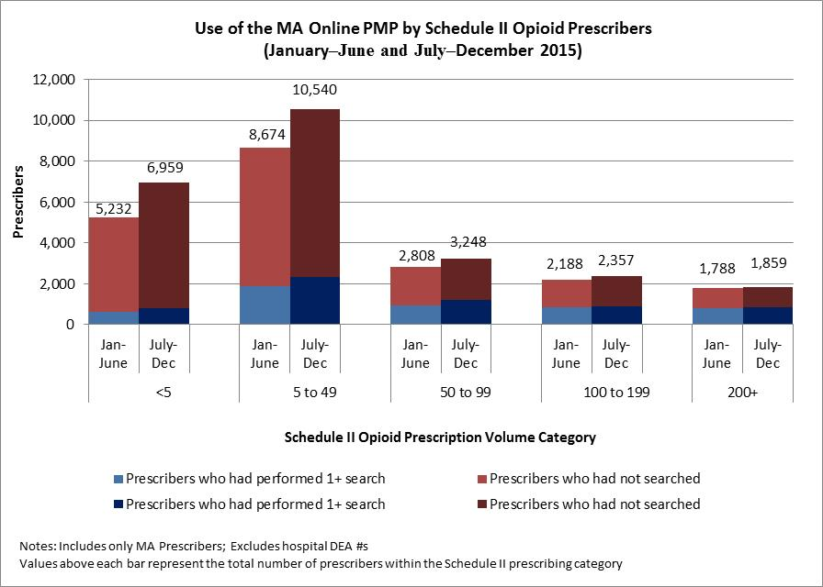

*What this means***:** There is a very large variation in prescribing of Schedule II opioid drug products among Massachusetts prescribers.[4] A relatively small number of prescribers account for a large proportion of Schedule II opioid prescribing in Massachusetts. Figure 1 presents only Massachusetts prescribers who have prescribed one or more Schedule II opioid drug products during 2015; separated out into 6-month periods for purposes of looking at utilization trends.

The vertical axis represents the number of prescribers who conducted at least one patient search during the 6-month time period (shaded in blue) versus those prescribers who did not conduct any patient searches during the time period (shaded in red). On the horizontal axis, the bars are separated into categories based on the quantity of Schedule II opioid prescriptions written by prescribers. For instance, the first category represents prescribers with fewer than five Schedule II opioid prescriptions during each 6-month time period; the highest category represents prescribers with two hundred or more Schedule II opioid prescriptions over each time period.

Among prescribers who issued fewer than fifty prescriptions for Schedule II opioid drug products, only a small percentage (17.9%) conducted at least one patient search during each of the 6-month time periods (i.e., January through June and July through December). However, among prescribers who issued fifty or more prescriptions for Schedule II opioid drug products, nearly 38% and 40% conducted at least one patient search during January through June and July through December time periods, respectively. Although there is only a small increase observed between the two 6-month intervals, it is expected that with increasing awareness and education about the requirements to use the PMP, these percentages will increase over time.[5]

**Figure 2**

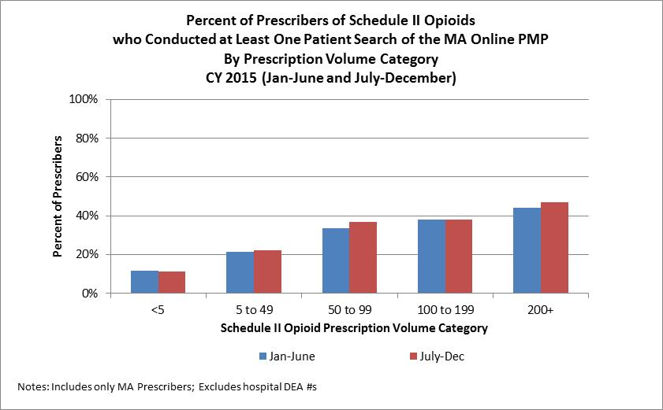



*What this means***:** Figure 2 (and accompanying data tables) shows that those prescribers who issue the highest number of Schedule II opioid prescriptions have the highest percentage utilization of the PMP. Additionally, there was a small increase from January through June compared with July through December in the percentage of prescribers who conducted at least one patient search for the prescribers with 50 to 99 and greater than 200 Schedule II opioid prescriptions reported to the MA PMP.

**Appendix B:** *MA Online PMP Enrollment*

Table 1

|  |  |  |  |  |
| --- | --- | --- | --- | --- |
| **Enrollment of Providers and Delegates in the MA Online PMP through Dec. 31, 2015** | | | | |
|  | Voluntary Enrollment  of Delegate Enrollment  (began March 2015) | Total Enrolled | Estimated Number Practicing in Massachusetts | Total Percentage Enrolled  (of eligible providers) |
| **Practitioners**  **(MD/DO/Dentists/Podiatrists** | ----- | 31,545 | 35,678 | 88.4 % |
| **Mid-Levels**  **(APRN/PA)** | ----- | 7,695 | 9,823 | 78.3 % |
| **Pharmacists** | ----- | 4,218 | 12,000* | 35.2 % |
| **Total Provider Enrollment1** | ----- | 43,458 | 57,501 | 75.6 % |
|  |  |  |  |  |
| **Delegates** | 1,654 | 1,654 | N/A | N/A |
| **1 Total enrollment only includes providers; excludes law enforcement, regulatory agency, and delegate enrollment.**  **\* This number represents an estimate of all registered pharmacists that are licensed in Massachusetts. Many licensed pharmacists do not work in retail pharmacy settings and are not dispensing controlled substances; therefore, the percentage enrolled for this provider category will be biased on the low side.**  **N/A = not available** | | | | |

1. While Chapter 258 of the Acts of 2014 requires this report to include information related to the prescribing practices of only Schedule II drugs, it is important to note that individual prescribers are also required to utilize the MA Online PMP prior to first-time prescribing of Schedule II and III narcotics or a prescription drug containing a benzodiazepine dispensed by Massachusetts pharmacies and out-of-state pharmacies that deliver to Massachusetts residents.
2. Park, T.W., et al. Benzodiazepine prescribing patterns and deaths from drug overdose among US veterans receiving opioid analgesics: case-cohort study. BMJ 2015:350:h2698.
3. Chapter 46 of the Acts of 2015
4. It is important to note that a large number of MA prescribers (approximately 25%) do not prescribe Schedule II –V controlled substances. These prescribers will rarely or never need to use the MA Online PMP because the prescriptions they write will not be monitored by the system.
5. Refer to Tables A1 and A2; the 38% and 40% values are derived from the accompanying data tables on next page.

   “Searches > 1” column divided by the “Totals” column

   Table A1 [(949+834+787)/(2,808+2,188+1,788)*100 = 37.9%

   Table A2 [(901+871+1,193)/(2,357+1,859+3,248)*100 = 39.7%