**Massachusetts Department of Public Health**

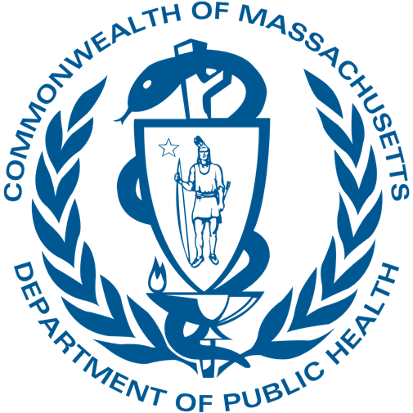

Stroke Advisory Committee

July 2024

**Bureau of Health Care Safety and Quality**

**Agenda**

* Department Updates
* Approval of October Meeting Minutes
* Data Presentation
* Overview of Proposed Tiering Regulation

**Map of PSS Facilities, CY 2023**

* 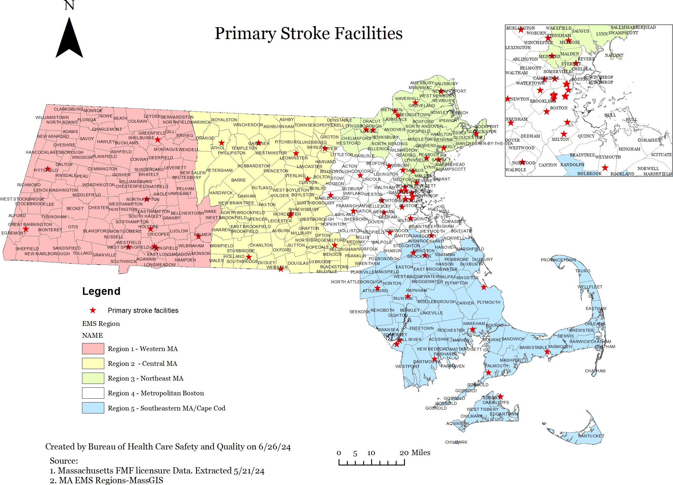Massachusetts has 61 active primary stroke service hospitals or satellite emergency facilities spread across its 5 EMS regions, with each region having between 9-20 facilities.
* In CY 2023, 8 PSS facilities reported performing thrombectomies, also known as mechanical endovascular reperfusion (MER) therapies.
  + Of these facilities, 5 are located in the Metro Boston region, with 1 facility each in MetroWest, Western MA, and Central MA.
  + Northeast & Southeast did not have any facilities reporting MER procedures in CY 2023.

Note: Norwood Hospital and Signature Brockton are temporarily closed.

**Current Primary Stroke Services in Massachusetts**

* Massachusetts has **one designation** for hospitals providing stroke services: **primary stroke service (PSS)**

center.

* PSS hospitals are self-certified and independently designated by the DPH as part of the hospital licensure process.
* PSS designation requires a "readiness to provide timely acute stroke evaluation and treatment," including:
  + Emergency diagnostic and therapeutic services 24 hours a day/7days a week to patients presenting with symptoms of acute stroke;
  + A designated stroke service director or coordinator who is a licensed physician with acute stroke expertise; and
  + A transfer agreement that includes stroke specific requirements for the care of patients with a known or suspected acute stroke.
* PSS hospitals must provide formal staff education for health care providers, including EMS personnel, which should include acute stroke prevention, diagnosis and treatment. Community education to the public must be provided which should include prevention of stroke, recognition of stroke symptoms and/or treatment of stroke.
* PSS designated facilities must submit case data to MA PSS registry; quality metrics are made available through a public dashboard: [mass.gov/info-details/primary-stroke-service-facilities-in-Massachusetts](https://www.mass.gov/info-details/primary-stroke-service-facilities-in-massachusetts).

1. Marulanda E, Bustillo A, Gutierrez CM, Rose DZ, Jameson A, Gardener H, Alkhachroum A, Zhou L, Ying H, Dong C, et al. Nationally certified stroke centers outperform self-attested stroke centers in the Florida Stroke Registry. *Stroke*. 2023;54:840–847. doi: 10.1161/STROKEAHA.122.038869

* In CY 2023, Massachusetts PSS hospitals reported 15,737 confirmed stroke cases.
  + The most common stroke type is ischemic stroke accounting for 67% of all reported strokes.
  + The median age was 73 years old and of all strokes, 50% were female and 50% were male.
  + Whites accounted for 76% of all reported strokes, however, there is well-documented evidence of structural bias and inequities in stroke care among patients from historically

underserved communities.1

**Strokes at Massachusetts PSS Facilities by Race & Ethnicity Strokes at Massachusetts PSS facilities by Age**

Unknown, nH/nL, 843 (5%)

Hispanic, 1171 (7%)

AI/AN, nH/nL, 32 (<1%) Asian, nH/nL,

510 (3%)

Black, nH/nL, 1330 (9%)

White, nH/nL, 11851, 76%

<45 yrs

741 (5%)

45-65 yrs

4343 (28%)

>65 yrs

10,653 ( 67%)

AI/AN= American Indian/Alaskan Native nH/nL= Non-Hispanic/Non-Latinx

1. Churchwell K, Elkind MSV, Benjamin RM, et al. Call to Action: Structural racism as a fundamental driver of health disparities: A presidential advisory from the American Heart Association. Circulation 2020: 454-468.

**Characteristics of Stroke Patients Reported in PSS**

*Source: Massachusetts PSS Registry, extracted May 28, 2024*

**CDC Stroke System of Care: State Policy Interventions**

* State and local stroke systems of care (SSOC) are approaches for coordinating stroke-related services to facilitate timely and effective care. SSOCs seek to address stroke patient care comprehensively and include efforts ranging from prevention, education, assessment, emergency transport, hospital care and treatment, and follow-up outpatient care.1
* Massachusetts has implemented the highlighted items below:

**Pre-Hospital Interventions**

**In-Hospital/Post-Hospital Interventions**

SSOC Task Force

EMS Stroke Assessment protocols

Standardized EMS Stroke Assessment Tool Use

Tiered stroke center approach

Tele-stroke to initiate treatment

Statewide CQI data system & reporting

EMS Triage & Transport

Air medical transport

Inter-Facility transfer

Nationally certified PSCs

Nationally certified CSCs

Nationally certified ASRHs

Stroke

pre-notification

Continuing education for EMS providers

CQI for EMS for stroke

State certified PSCs

State certified CSCs

State certified ASRHs

1. [cdc.gov/coverdell/php/report/stroke-pear.html](https://www.cdc.gov/coverdell/php/report/stroke-pear.html)

**Current State-wide EMS Treatment Protocol for Stroke**

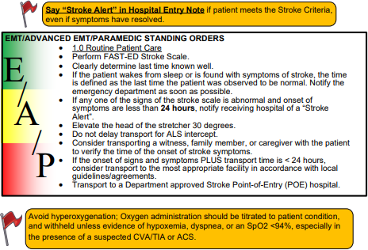 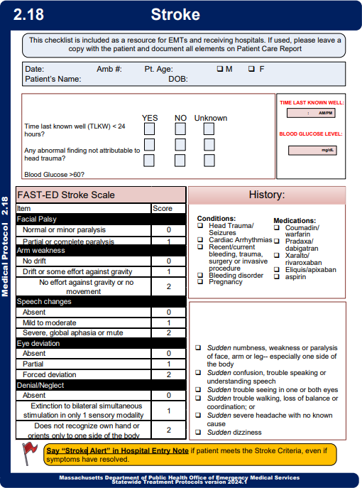

* In CY 2023, there were 11,139 suspected stroke EMS runs reported in the Massachusetts Ambulance Trip Record Information System (MATRIS).
  + PSS hospitals reported 8,468 confirmed strokes arriving via EMS in CY 2023.
* Among CY 2023 EMS runs with known FAST-ED scores, 22% had a score of 4 or higher and 8% had a score of 6 or higher.
  + 39% of the suspected stoke had missing FAST-ED scores though missingness is improving over time.
  + DPH began to require ambulances submit numeric values for FAST-ED scores in November 2022.

**Number of Suspected Stroke Runs**

**No. of Suspected Strokes by Fast-ED scores, CY 2023 (N=6,833)**

**Region 5- Southeastern/ Cape Cod, 2539, 23%**

**Suspected Strokes in EMS, CY 2023**



**Region 4- Metropolitan Boston, 3118,**

**28%**

**Region 1- Western, 2001, 18%**

**Region 2-**

**Central, 1626,**

**14%**

**Region 3- Northeastern, 1855, 17%**

2000

1800

1600

1400

1200

1000

800

600

400

200

0

*Source: Massachusetts Department of Public Health, MATRIS V3, Extracted May 23, 2024*

1898

**22%**

1418

1268

**8%**

779

562

354

235

187

82

50

0

1

2

3

4

5

6

7

8

9

**Suspected Stroke in EMS, CY 2023**

* EMS personnel are required to collect time last known well (LKW) for all suspected stroke runs.
* In CY 2023, the median time from last known well to EMS arrival was about 2.1 hours
  + 59% of the suspected strokes with LKW less than 3 hours
  + LKW times were missing for 4,916 (44%) suspected stroke runs

# Last Known Well of Stroke Patient to EMS Arrival in MATRIS, CY 2023

|  |  |  |
| --- | --- | --- |
| **LKW to Arrival** | **No. of Suspected Strokes** | **% of Suspected Strokes** |
| ≤ 3 hours | 3,687 | 59.3 |
| 3 hours - 24 hours | 1,956 | 31.4 |
| ≥ 24 hours | 580 | 9.3 |

**Current MA Treatment Protocol/Stroke Point of Entry Plan:** If LKW < 24 hours, then EMS are directed to the closest PSS hospital.

[**Maine EMS Protocols:**](https://www.maine.gov/ems/sites/maine.gov.ems/files/inline-files/2023-Maine-EMS-Protocols-20231116.pdf)

* If LKW ≤ 3 hours and FAST-ED ≥ 4 then transfer to nearest hospital for IV- tPA
* If LKW > 3 hours and FAST-ED ≥ 4, then divert to higher level of care for MER if facility is within 30 minutes

[**Pennsylvania EMS Protocols:**](https://www.health.pa.gov/topics/Documents/EMS/2023v1-2%20PA%20ALS%20Protocols.pdf)

* If LKW ≤ 3 hours and LVO suspected or contraindications to IV-tPA, then transport to closest CSC/TSC if within 45 minutes
* If LKW between 3 and 24 hours, then transport to closest CSC/TSC if within 45 minutes.

[**Rhode Island EMS Protocols:**](https://health.ri.gov/publications/protocols/StatewideEmergencyMedicalServices.pdf)

* If LAMS ≥ 4 and LKW <24 hours, then transport to the nearest CSC.

*Source: Massachusetts Department of Public Health, MATRIS V3, Extracted May 23, 2024*

* The proportion of stroke patients arriving via EMS from home increased slightly from 50% in 2019 to 54% in 2023.
* Region 4- Metropolitan Boston has the smallest proportion of stroke patients transported by EMS (44% vs 66% highest).
  + Note, the highest volume of transfers patients from other hospitals may account for the lower proportion.

**Total strokes and % arriving via EMS from home by year, 2019-2023 Arrival modes of Stroke patients by region, CY2023**

17000

16000

15000

14000

13000

12000

11000

10000

9000

8000

2019 2020 2021 2022 2023

56.0

54.0

**54**

**50**

52.0

50.0

48.0

46.0

44.0

42.0

7000

6000

hospital Private

3116

210

2341

1920

Region 1- Western

Region 2- Central

Region 3- Northeast

Region 4- Region 5- Metropolitan Southeastern/ Boston Cape Cod

1119

58%

1188

56%

1442

62%

2072

66%

**2647**

**44%**

5985

Transfer from another

5000

4000

3000

2000

1000

0

 Total Strokes %. of Strokes arriving via EMS from home/Scene

**Stroke Patient Mode of Arrival**

*Source: Massachusetts PSS Registry, extracted May 28, 2024*

**Flowchart of Patient Evaluation and Alteplase Treatment in Ischemic Stroke Patients in Massachusetts at PSS-licensed facilities, CY 2023**

804 treated, 89% Eligible population

Ischemic Stroke Patients: 10,478

* Patients with no LKW and no outside alteplase administration: 4,090

Patients with known LKW

and no outside alteplase: 6,388

Patients arriving within 3.5

hrs of LKW: 2,424

Patients eligible for alteplase

treatment: 902

Patients treated with

alteplase within 4.5 hours of LKW: 804

Number of eligible patients NOT treated with alteplase: 98

* Patients not receiving a CT within

4.5 hours of LKW: 0

* Patients with documented alteplase contraindications:475
* Number of patients with documented warnings: 1,047

**Opportunity for Improvement: Making sure patients present for care as soon as signs recognized**

* Patients arriving to ED after 3.5 hrs of LKW: 3,964

*Source: Massachusetts PSS Registry, extracted May 28, 2024*

* In CY 2023, there were 15,737 stroke cases reported by PSS hospitals which is approaching levels in 2019.
  + 2,498 (15.9%) were interhospital transfers.
* There is higher percent transfers among younger age groups.
  + During COVID-19, all the age groups had the same decreased transfer trend.

**Stroke Transfers in PSS Hospitals, CY 2023**

17000

16000

15000

14000

13000

12000

11000

10000

9000

8000

**Total Strokes and Percent Interhospital Transfers in**

 Total Strokes % Interhospital Transfer

**PSS, CY 2023**

18.4

**15696**

18.8

16.8

15.1

15.9

**15737**

2019

2020

2021

2022

2023

35.0

20

18 30.0

16

25.0

14

12 20.0

10

8 15.0

6

10.0

4

2 5.0

0

0.0

**% Transfers by age group**

<45 yrs

45-65 yrs

>65 yrs

2019 2020 2021 2022 2023

**Interhospital Transfers in PSS Facilities**

* In CY 2023, PSS facilities reported 2,498 interhospital stroke transfers. The top 8 receiving hospitals account for 93% of the total transfers.
  + 467 interhospital transfers (19%) were missing the name of the sending facility
  + 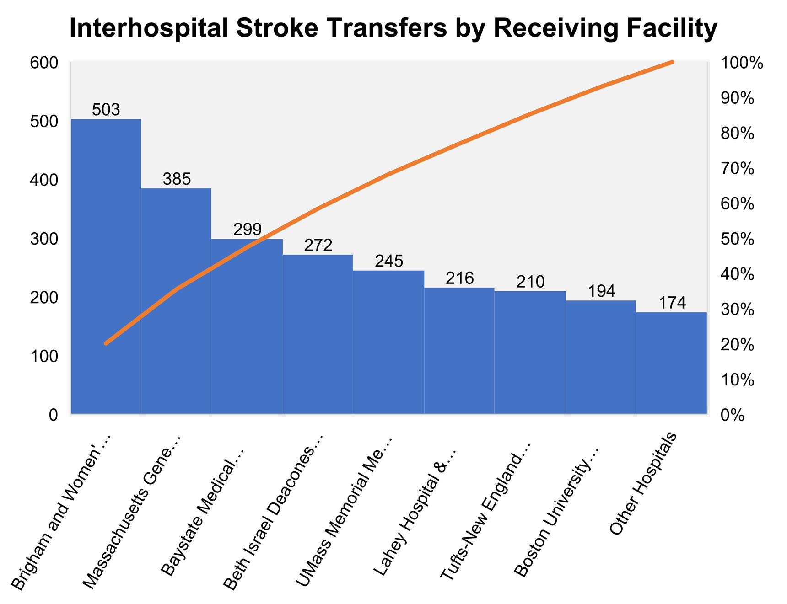220 interhospital transfers (9%) of the transfers came from hospitals from outside of Massachusetts

**Interhospital Stroke Transfers by Sending Facility**

140

120

98

75 69 67 66 66 64 64

58 53 52 47 47

44 43 42 42 41 38 34 33 32

31 31 30 30 30

120

100

80

60

40

20

0

South Shore… Good Samaritan…

Salem… UMass Memorial… Milford Regional…

Beverly… Melrose-Wakefield…

Cape Cod… Newton-Wellesley… Brigham and Women's… Baystate Noble… UMass Memorial-… MetroWest Medical… Baystate Wing…

Lahey Medical Center,… Cooley Dickinson… Lowell General…

Falmouth… Harrington…

North Shore Medical… Catholic Medical… Addison Gilbert… Morton Hospital and… Baystate Franklin… Holyoke Medical… Lowell General… Berkshire Medical…

Winchester…

250

200

150

Minutes

100

50

**Median Door-in-door-out for Interhospital Stroke Transfers**

* The median door-in-door-out (DIDO) time for all interhospital stroke transports **increased 14%** from 2019

210

206

208

182

175

121

127

135

112

120

to 2023.

* For interhospital transports where an MER was performed, the median DIDO **increased 12%** from 2019 to 2023.
  + the percent of stroke patients arriving via EMS increased to 54% in 2023 ( was 50% in

2019)

**Median Door-In-Door-Out Time for Interhospital Transfers**

0

2019 2020 2021 2022 2023

Transfers where MER was performed All Interhospital Stroke Transfers

**Proximity to PSS Hospitals that Report MER Capabilities**

* 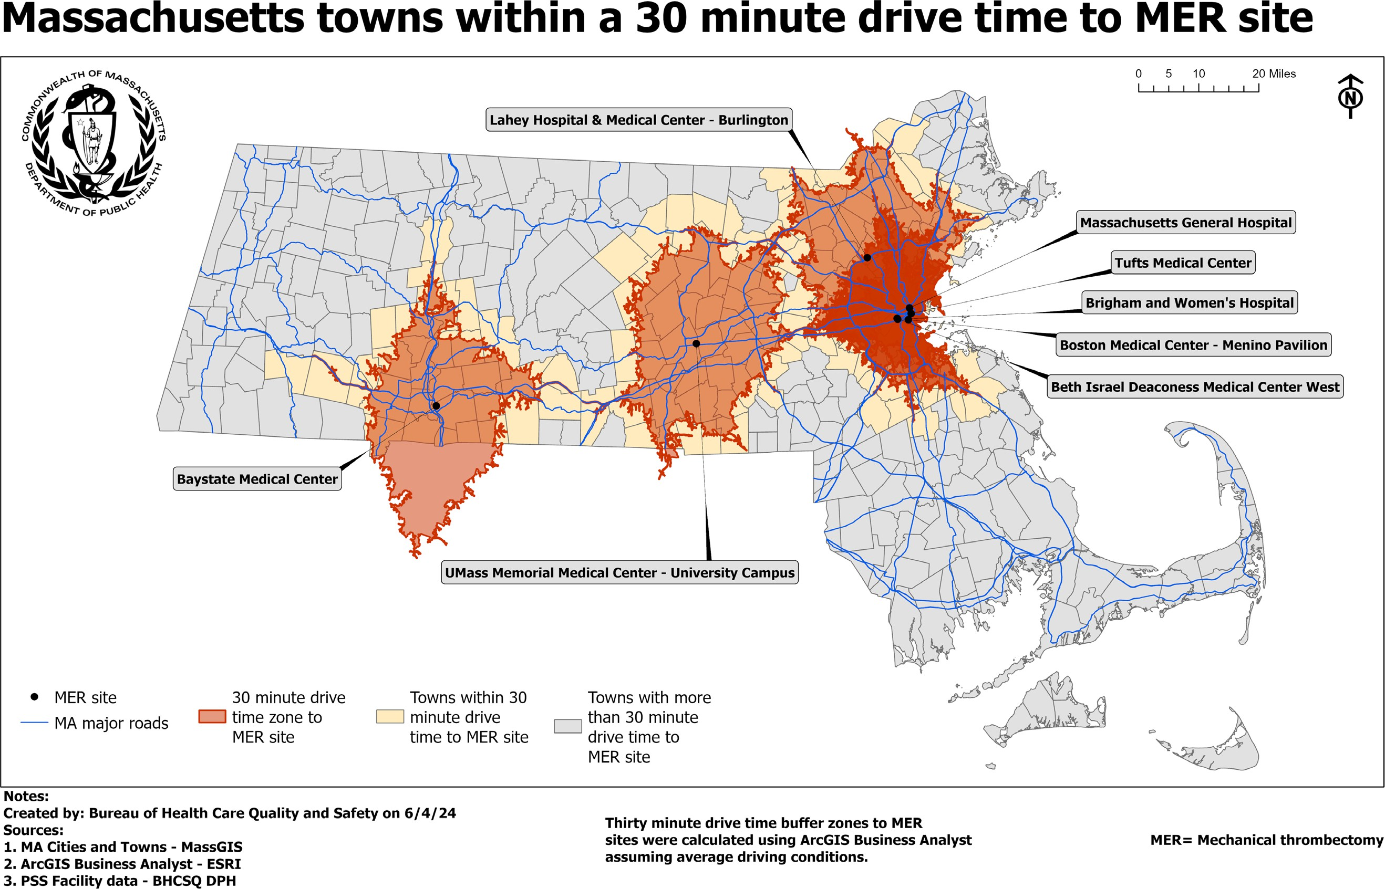72% (N=5,047,045)

of MA residents live in the 158 towns within a 30-minute drive time of any MER site.

* Among residents over 65 years old, 66% (N=793,138) live

in towns that are within 30 minutes of any MER site.

*Based on MA population estimates from the UMass Donahue Center based on 2020 US Census Data

**Hospitals that Reported Performing Mechanical Endovascular Reperfusion, CY 2023**

* There were 763 reported mechanical endovascular reperfusion (MER) procedures performed in CY 2023.
* Of patients that received these procedures, 64% arrived via interhospital transfer.

|  |  |  |  |
| --- | --- | --- | --- |
| **Facility Name** | **No. of MER performed** | **No. of Ischemic Strokes Treated** | **Percent of All Ischemic Strokes where MER was performed** |
| UMass Memorial Med. Ctr. -  University | 158 | 599 | 26.38 |
| Boston Medical Center | 108 | 458 | 23.58 |
| Beth Israel Deaconess Medical Ctr | 102 | 458 | 22.27 |
| Massachusetts General Hospital | 99 | 609 | 16.26 |
| Brigham and Women's Hospital - Boston | 95 | 461 | 20.61 |
| Baystate Medical Center | 84 | 644 | 13.04 |
| Tufts Medical Center | 65 | 258 | 25.19 |
| Lahey Hospital & Medical Center | 52 | 522 | 9.96 |

*Source: Massachusetts PSS Registry, extracted May 28, 2024*

**PHIT Dashboard: PSS Facility Data**

* DPH offers comprehensive data on strokes in PSS facilities and locations of PSS-designated facilities in an interactive dashboard on the mass.gov webpage
* The dashboard tracks stroke performance metrics and stroke patient care with a special emphasis on health equity

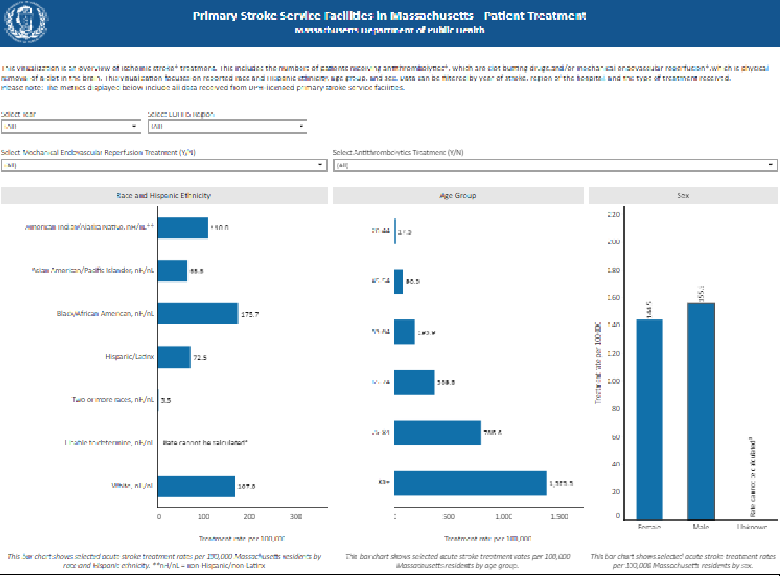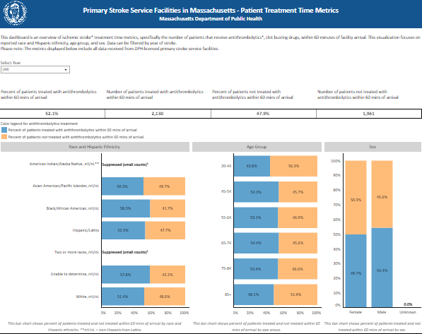

Dashboard can be found here: [mass.gov/info-details/primary-stroke-service-facilities-in-massachusetts](https://www.mass.gov/info-details/primary-stroke-service-facilities-in-massachusetts%C2%A0)

**Designating Hospitals In a Tiered System: Legislative Mandate**

**Section 90 of Chapter 28 of the Acts of 2023**

Notwithstanding any general or special law to the contrary and not later than 180 days after the effective date of this act, the department of public health shall promulgate regulations that create:

* 1. a statewide standard pre-hospital care protocol related to the assessment, treatment and transport of stroke patients by emergency medical services providers to a hospital designated by the department to care for stroke patients; provided, however, that the protocol shall be based on national evidence-based guidelines for transport of stroke patients, consider transport that crosses state lines and include plans for the triage and transport of suspected stroke patients, including, but not limited to, those who may have an emergent large vessel occlusion, to an appropriate facility within a specified timeframe following the onset of symptoms and additional criteria to determine which level of care is the most appropriate destination;
  2. statewide criteria for designating hospitals in a tiered system, featuring advanced designations in addition to primary stroke services, to treat stroke patients based on patient acuity; provided, however, that the tiers shall be based on criteria from at least 1 nationally-recognized program and shall not permit self-designation; provided further, that in developing such criteria, the department shall consider:
     1. designation models and criteria developed by the Joint Commission, DNV GL Healthcare USA, Inc. or another national certifying body recognized by the Centers for Medicare and Medicaid Services;
     2. designation models and criteria adopted by other states and the differences in geography and health care resources of such other states;
     3. the clinical and operational capability of a facility to provide stroke services, including emergency and ancillary stroke services;
     4. limiting the routing of stroke patients to thrombectomy-capable facilities whenever a comprehensive stroke center is within a recommended timeframe to maximize technical competency and patient outcomes; and
     5. procedures to suspend or revoke a facility's designation if the department determines that the facility is not in compliance with designation requirements and procedures to notify emergency medical services providers of any such suspension or revocation; and
  3. recommended national evidence-based quality and utilization measure sets for stroke care for use by the center for health information and analysis pursuant to [**section 14 of chapter 12C**](https://malegislature.gov/Laws/GeneralLaws/PartI/TitleII/Chapter12c/Section14)of the General Laws; provided, however, that the department shall consider measures in current use in national quality improvement programs, including, but not limited to, the Centers for Medicare and Medicaid Services, the National Quality Forum, the Paul Coverdell National Acute Stroke Program or other nationally recognized data platforms.

**Overview of Tiering Regulation**

Proposed Revisions to Hospital Licensure Regulation, 105 CMR 130:

* Set specific licensure requirements for **hospitals with emergency departments and satellite emergency facilities** (SEFs) to be "**acute stroke ready**."

# Define higher acuity capability levels in the regulation. Allow hospitals demonstrating capability to care for higher acuity patients to seek certification through nationally recognized accreditation entity.

* Maintain current requirements for data collection and reporting. Proposed Updates to EMS Protocols (sub-regulatory):
* Maintain FAST-ED as required tool for assessment by EMS personnel
* Update EMS Stroke Point of Entry Plan to **allow for transport to mechanical endovascular reperfusion (MER) site** if the following criteria are met:
  + FAST-ED score is 6 or higher
  + Last Known Well is 4.5 hours or less
  + MER site is no more than 30 minutes farther travel than closest stroke ready hospital