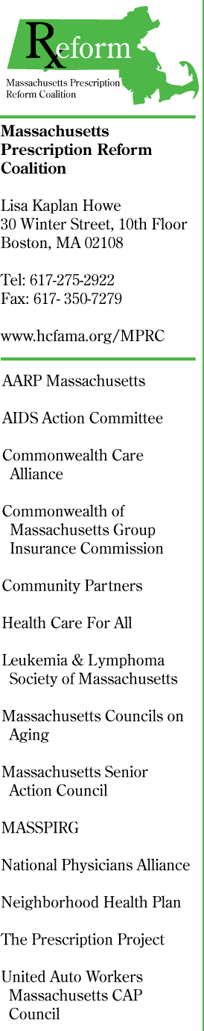
Testimony of the Massachusetts Prescription Reform Coalition

Before the Executive Office of Health and Human Services

August 27, 2008

Thank you for the opportunity to provide testimony as you develop your FY2010 budget proposal. My name is Lisa Kaplan Howe. I am the Private Market Policy Manager at Health Care For All, and I am offering testimony on behalf of the Massachusetts Prescription Reform Coalition (MPRC).

The MPRC is a diverse group of local and national non-profit organizations, health care advocates, private insurers, public payers and health care providers committed to promoting evidence-based, unbiased prescribing and access to appropriate and affordable prescription drugs. Our work is guided by the following principles:
- Prescription drugs should be affordable for all patients and payers.
- Pharmaceutical marketing should be focused on getting the right drug to the right person.
- Prescribers and consumers should have access to evidence-based, unbiased information about prescription drugs.
- Decisions of whether to prescribe, what to prescribe and what drugs to cover should be based on timely, unbiased, evidence-based data and should be guided by the best interests of the patient. The process of making those decisions should be transparent.
- Relationships between pharmaceutical companies, prescribers and payers should be transparent and free from conflicts of interest.
- Prescription data should be protected from use in marketing.

The MPRC thanks the secretariat and Governor Patrick for prioritizing health care cost control and, in particular, for supporting Chapter 305 of the Acts of 2008. The MPRC strongly supports the prescription reform provisions that Governor Patrick signed into law as part of Chapter 305 and we urge you to provide adequate funding for the full implementation and enforcement of those provisions in your FY2010 budget proposal.

Prescription drug cost control is critical to overall cost control. Prescription drug prices continue to grow faster than the growth in overall health care costs. The prices of the most widely used brand-name prescription drugs rose nearly 50% between 2000 and 2006, more than twice the rate of inflation. These costs put consumers at risk for medical debt and bankruptcy, and threaten access to needed medications. Rising prescription drug costs also threaten the continued success of Massachusetts health reform and the financial stability of the state and employers that provide health care coverage.

The prescription reform provisions included in Chapter 305, if fully implemented, will help to ensure prescription drug cost control and improved quality of care.

- Evidence-Based Outreach and Education to Providers. Too often prescribers are left to rely on the pharmaceutical industry’s sales representatives for information about prescription drugs. This information is one-sided, incomplete and is given with the goal of promoting sales of particular products. The “Academic Detailing” program created by Chapter 305 will ensure that prescribers have the well-rounded and unbiased safety and efficacy data they need to make high quality prescribing decisions. Research shows that state-funded, evidence-based outreach and education programs improve patient safety and create savings that far exceed the cost of such programs.

We thank you for supporting funding for the first six months of the evidence-based outreach and education program for prescribers in the FY2009 state budget (line item 4510-0716). We urge the secretariat to allocate sufficient full-year funding in FY2010 to enable the Department of Public Health to fully implement and monitor a statewide outreach and education program.

      - Pharmaceutical and Medical Device Marketing Code of Conduct and Disclosure. A wealth of research shows that industry gifts and other financial conflicts of interest inherently influence prescribing decisions, leading to increased prescribing of the newest drugs, which are more expensive than other equally safe and effective drugs. These are also drugs about which we have the least safety and efficacy data. Chapter 305’s statewide marketing code of conduct and requirement that pharmaceutical and medical device companies disclose financial relationships with providers will prevent the dangerous influence of financial conflicts of interest.

Chapter 305 provides for a fee to be collected from companies disclosing financial relationships and for this fee to fund the implementation and enforcement of the disclosure provision. We urge you to include in the FY2010 budget sufficient funding from this fee to enable the Department of Public Health to fully implement and enforce that provision as well as any funding necessary to fully implement and enforce the code of conduct provision.

The prescription reform provisions that the Governor signed into law as part of Chapter 305 will provide prescribers with the unbiased data they need to make safe and cost-efficient prescribing decisions, while ensuring that prescribing decisions are not unduly influenced by conflicts of interest or inappropriate marketing tactics. We ask for your continued support of these provisions by ensuring adequate funding for the Department of Public Health to fully implement, monitor and enforce them. The full implementation of these provisions will give consumers the peace of mind that the medications they are prescribed are the most appropriate for them and that the decision of what to prescribe is based on unbiased evidence, not the result of inappropriate influence of the pharmaceutical industry.

Thank you again for your time this afternoon. The MPRC looks forward to working with you and the Department of Public Health as you develop your FY2010 budget proposal and implement the prescription reform provisions of Chapter 305. We also seek to be a resource to you as you consider funding sources for the prescription reform provisions. Please do not hesitate to contact me if we can provide you with any information or other support.

