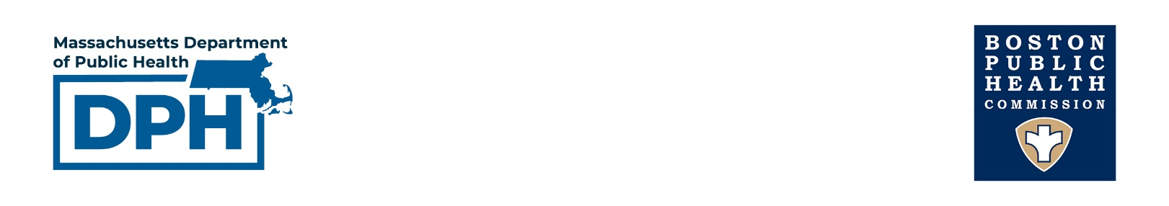

Clinical Advisory: Upcoming FIFA World Cup 2026 Events

To: Healthcare Providers
From: Massachusetts Department of Public Health and Boston Public Health Commission
Date: June 2, 2026
Re: Infectious disease risks associated with increased travel to Massachusetts in June and July 2026

Massachusetts will experience large numbers of international and domestic visitors for the FIFA World Cup and accompanying events in June and July 2026. Massachusetts residents and visitors are anticipated to gather in large groups, which may increase the risk of infectious disease transmission. When seeing patients during this time period, healthcare providers are advised to maintain heightened awareness for infectious diseases that are uncommon in Massachusetts but are more prevalent in other parts of the country or world. Providers should continue to include considerations of common, non-life-threatening conditions as well.

Recommendations for healthcare providers:

When individuals present with potentially infectious symptoms, providers should inquire about local exposures and risk factors. In addition, healthcare providers should obtain a detailed travel and exposure history to assess for possible imported infectious diseases, accessing interpreter services when appropriate.

- Recent attendance at large gatherings such as soccer games, fan festivals, or crowded public transit
- New sexual partners
- Dietary exposures including products consumed from vendors at a mass gatherings
- Close contacts with recently or currently ill individual(s)
- Immunization status, e.g. prior receipt of MMR vaccine
- Recent domestic or international travel or residence, dates of travel, and any transit locations
- Mosquito or tick bites and any previous diagnosis of malaria
- Unusual dietary exposures (e.g., uncooked meat or seafood, or unpasteurized dairy products)
- Recent receipt of healthcare in another country

Consider travel-associated and imported infections in the differential diagnosis for at-risk patients. The following are infectious diseases that may affect both Massachusetts residents and travelers during this time:

Respiratory and airborne infections:
- Influenza, RSV, COVID-19 (respiratory virus season in the Southern Hemisphere corresponds to summer in North America)
- Measles*
Sexually transmitted and close contact infections
- HIV (acute)*, gonorrhea, syphilis and other STIs
- Mpox*
Enteric infections:
- Typhoid and enteric fevers*
- Hepatitis A*

In addition, domestic or international travelers may be at elevated risk for infections acquired outside of Massachusetts (depending on their residence and travel history):
Vectorborne:
- Malaria**
- Dengue
- Other arboviruses: Chikungunya, Zika, Oropouche
Respiratory and airborne infections:
- Tuberculosis*
- MERS*

*These diseases and any unusual diseases or illness believed to be part of a cluster or outbreak should be reported immediately.
**Require notification within 24 hours

If providers have concern for any of these infections, they should promptly implement infection control measures as appropriate and contact their local board of health or the Massachusetts DPH at 617-983-6800 (24/7 Epidemiology line). For patients diagnosed in Boston, contact the Boston Public Health Commission at 617-534-5611.

DPH and BPHC or other local health authorities can assist with diagnostic testing and isolation guidance. Remember the importance of reporting conditions regardless of whether patient is a Massachusetts resident.

Additional Resources:

CDC Travelers Health Clinician Guidance
Massachusetts DPH World Cup website
Massachusetts Reporting Requirements During World Cup

